**PII analysis using** **presidio API for Intelligent PII scrubbing.**

**1. Open source API:** presidio

**Sample data:**

1. ebidm-dsai meeting notes 2022-01-21.
2. 2021-08-23 Doris Paquin (Spectrum) meeting notes.docx
3. 2020-11-16 GSA USAB meeting notes.docx
4. 2022-06-15 Onyx demo from Curtis ONeil.txt

**Execution time:**

PII analysis for ebidm-dsai meeting notes 2022-01-21.docx completed in

0.17 seconds.

PII analysis for 2021-08-23 Doris Paquin (Spectrum) meeting notes.docx completed in 0.10 seconds.

PII analysis for 2020-11-16 GSA USAB meeting notes.docx completed in

0.17 seconds.

PII analysis for 2022-06-15 Onyx demo from Curtis ONeil.txt completed in

0.05 seconds.

**Results:**

<class 'presidio_analyzer.recognizer_result.RecognizerResult'>

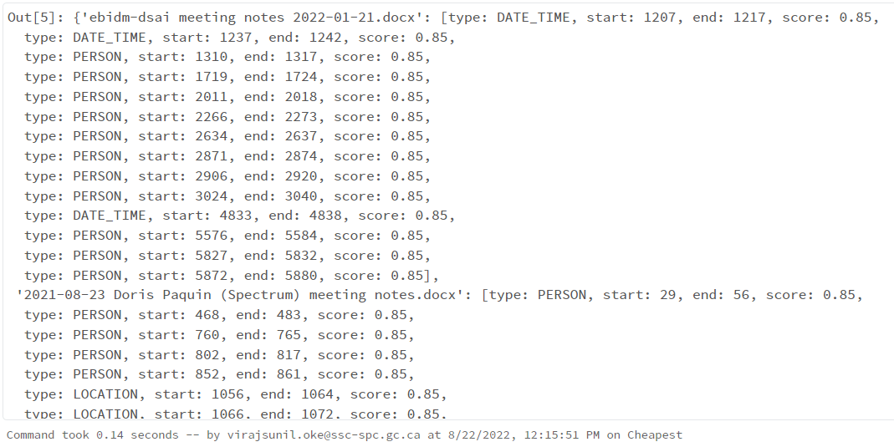

**DataFrame of the detected PIIs with document name column:**

