# Subject: Object Oriented Programming Lab SUBJECT ACTIVITY

**Sequences in C++**

**Class:** SE **Div.:** C

# Name: Arundhati Deshpande Roll No.: SEETC315

**Sequences Problem Statement 1**

## Aim:

Given a list of n distinct numbers (where n <= 1000), find the length of the longest monotone decreasing subsequence.

**Code:**

#include<stdio.h> #include<stdlib.h> int main(){

int num;

int length=1;

int max_length=0,i,curr_num; if(fscanf(stdin,"%d",&num)!=EOF) /* If there is no

number in the input file maximum length must be 0,

otherwise it is atleast 1*/

max_length=1;

while(fscanf(stdin,"%d",&curr_num)!=EOF){

// Scan and compute longest subsequence till EOF if(curr_num<num)

length++;

else

length = 1;

if(max_length<length)

max_length = length; num = curr_num;

}

printf("%d\n",max_length); return 0;

}

**Output:**

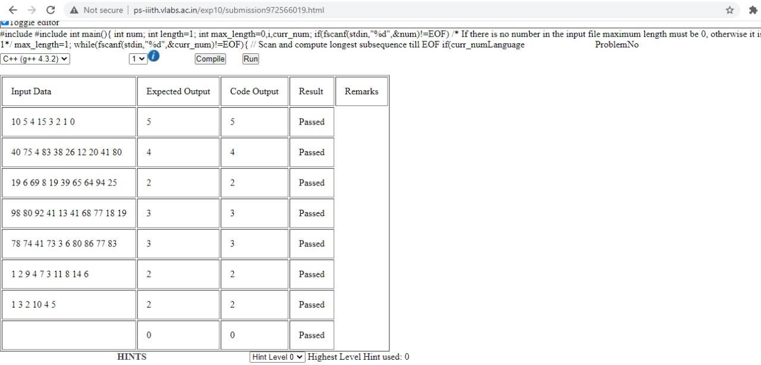

**Quiz:**

### The execution of a loop typically starts with:

* 1. initialization statements
  2. Loop body
  3. test condition
  4. update statements

### The break statement is used to exit from:

* 1. an if statement
  2. a for loop
  3. a program
  4. the main( ) function

### A do-while loop is useful when we want that the statements within the loop must be executed

* 1. only once
  2. At Least Once
  3. More than once
  4. None of the above

### In what sequence the initialization, testing and execution of body is done in a do-while loop

* 1. Initialization, execution of body, testing
  2. Execution of body, initialization, testing
  3. Initialization, testing, execution of body
  4. None of the above

### Which looping process checks the test condition at the end of the loop?

* 1. for
  2. while
  3. do-while
  4. No looping peocess check condition at the end

### A continue statement causes execution to skip to:

* 1. the end of the program
  2. the first statement after the loop
  3. the statement following the continue statement
  4. the next iteration of the loop

### The statement i++; is equivalent to:

|  |  |  |  |  |
| --- | --- | --- | --- | --- |
| i i i | =  =  = | i i i | +  +  - | i;  1;  1; |
| i | - | - | ; |  |

a)

b)

c)

d)

### Another word for "looping" is:

* 1. recapitulation
  2. tintinabulation
  3. iteration
  4. reiteration

### Which looping process is best used when the number of iterations is known?

* 1. for
  2. while
  3. do-while
  4. all of the above

### Which of the following is not an infinite loop.

for(int i =1; i<100; i++) printf("Hello World"); int i = 0; do{ i-- printf("%d ",i); }while(i>0);

for( int i =1; i < 10 ; i--) printf("Hello World");

int i = 1 ; while ( 1 ) { i++ ; }

a)

b)

c)

d)

## Result:

