NAME - Viraj Shirke

PRN - 2408040325072

**CLOUD**

Step1: Create a IAM user

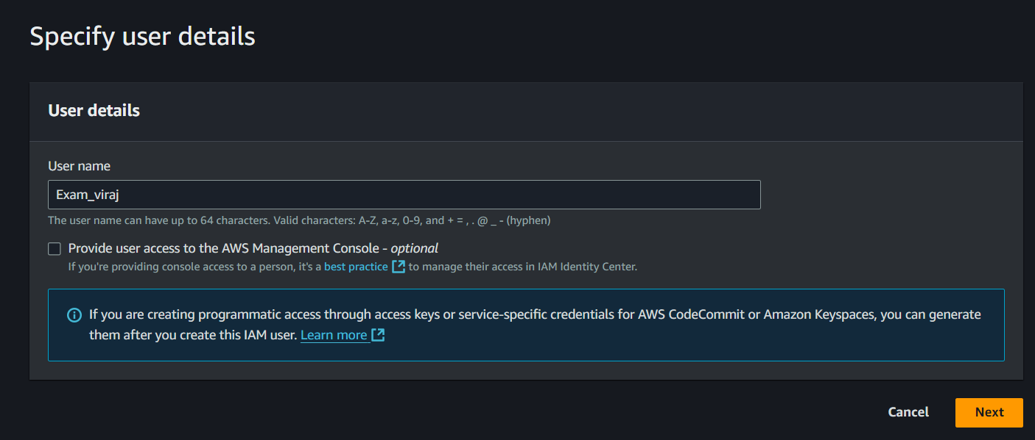

Steo 2: Granting policiy of EC2 Full Access

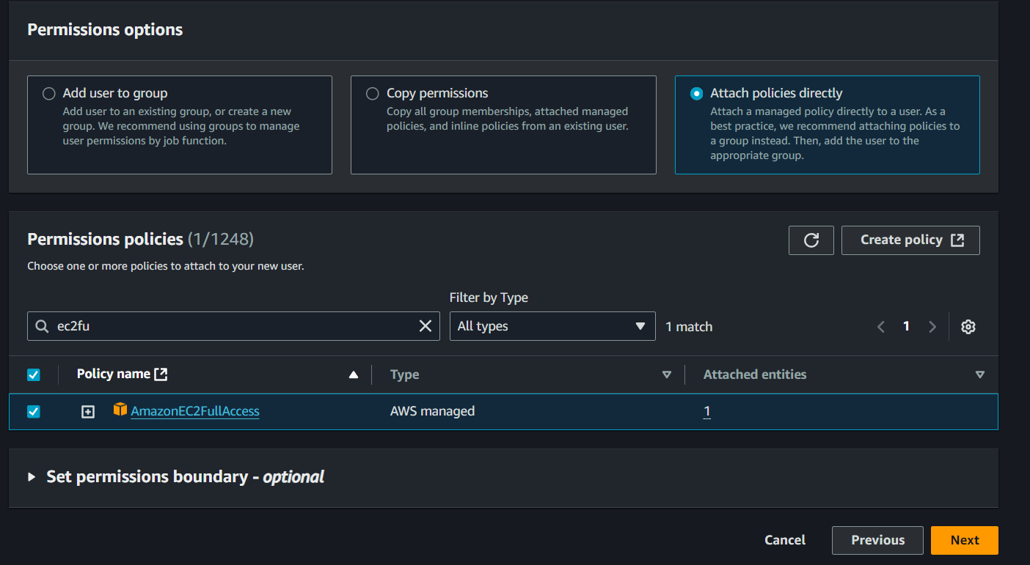

Step 3: The User has Assign the policiy of EC2 Full Access

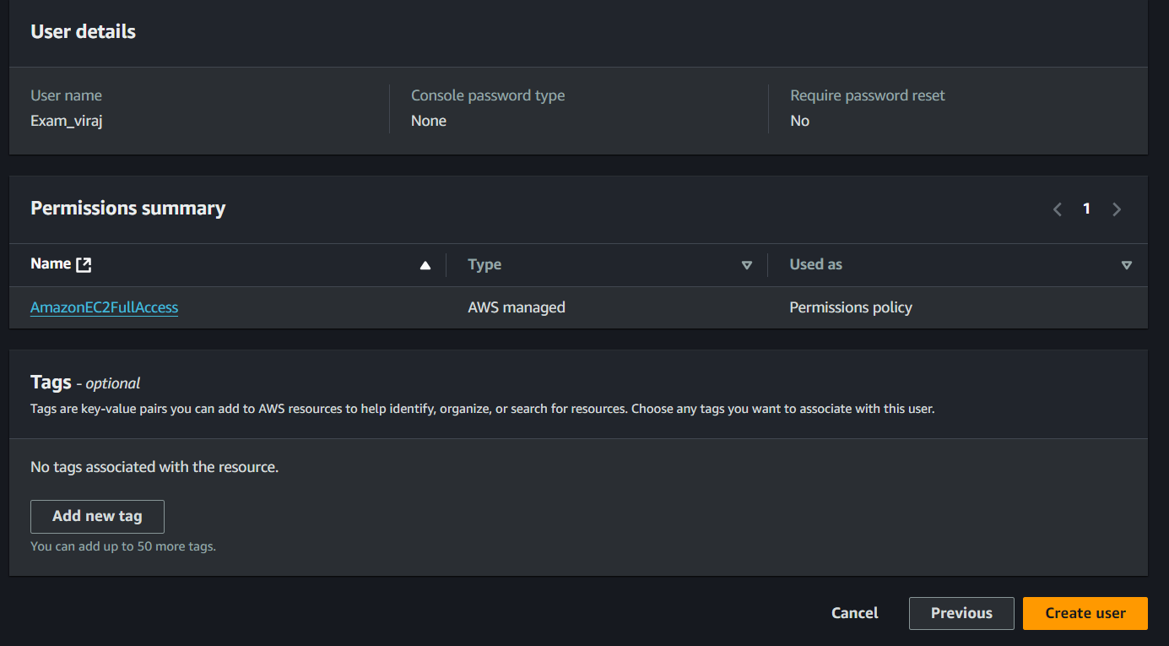

Step 4: Launching EC2 Instance

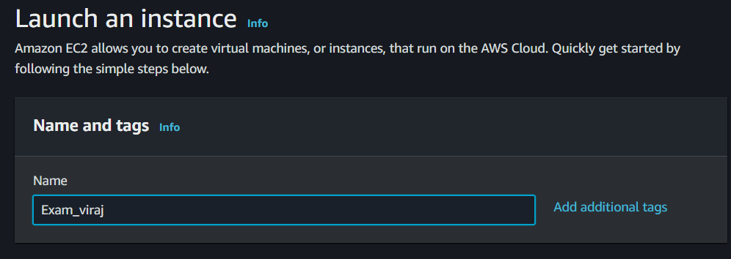

Step 5: Assinging Amazon Machince image

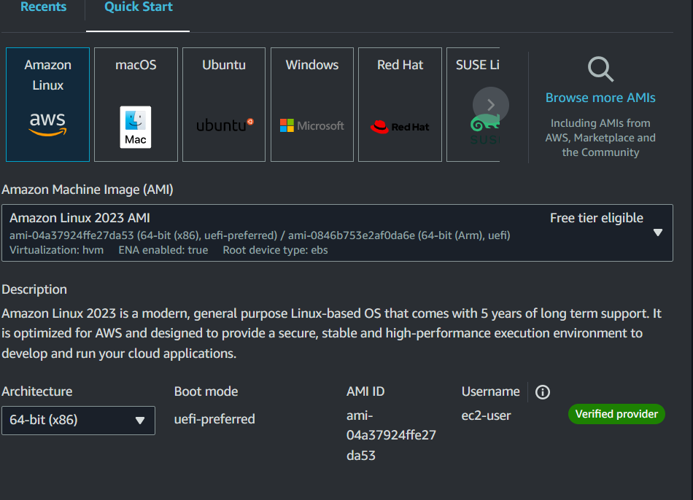

Step 6: Assging T2 micro instance

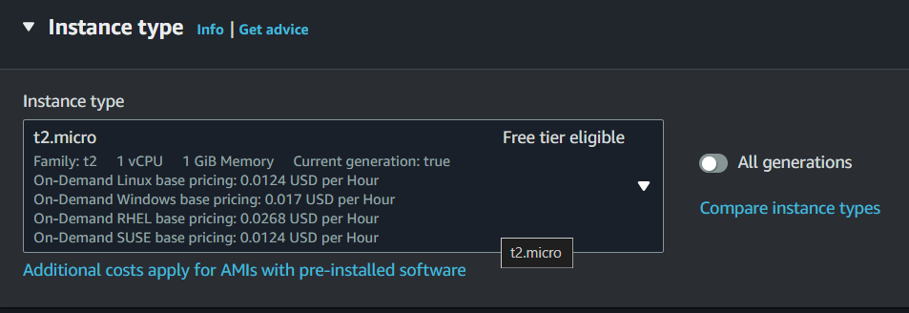

Step 7: Assinging Key Pair

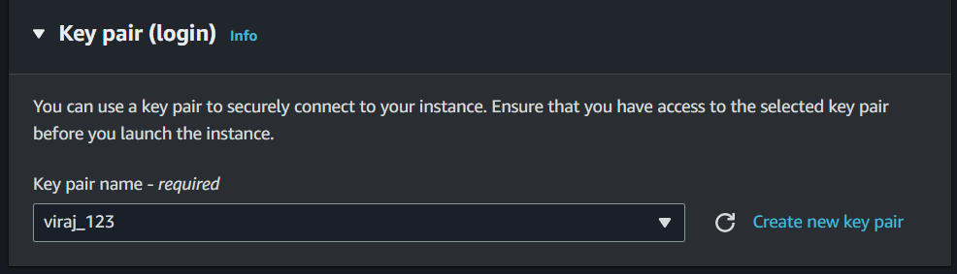

Step 8: Allowing HTTPS and HTTP Traffic from the internet

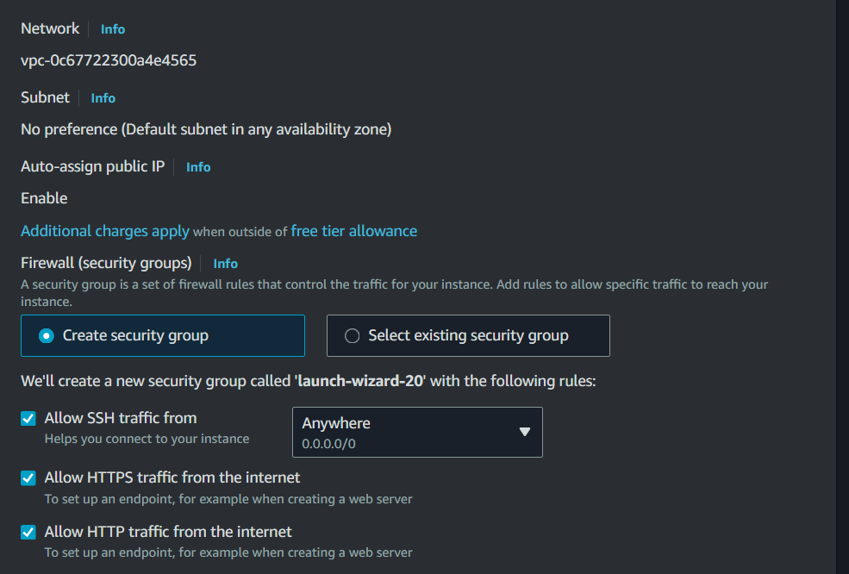

Step 9: EC2 Instance Created

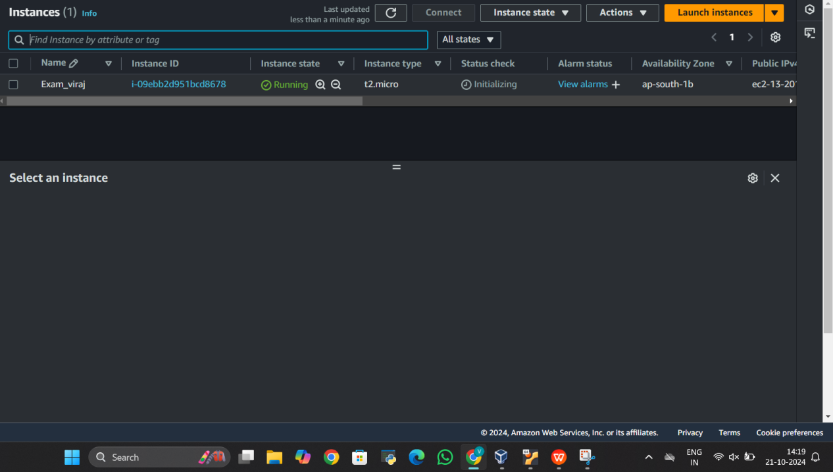

Step 10: IAM user Credentials

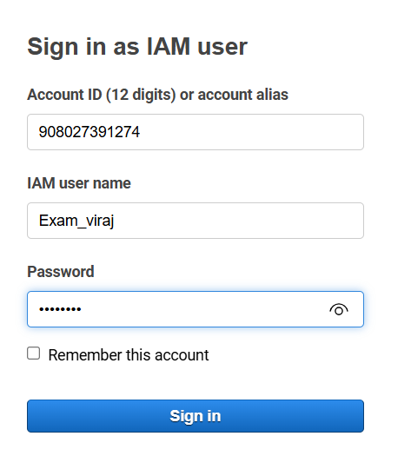

Step 11: Login into IAM user

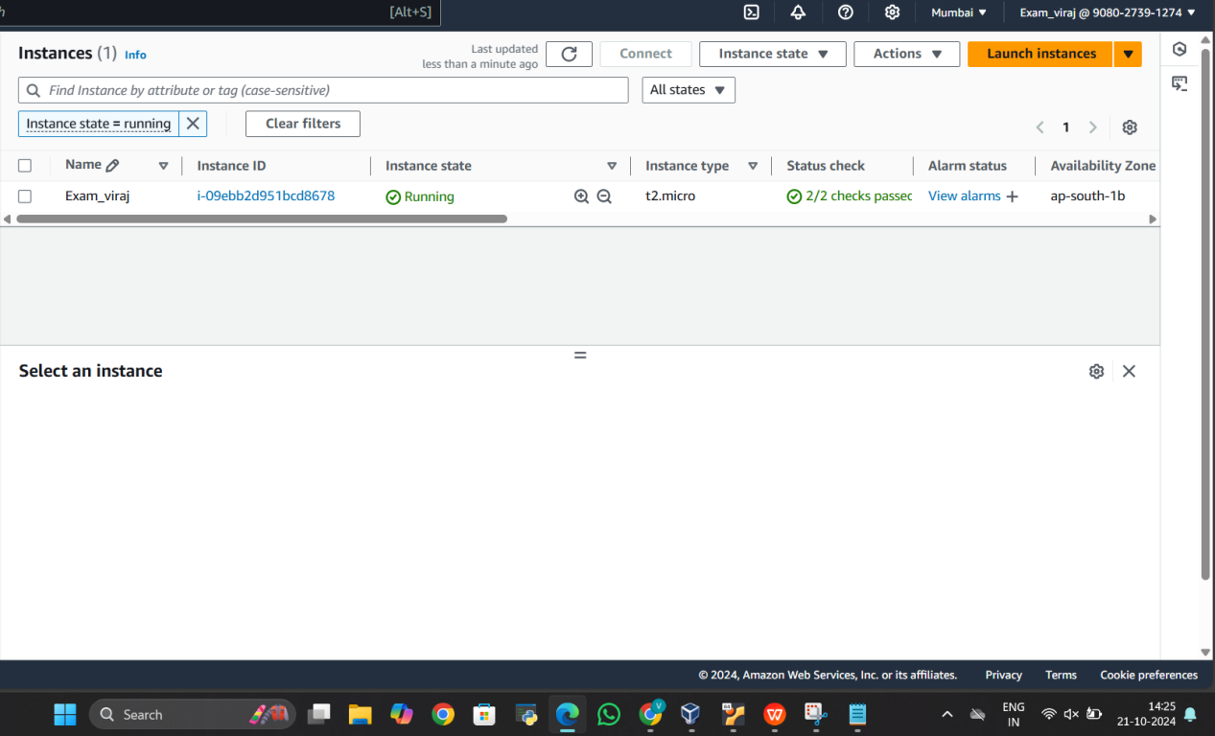

Step 12: Connenting to Ec2 instance through Putty

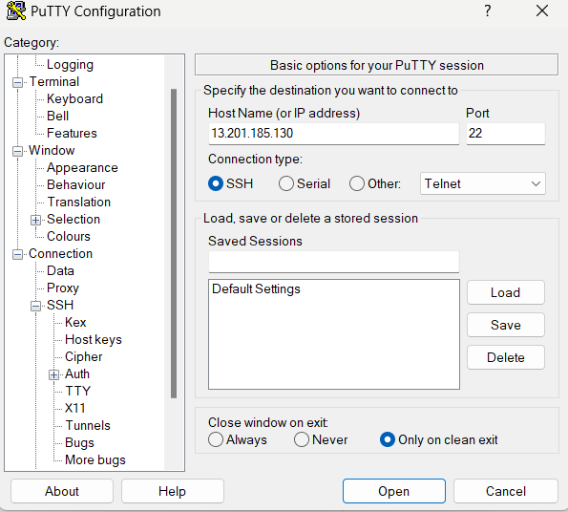

Step 13: Assiging the path of Key

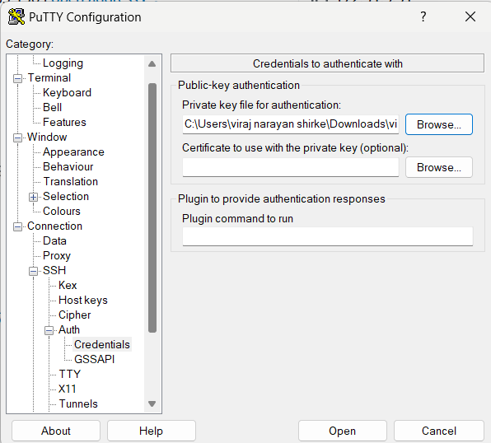

Step 14: Login into Ec2 instance

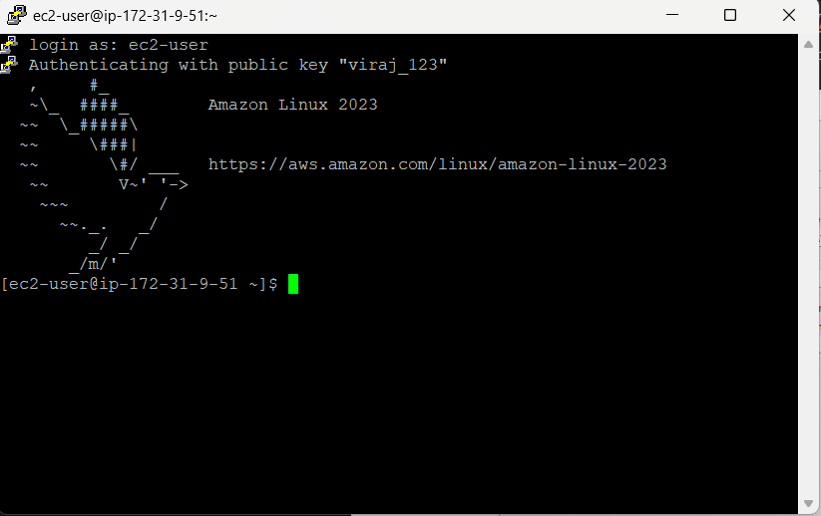

Step 15 : using Root user and installing httpd

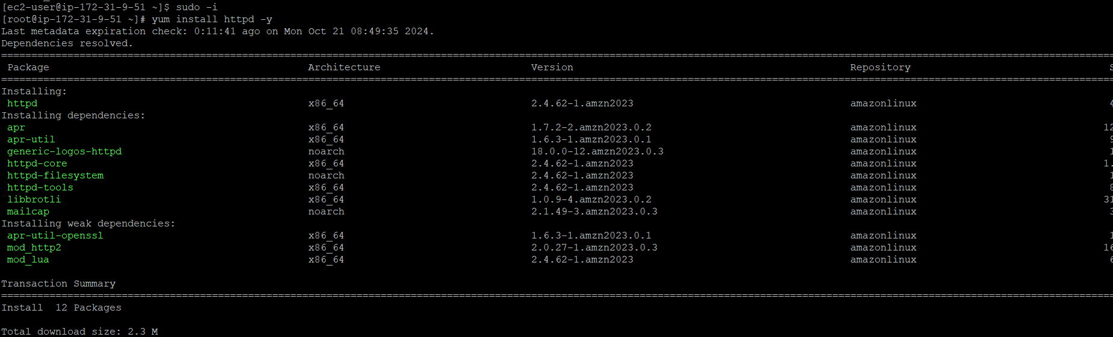

Step 16: Changing the Driectroy to cd /var/www/html

Screenshot 2024-10-21 143331

Step 17: Starting the httpd

Screenshot 2024-10-21 143515

Step18 : Enabling the httpd



Step 19: Creating the webpage

Screenshot 2024-10-21 143705

Code :

<!DOCTYPE html>

<html lang="en">

<head>

    <meta charset="UTF-8">

    <meta name="viewport" content="width=device-width, initial-scale=1.0">

    <title>Introduction</title>

</head>

<body>

    <p>I am Viraj Shirke Studying in CDAC</p>

</body>

</html>

Step 20: Creating amazon S3 Bucket

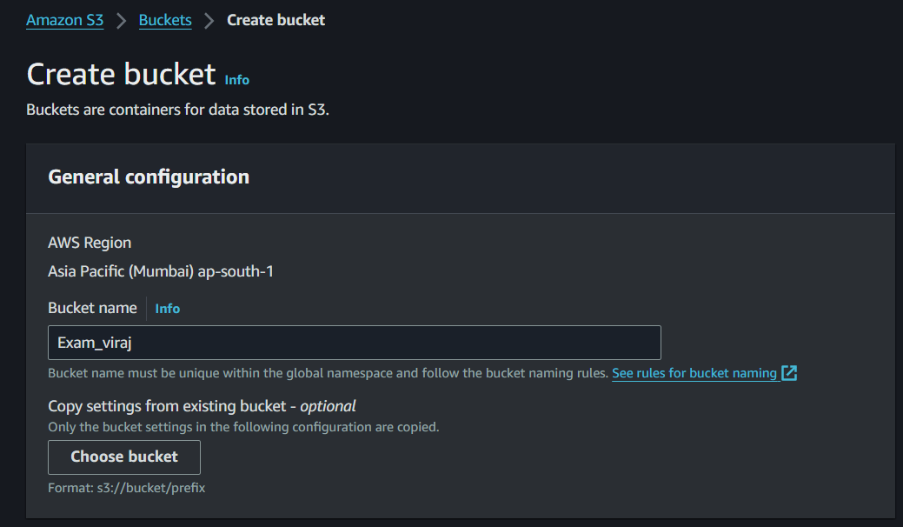

Step 21: Enabling ACLs

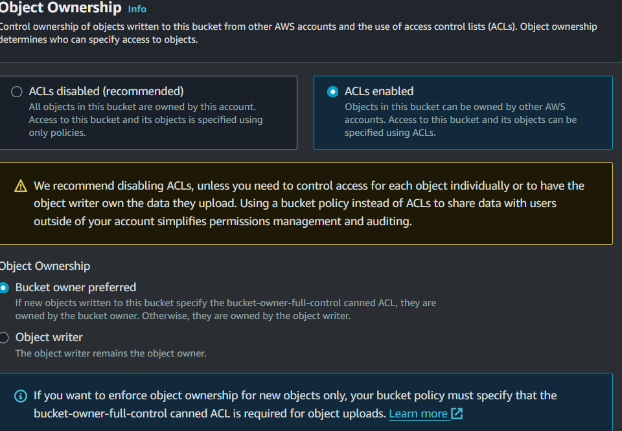

Step 22: Giving access to Public

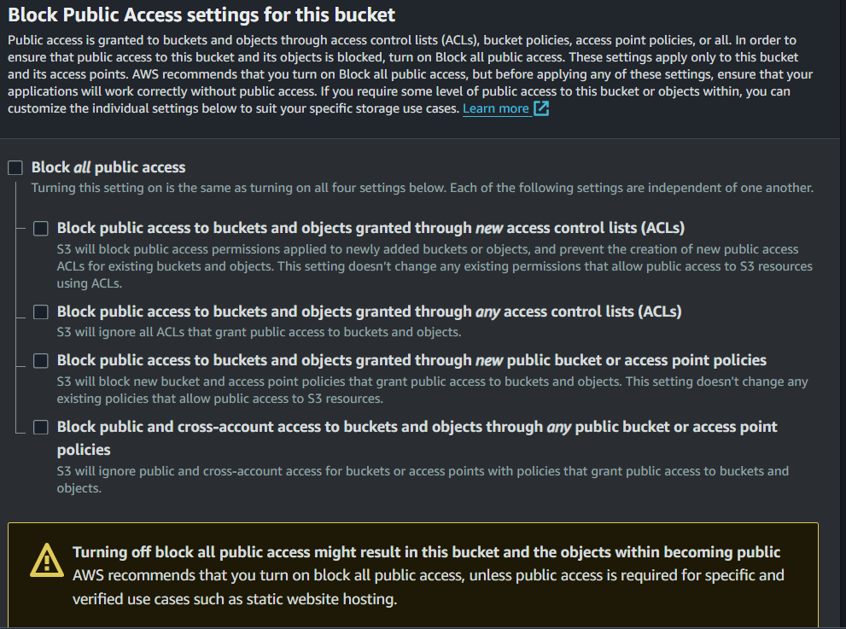

Step 23: Enabling Bucket versioning

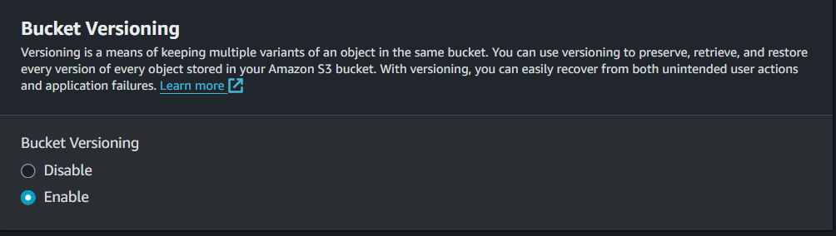

Step 24: Bucket is created

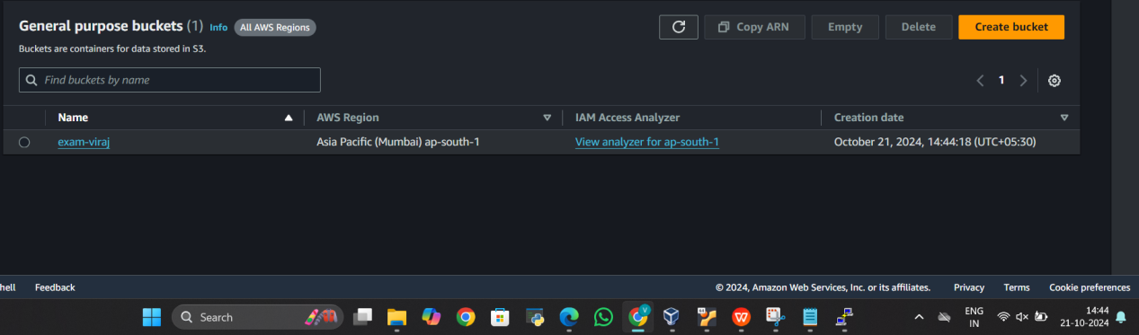

Step 25: Uploading the index.html

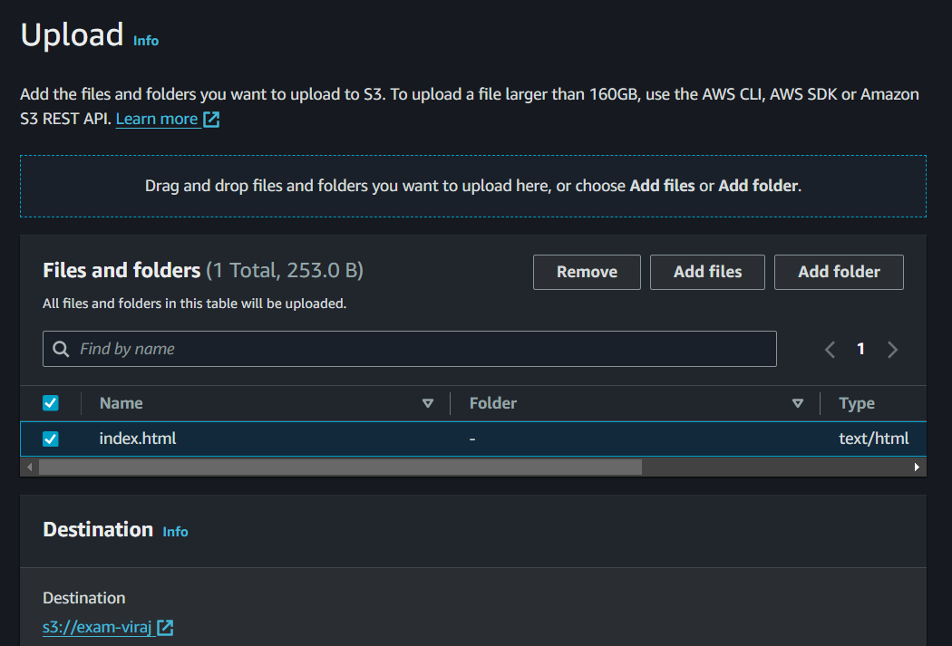

Step 26: editing the ACL

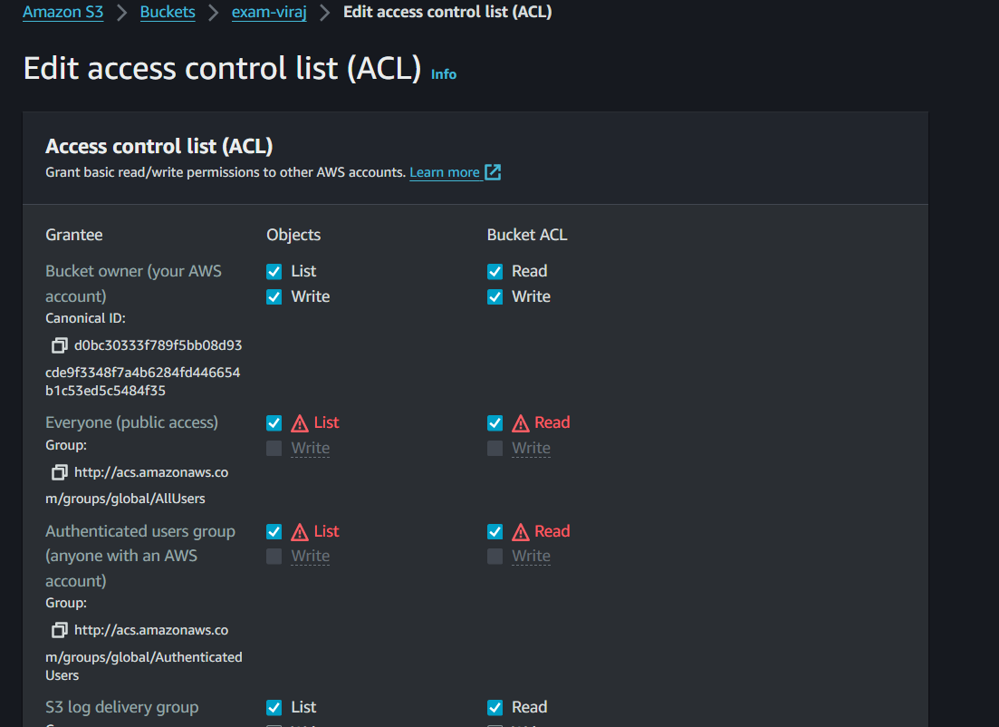

Step 27: editing the ACL of index.html

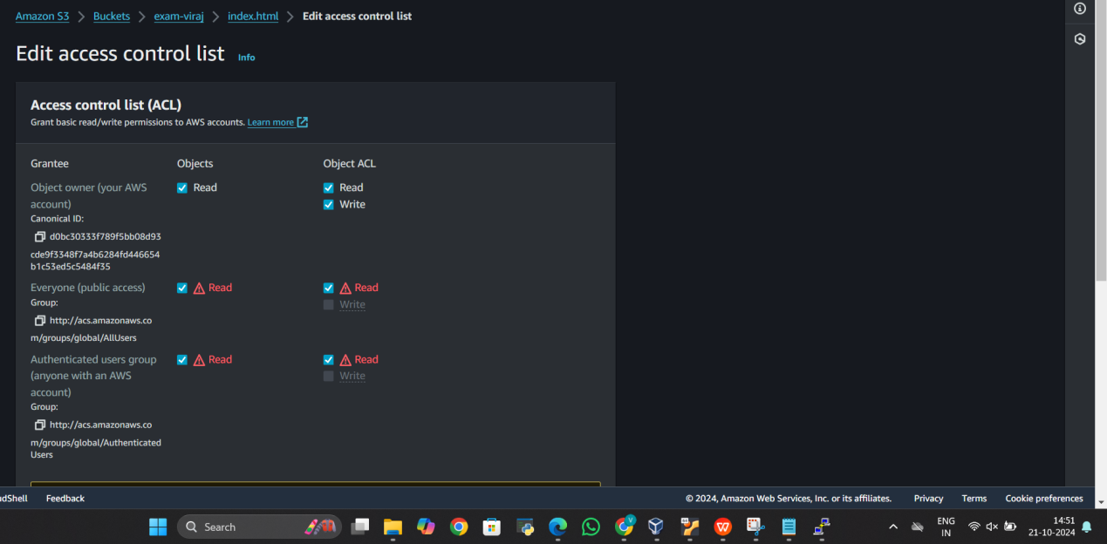

Step 28: The static html page is

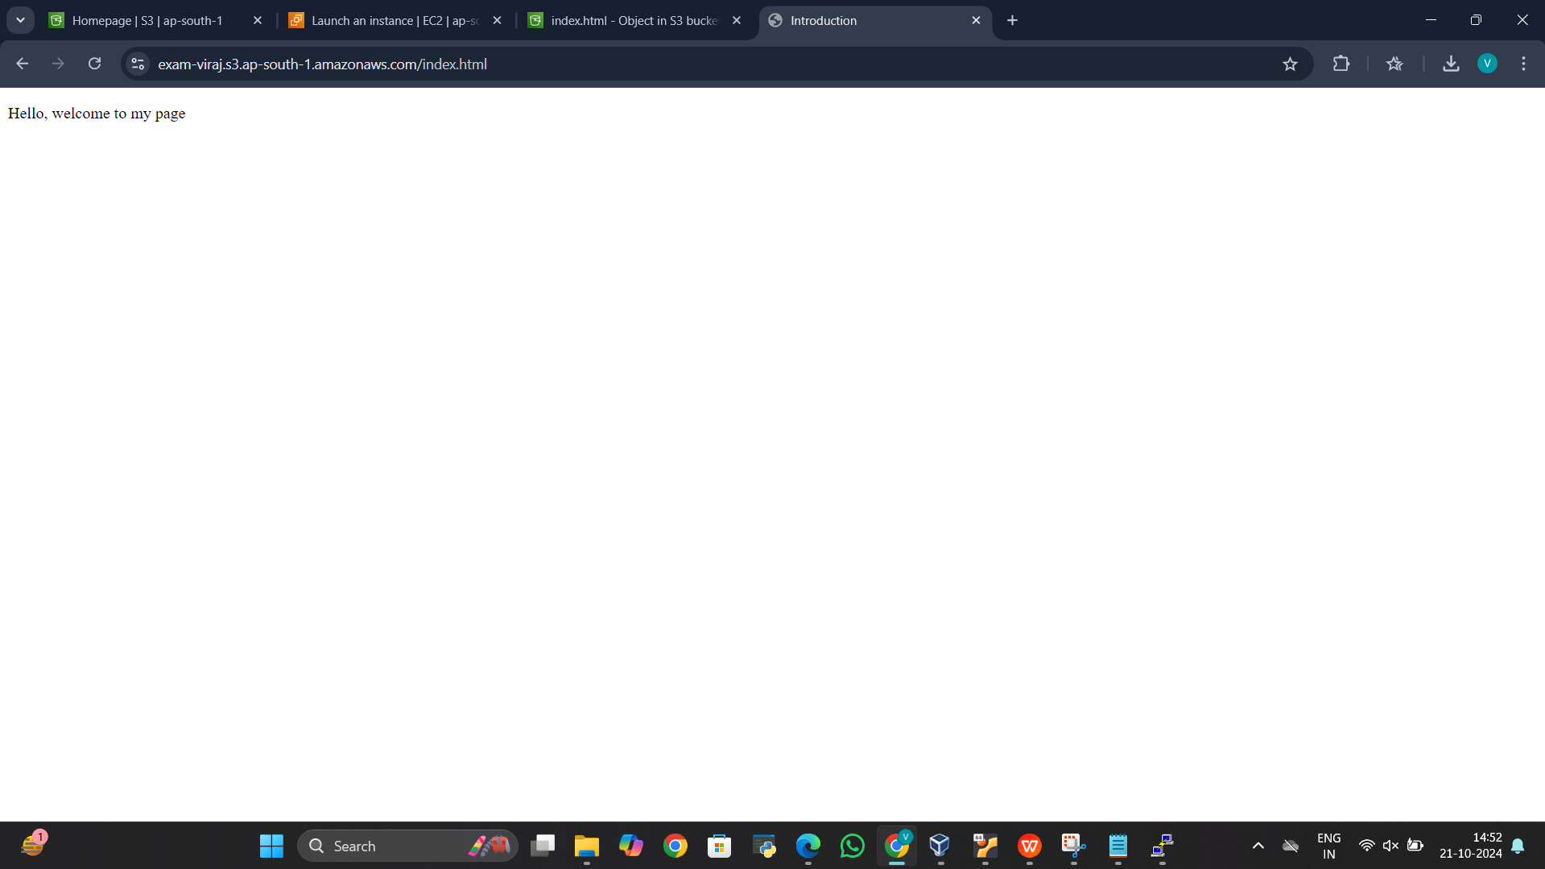

<https://exam-viraj.s3.ap-south-1.amazonaws.com/index.html>

**LINUX SECTION**

Q1.

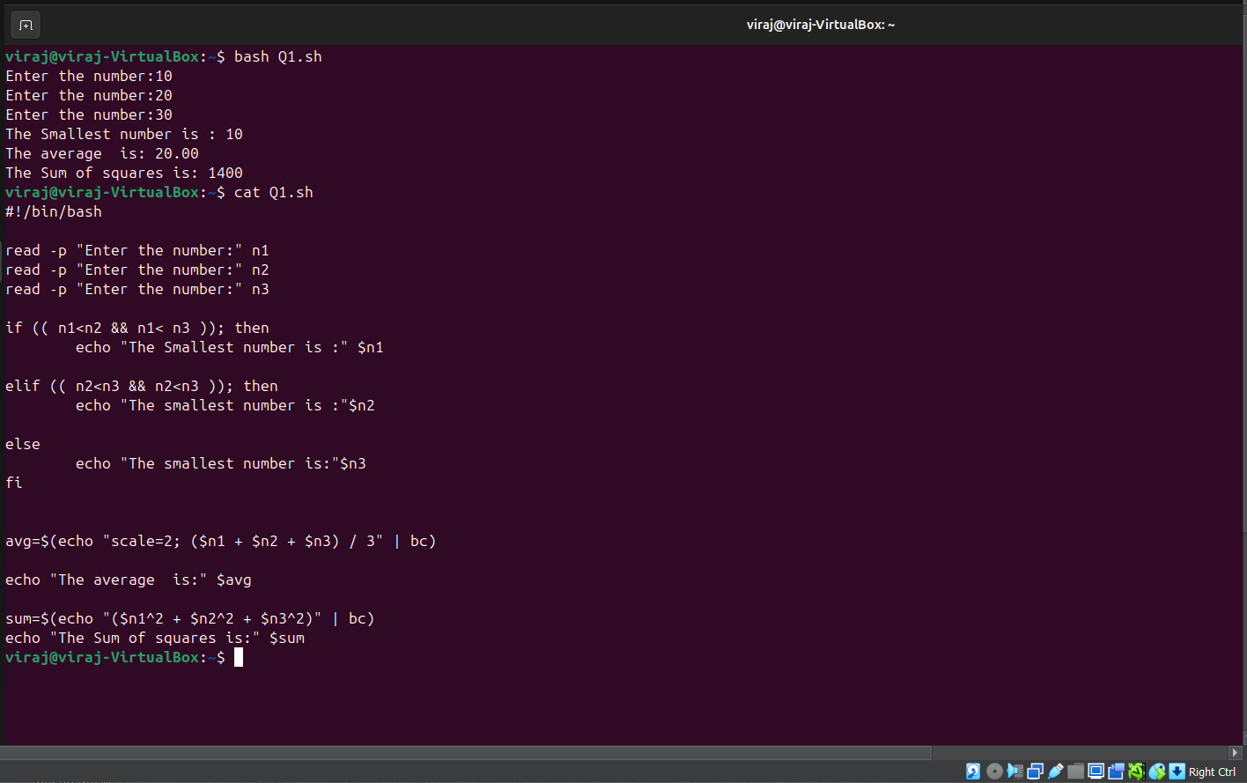

Q2:

