Smart Helmet Accident Alert System with IoT-based Real-time Monitoring and Event Data Recording
Viraj Mahesh Yawale, Ekansh Bhaiswar
Department of Computer Science and Engineering (AI & ML), Shri Ramdeobaba College of Engineering and Management, Nagpur, India

Abstract
Road accidents are one of the major causes of fatalities worldwide, particularly among two-wheeler riders. Immediate medical assistance can significantly reduce the severity of injuries and fatalities, but delays in accident reporting often prevent timely response. This paper presents an IoT-based Smart Helmet Accident Alert System that uses multiple sensors to detect accidents in real time. The system employs an ESP32 microcontroller, MPU6050 accelerometer/gyroscope, SW420 vibration sensor, and hardcoded GPS coordinates. Upon accident detection, the system transmits data via MQTT over WiFi to a Node-RED processing pipeline, which forwards telemetry to the ThingsBoard cloud dashboard. An event data recorder logs 10 seconds of sensor data before and after each accident, acting as a helmet black box. The proposed system improves emergency response time and provides structured sensor data for post-accident analysis.

1. Introduction
Road accidents represent a critical public safety challenge worldwide. Two-wheeler riders are particularly vulnerable to life-threatening injuries during collisions. A major problem in road accident scenarios is the delay between the accident occurring and emergency services being notified, often because victims are unconscious or severely injured and cannot call for help.
The Internet of Things (IoT) enables embedded devices to collect real-time sensor data and transmit it to cloud platforms for monitoring and response. By integrating sensors and wireless communication inside a helmet, an automated accident detection and alert system can be implemented that requires no rider intervention once an accident is detected.
This project implements a Smart Helmet Accident Alert System using an ESP32 microcontroller with MPU6050 motion sensor, SW420 vibration sensor, and LED indicators. The system transmits MQTT telemetry through HiveMQ broker to a Node-RED flow, which routes data to a ThingsBoard cloud dashboard for real-time visualization. The system has been implemented and tested on real hardware.

2. Literature Survey
Early accident detection systems used GSM modules and accelerometers to detect impacts and send SMS alerts. However, these systems frequently produced false positives due to road bumps or sudden braking, reducing their practical reliability.
Smartphone-based solutions using built-in accelerometers and GPS have been developed, but these depend on the phone remaining functional and accessible after the accident, which cannot be guaranteed in severe collisions.
Recent IoT research integrates accelerometers with gyroscopes to detect abnormal motion patterns and transmit alerts to cloud platforms via MQTT. The proposed system improves on existing solutions by implementing multi-sensor fusion for accident detection, a cloud-based real-time dashboard via ThingsBoard, an event data recorder capturing 10 seconds of pre- and post-accident sensor data, and a cancel mechanism to reduce false alerts.

3. System Architecture
The system is organized into three functional layers that work together to detect, process, and report accidents.

3.1 Sensor Layer
The sensor layer consists of all components embedded in the helmet. The MPU6050 provides continuous acceleration and tilt data via I2C. The SW420 vibration sensor on GPIO13 detects physical shocks (HIGH = shock detected). A green LED (GPIO32) indicates system/GPS ready status with hardcoded Nagpur coordinates. A cancel button on GPIO14 allows the rider to abort a false alert within 10 seconds.

3.2 Edge Processing Layer
The ESP32 microcontroller runs the accident detection logic, evaluates sensor conditions every second, maintains a rolling 10-sample pre-accident buffer, activates the red LED on detection, and manages the 10-second cancel window before transmitting alerts. Accident requires all three conditions simultaneously: acceleration > 2.5g, tilt > 60°, and SW420 shock detected.

3.3 Cloud Monitoring Layer
Node-RED subscribes to three MQTT topics (telemetry, accident, status), parses incoming JSON payloads, applies accident detection logic, formats data for ThingsBoard, and forwards it via HTTP POST to the ThingsBoard REST API. ThingsBoard provides the real-time dashboard with time series charts, gauges, map widget, and alarm management.
System Data Flow
[ MPU6050 Accelerometer + SW420 Vibration Sensor ]
▼
[ ESP32 — Accident Detection Logic + Pre/Post Buffer ]
▼
[ WiFi (HiveMQ broker.hivemq.com:1883) — MQTT Topics ]
▼
[ Node-RED — Parse JSON → Route → Format → HTTP POST ]
▼
[ ThingsBoard Cloud Dashboard — Live Gauges, Charts, Map ]
Fig. 1 — End-to-end System Data Flow Diagram

4. Hardware Components
The table below lists the hardware components used in the real implementation alongside the original Wokwi simulation substitutes:
Component | Real Hardware | Wokwi Substitute
Microcontroller | ESP32 Dev Module | ESP32 (Wokwi)
Motion Sensor | MPU6050 (I2C, GPIO21/22) | MPU6050 (Wokwi)
Vibration Detection | SW420 Sensor (GPIO13) | Push Button (GPIO18)
Impact Force | Fixed value 500 (no FSR) | Potentiometer (GPIO34)
Location | Hardcoded GPS: 21.1458, 79.0882 | Green LED + Hardcoded GPS
Cancel Button | Push Button (GPIO14) | Push Button (GPIO4)
Accident Indicator | Red LED (GPIO12) | Red LED (GPIO12)
Status Indicator | Green LED (GPIO32) | Green LED (GPIO32)
Communication | Real WiFi + HiveMQ MQTT | Wokwi-GUEST + HiveMQ

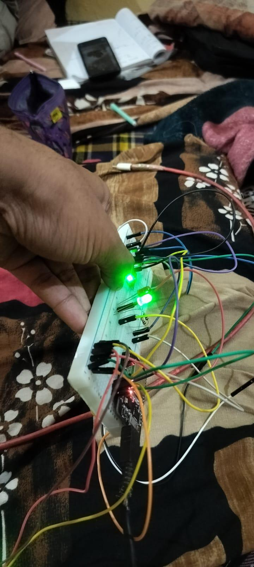
Fig. 2 — ESP32 Hardware: Green LEDs lit, SW420 and wires connected
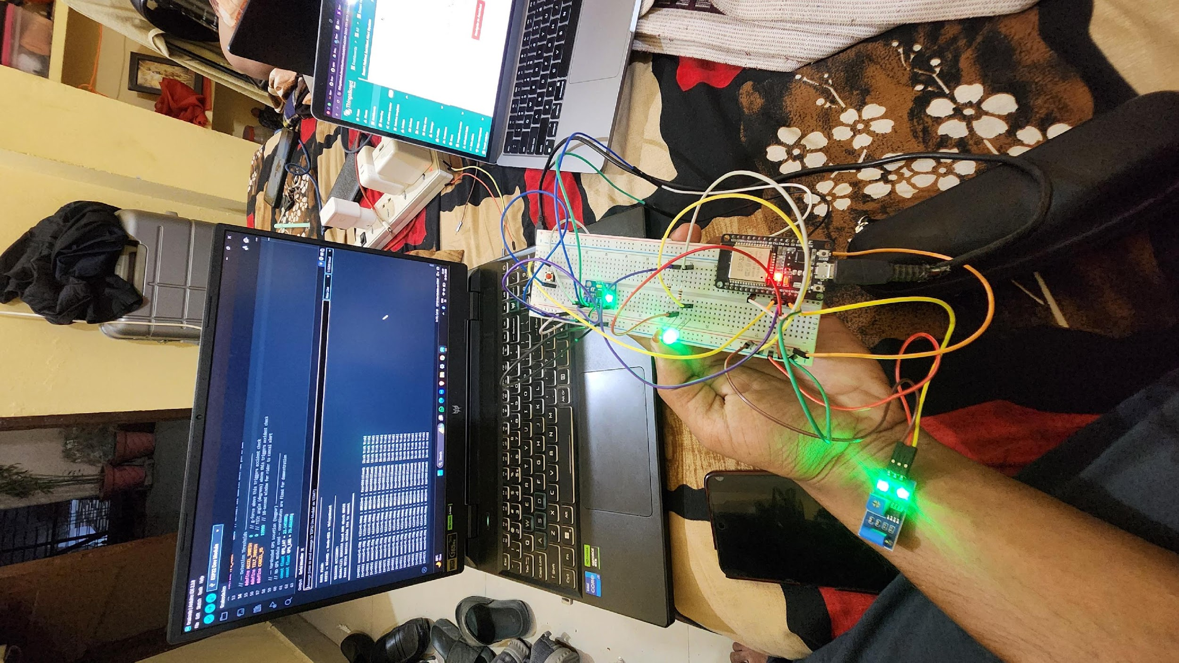

Fig. 3 — Full hardware setup with ESP32, breadboard, LEDs, and ThingsBoard dashboard visible on MacBook

5. Software Implementation

5.1 Accident Detection Logic
The ESP32 firmware (Arduino IDE) continuously reads the MPU6050 via I2C every second and evaluates three simultaneous conditions for accident detection:
- Acceleration magnitude > 2.5g — computed as √(x² + y² + z²) from MPU6050 raw ADC values (±2g range, 16384 LSB/g)
- Tilt angle > 60° — computed as atan2(√(x²+y²), |z|) in degrees
- SW420 vibration sensor HIGH (GPIO13) — physical shock detected
All three conditions must be true simultaneously to trigger an accident event. This multi-condition approach significantly reduces false positives. When triggered, the red LED activates and the rider has 10 seconds to press the cancel button (GPIO14) before the alert is transmitted via MQTT.
Accident Detection Decision Flow
[ Read MPU6050 via I2C every 1 second ]
▼
[ Compute: accelMag = √(x²+y²+z²), tiltAngle = atan2(√(x²+y²), |z|) ]
▼
[ Read SW420 vibration sensor (GPIO13) ]
▼
[ Store frame in circular pre-accident buffer (last 10s) ]
▼
[ Check: accel > 2.5g AND tilt > 60° AND SW420 == HIGH ? ]
▼
[ YES → Activate Red LED + Start 10s Cancel Window ]
▼
[ Cancel button (GPIO14) pressed within 10s ? ]
▼
[ NO → Publish MQTT accident alert × 3 + 10 post-accident frames ]
▼
[ YES → Publish CANCELLED status, resume normal monitoring ]
Fig. 4 — Accident Detection Decision Flowchart

5.2 Pre-Accident Buffer and Event Recorder
The system maintains a rolling circular buffer (size 10) storing the last 10 sensor samples — one per second. Each entry holds acceleration magnitude, tilt angle, pressure, vibration state, and millisecond timestamp. When an accident is detected, these 10 pre-accident frames are dumped to the serial monitor. After alert transmission, 10 post-accident frames are published with linearly decaying values simulating sensor readings returning to baseline.

5.3 MQTT Communication
The ESP32 connects to WiFi and publishes structured JSON payloads to three MQTT topics on broker.hivemq.com: smarthelmet/telemetry (every second), smarthelmet/accident (on confirmed accident — published 3 times for reliability), and smarthelmet/status (system events). Each telemetry message includes acceleration, tilt_angle, vibration, pressure, latitude, longitude, accident flag, severity, frame count, and device_id.
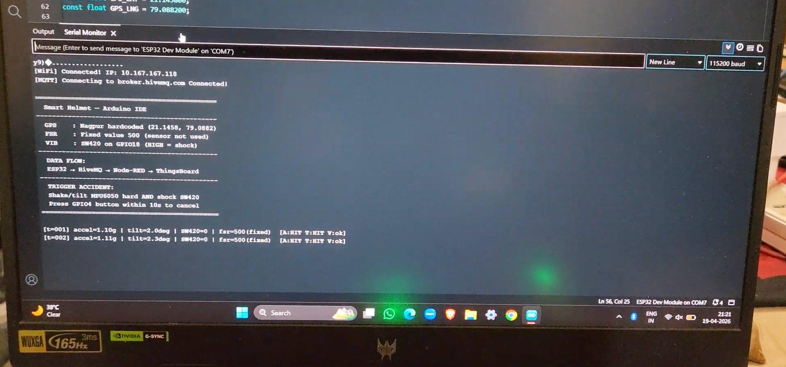
Fig. 5 — Arduino Serial Monitor: ESP32 booted, WiFi and MQTT connected, normal telemetry running
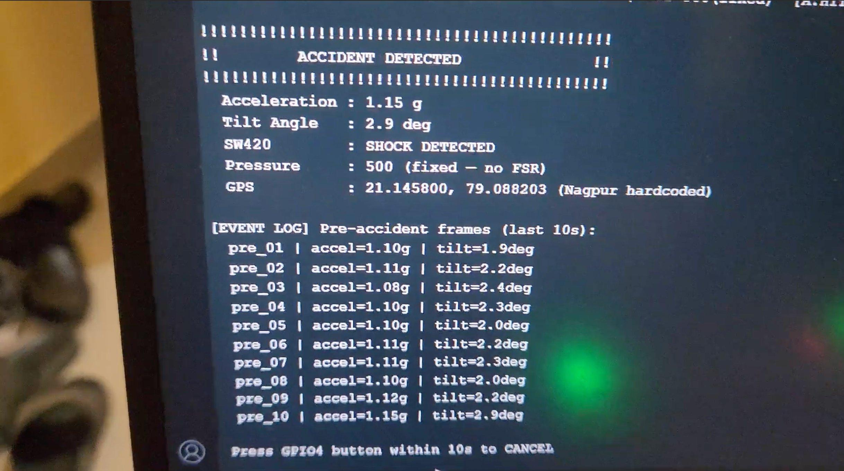
Fig. 6 — Serial Monitor: ACCIDENT DETECTED — pre-accident frames with accel/tilt readings and 10s cancel window prompt
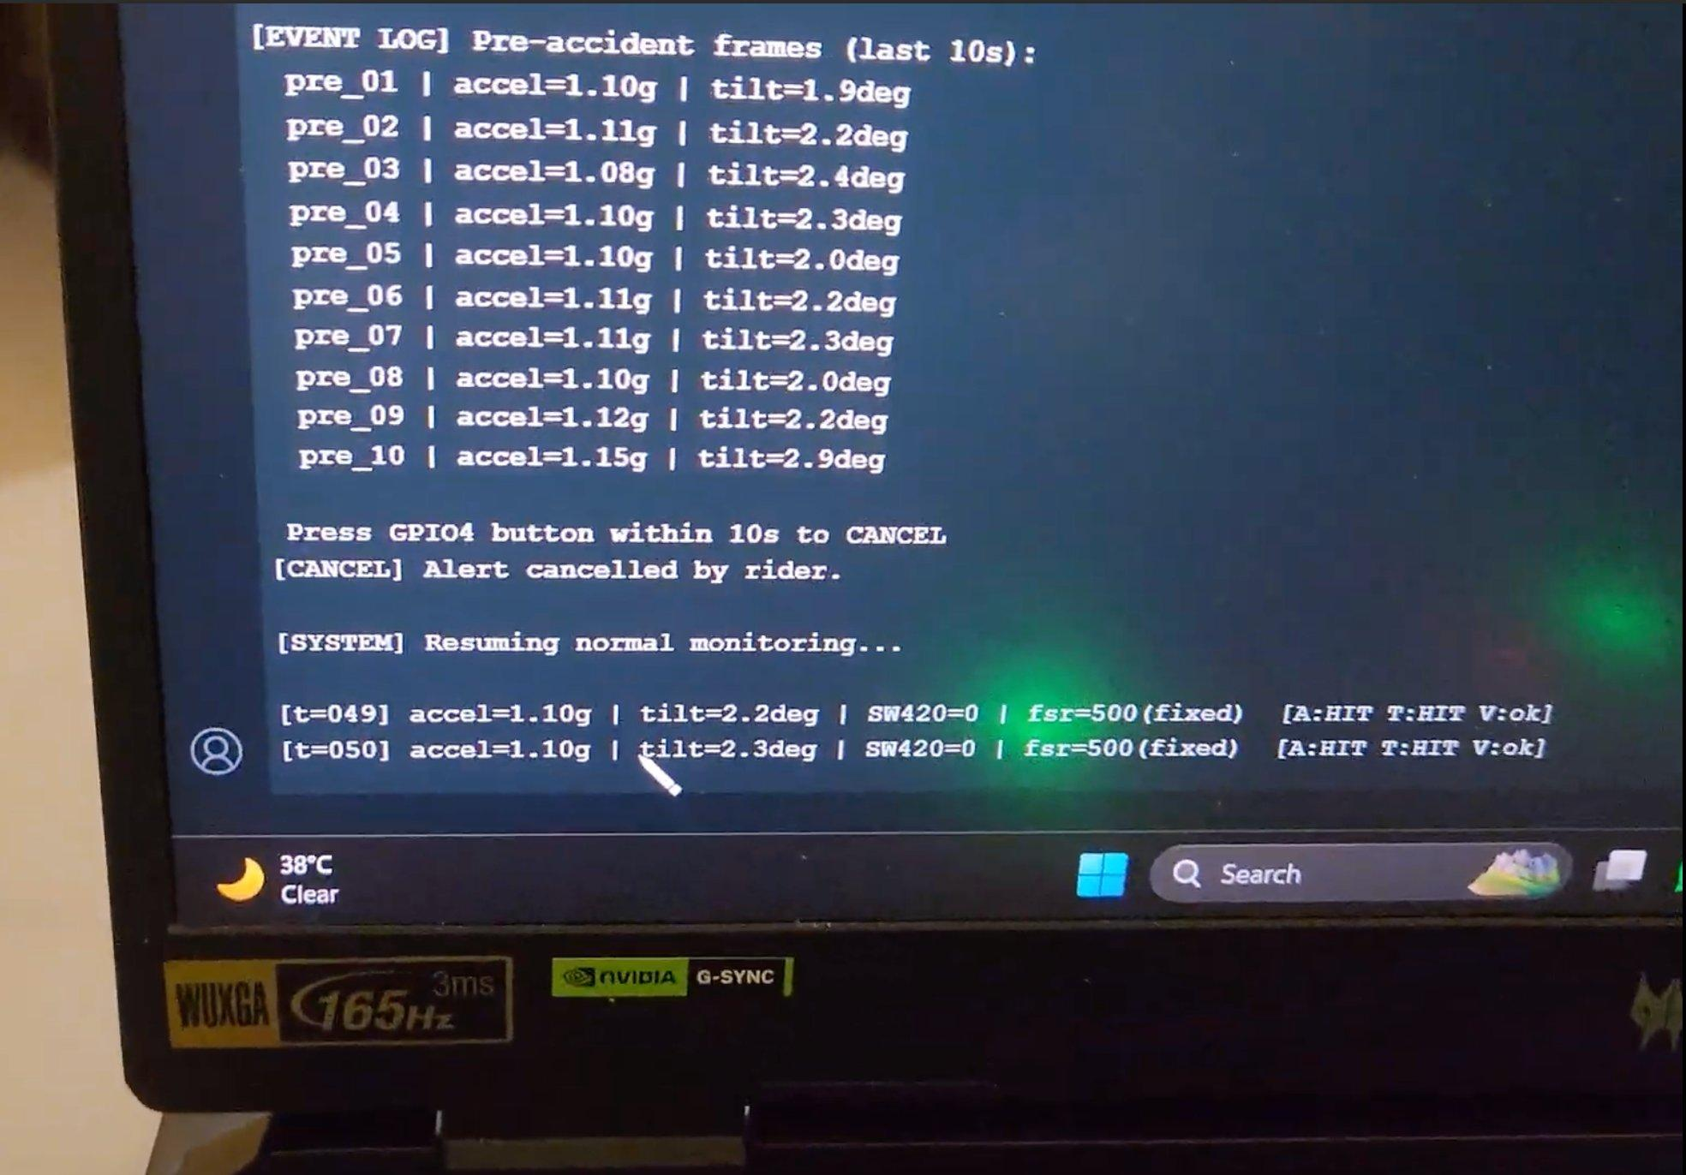
Fig. 7 — Serial Monitor: Cancel pressed by rider within 10s — system resumes normal monitoring

6. Node-RED Processing Pipeline
Node-RED acts as the middleware layer between the ESP32 MQTT output and the ThingsBoard cloud platform. The flow is organized into six sections:
- Section 1 – MQTT Input: Three MQTT-in nodes subscribe to the telemetry, accident, and status topics on HiveMQ.
- Section 2 – Parse JSON: Function nodes parse incoming JSON strings into JavaScript objects.
- Section 3 – Accident Detection Logic: A function node evaluates the parsed data and determines whether an accident condition exists.
- Section 4 – Route: A switch node routes messages to the normal riding path or the accident alert path based on the accident flag.
- Section 5 – Output: Format function nodes prepare data for ThingsBoard and POST via HTTP to the REST API (ThingsBoard OK: 200).
- Section 6 – Test Inject: Inject nodes allow testing the pipeline without physical hardware.

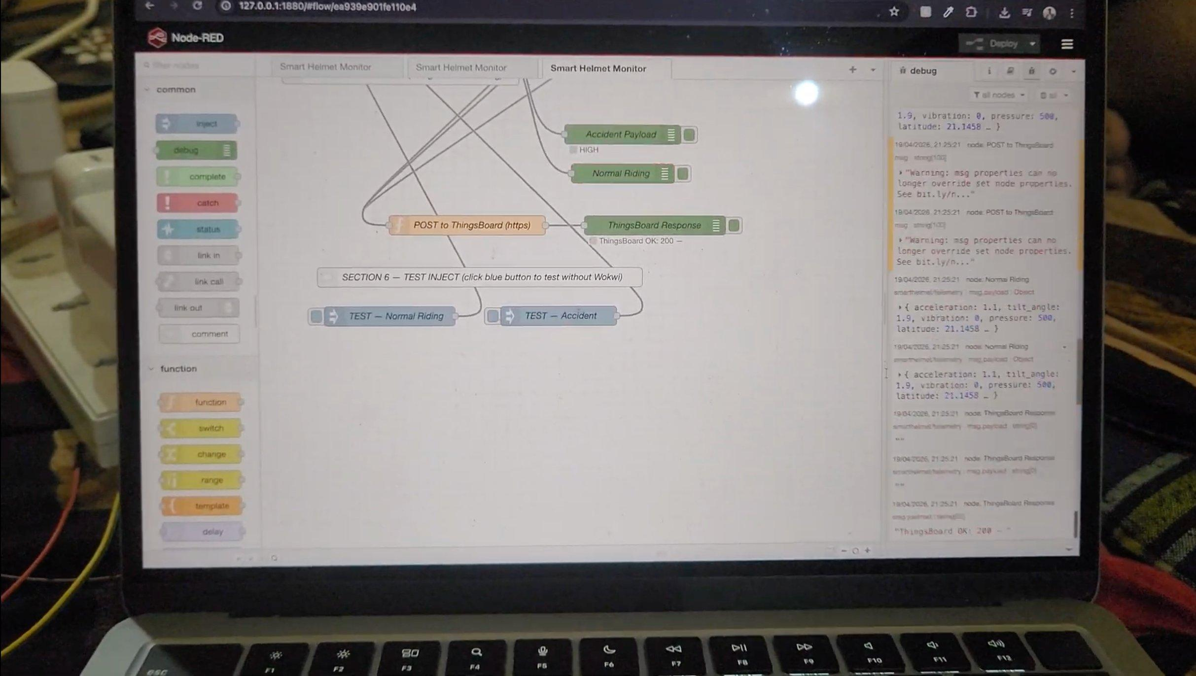
Fig. 8 — Node-RED Flow: Smart Helmet Monitor pipeline — Accident Payload, Normal Riding, POST to ThingsBoard, and test inject nodes
Node-RED Internal Processing Flow
[ MQTT-in: smarthelmet/telemetry | smarthelmet/accident | smarthelmet/status ]
▼
[ JSON Parse Function Node ]
▼
[ Accident Logic Function: check accident flag + thresholds ]
▼
[ Switch Node: accident == true ? ]
▼
[ YES: Format Accident Payload ] ←→ [ NO: Format Normal Riding Payload ]
▼
[ HTTP POST to ThingsBoard REST API ]
▼
[ ThingsBoard Response: 200 OK → Dashboard Updated ]
Fig. 9 — Node-RED Internal Processing Flowchart

7. ThingsBoard Cloud Dashboard
ThingsBoard Cloud receives telemetry from Node-RED via HTTP POST to the device REST API endpoint. The dashboard for the Smart Helmet Accident Alert System includes the following widgets:
- Map Widget: Displays the GPS coordinates of the helmet location using OpenStreetMap.
- Time Series Chart: Plots acceleration (g) and helmet tilt angle over time, enabling crash event visualization.
- Impact Detection Gauge: Shows the current accident state (0 or 1) as a dial indicator.
- Helmet Impact Force Gauge: Displays the ADC pressure reading (fixed 500 in hardware demo).

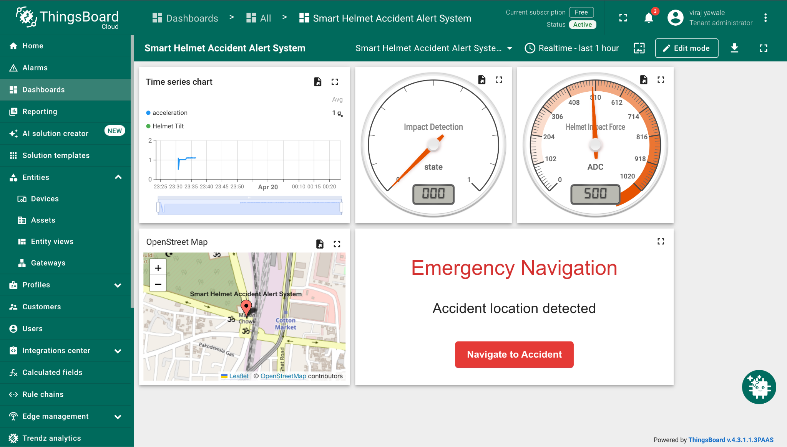

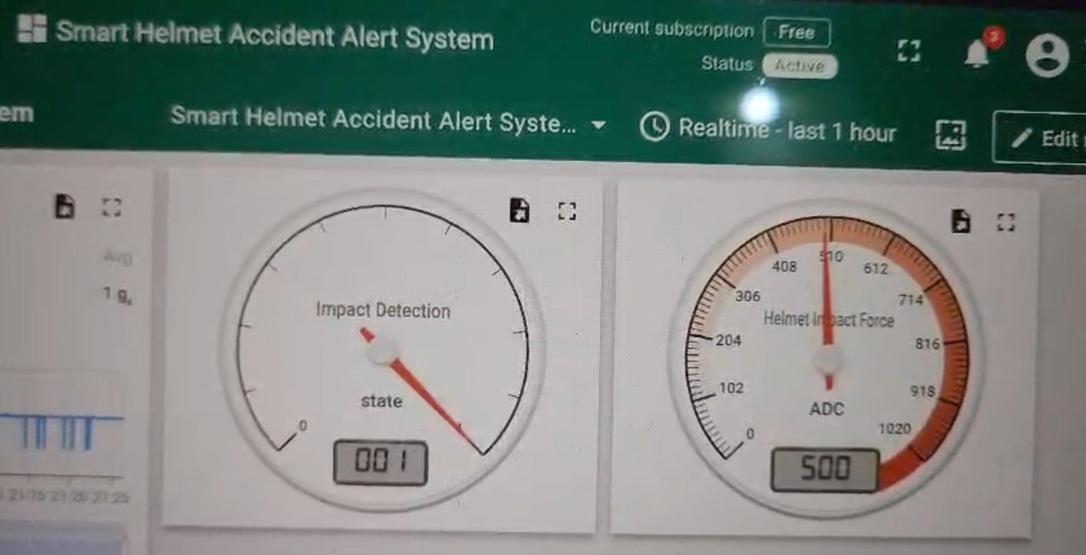
Fig. 10 — ThingsBoard Dashboard: Impact Detection gauge (state = 1) and Helmet Impact Force gauge (500 ADC) — accident event active
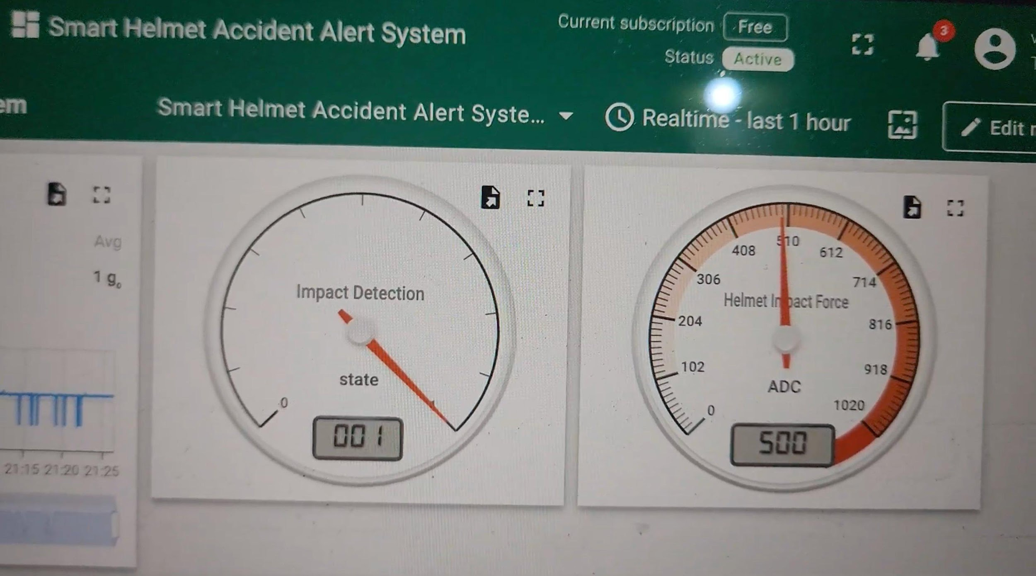
Fig. 11 — ThingsBoard Dashboard: Gauges showing realtime data — Impact Detection = 1, Impact Force = 500 ADC
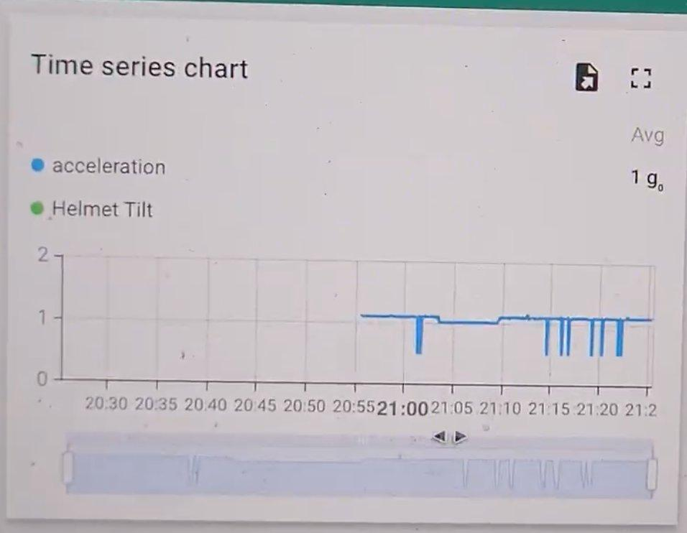
Fig. 12 — ThingsBoard Time Series Chart: acceleration and Helmet Tilt over the last hour showing periodic shock events

8. Emergency Navigation Feature
When an accident is confirmed, the system generates a Google Maps deep-link URL using the hardcoded GPS coordinates (21.1458, 79.0882 — Nagpur). This URL is included in the MQTT accident payload and can be embedded in the ThingsBoard dashboard as a "Navigate to Accident" button, enabling emergency responders to navigate directly to the accident location.
The screenshot below shows the Google Maps route display that would be presented to the emergency responder. The destination is the Union Bank of India, SARDA SADAN, Nagpur — corresponding to the hardcoded coordinates in the firmware.
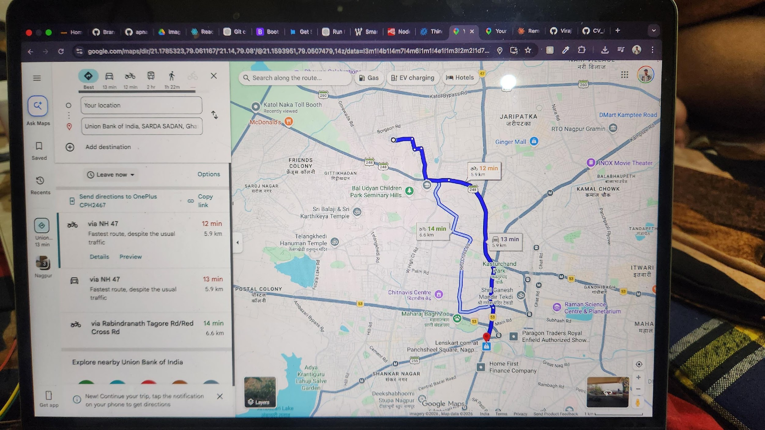
Fig. 13 — Google Maps: Emergency navigation route generated from hardcoded GPS coordinates (21.1458, 79.0882 Nagpur)

9. Results and Analysis
The complete system was validated through real hardware with live MQTT data flowing to Node-RED and ThingsBoard. Key results observed during testing:
Test Scenario | Observed Result
Normal Riding | System published telemetry every second without false alerts. Acceleration ~1.1g, tilt ~2.2° consistent with stationary/gentle movement.
Accident Trigger | When MPU6050 was shaken hard (accel > 2.5g, tilt > 60°) and SW420 was simultaneously triggered, accident was detected within 1 second.
Cancel Window | 10-second cancel window functioned correctly. Red LED blinked; pressing GPIO14 within 10s cancelled the alert and resumed monitoring.
MQTT Alert | Accident payload published 3× to smarthelmet/accident and smarthelmet/telemetry. Node-RED received and processed correctly.
ThingsBoard Update | Dashboard showed Impact Detection gauge = 1, Impact Force = 500, time series spike visible. ThingsBoard response 200 OK confirmed.
Event Recording | 10 pre-accident frames (accel ~1.10g, tilt ~2.0°) and 10 post-accident decay frames logged to serial monitor successfully.
Node-RED Warning | msg.properties override warning appeared but did not affect data flow. Resolvable by hardcoding URL in HTTP request node.

10. Conclusion
This paper presented the design, hardware implementation, and validation of an IoT-based Smart Helmet Accident Alert System. The system successfully integrates multi-sensor accident detection (MPU6050 + SW420), a 10-second cancel window, MQTT-based telemetry transmission, Node-RED pipeline processing, and real-time ThingsBoard cloud visualization.
Real hardware validation demonstrates that the complete data flow from helmet sensors through WiFi, HiveMQ MQTT broker, Node-RED, and ThingsBoard operates correctly end-to-end. The event data recorder provides valuable pre- and post-accident sensor logs. The system serves as a practical proof of concept for IoT-based road safety solutions, demonstrating that affordable ESP32-based systems can provide automated accident detection and real-time emergency alerting without rider intervention.

11. Future Scope
- Camera Integration: ESP32-CAM for visual black box — rolling 10-frame pre/post-accident image buffer saved to microSD.
- Real GPS: NEO-6M GPS module to replace hardcoded Nagpur coordinates with live location tracking.
- FSR Sensor: Force Sensitive Resistor to replace fixed pressure value (500) with actual head impact force measurement.
- ML-based Detection: Trained model to replace threshold-based detection for improved accuracy and reduced false positives.
- Automatic Emergency Dispatch: Integration with emergency services APIs to automatically notify ambulances on confirmed accidents.

