What is **SALTSTACK**?

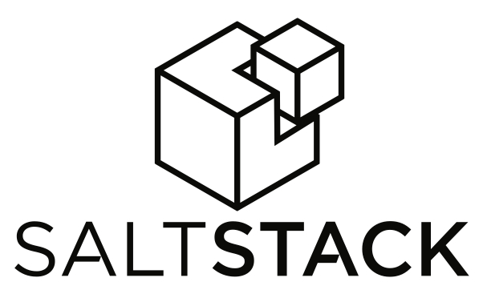

**SaltStack** platform or Salt is a Python-based open-source configuration management software and remote execution engine.

Salt as:

• a **configuration management system** is capable of maintaining remote nodes in defined states (for example,

ensuring that specific packages are installed and specific services are running)

• a **distributed remote execution system** can be used to execute commands and query data on remote nodes, either individually or by arbitrary selection criteria.

The networking layer is built with the excellent

ZeroMQ networking library, so the Salt daemon includes a viable and transparent AMQ broker. Salt uses public

keys for authentication with the master daemon, then uses faster AES encryption for payload communication; authentication and encryption are integral to Salt. Salt takes advantage of communication via msgpack, enabling fast and light network traffic

Salt consists of a salt-master which controls and manages salt-minions.Salt-minions are the agents installed on the remote machine which carry out the tasks assigned to them by the salt-master.

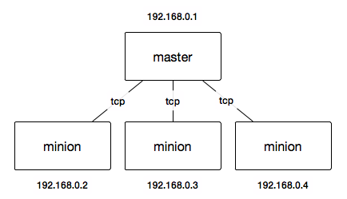

The generic format of a saltstack command:-

**salt '<target>' <function> [arguments]**

The arguments are always in the form of **kwarg=argument**