Output –

1. output.xls consists of all the Dimension tables and Fact Table
2. source.xls consists of the staging data

Overall Workflow –

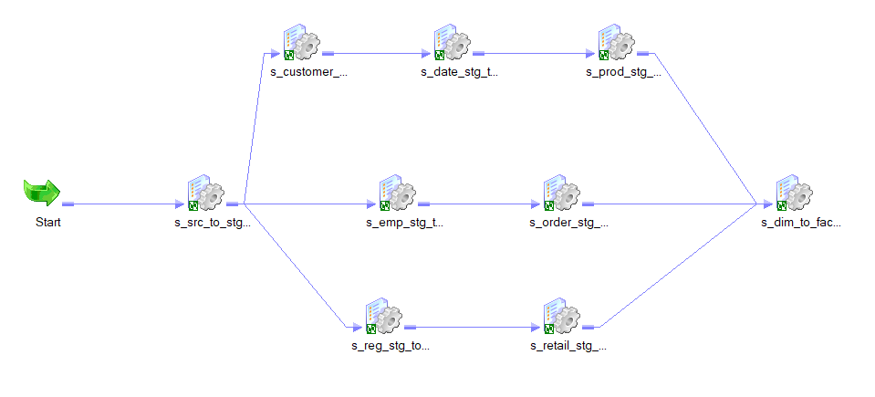

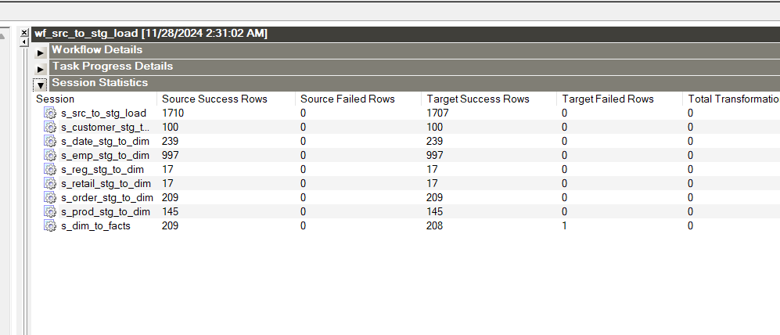

SRC to STG Load

Mapping –

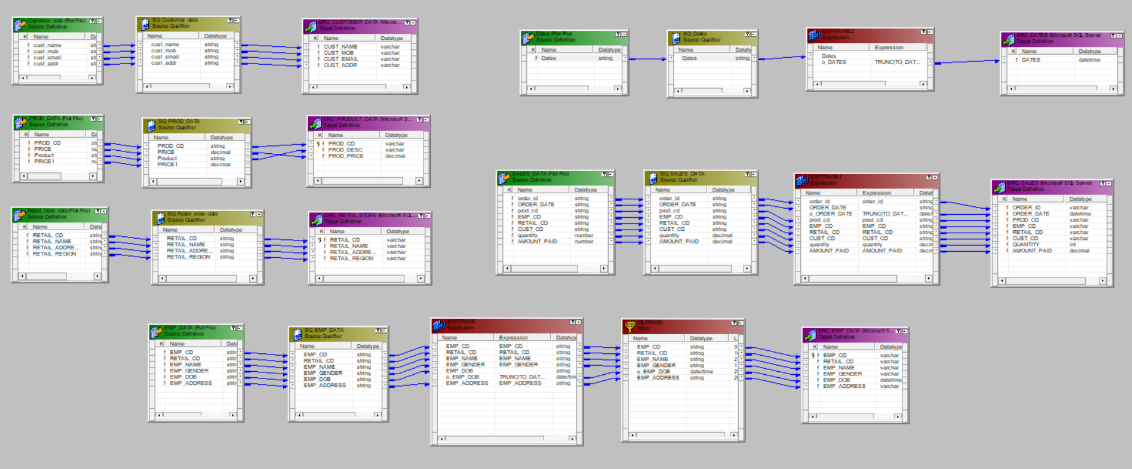

Workflow Monitor –

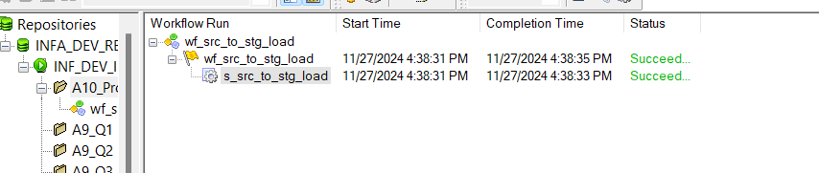

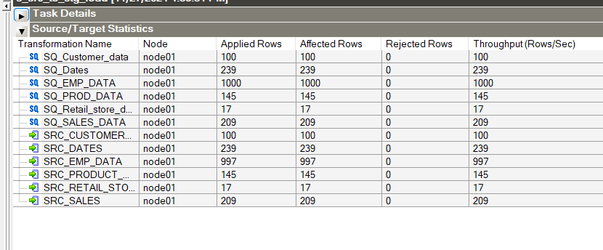

STG_CUSTOMER to DIM_CUSTOMER

Mapping –

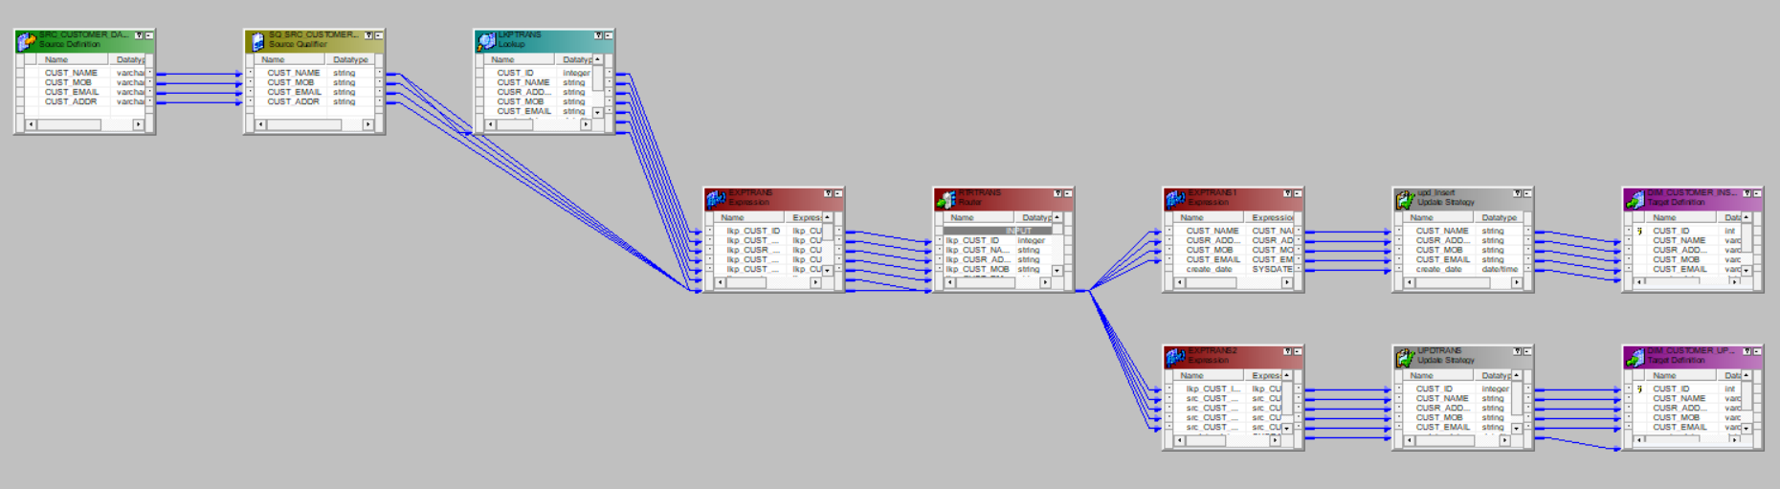

Workflow Monitor –

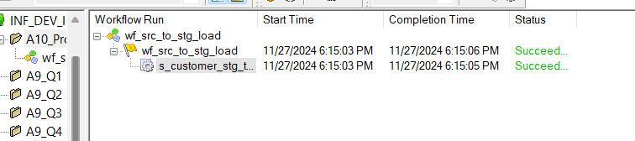

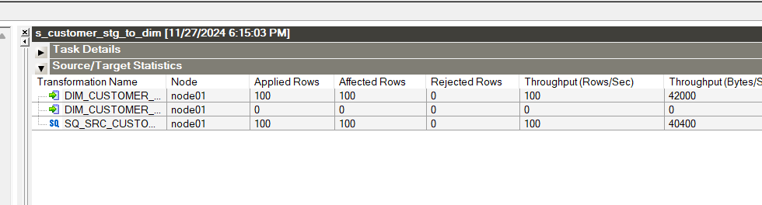

STG_DATE to DIM_DATE –

Mapping –

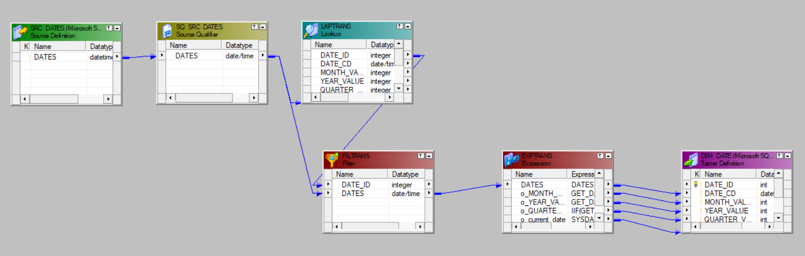

Workflow Monitor –

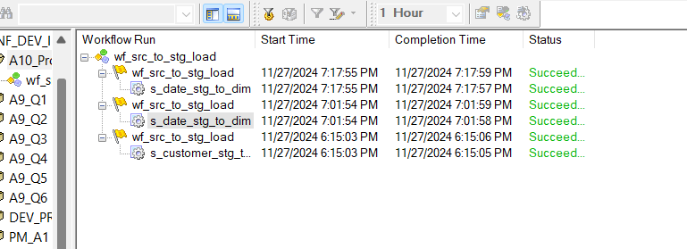

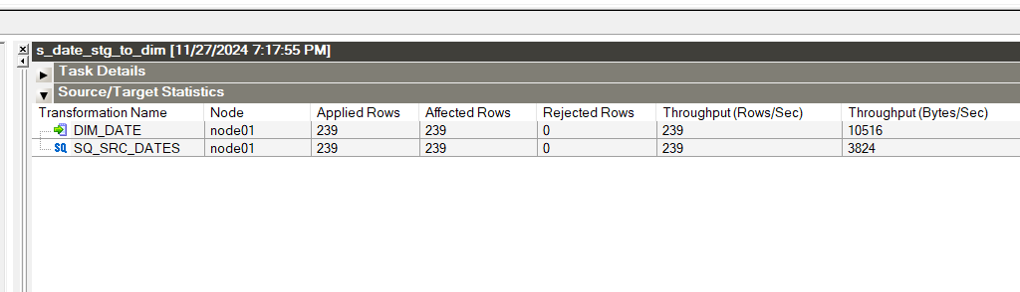

STG_EMP to DIM_EMPLOYEE

Mapping –

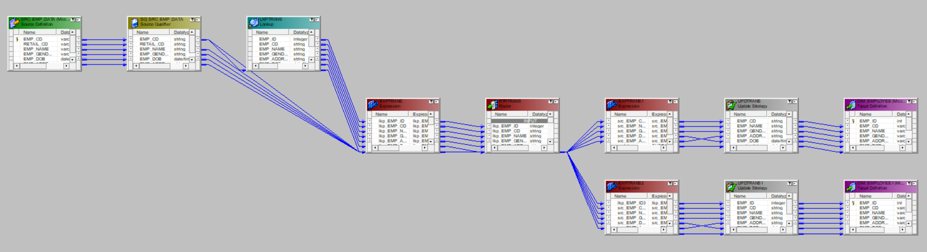

Workflow Monitor –

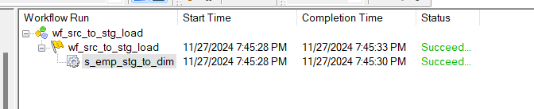

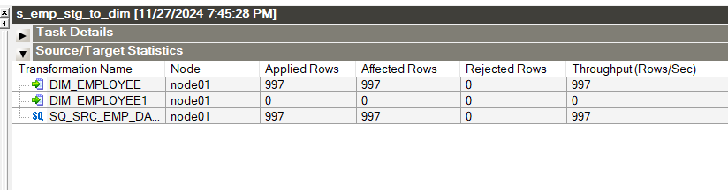

STG_REG to DIM_REG

Mapping –

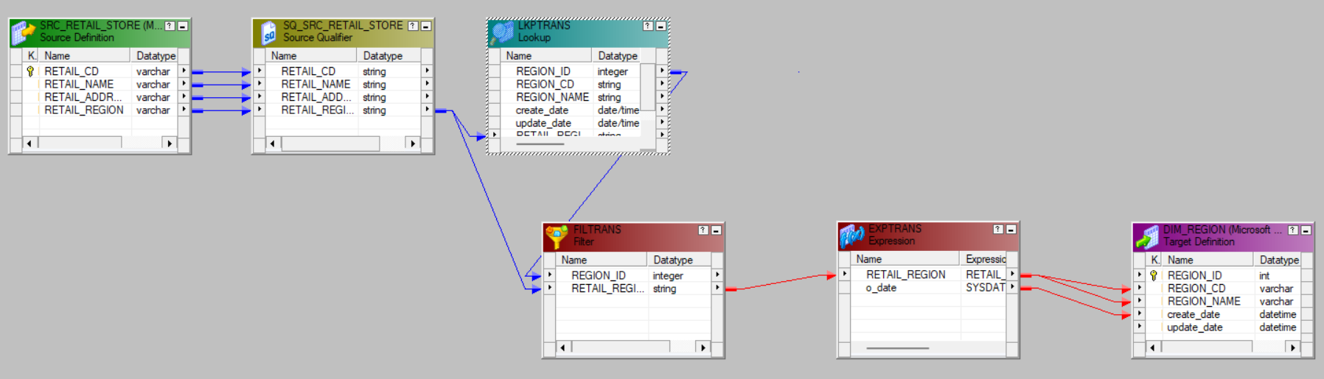

Workflow Monitor –

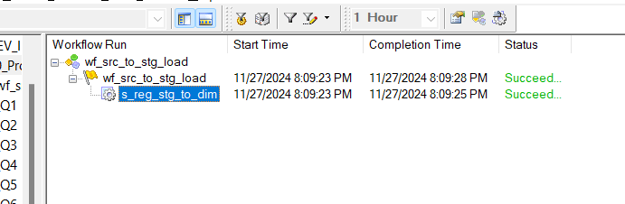

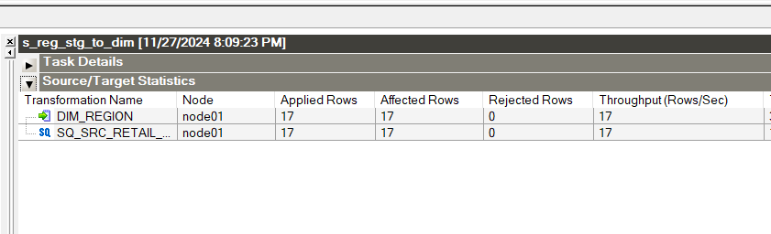

STG_RETAILER to DIM_RETAILER

Mapping –

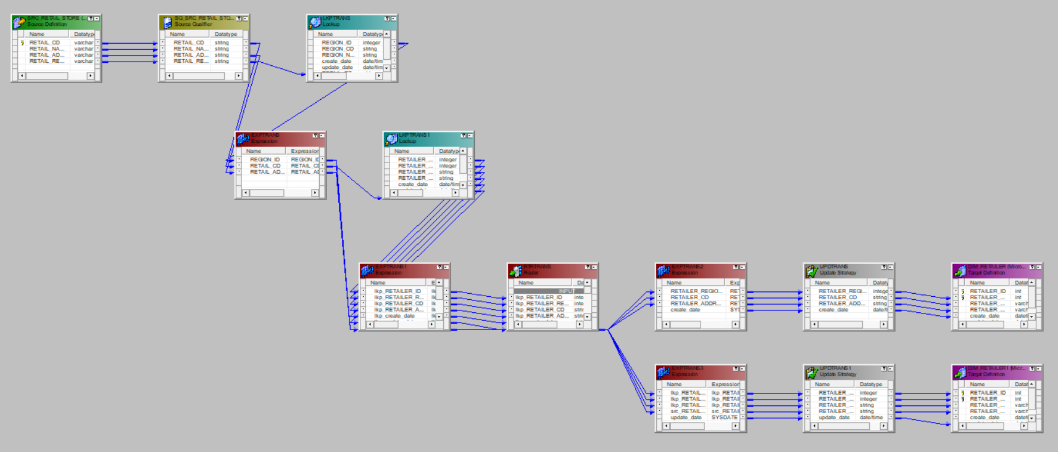

Workflow Monitor –

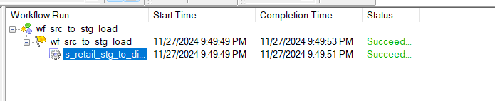

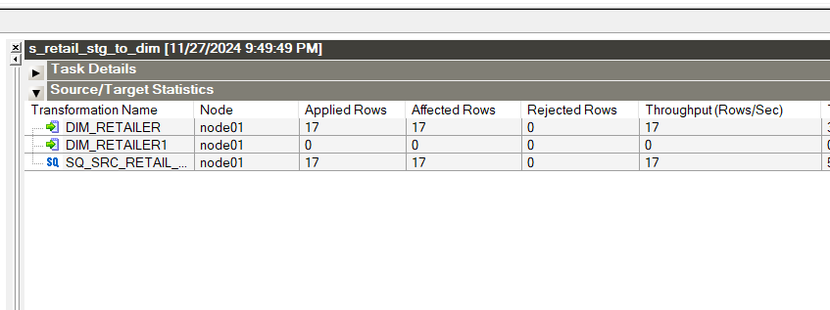

STG_ORDER to DIM_ORDER

Mapping –

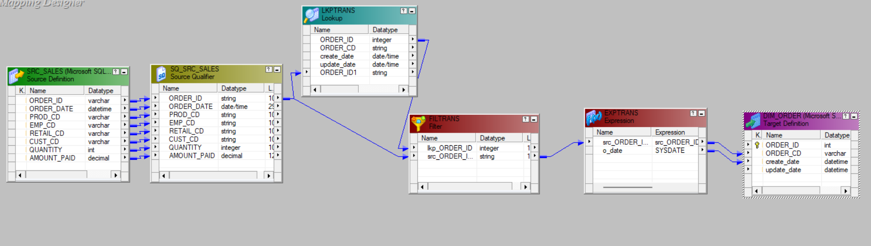

Workflow Monitor –

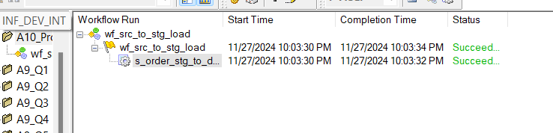

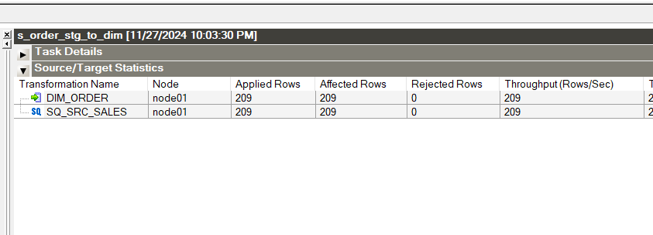

STG_PRODUCT to DIM_PRODUCT

Mapping –

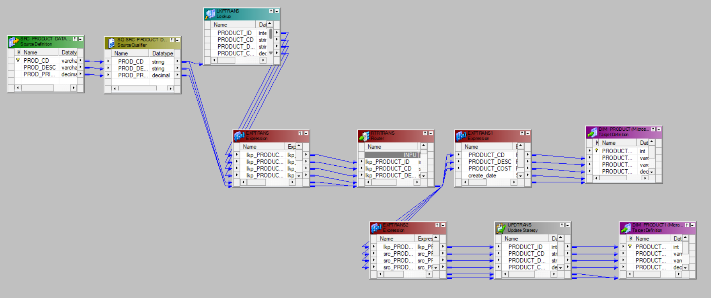

Workflow Monitor –

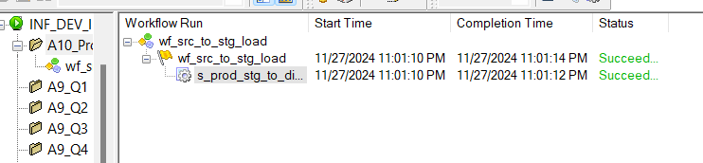

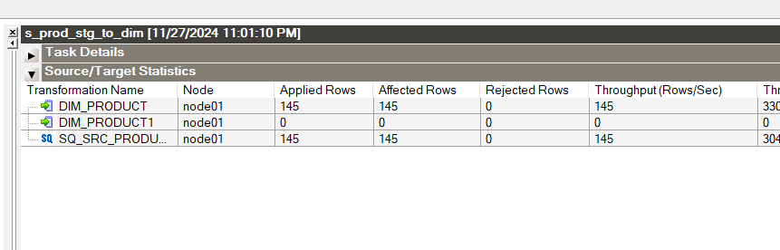

All DIM_TABLES to FACT_SALES

Mapping –

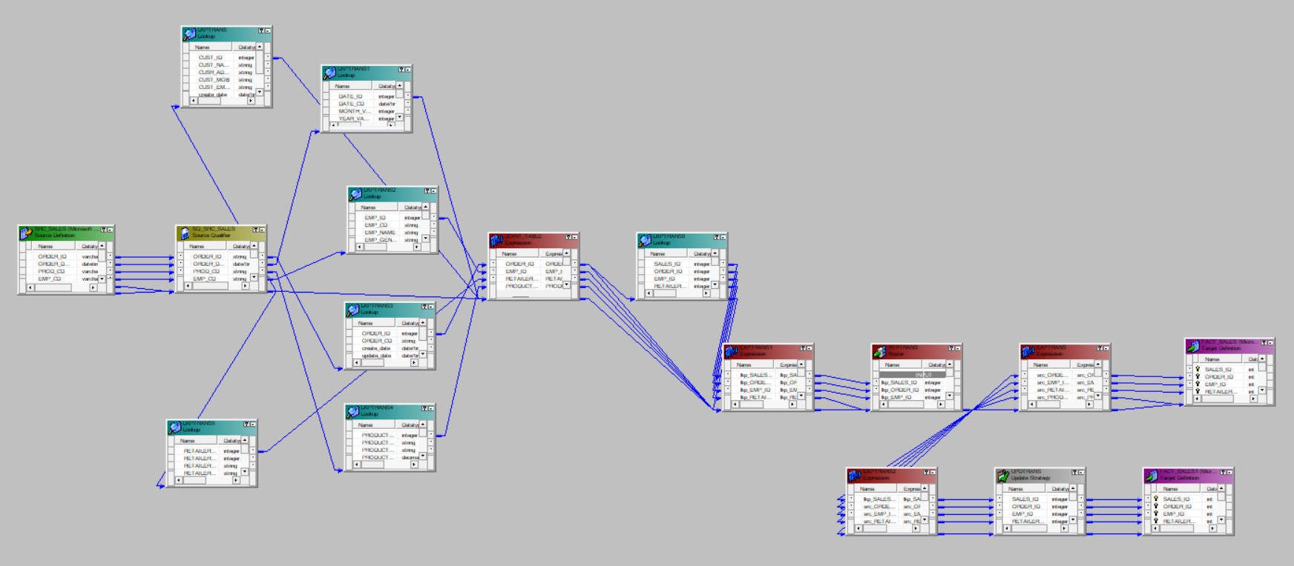

Workflow Monitor –

