**Integration-Testing**

It is a type of Software testing in which the different units, modules, or components of a software application are tested as a combined entity.

Integration testing is the second level of the software testing process after unit testing. In this testing, units or individual components of the software are tested in a group. The focus of the integration testing level is to expose defects at the time of interaction between integrated components or units.

We will check the functionality of the mappings.

**There are 2 mappings.**

1.M_MAPP_PROJECT_ROUTER_RANK

**Test Case ID: M1**

Test Case Purpose:Validate Mapping M_MAPP_PROJECT_ROUTER_RANK,Validate Workflow, WF_M_MAPP_PROJECT_ROUTER_RANK

**Test Procedure:**

* Go to Mapping
* Connect Source and Target
* Use Transformation
* Connect All and then Save it
* Go to menu> mapping> Click on validate

**Reason Test case can be Failed:**

Message in Mapping > Not Valid Mapping

**Remarks:** **Fail**

**Input Value/Test Data:**

**Source Tables** : BOOK_DETAILS

**Target Tables** :PROJ_TRG1_RANK1,

PROJ_TRG1_RANK2

**Transformation:**

1.Router: We defined two groups in the router as G1 and G2.We used G1 to get book price from 100 to 350 and we used G2 to get the book from 351 to 700.

2. Rank: RANK Transformation is used to rank according to the MRP of a book.

**Expected Result:**

Check Mapping> Mapping is validate

Go to workflow > Message in workflow manager status bar: “Workflow WF_S_M_MAP_PROJECT_ROUTER_RANK is valid”

**Actual Result:**

Message in workflow manager status bar : ”Workflow WF_S_M_MAP_PROJECT_ROUTER_RANK is valid”

**Remarks** **: Pass**

**Tester comments:**

Retrieved the data from source table SALES_DETAILS and grouped it in 2 categories BID, Title, MRP using transformations. The output is useful to identify the costliest and cheapest books in the store.

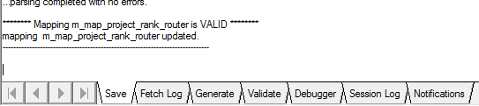

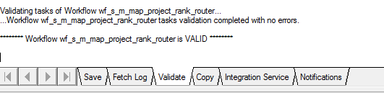

**Test Case ID: M2**

Test Case Purpose: Validate Mapping, M_MAP_PROJECT_FILTER_AGG,Validate Workflow, WF_S_ M_MAP_PROJECT_FILTER_AGG

**Test Procedure:**·

* Go to Mapping
* Connect Source and Target
* Use Transformation
* Connect All and then Save it
* Go to menu> mapping> Click on validate

**Reason Test case can be Failed:**

Message in Mapping > Not Valid Mapping

**Remarks:** **Fail**

**Input Value/Test Data:**

**Source Tables :** SALES_DETAILS

**Target Tables** : PROJ_TRG3_FILTER

**Transformation:**

1. Sorter: We have used the sorter to get the data in ascending order of CID.

2. Expression: We have used the expression to find the total price.

3. Aggregator: We have used the aggregator to find the sum of total price and to find the total bill of each customer. We have also applied a discount on the total bill.

4. Filter: We used it to filter the customer id’s.

**Expected Result:**

Check Mapping> Mapping is validate

Go to workflow > Message in workflow manager status bar: “Workflow WF_S_M_MAP_PROJECT_FILTER_AGG is valid”

**Actual Result:**

Message in workflow manager status bar : “Workflow WF_S_M_MAP_PROJECT_FILTER_AGG is valid”

**Remarks** : **Pass**

**Tester comments:**

Retrieved the data from the SALES_DETAILS and sorted,aggregated to find the bill the customer has to pay. This data will be useful to know billing details of each customer.

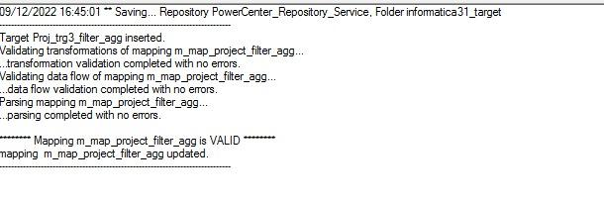

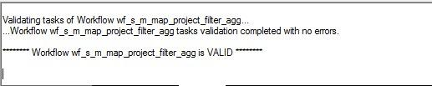

**Test Case ID: M3**

Test Case Purpose: Validate Mapping, M_MAP_PROJECT_AGG_FLATFILE,Validate Workflow, WF_S_ M_MAP_PROJECT_AGG_FLATFILE

**Test Procedure:**·

* Go to Mapping
* Connect Source and Target
* Use Transformation
* Connect All and then Save it
* Go to menu> mapping> Click on validate

**Reason Test case can be Failed:**

Message in Mapping > Not Valid Mapping

**Remarks:** **Fail**

**Input Value/Test Data:**

**Source Tables :** TRG_FLATFILE1.TXT

**Target Tables** : PROJ_TRG7

**Transformation:**

1. Aggregator: We have used the aggregator to find the most popular book

2. Expression: WE have used the expression to handle the null values.

**Expected Result:**

Check Mapping> Mapping is validate

Go to workflow > Message in workflow manager status bar:“Workflow WF_S_M_MAP_PROJECT_AGG_FLATFILE is valid”

**Actual Result:**

Message in workflow manager status bar : ”Workflow WF_S_M_MAP_PROJECT_AGG_FLATFILE is valid”

**Remarks** : **Pass**

**Tester comments:**

Retrieved the data from TRG_FLATFILE1.TXT and used the aggregator transformation on the data. This data is used to find the mostly sold out book and also the books which are not sold at least once.

