**MAPPINGS**

**MAPPING:01**

**Mapping Name:m_map_project_rank_router**

To find the costliest and cheapest book in the book list?

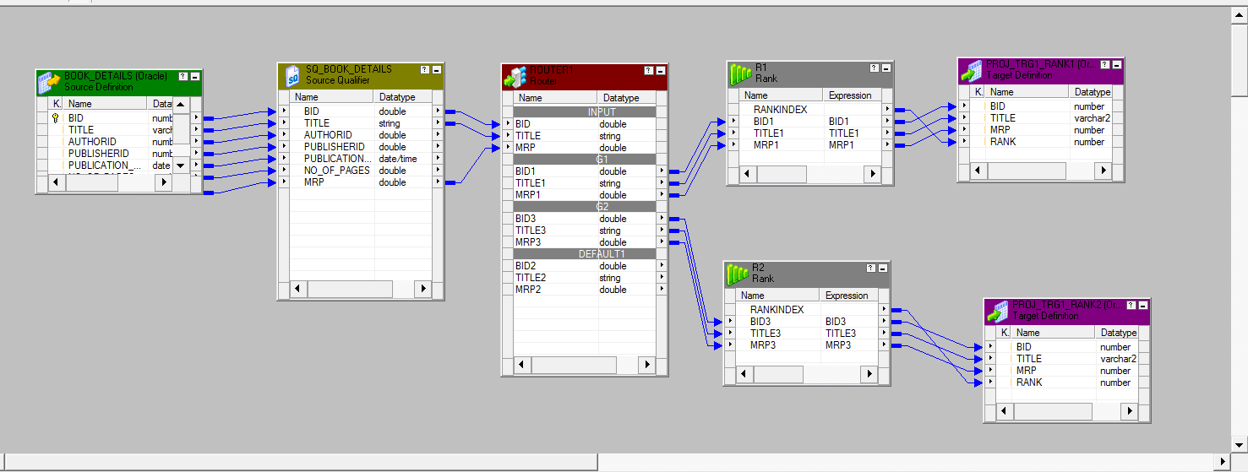

**TRANSFORMATIONS:**

**Router Transformation:**

Router Transformation is used to find the costliest and cheapest book between a Specific

Range.We used Two Groups:

1.By using Group G1 we retrieved the data of the books whose MRP range is between 100 and 350.

2.By using Group G2 we retrieved the data of the books whose MRP range is between 351 and 700

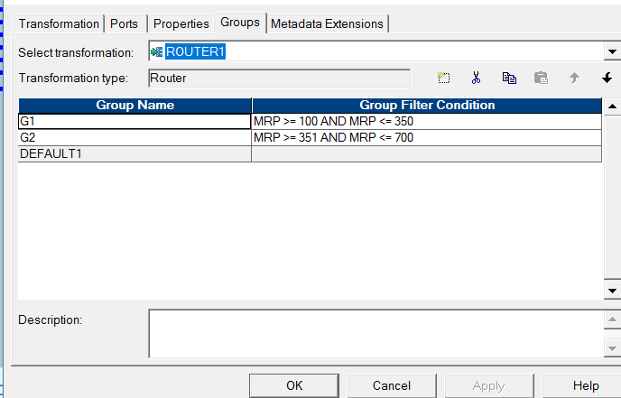

**Rank Transformation:**

We used Two Rank Transformations :

1.Rank R1 is used to fetch the book which is the cheapest between the given range.

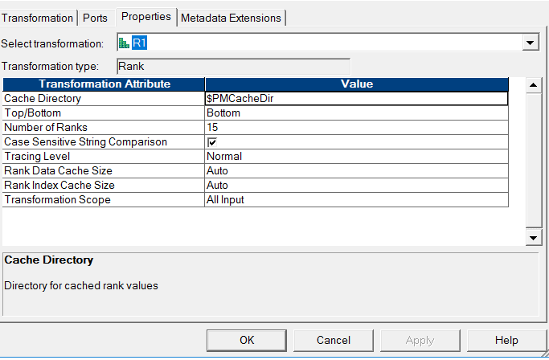

2.Rank R2 is used to fetch the book which is the costliest between the given range.

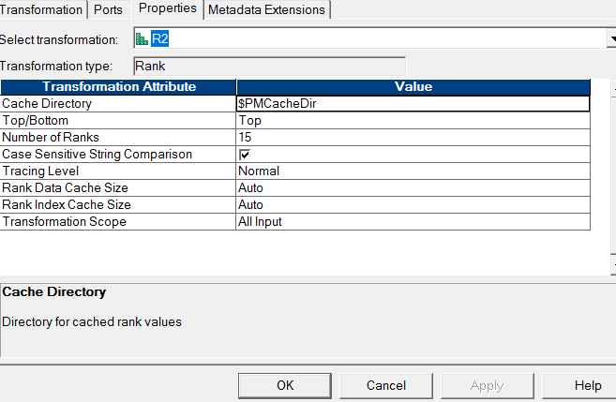

**SESSION AND WORKFLOW:**

We have created session and workflow and started the workflow

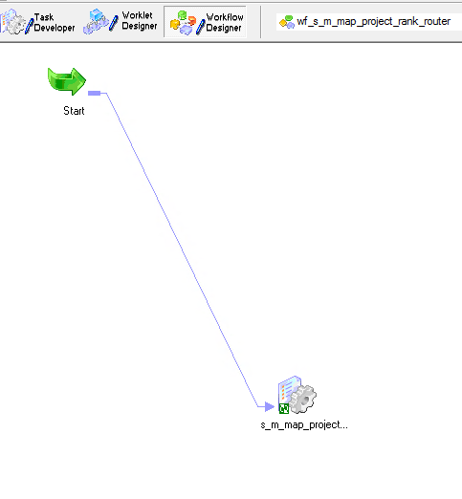

The Output of the mapping is:

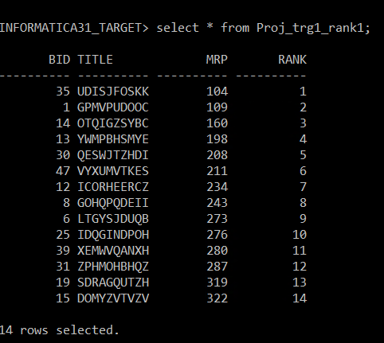

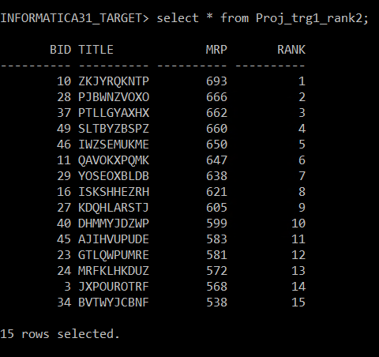

**MAPPING:02**

**Mapping Name:m_map_project_filter_agg**

To find the Total Bill of the Customer?

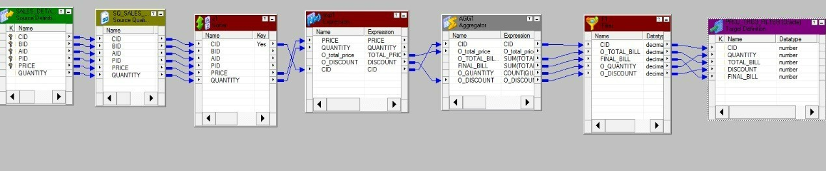

**TRANSFORMATIONS:**

**SORTER TRANSFORMATION:**

To get the data in the sorted format.We have given an Ascending order on CID.

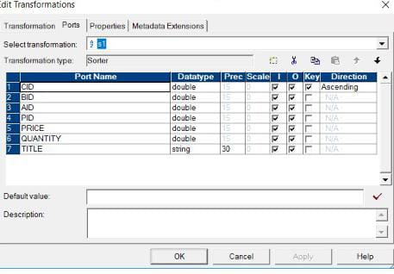

**EXPRESSION TRANSFORMATION:**

We used Expression Transformation to calculate the total bill and the discount that is applicable.

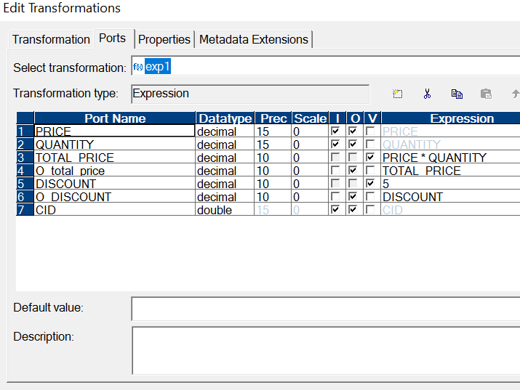

**AGGREGATOR TRANSFORMATION:**

We used Aggregator Transformation to find the Final Price and the count of the books that are Purchased by each Customer.

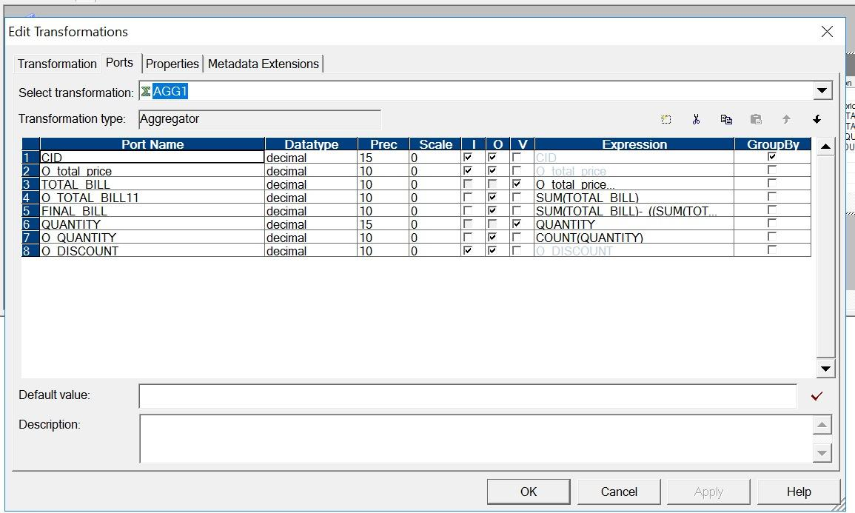

**FILTER TRANSFORMATION:**

We used Filter condition to get the data of the customers.

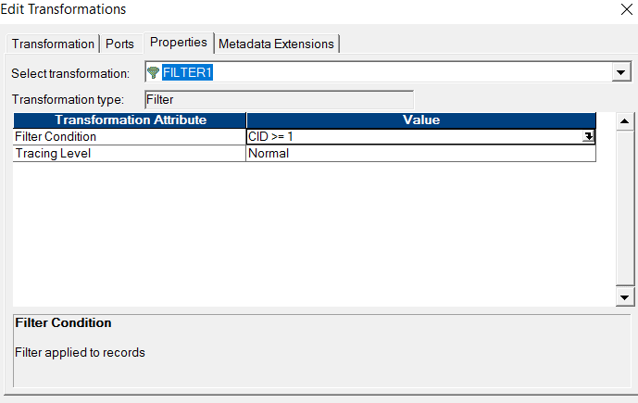

**SESSION AND WORKFLOW:**

We created a session and started the work flow.

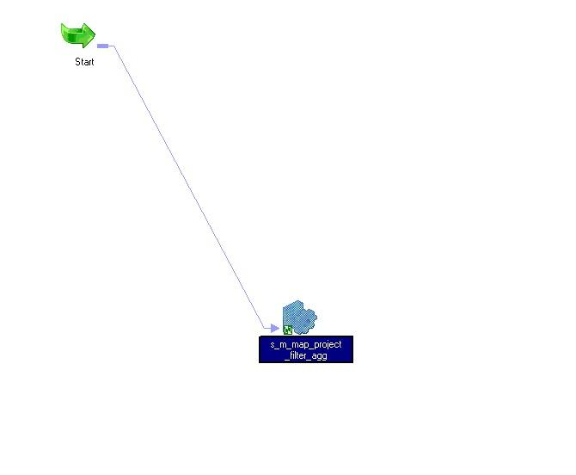

The output of the mapping is as follows:

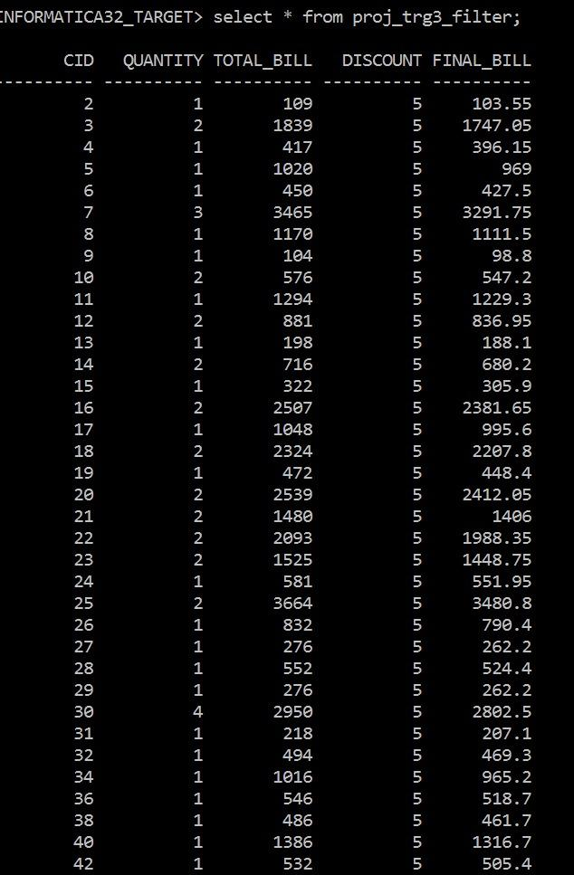

**MAPPING:03**

**Mapping Name:**M_MAP_PROJECT_AGG_FLATFILE

To find the most popular book.

Before doing mapping we should create a flat file as a source file. For this we did the below mapping.

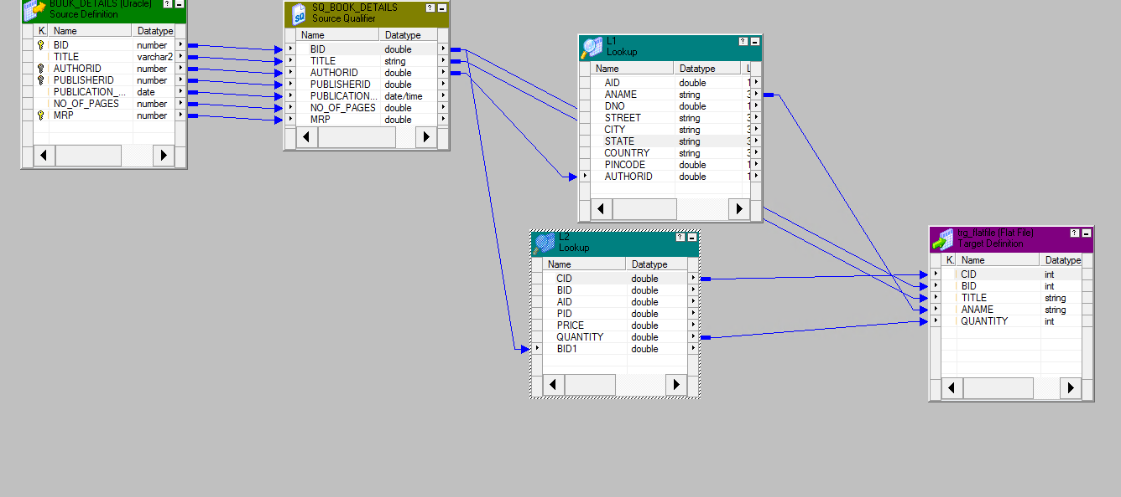

We have used two lookups in the mapping. Because we have to join 3 tables

**LOOKUP1:**

We created AUTHOUR_DETAILS as the first lookup.

**LOOKUP2:**

We created CUSTOMER_DETAILS as the second lookup.

**OUTPUT:**

The flat file output is as follows:

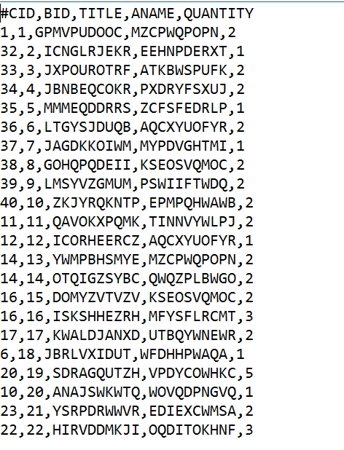

Now we considered this flat file as a source file and did the following mapping.

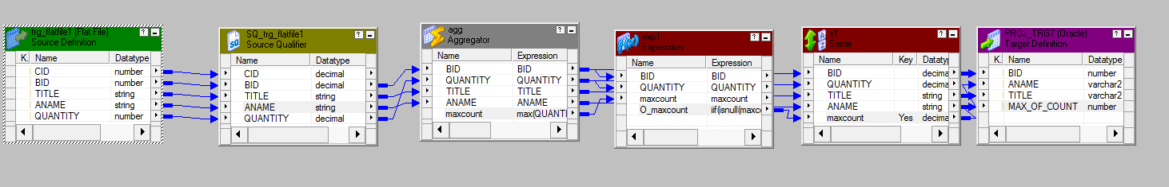

**TRANSFORMATIONS:**

**AGGREGATOR TRANSFORMATION:**

We have used aggregator transformation to find the maximum quantity of books sold based

on BID.

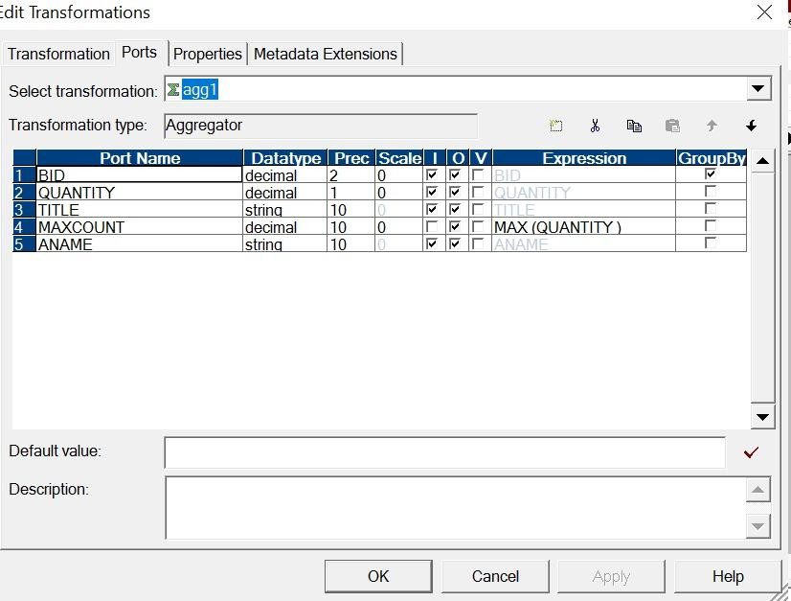

**EXPRESSION TRANSFORMATION:**

We used expression transformation to handle nulls.

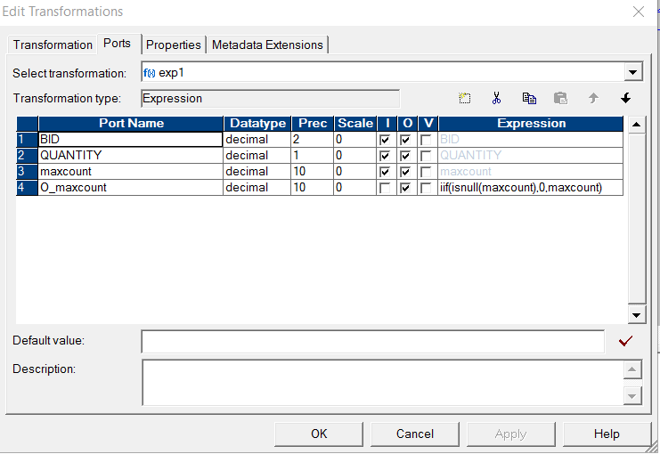

**SORTER TRANSFORMATION:**

We used Sorter Transformation to get the data in the descending order based on Max(Count).

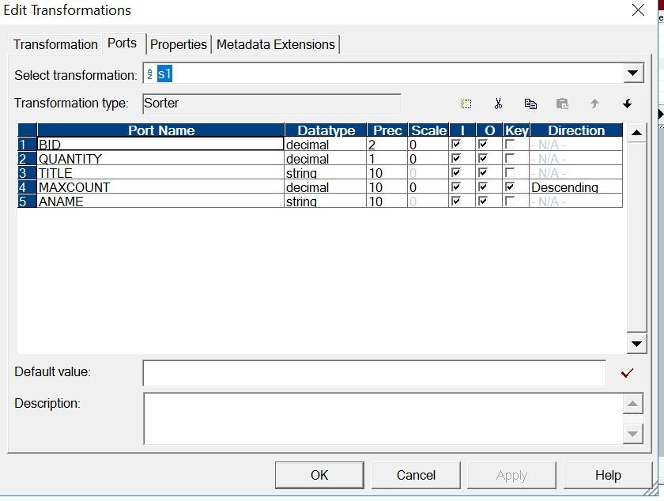

**SESSION AND WORKFLOW:**

We created a session and started the Workflow.

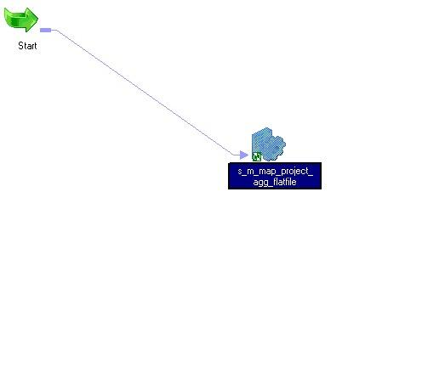

The output of the mapping is:

