CASE STUDY


For

TRACE
(Tactical Real-time Analysis of Criminal Events)

HARSHA RAJKUMAR CSE22119
SANAY SANTH V CSE22148
VIRAJ KISAN DAULE CSE22162
DATE: 15th May 2025
Table of Contents
Table of Contents ii
Revision History ii
1. Introduction 1
1.1 Purpose 1
1.2 Document Conventions 1
1.3 Intended Audience and Reading Suggestions 1
1.4 Project Scope 1
1.5 References 1
2. Overall Description 2
2.1 Product Perspective 2
2.2 Product Features 2
2.3 User Classes and Characteristics 2
2.4 Operating Environment 2
2.5 Design and Implementation Details 2
2.6 User Documentation 2
2.7 Assumptions and Dependencies 3
3. System Features 3
3.1 Login/Signup 3
3.2 Access current case details 4
3.3 Dashboard………………………………………………………………………..…………4
4. External Interface Requirements 4
4.1 User Interfaces 4
4.2 Hardware Interfaces 4
4.3 Software Interfaces 4
4.4 Communications Interfaces 4
5. Other Nonfunctional Requirements 5
5.1 Performance Requirements 5
5.2 Safety Requirements 5
5.3 Security Requirements 5
5.4 Software Quality Attributes 5
6. Other Requirements 5
7. Scrum Report………………………………………………………………………………...6

Revision History
Name | Date | Reason For Changes | Version
TRACE |  | Initial Development | 1

Introduction

Purpose
The product TRACE is a software for digitalization of police investigation process. This software will be used to record case details in real time digital data. This includes individual case details such as location of crime, evidences gathered, victim(s), witness(s), suspects, forensic reports, ballistics, officers and doctors involved, etc. The software is made for government law and enforce authorities which includes police, forensics, experts, advisors and government. The purpose of this project is to digitalize the process of investigation for smooth communication, real-time updation and formal documentation. This will benefit the authorities in smooth conduct of an investigation and will reduce the job of documenting and storing cases and its details.

Document Conventions
The following conventions are used in this SRS:
Bold text is used to highlight section headings and important terms.
‘Italicized’ terms indicate technical concepts or system components.
Requirements are categorized by priority:
M – Mandatory
O – Optional
PO- Product Owner
SM- Scrum Master
DLP- Developer

Intended Audience and Reading Suggestions
- Officers: The police personnel who will work on the case.
- Forensics: A person or a group who will handle the forensics part of a case.
- Ballistics: Expects on weaponries assigned on cases.
- Inspector: Person who will overview the cases under him/her.
- Technical Writers: A person who generates user manuals and documentation.
- Admin: A person who will manage the software and its functionalities.
- Database Manager: A person or a group who is solely entitled to access the database of the software.

Project Scope
The software envisions to implement the following functionalities:
- Case Record Creation and Closure.
- Real-time Updation of Case Details.
- Bringing onboard the authorized entities.
- Proper Documentation
- Efficient Database Updation and Maintenance.

The future scope of this software includes:
- Extension of the project to a larger scale under government.
- Improving the features to make it department specific software under different authorities.
- Adding AI to find correlations and pattern matching which will fasten the investigation process.

References
- https://ieeexplore.ieee.org/document/10360832
- https://ieeexplore.ieee.org/document/10210028
- https://ieeexplore.ieee.org/document/9392497
- https://ieeexplore.ieee.org/document/8865056
- https://ieeexplore.ieee.org/document/10547601

Overall Description

Product Perspective
The product is a standalone software designed with the aim to facilitate users with the case investigation. It allows the authorized users to upload case details. With the advantage of real-time updation, the case module is updated whenever logged in. HTML, CSS and JavaScript has been used to design the frontend of the product. With the help of MongoDB, the database is created, updated and maintained. The database is a vital aspect of the product and is highly dependent on it. The product focuses on a specific group of entities and a specific work type- Case Investigation. The future scope of the same may include using new technological tools such as AI to speed up the process.

Product Features
- Login
- Current Case Modules
- Previous Case Modules
- Notification
- Profile
- Officers’ Profile
- Evidence Module
- Ballistics Module
- Suspects’ Module
- Victim Module
- Witness Module
- Database Access
- Contact and Query

User Classes and Requirements
User Class | Requirements
Officers and Inspectors | Intuitive UI with mobile-friendly access.
Forensics and Ballistics Experts | Secure file upload and integration with forensic tools.
Admins and Database Managers | Advanced security features and audit logging.
Technical Writers | Read-only mode to access system workflows for documentation.

Operating Environment
- Client-Side:
- Web Browser- Chrome, Firefox, Edge, Brave, etc.
- HTML, CSS, JavaScript
- Device Type – desktops, tablets, and phones with varying screen sizes.
- User Input – interactions like clicks, form submissions, and API requests.
- Server-Side:
- Web Server- Apache
- Application Server- Node.js
- Database Management System- MongoDB
- Server Operating System- Windows, Linux

- Cloud Hosting
- CDN (Content Delivery Network)
- Version Control System- GitHub
- Monitoring Tool- Google Analutics
- Security Measures- Firewalls, DDoS protection, encryption techniques.

Design and Implementation Details
Architecture:
- Presentation Layer (Frontend): Provides the user interface for police officers, forensic experts, and government officials.

- Application Layer (Backend): Handles business logic, user authentication, and real-time updates.

- Data Layer (Database & Storage): Stores case records, forensic data, evidence, and reports.

Implementation Details:
Link- https://trace-cat.netlify.app/
- Backend Development:
- API Development using RESTful principles.
- Middleware for Authentication to validate user roles.
- Logging and Monitoring with ELK Stack.

- Frontend Development:
- React.js with Material UI for a responsive and accessible design.
- State Management with Redux.
- Graphical Timelines to track investigation progress.

- Security Measures:
- Data Encryption using AES-256 for sensitive case files.
- Role-Based Access Control (RBAC) to prevent unauthorized access.
- Audit Logs to track all changes made to case files.

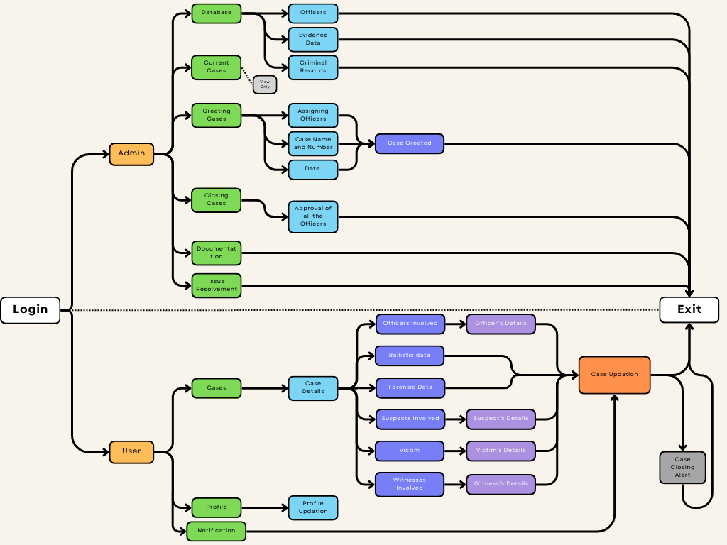
Fig. 1: System Flow Diagram
Diagrams:
- System Flow Diagram: Fig. 1 depicts the system flow diagram for the project. It starts with Login and divides into 2 sections based on the user type- admin and user. The functionalities available for both the types of user is then followed. Both ends with login out and exiting the software.
- Use Case Diagram: Fig. 2 depicts the use case diagram for the project. It provides with the functionalities that can be performed by a user in the software and shows its connectivity to the functionalities that can be performed by an admin.
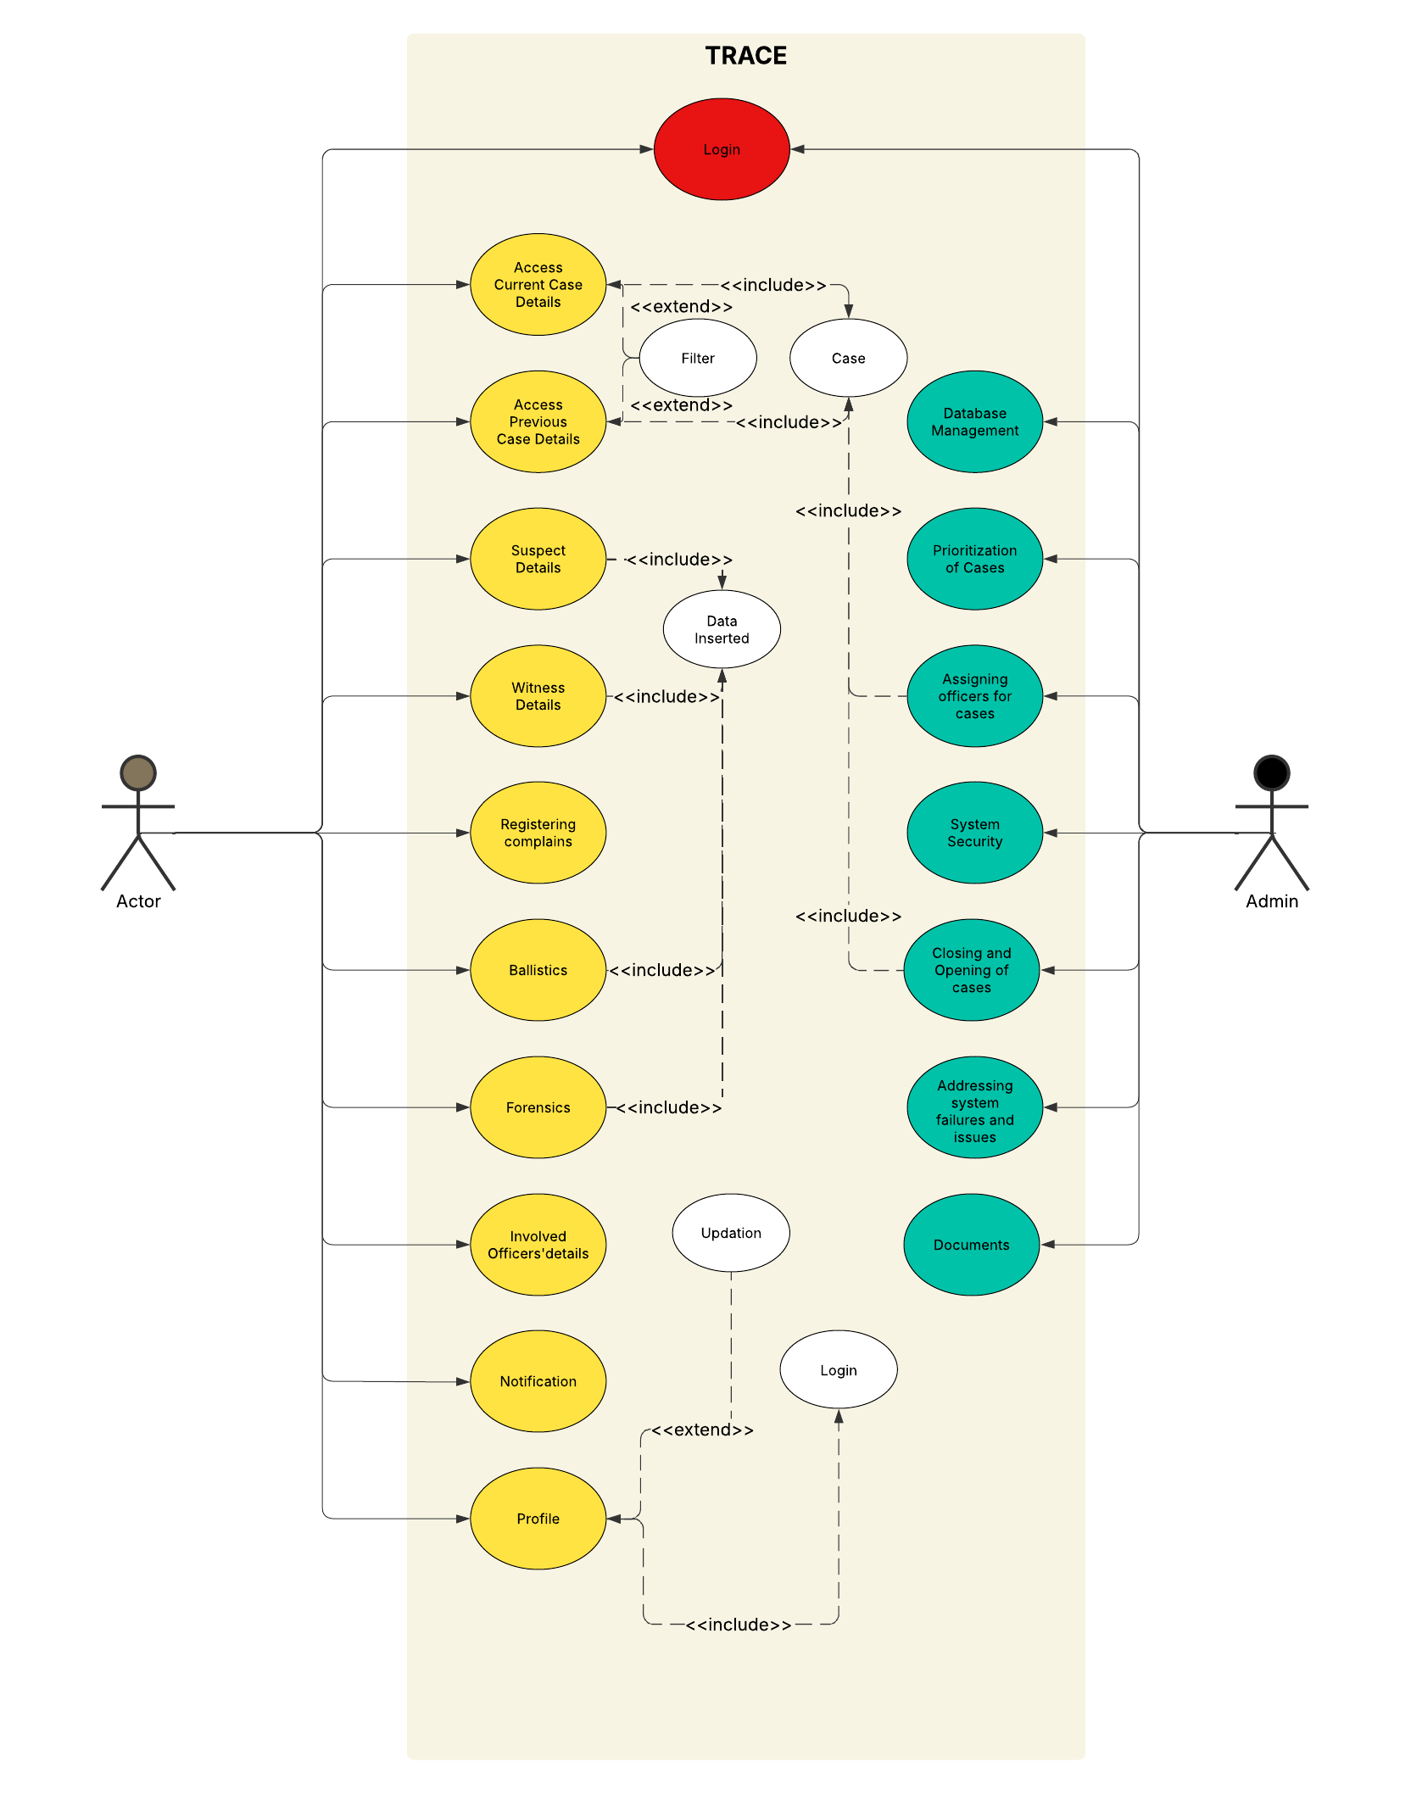
Fig. 2 Use Case Diagram

User Documentation
- Product Manual
- Wireframes
- System Flow Diagram
- User Case Diagram
- Login or Register Details to authorized user.
- Database Manual

Assumptions and Dependencies
- Assumptions:
- Law enforcement agencies will have the necessary technical infrastructure (computers, secure internet access, and storage facilities) to use the software efficiently.
- All authorized users (police officers, forensic experts, advisors) will be provided proper training on how to use the system.
- The system will be used in a secure environment, and access will be limited to authorized personnel only.
- Government policies and regulations regarding digital case management and data privacy will remain stable and will not impose unexpected constraints.
- The integration of external forensic and ballistic data sources will be feasible and supported by concerned departments.
- The internet and cloud storage services required for real-time data synchronization will be reliable and available at all times.

- Dependencies:
- Government Regulations & Compliance – The software must comply with legal and cybersecurity policies imposed by law enforcement authorities.
- Third-party Integrations – The system may rely on external forensic, biometric, and criminal databases for case updates and verification.
- Secure Data Storage & Hosting – The project depends on government-approved secure cloud storage or on-premises servers for storing case details and sensitive information.
- API Support for Law Enforcement Systems – TRACE may need to integrate with existing crime databases, court records, and forensic labs, which requires proper API access and cooperation from respective agencies.
- User Authentication & Cybersecurity – The system depends on secure authentication mechanisms (e.g., multi-factor authentication, biometric login) to prevent unauthorized access.

System Features
TRACE implements major important and specific purpose features which can be easily accessible and used by personnel. These features are designed and implemented in a way which reduces the browsing time and can guide directly to the area of interest of the user.

Login/ Signup
3.1.1 Description and Priority
The login system provides authorized users to gain access to the TRACE Evidence Management System. Although this is a high level application, it is of high priority.
3.1.2 Stimulus/Response Sequences
User enters username
User enters the password when prompted by the system.
The credentials are validated by the system.
Post validation, the user is directed to their respective webpage based
on whether they are a admin or any other user.
3.1.3 Functional Requirements
- The system shall require users to authenticate with a valid username and password before granting access.
- System compares entered username and password with the credentials stored in the database
- If authentication fails, system displays an error. If user is signing up for the first time, system implements a password policy by adding specifications such as password length, complexity etc.
- System locks the account after a minimum number of login attempts.
- System provides password reset system incase password is forgotten.
- The system shall allow an Admin to create, modify, and delete user accounts.

Access current Case Details
3.2.1 Description and Priority
This feature allows users to access and view details of current cases to which they are assigned.
3.2.2 Stimulus/Response Sequences
User navigates to the "Current Cases" section.
System displays a list of cases assigned to the user
The user selects a specific case
The system displays the details of the case that was selected.
3.2.3 Functional Requirements
- The system displays a set of current cases.
- The system shall allow the user to sort the list of cases by date, case number, and priority.
- Upon selection of a case, the system shall display the following details
-Officer data
-Balistic information
-Forensic Data
-Suspects involved
-Victim
-Witness involved.

- The system shall allow the user to search for specific cases by case number, suspect name, or keyword.

Dashboard
3.3.1 Description and Priority
This feature provides an overview that displays the current crime log, crime trends, Zone Wise Heatmap and automated alerts
3.3.2 Stimulus/Response Sequences
User successfully logs in
System displays the trace dashboard
The system dashboard consists of real-time or near real-time data
The system displays the details of the case that was selected.
The user can interact with elements on the dashboard to drill down into more detailed information
3.3.3 Functional Requirements
- The dashboard displays a "Current Crime Log" component showing recent crime incidents.
- The Current Crime Log shall include the following information for each incident: crime type, date, time, zone.
- The system shall display "Crime Trends" in a graphical format

- The system displays the last 24-hour crime trend.
- The system displays contact information for easy access to users.

External Interface Requirements

User Interfaces

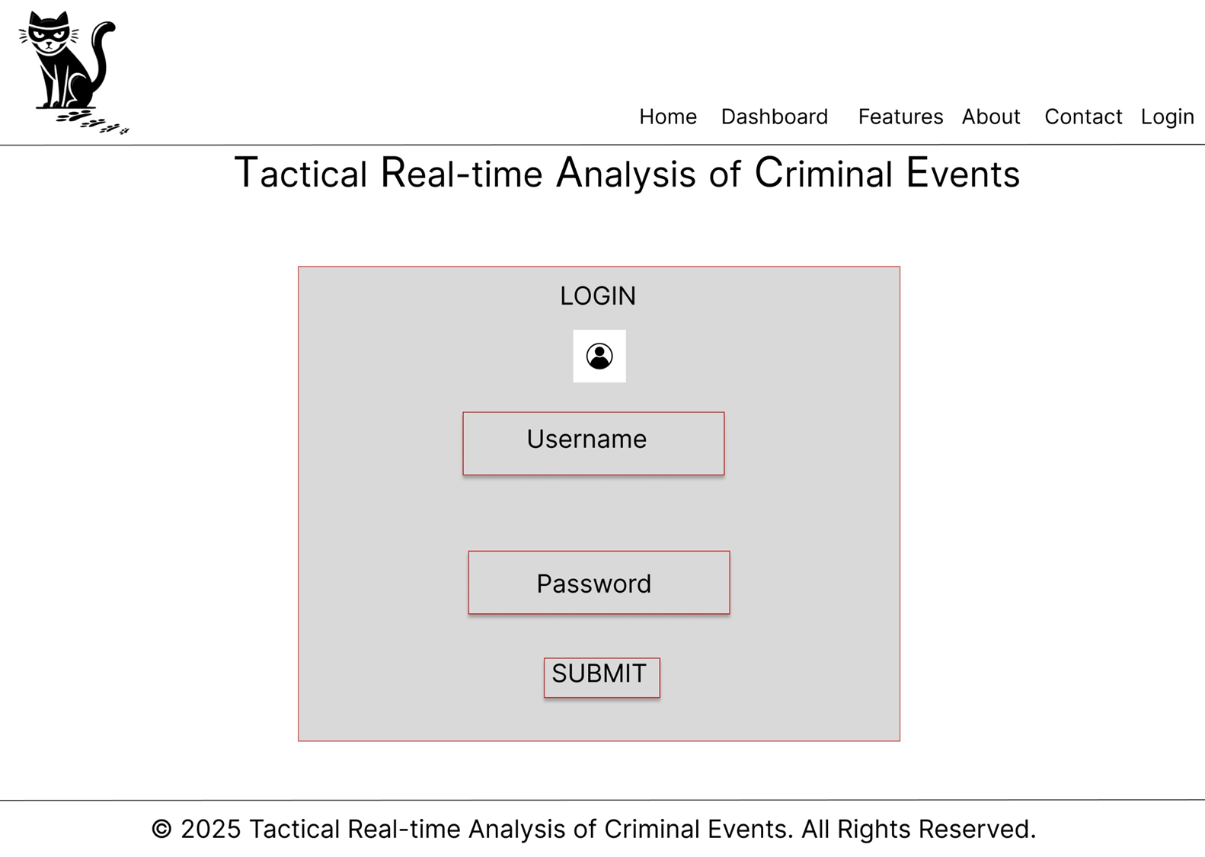
Fig. 3: Login Page

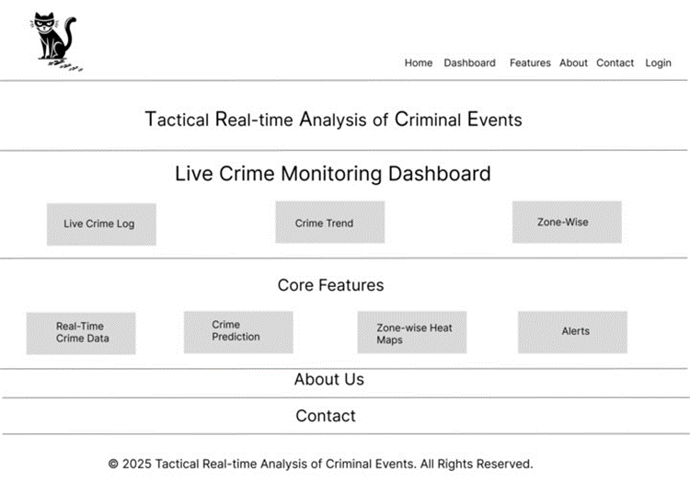
Fig. 4: Home page

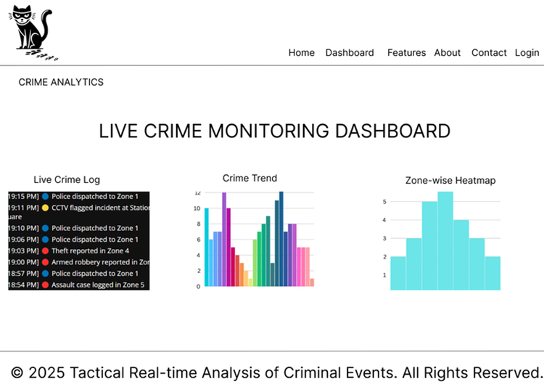
Fig. 5: Dash Board

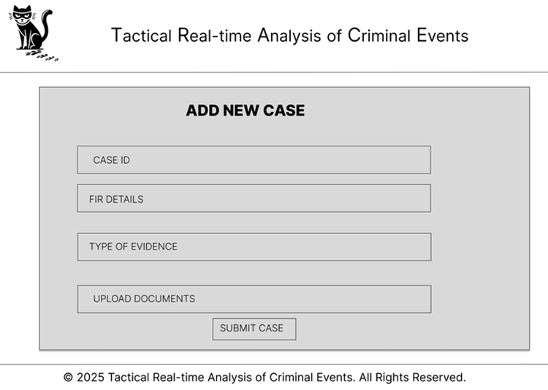
Fig. 6: Case Details Entry

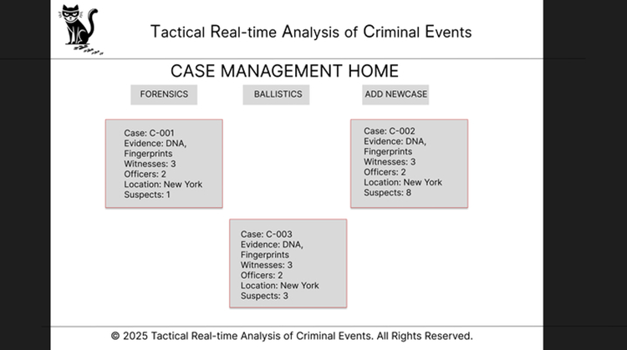
Fig. 7: Cases Page

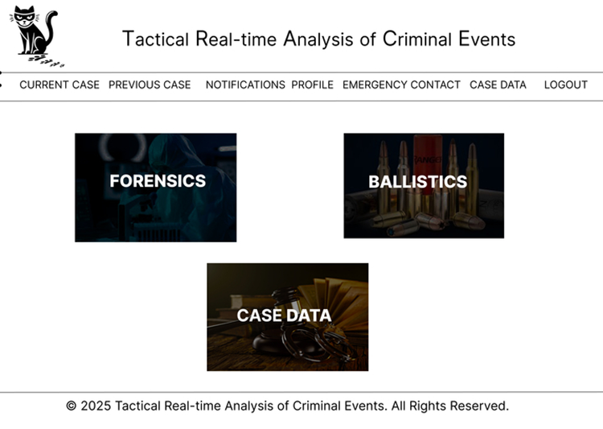
Fig. 8: Individual Case

Hardware Interfaces
TRACE system is designed to operate seamlessly across a variety of hardware platforms used by law enforcement agencies. It will interact with both standard computing hardware and specialized forensic equipment where applicable.
- Desktop Computers and Laptops- Windows, Linux
- Tablets and Smartphones – Android, iOS
- Secure Government Servers
- Peripheral Devices: Printers, Scanners, Fingerprint Scanner.

Software Interfaces
Component | Technology | Purpose
Operating System | Linux, Windows | Server deployment & execution
Database | MongoDB
  Storing logs, media files, and unstructured data
Web Framework | Node.js | Backend API development
Frontend Framework | React.js | User interface for police officers & forensic teams
Cloud Storage | Google Cloud Storage
  Secure evidence and forensic report storage

Communications Interfaces
- HTTPS/SSL: For all software-to-server and inter-device communication.
- REST APIs: For communication between software modules and external forensic systems or biometric hardware.
- USB/Bluetooth/Wi-Fi: For connecting to printers, scanners, and portable forensic tools (based on local setup).
- GovNet: For internal communication on secure government networks.

Other Nonfunctional Requirements

Performance Requirements
- Response Time- System should respond to user actions within 1.5 seconds.
- Data Retrieval- Case search queries should return results in under 3 seconds.
- Concurrent Users- Should support 500+ simultaneous users without performance degradation.
- File Upload Processing- Uploading forensic evidence (images, videos) should take ≤5 seconds for files under 100MB.
- API Latency- API response time should be ≤100ms for standard requests.

Safety Requirements
- Data Integrity: Any modification to case files must be logged and time-stamped for accountability.
- Tamper Detection: Digital evidence (e.g., forensic reports) must be checksum-verified to detect alterations.
- Legal Compliance: The system must comply with CJIS (Criminal Justice Information Services) Security Policy.

Security Requirements
- Authentication- Multi-Factor Authentication (MFA) required for all users.
- Access Control- Role-Based Access Control (RBAC) to restrict user permissions.
- Encryption- Data stored and transmitted using AES-256 & TLS 1.3 encryption.
- Forensic Evidence Protection- Digital signatures on forensic files to ensure authenticity.
- Account Lockout- 5 failed login attempts trigger a temporary account lockout.

Software Quality Attributes
- Availability
- Reliability
- Interoperability
- Usability
- Scalability
- Maintainability
- Auditability
- Portability

Other Requirements
- Legal & Compliance Requirements-
- TRACE must comply with national and international law enforcement data regulations.
- Compliance with ISO 27001 for information security.
- Internationalization & Localization-
- Support for multiple languages for different jurisdictions.
- Date & time format should adapt to regional settings.

Scrum Report

WEEK | SPRINT GOAL | PRODUCT OWNER AND AMANUENSIS | SCRUM MASTER | DEVELOPER | Tasks
01 | Project Setup and Requirements | V | S | H | Defining Project Objective, Requirements and Data collection.
02 | System Architecture Designing | S | H | V, H | Data collection, functionality requirements(developer end)
03 | User Story Collection | H | V | S,V,H | Collection of User Stories and UML diagrams.
04 | UI - 1 | V | H | S | UI development of the TRACE- Login
05 | UI-2 | V | H | S | UI development of the TRACE – Home page, Dash Board
06 | Real Time Updation | S | V | H | Working on synchronization of data.
07 | Case Study | H | S | S,V,H | Documenting Project SDLC
08 | Uploading Image datatype | V | H | S | Integrating Cloudinary to the software
09 | Final updations | S | V | H | To adjust minor functionalities and details

SPRINT SCHEDULE
S- Sanay Santh V
V- Viraj Kisan Daule
H- Harsha Rajkumar

Fig. 9 JIRA framework for Scrum

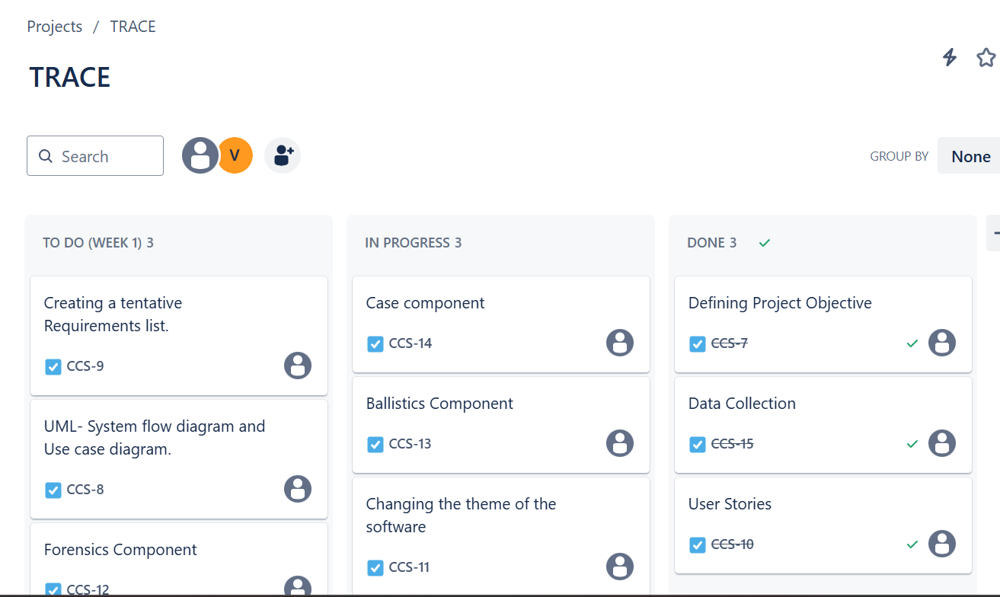

Week 01

Goal- Defining Project Objective, Requirements and Data collection.
Duration- 14th February to 21st February
Product Owner and Amanuensis - Viraj Kisan Daule
Scrum Master- Sanay Santh V
Developer- Harsha Rajkumar
Sprint:
- Sprint Tasks-
- Describing Project object and goal to the Scrum master.
- Providing tentative but necessary project requirements (functionalities).
- Scrum meeting to agree upon providing dataset at later stages of the development lifecycle to ensure documents on terms and conditions are filled.
- Documenting project objective and requirements listed at the end of the sprint.

- Daily Scrum-

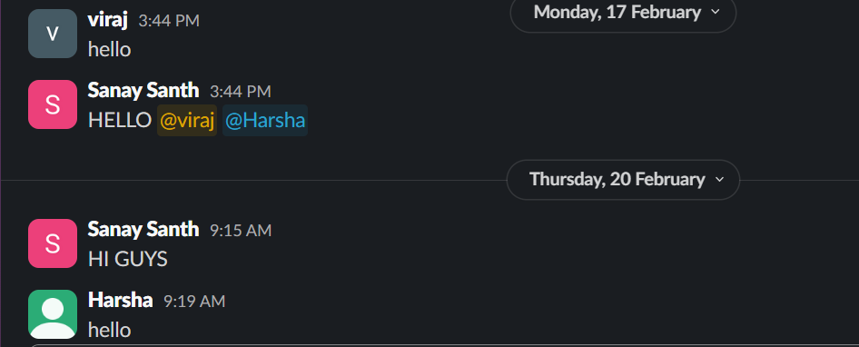

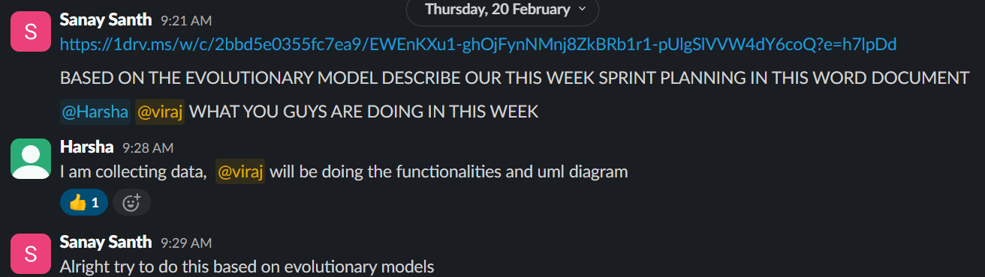

- A group was created on slack with all the stakeholders- Product Owner(PO), Scrum Master(SM), Developer(DEVL).
- I defined the sprint objective and requirements.
- Scrum Master assigned the work for the week.
- I was asked to define the functionalities, requirements and UML diagram and to document it.
- The developer was assgined the task to arrange for the data.

- Sprint Review-
- Tasks Completed-
- Objective was clearly defined to the Scrum master of the week.
- Tentative requirements list provided as well as documented.
- In the Scrum meeting, it was agreed upon to provide the dataset at later stages of development.

- Tasks Carry Forward-
- Creation of UML diagram

- Sprint Retrospective-
- To allocate the task of collecting User stories in the 3rd week of sprint.

Week 02

Goal- Data collection, functionality requirements(developer end)
Duration- 21th February to 28st February
Product Owner and Amanuensis - Sanay Santh V
Scrum Master- Harsha Rajkumar
Developer- Viraj Kisan Daule
Sprint:
- Sprint Tasks-
- Collection of functionalities given by PO through SM.
- Listing out the components which will be implemented in the Software.

- Daily Scrum
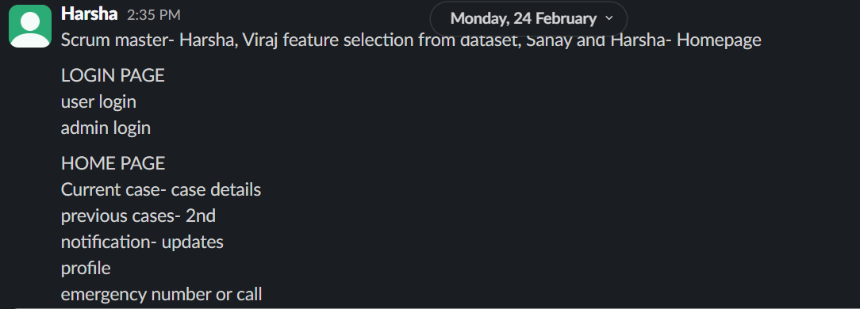

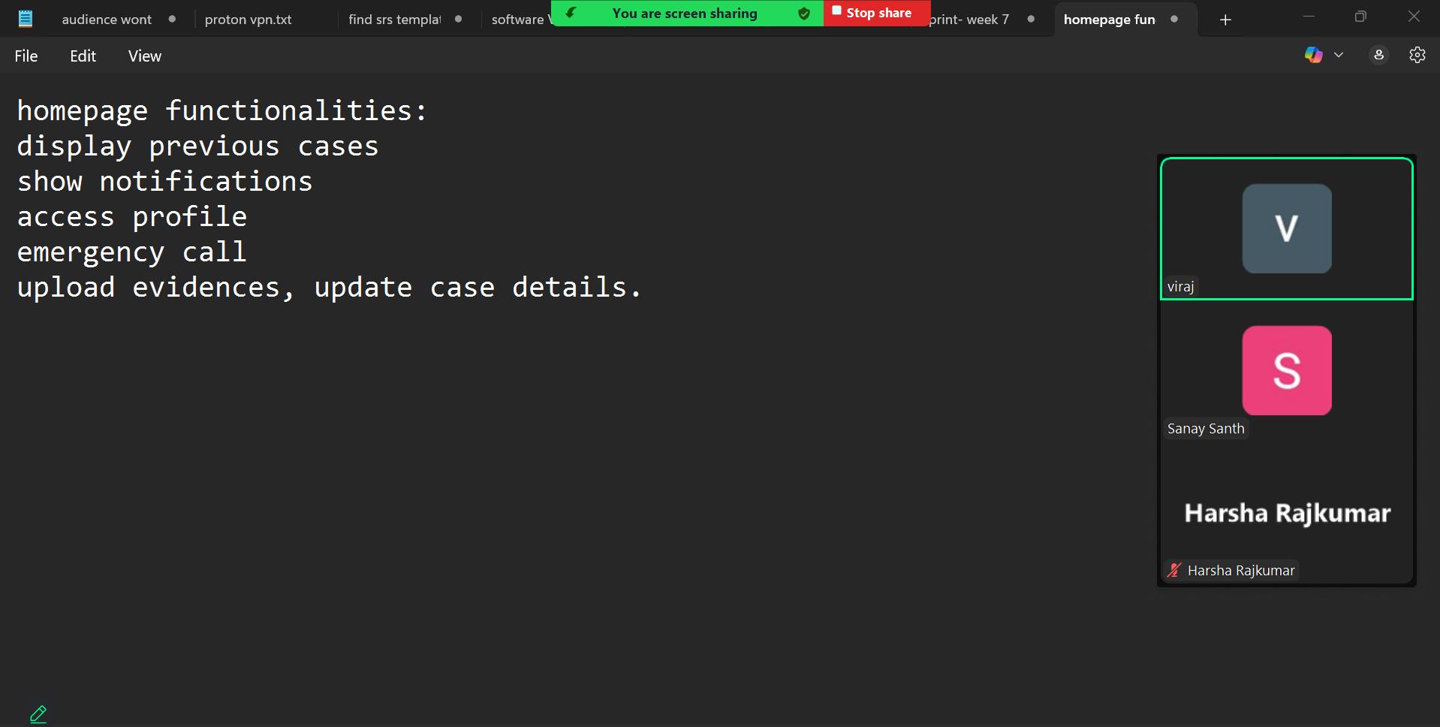

- A discussion took place among the stakeholders to decide the components which will be implemented in the product.
- Based on the dataset acquired, analysis component was added in the requirements.

- Sprint Review-
- Tasks Completed-
- Requirements were gathered and analysed
- List of components was created and discussed among the stakeholders.

- Tasks Carry Forward-
- NONE

- Sprint Retrospective-
- NONE

Week 03

Goal- Collection of User Stories and UML diagrams.
Duration- 28th February to 4th March
Product Owner and Amanuensis – Harsha Rajkumar
Scrum Master- Viraj Kisan Daule
Developer- Sanay Santh V, Viraj Kisan Daule, Harsha Rajkumar
Sprint:
- Sprint Tasks-
- Dividing the User stories into broad sections to assign it to developers.(SM)
- Collection of User stories from Forensics point of view as assigned by Scrum Master.(Developer)
- Daily Scrum

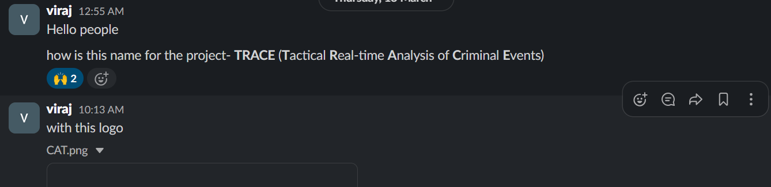

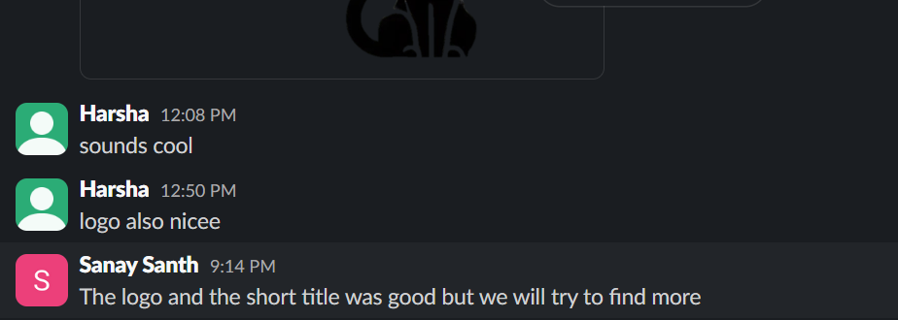

- The meeting had a discussion on Logo and the changes made to it based on its depiction.
- Tasks were assigned to the developers regarding their task for the week.

- Sprint Review-
- Tasks Completed-
- User Stories collected from majority of the users.(SM)
- Forensics user stories collected.

- Tasks Carry Forward-
- Collection of user stories from the remaining users.(SM)

- Sprint Retrospective-
- NONE

Week 04

Goal- UI development of the TRACE- Login
Duration- 12th March to 19th March
Product Owner and Amanuensis –Viraj Kisan Daule
Scrum Master- Harsha Rajkumar
Developer- Sanay Santh V
Sprint:
- Sprint Tasks-
- Checking if the developer has made a login page with the 2 types of user and reviewing it.

- Daily Scrum
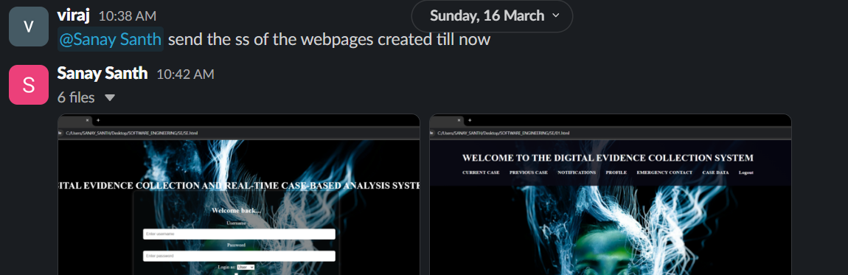

- The login page was created by the developer.
- After reviewing, additional functionality was decided to be added, i.e. User can login only 5 times.

- Sprint Review-
- Tasks Completed-
- Initial creation of Login page.

- Tasks Carry Forward-
- Additional feature discussed in the scrum, to be implemented in the upcoming sprint

- Sprint Retrospective-
- Documentation updation after every sprint.

Week 05

Goal- UI development of the TRACE – Home page, Dash Board
Duration- 19th March to 26th March
Product Owner and Amanuensis –Harsha Rajkumar
Scrum Master- Viraj Kisan Daule
Developer- Sanay Santh V
Sprint:
- Sprint Tasks-
- Providing the developer with the features to be implemented while creating the Homepage and Dashboard.
- Ensuring the features implemented can be easily editable to cope up with the changing requirements.

- Daily Scrum
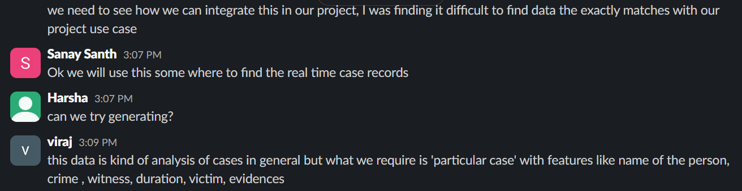

- Both the pages were created with a dark theme template.
- Product owner asked for the template to be light and same was clearly conveyed to the developer team.

- Sprint Review-
- Tasks Completed-
- Home page was created with all the functionalities and components mentioned.
- Dash Board was created with all the functionalities and components mentioned.

- Tasks Carry Forward-
- Implementing light theme template to the software.

- Sprint Retrospective-
- NA

Week 06

Goal- Real Time updation.
Duration- 26th March to 2nd April
Product Owner and Amanuensis –Sanay Santh V
Scrum Master- Viraj Kisan Daule
Developer- Harsha Rajkumar
Sprint:
- Sprint Tasks-
- Get the features and information from the product owner and assign to developer.
- Divide the features into multiple sub class in updation of data.
- Assign the functionality such as test real time data to developer.

- Daily Scrum-

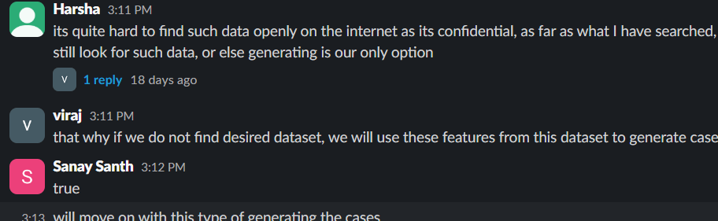

- I defined the integration of real time data exchange.
- As a scrum master, I defined the task in data updation in real time.
- The developer was assgined to update the data.

- Sprint Review-
- Tasks Completed-
- Real time updation of data is successfully accomplished

- Tasks Carry Forward-
- Expansion of real time updation of data.

- Sprint Retrospective-
- Plan for final integration and documenting in week 7.

Week 07

Goal- Case Study to evaluate the system
Duration- 2nd April onwards
Product Owner and Amanuensis –Harsha Rajkumar
Scrum Master- Sanay Santh V
Developer- Sanay Santh V, Viraj Kisan Daule, Harsha Rajkumar
Sprint:
- Sprint Tasks-
- As a developer, I documented the project based on the SDLC goals.
- Scrum master and the product owner was assigned task based on the Case study.
- Gather feedback from the stakeholders for further improvements for the system

- Daily Scrum-

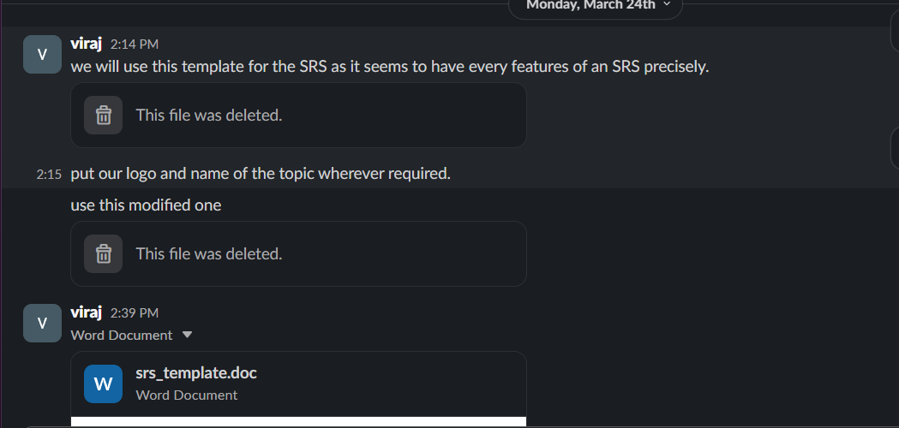

- Identified the content and relevant scenarios based on the real police work flows.
- Collected required insights from the users and admin.
- Documented the pain points and suggestion for future enhancements.

- Sprint Review-
- Tasks Completed-
- Case study is successfully completed with multiple information.
- Documents are properly aligned.

- Tasks Carry Forward-
- Based on the suggestions future enhancements has to be done

- Sprint Retrospective-
- Enhancement of the documentation(report) regularly.

Week 08

Goal- Integrating Cloudinary to the software
Duration- 2nd April onwards
Product Owner and Amanuensis –Viraj Kisan Daule
Scrum Master- Harsha Rajkumar
Developer- Sanay Santh V,
Sprint:
- Sprint Tasks-
1.Implemented Cloudinary
2.Create Cloudinary account and configure API keys (env variables setup)
3.Decide on SDK vs API usage (based on language/framework)
- Daily Scrum-
- Unblock team issues
- Monitor burndown chart
- Ensure Cloudinary credentials & access are working

- Sprint Review-
- Demo media upload feature (both backend and frontend)
- Show Cloudinary dashboard with assets
- Review test coverage and results
- Sprint Retrospective-
- Document outcomes and assign action items (e.g., automate tests, better error logging).

Week 09

Goal- Final updations
Duration- 28th April- 30th April
Product Owner and Amanuensis –Sanay Santh
Scrum Master- Viraj Kisan Daule
Developer- Harsha Rajkumar
Sprint:
- Sprint Tasks-
1. Frontend UI Finalization
2. Style upload area: border, hover effects, icons, responsive layout
3. Verify file uploads and previews on Chrome, Firefox, Edge, Safari
- Daily Scrum-
1. End-to-end testing, code cleanup, documentation
- Final testing on staging, prepare demo, production readiness checks
- Finalize drag-drop UI, Cloudinary integration review, confirm signed/unsigned strategy

- Sprint Review-

- Live demo of Project.
- Walk through error scenarios and how they are handled
- Confirm code cleanliness and documentation
- Sprint Retrospective-
- More time should’ve been allocated for mobile responsiveness.

