ADS ISE 2

PRN: 22510097

Name: Viraj Patil.

Batch: T5

Subject: Advanced Database lab.

Q1) How to take backup of MySQL databases? What are the different tools?

Before

Answer:

**Method 1: Back up MySQL Database Using mysqldump**

1. mysqldump is the native MySQL backup solution. It allows the user to create a backup with a single command. The syntax is:

**Query:** mysqldump -u username -p dbname > backup.sql

1. Replace username with your MySQL username.
2. dbname is the database name you want to back up.
3. Replace backup.sql with the desired name for the backup file.

Screenshots:

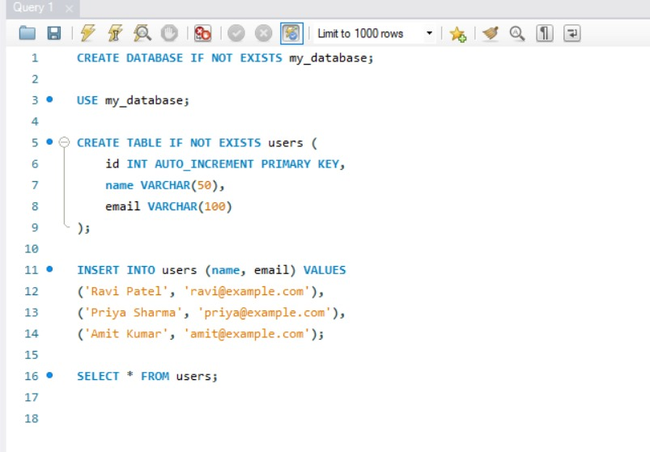

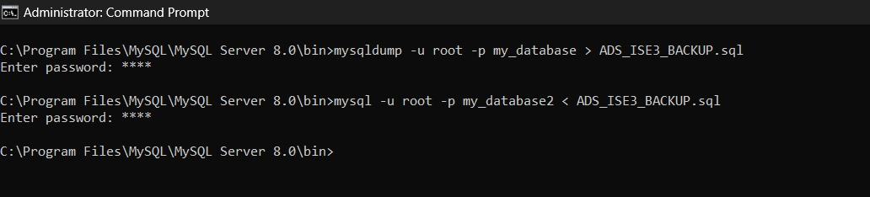

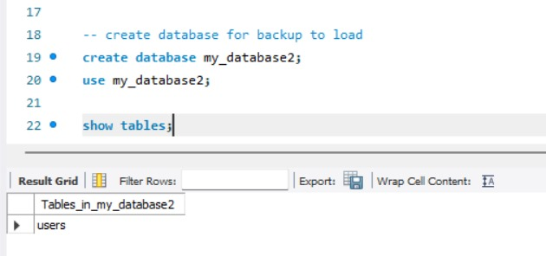

Q2) What are the API available in MySQL to take backup from any language platform like Python / C#.Net / Java.

Answer:

**Python Code:**

import subprocess

def backup_mysql_database(

    mysql_dump_path, hostname, username, password, database, output_file_path

):

    # Construct the command

    command = [

        mysql_dump_path,

        f"--host={hostname}",

        f"--user={username}",

        f"--password={password}",

        database,

    ]

    # Redirect output to file

    with open(output_file_path, "w") as output_file:

        # Start the process

        process = subprocess.Popen(command, stdout=output_file, stderr=subprocess.PIPE)

        # Wait for process to complete

        _, error_output = process.communicate()

        exit_code = process.wait()

        if exit_code != 0:

            raise RuntimeError(

                f"Failed to execute mysqldump command. Exit code: {exit_code}, Error: {error_output.decode('utf-8')}"

            )

if __name__ == "__main__":

    mysql_dump_path = "C:\\Program Files\\MySQL\\MySQL Server 8.0\\bin\\mysqldump"

    hostname = "localhost"

    username = "root"

    password = "1111"

    database = "my_database"

    output_file_path = "ADS_ISE2.sql"

    try:

        backup_mysql_database(

            mysql_dump_path, hostname, username, password, database, output_file_path

        )

        print("Backup completed successfully.")

    except Exception as e:

        print("Error:", e)

Output:

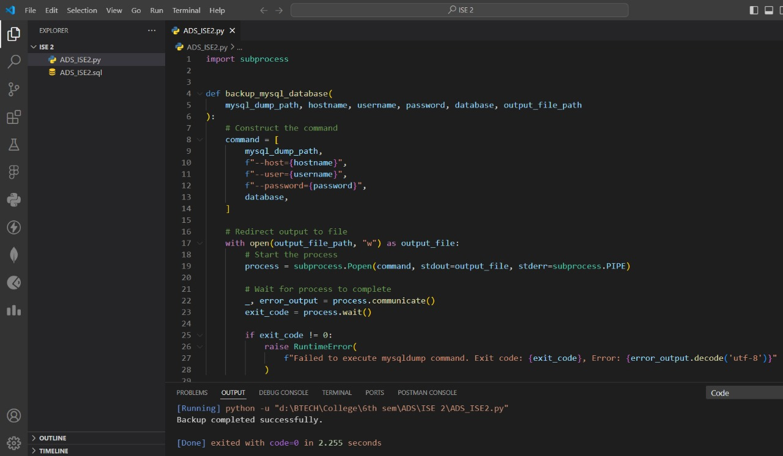

Q3) How to schedule a particular task in MySQL or in Python / C#.Net /Java ? Use case : IoT data needs to be dumb in MySQL database afterevery one hour.

**Python Code:**

import pymysql

import schedule

import time

# Define the connection parameters

main_connection_params = {

    "host": "localhost",

    "user": "root",

    "password": "1111",

    "database": "ads_ise",

}

# Execute SQL statement to insert IoT data

def dump_iot_data():

    try:

        # Connect to MySQL database

        with pymysql.connect(**main_connection_params) as connection_main:

            with connection_main.cursor() as cursor_main:

                # Fetch data from lot_data table

                sql_lot_data = "SELECT timestamp, value, location, status FROM lot_data"

                cursor_main.execute(sql_lot_data)

                lot_data = cursor_main.fetchall()

                # Insert data into iot_data_table

                for data in lot_data:

                    timestamp, value, location, status = data

                    sql_insert = "INSERT INTO iot_data_table (timestamp, value, location, status) VALUES (%s, %s, %s, %s)"

                    cursor_main.execute(

                        sql_insert, (timestamp, value, location, status)

                    )

        print("IoT data dumped into the database successfully")

    except Exception as e:

        print(f"Error: {e}")

# Define the scheduler

def schedule_task():

    # Schedule the dump_iot_data function to run every 10 seconds

    schedule.every(10).seconds.do(dump_iot_data)

    # Run the scheduler

    while True:

        schedule.run_pending()

        time.sleep(1)

# Start the scheduler

schedule_task()

