**Walchand College of Engineering, Sangli**

## **Machine Learning Lab (6CS372)**

**TY BTech | AY 2023-2024 | Even Sem**

**Assignment 1**

Name : Viraj Patil

Batch : T5

PRN : 21510097

Download dataset from <https://raw.githubusercontent.com/rashida048/Datasets/master/home_data.csv>



Read home_dataset.csv file in pandas data frame and perform following operations:

1. Display shape of the data frame

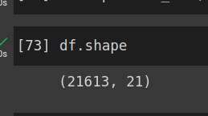

1. Display column names

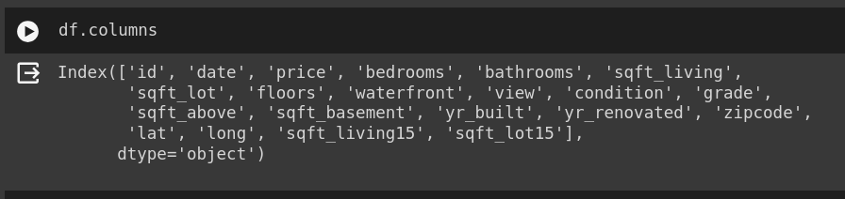

1. Display 5 quantiles of the dataset

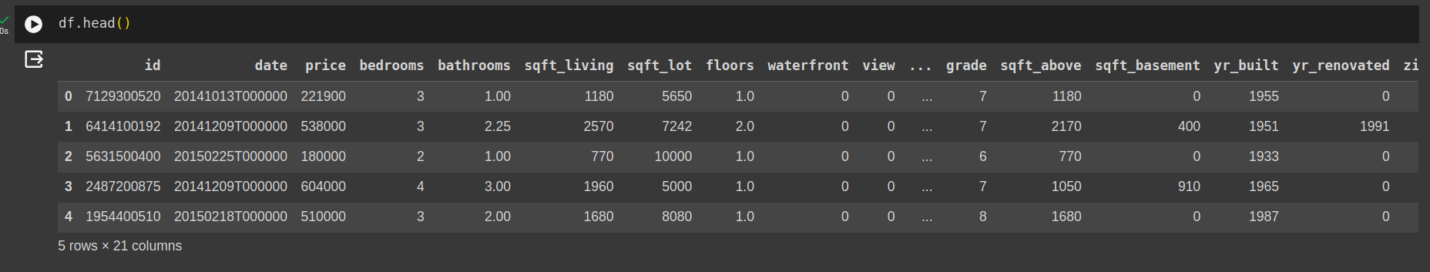

1. Display count of rows having null in any column

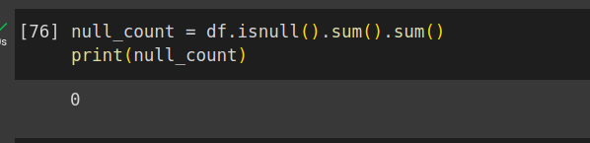

1. Display first 10 rows

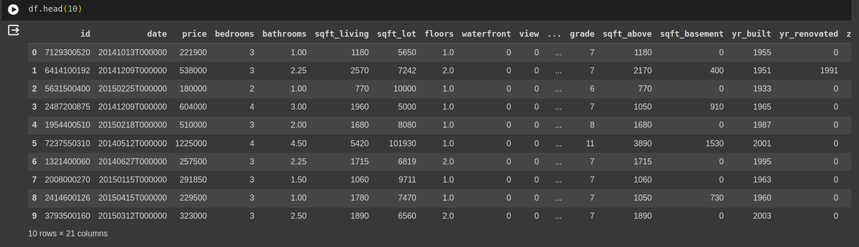

1. Display last 10 rows

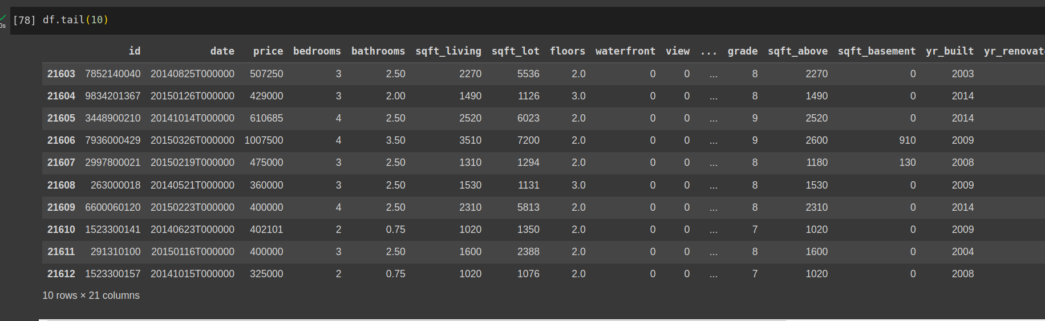

1. Display rows having number of floors more than or equal to 1.5

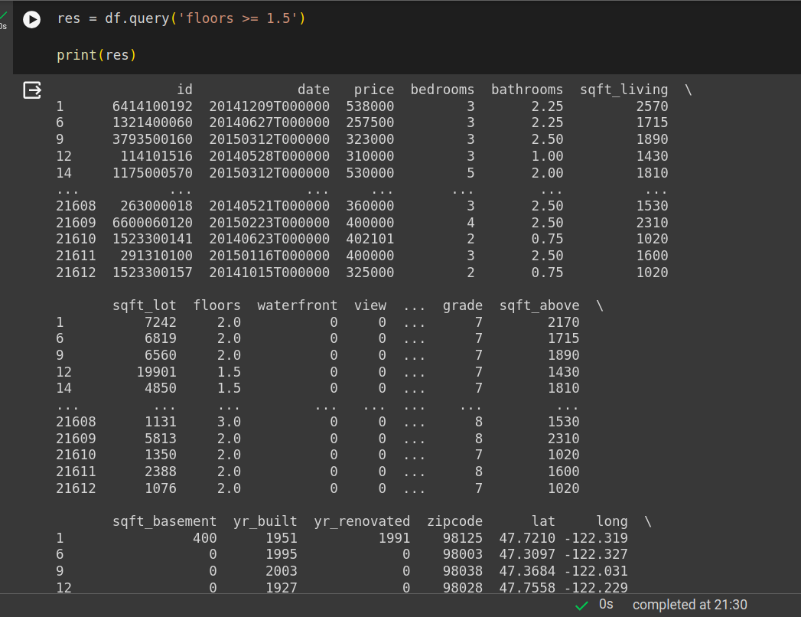

1. Display houses older than 1968 and their count

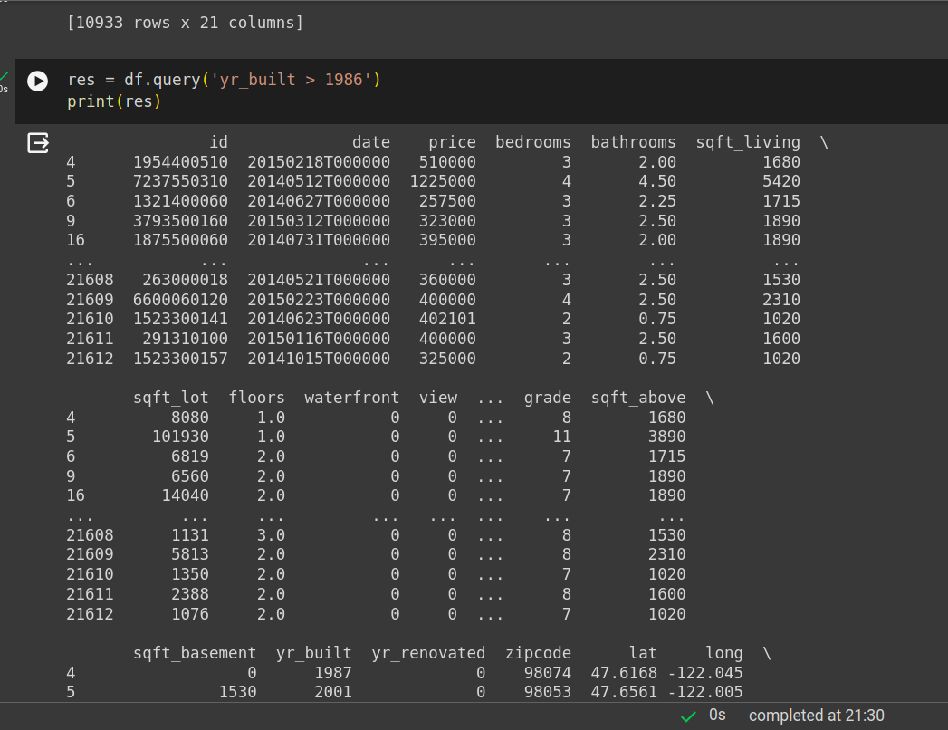

1. Display houses having price more than 50000/- and their count

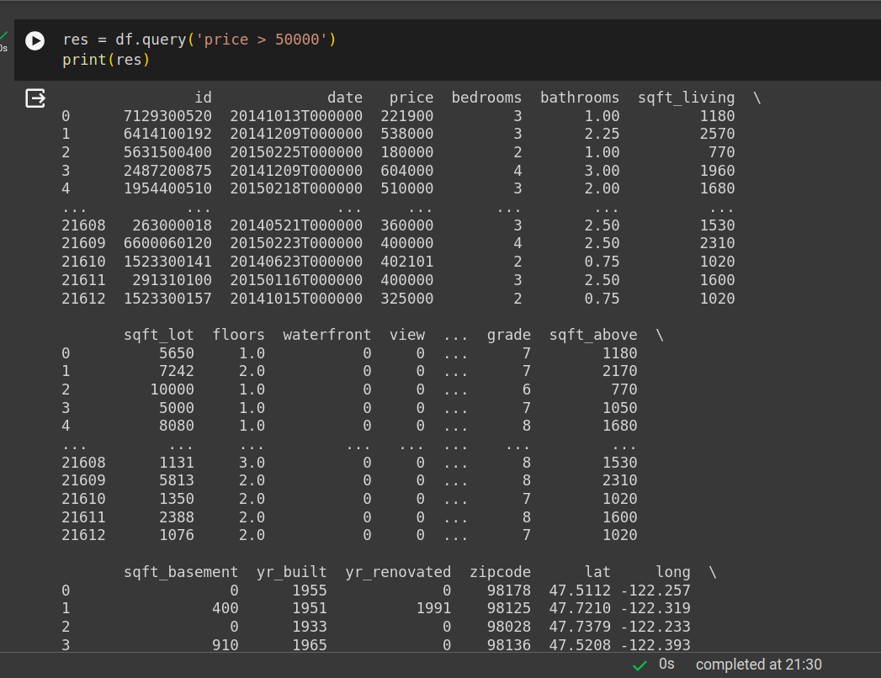

1. Display houses having number of bedrooms less than or equal to 2 and price above 51000/- along with their count

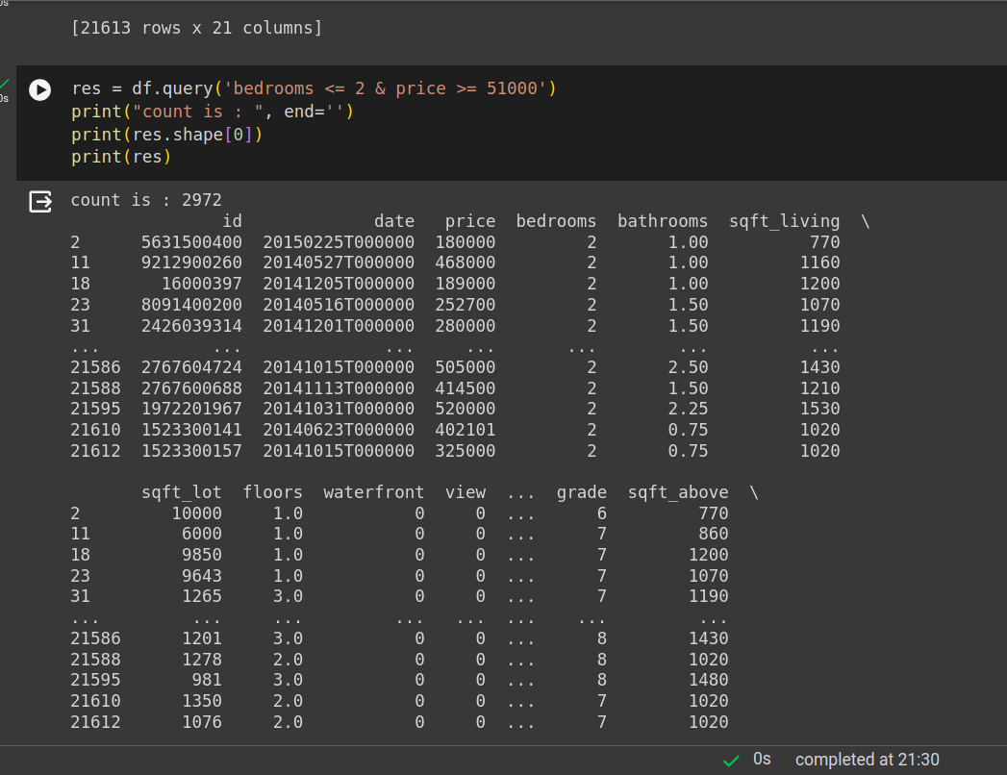

1. Display houses having number of bedrooms more than 2 and square foot

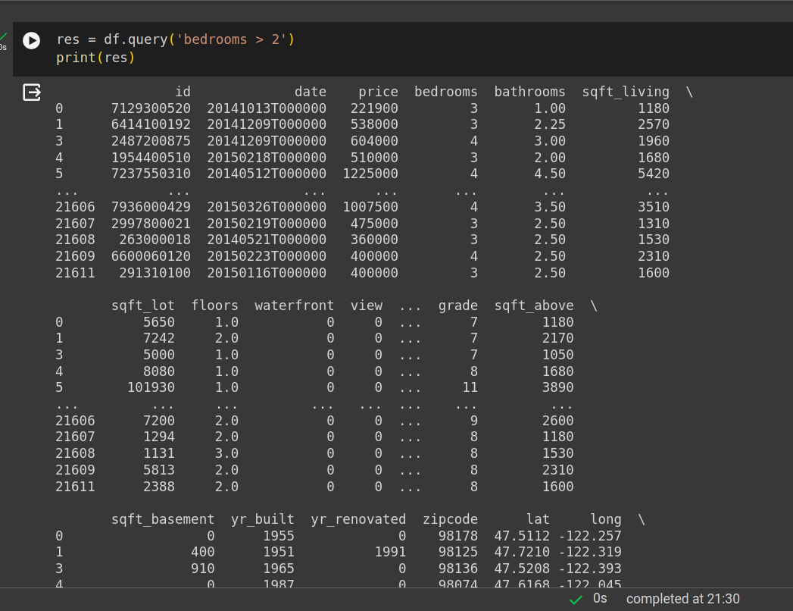

1. Replace/eliminate missing values

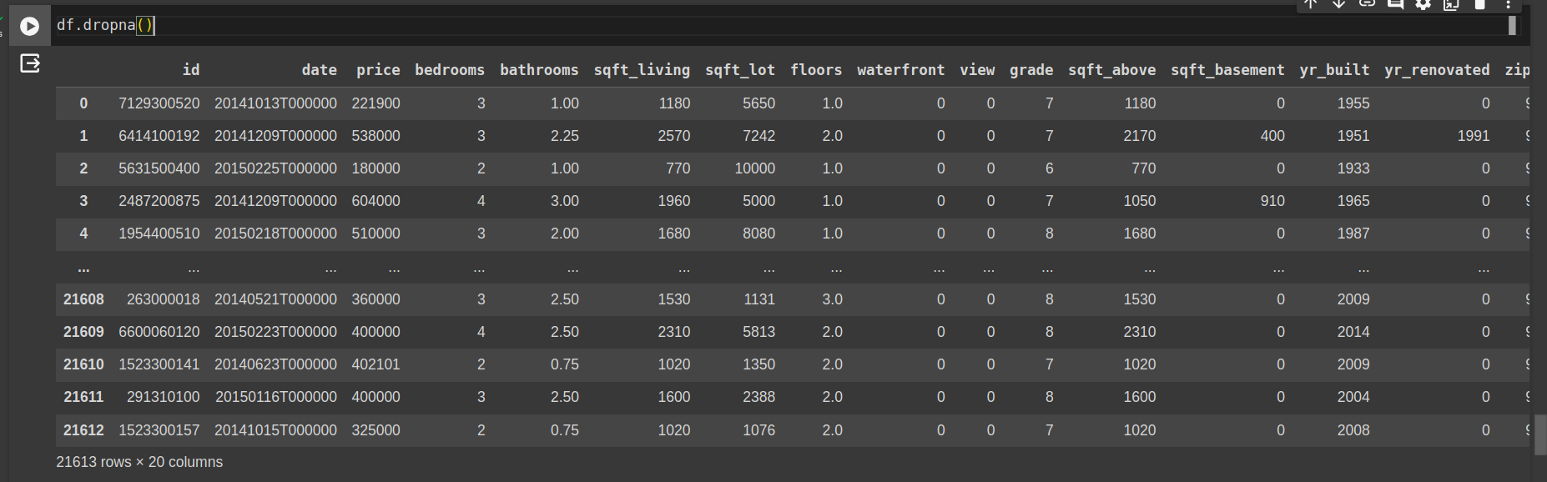

1. Change column name(s) to short/easy names if required.

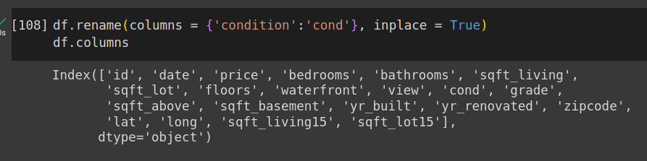

1. Drop unessential columns (feature selection).

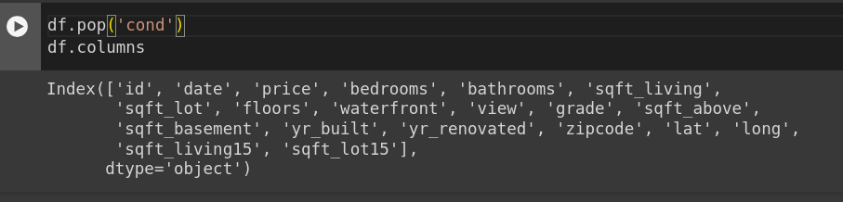

1. Find mean/min/max of numeric columns.

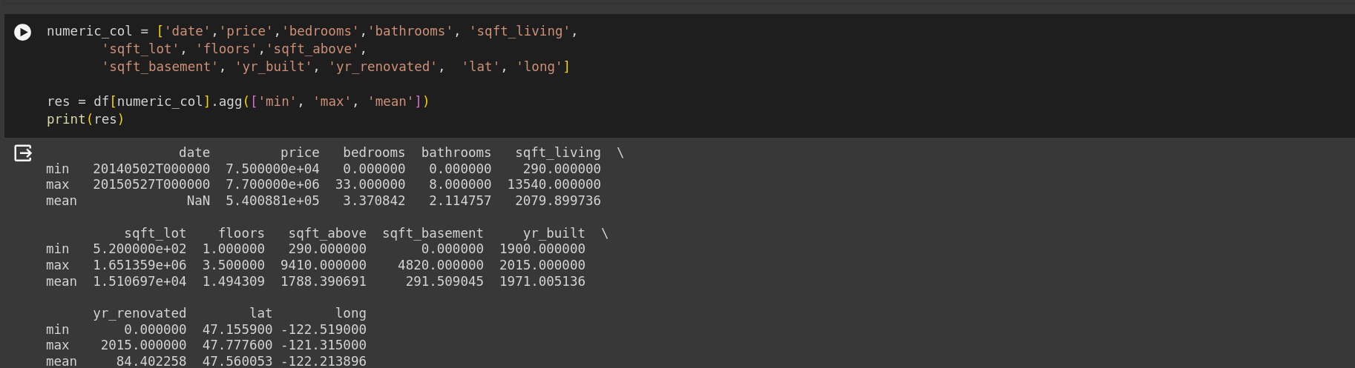

1. Find mode of all columns.

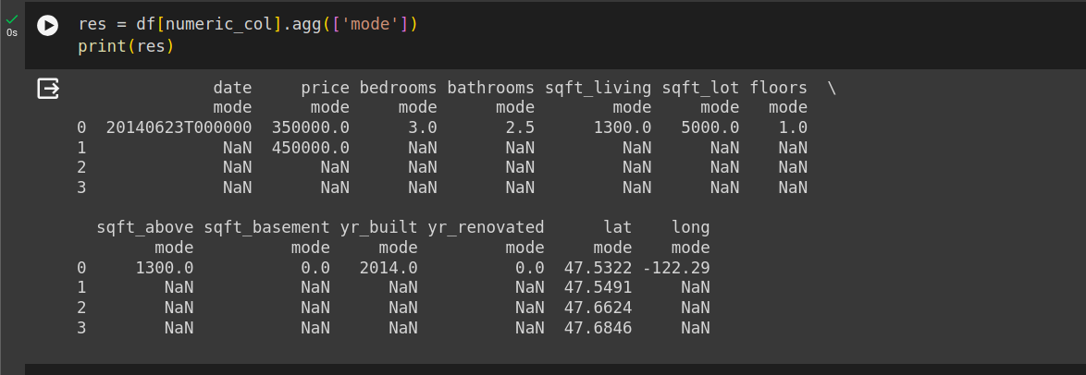

1. Display unique values in each column

