**Walchand College of Engineering, Sangli**

## **Machine Learning Lab (6CS372)**

**TY BTech | AY 2023-2024 | Even Sem**

**Assignment 3**

**PRN : 21510097**

**Name : Viraj Patil**

**Batch : T5**

1. **Simulation based assignment on python built-in functions**

Visit link <https://python-iitk.vlabs.ac.in/exp/built-in-functions/>

Click on tabs on left hand side from Aim to References and read / complete the activity.

1. **Linear regression**

**Part 1: Linear regression *without* scikit-learn (Refer linReg demo)**

* 1. Load diabetes dataset from sklearn.

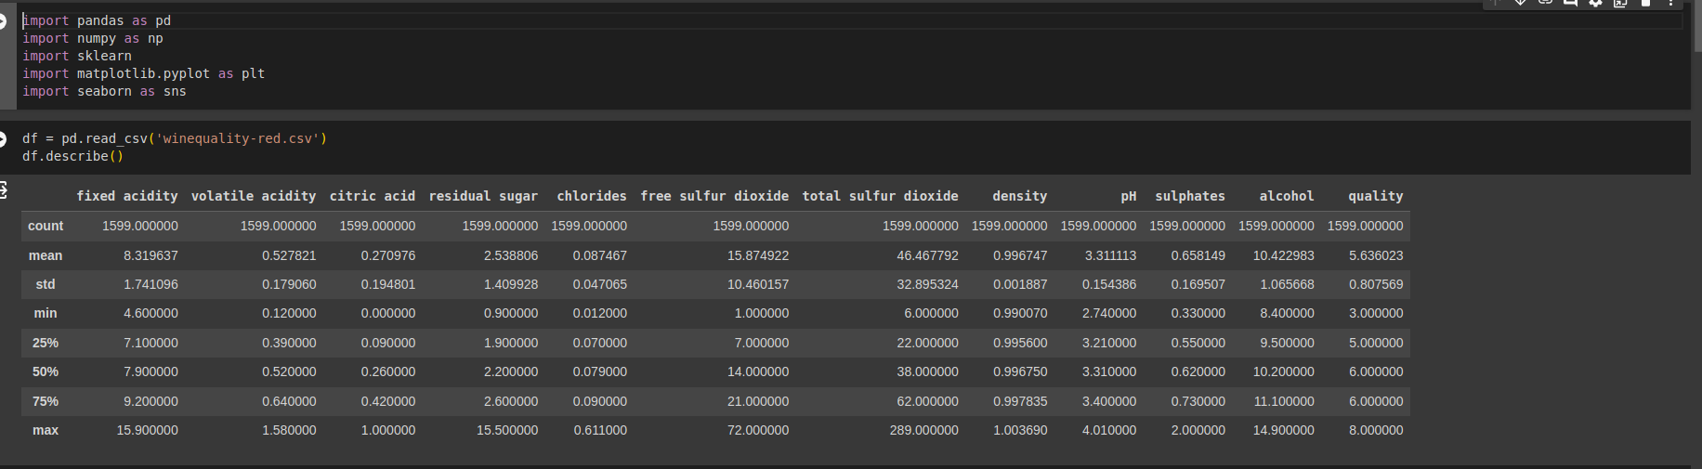

* 1. Preprocessing: Null value handling, standardization

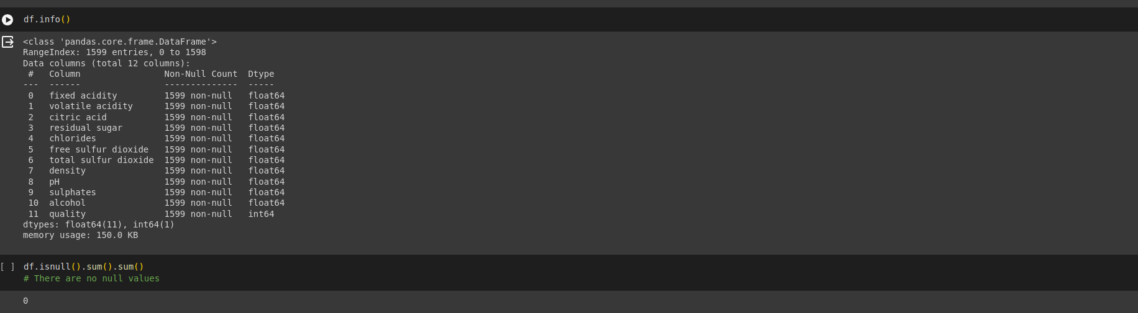

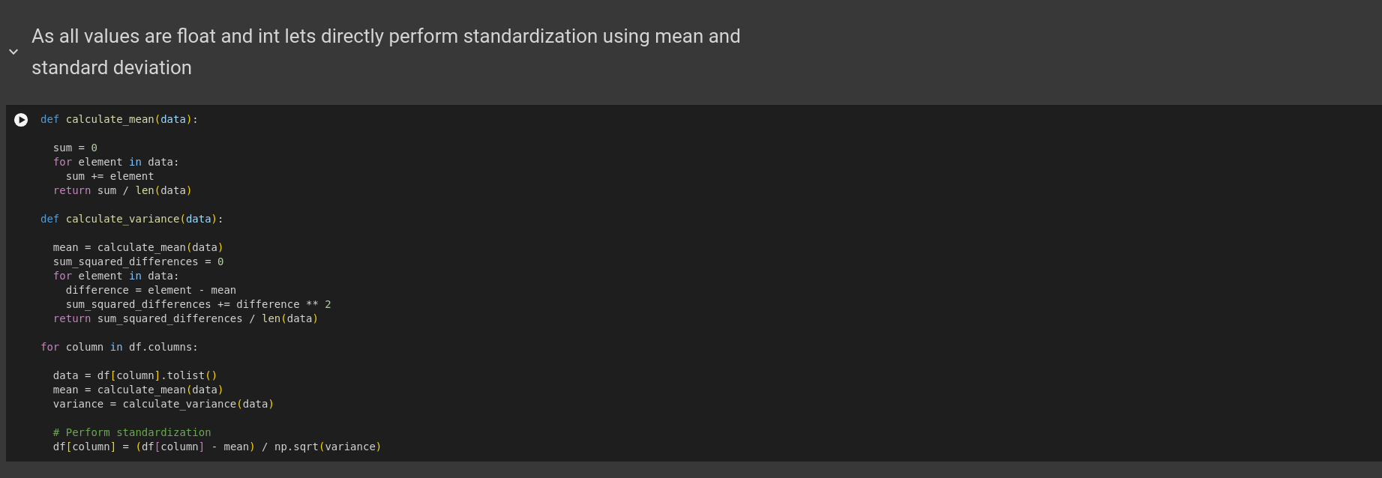

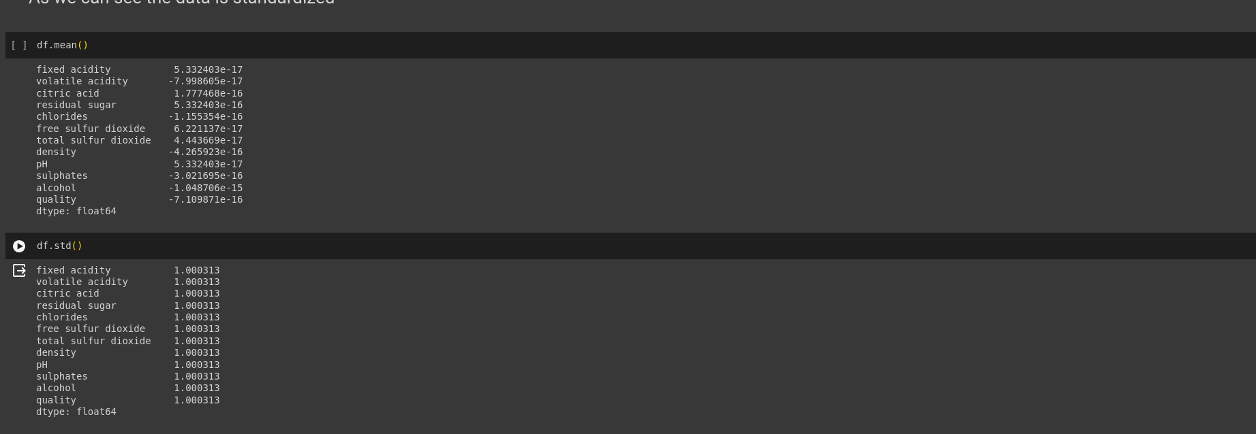

* 1. Data splitting: Split data as 70% train and 30% test.

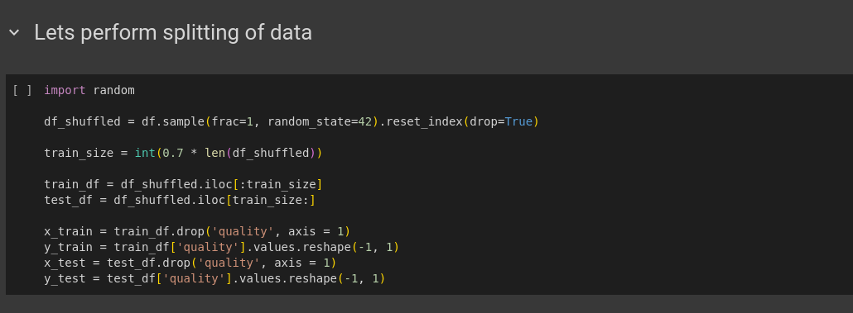

* 1. Select a single input feature. Plot input feature against target variable.

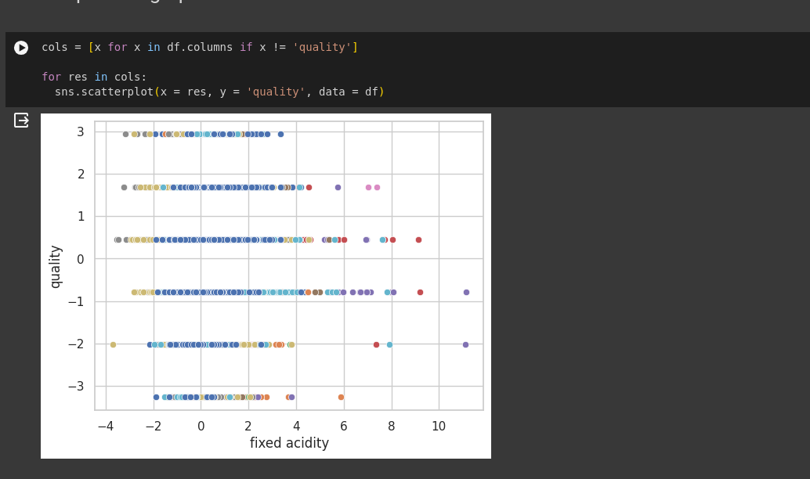

* 1. Write functions for computing cost, gradients and gradient descent algorithm. (Save cost values of each iteration).

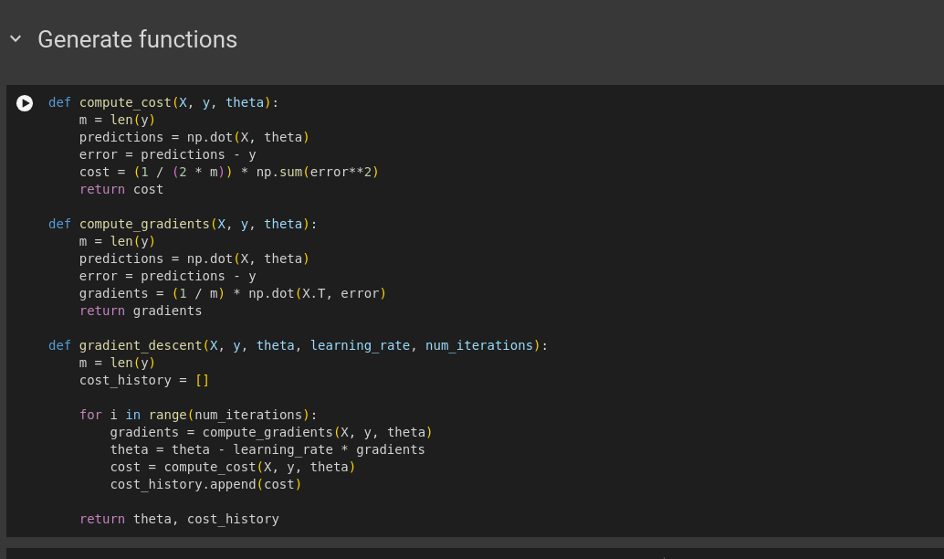

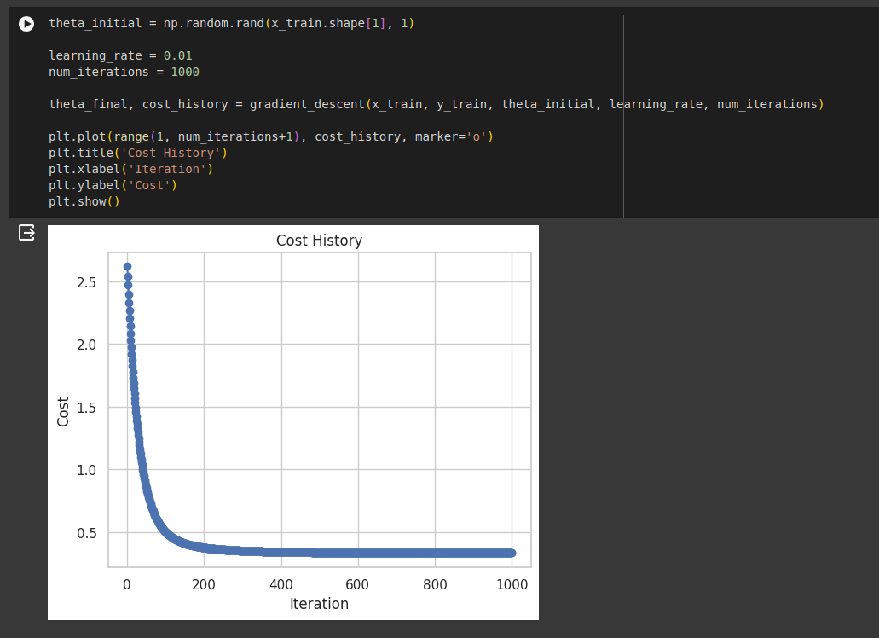

* 1. Plot regression line on scatter plot of feature vs target.

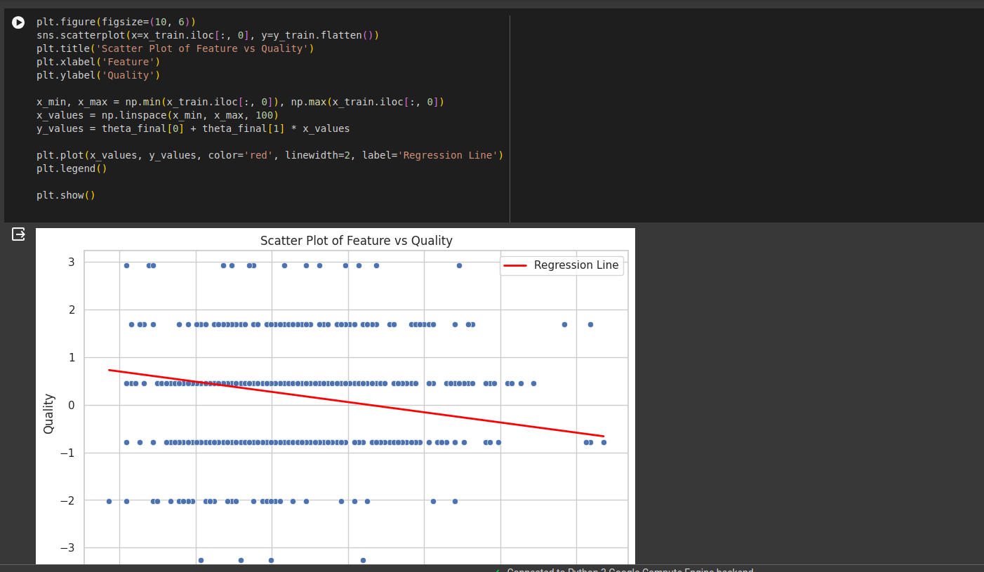

* 1. Plot cost vs #iterations.

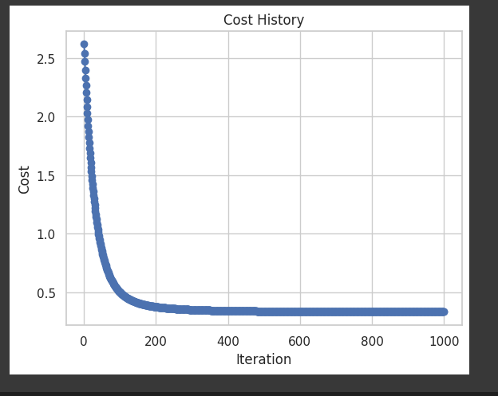

* 1. Report parameter values, training error, test error and model accuracy.

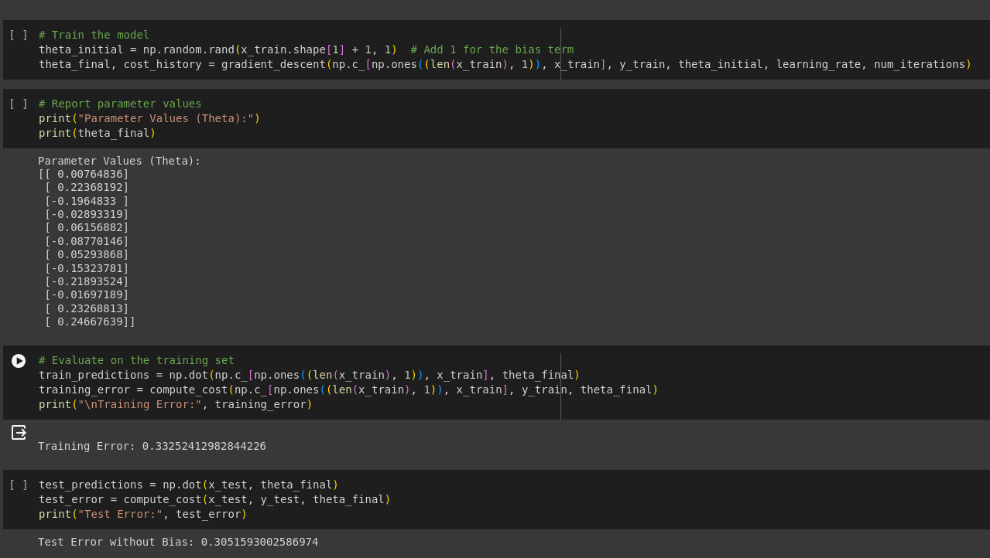

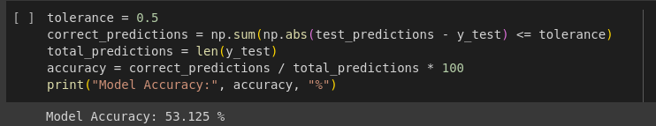

**Part 2: Linear regression *with* scikit-learn**

1. Download dataset as per your batch

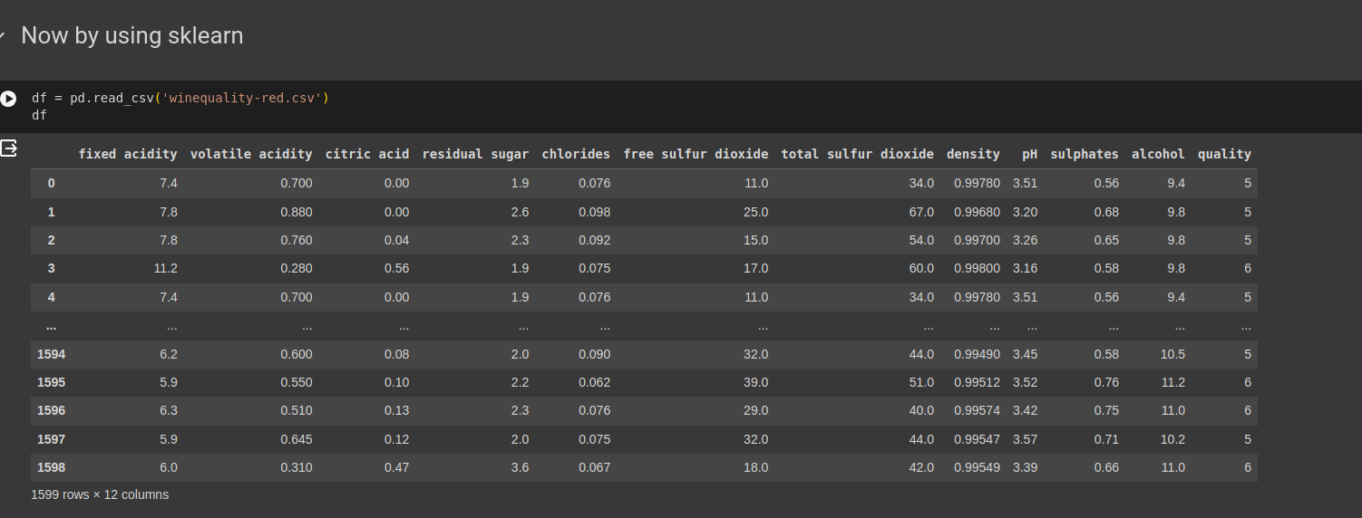

.

1. Preprocessing: Null value handling, standardization, replace categorical values with numeric values (e.g. 0, 1, 2 etc.)

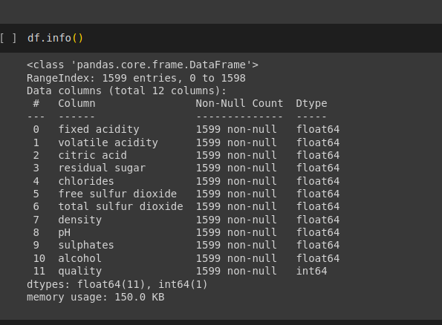

1. Data splitting: Split data as 70% train and 30% test using train_test_split function.
2. Feature selection: Dimensionality reduction / select manually
3. Fit model using fit function.
4. Report parameter values, training error and test error and model accuracy.

