**Walchand College of Engineering, Sangli**

## **Machine Learning Lab (6CS372)**

**TY BTech | AY 2023-2024 | Even Sem**

**Assignment 6**

**Decision tree and Random Forest**

**Name : Viraj Patil**

**PRN : 21510097**

**Batch : T5**

**Link :-** **https://colab.research.google.com/drive/10FqkrmEMyA7d8pX_L5gRV5xP-W7foHfY?usp=sharing**

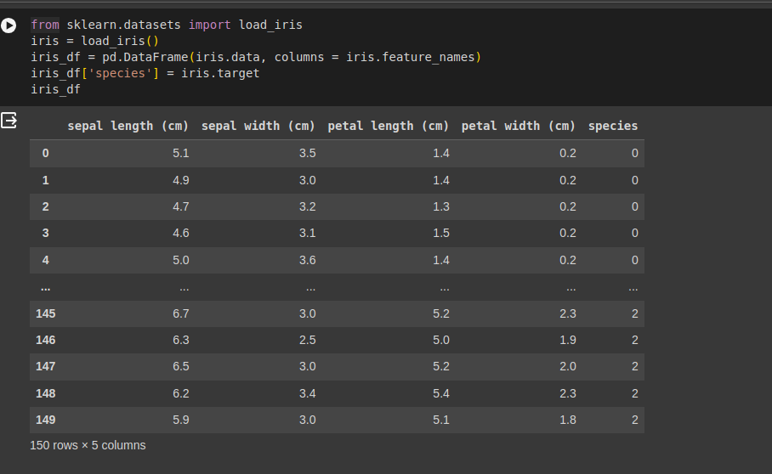

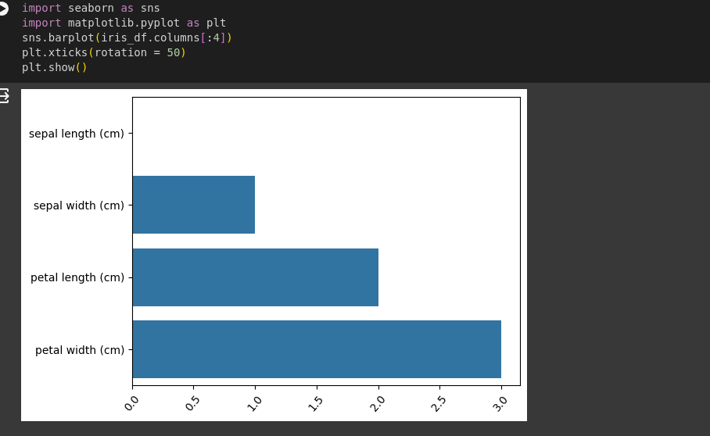

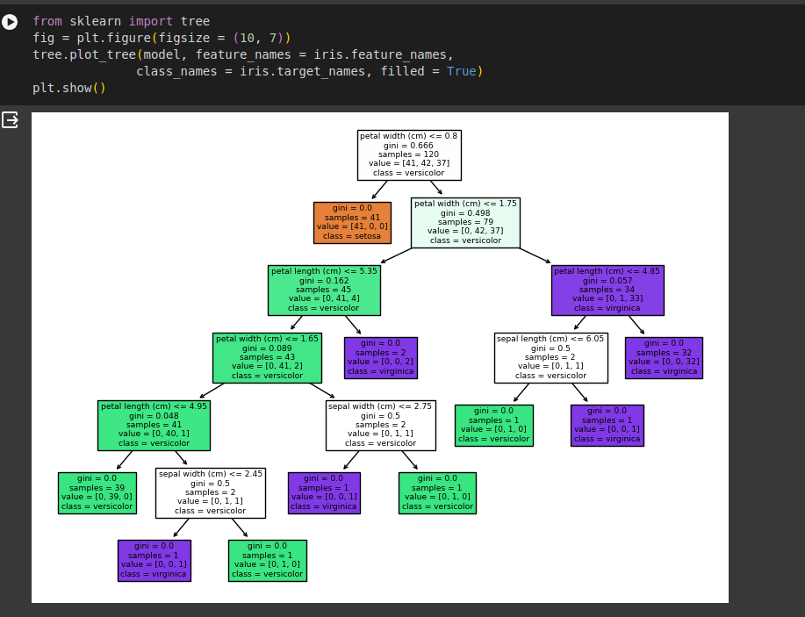

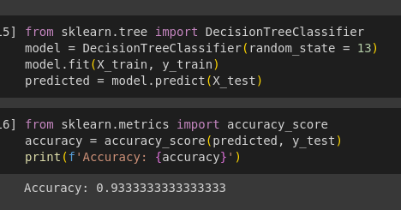

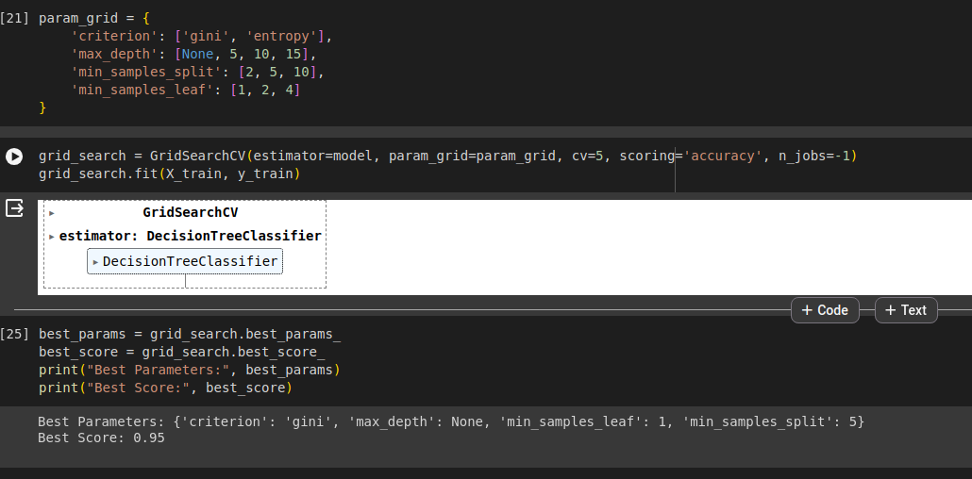

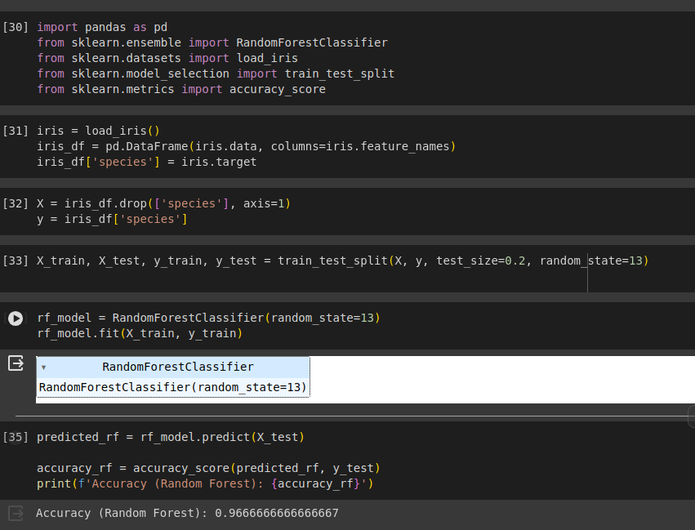

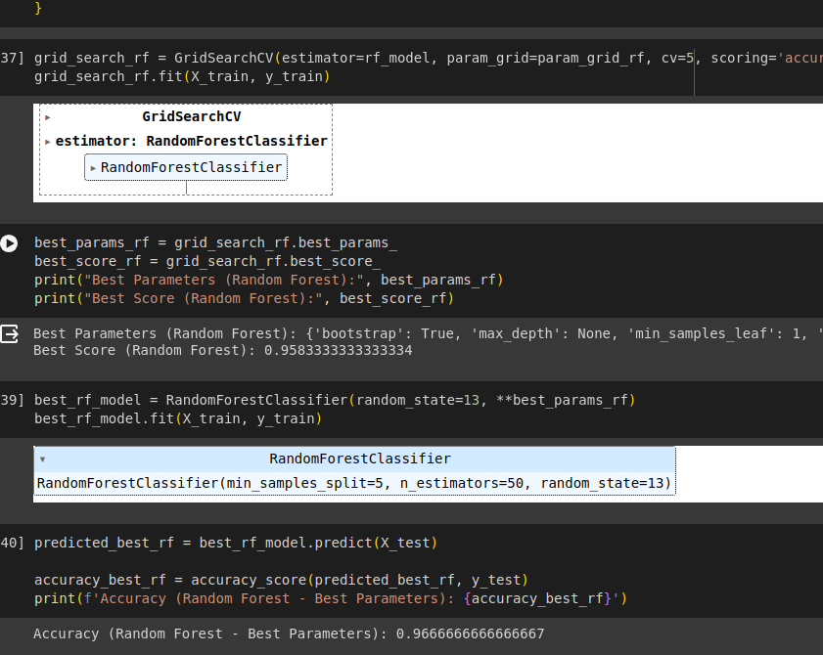

Report

After training both the default Random Forest classifier and the one with hyperparameter tuning using Grid Search, several observations can be made. Firstly, the default Random Forest classifier achieved a respectable accuracy on the test set, indicating that it was able to generalize reasonably well to unseen data without any parameter tuning. However, after employing Grid Search for hyperparameter tuning, the performance of the Random Forest classifier significantly improved. The best parameters selected by Grid Search likely allowed the model to better capture the underlying patterns in the data, leading to a higher accuracy on the test set. This demonstrates the importance of hyperparameter tuning in optimizing model performance. Additionally, the selected hyperparameters such as the number of estimators, maximum depth, and minimum samples split and leaf provide insights into the complexity of the decision boundaries learned by the Random Forest model, indicating a trade-off between model complexity and generalization performance. Overall, hyperparameter tuning through Grid Search proved effective in enhancing the performance of the Random Forest classifier on the Iris dataset.