Soft Computing

Name : Viraj Patil

PRN : 21510097

Batch : T5

1. [Introduction to Neural Networks and Perceptron Example](https://scte-iitkgp.vlabs.ac.in/exp/neural-networks-perceptron/)

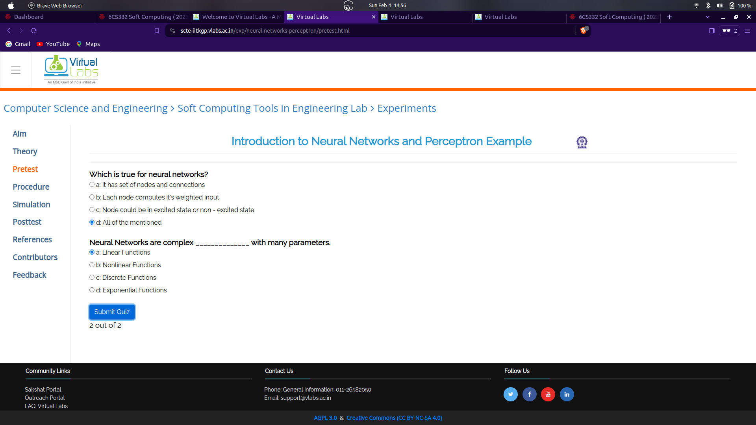

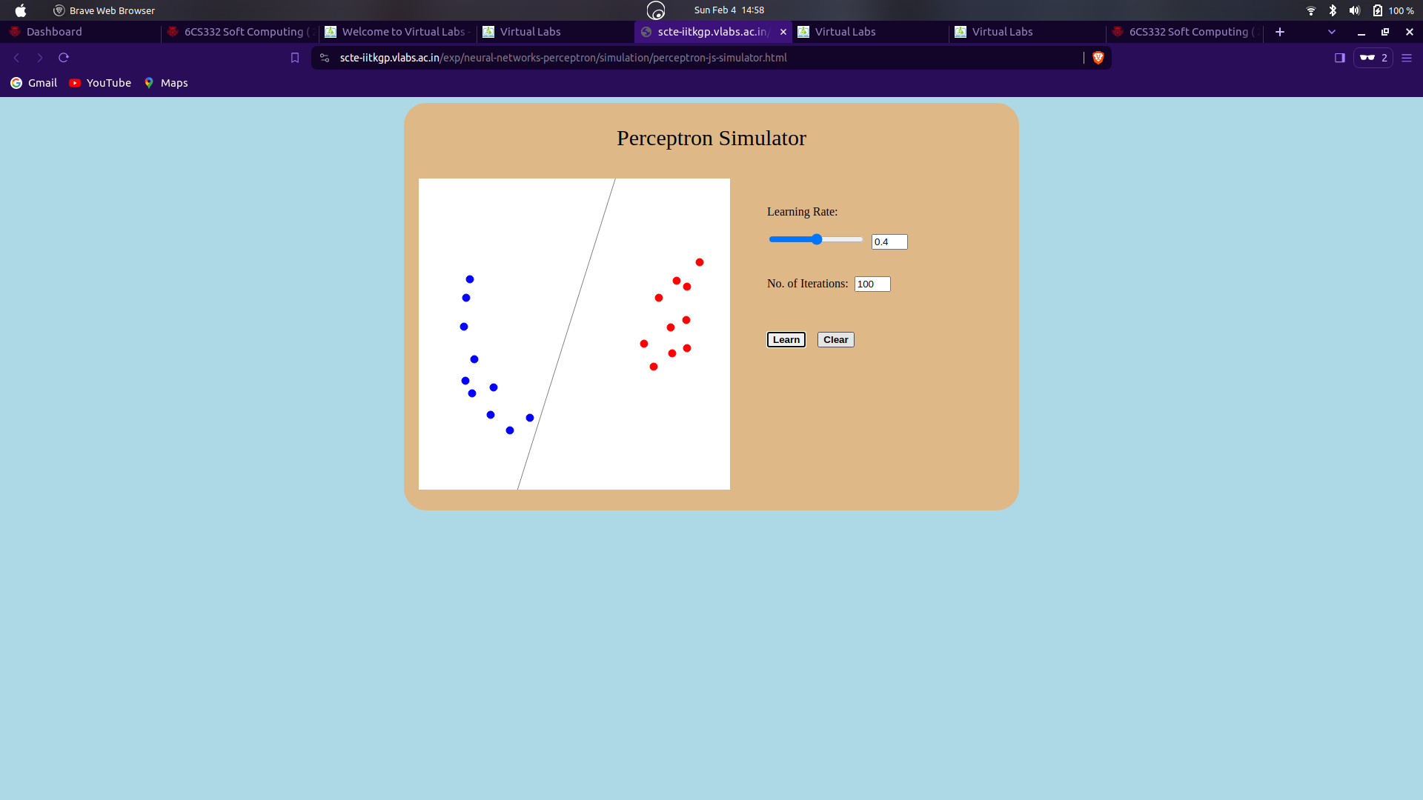

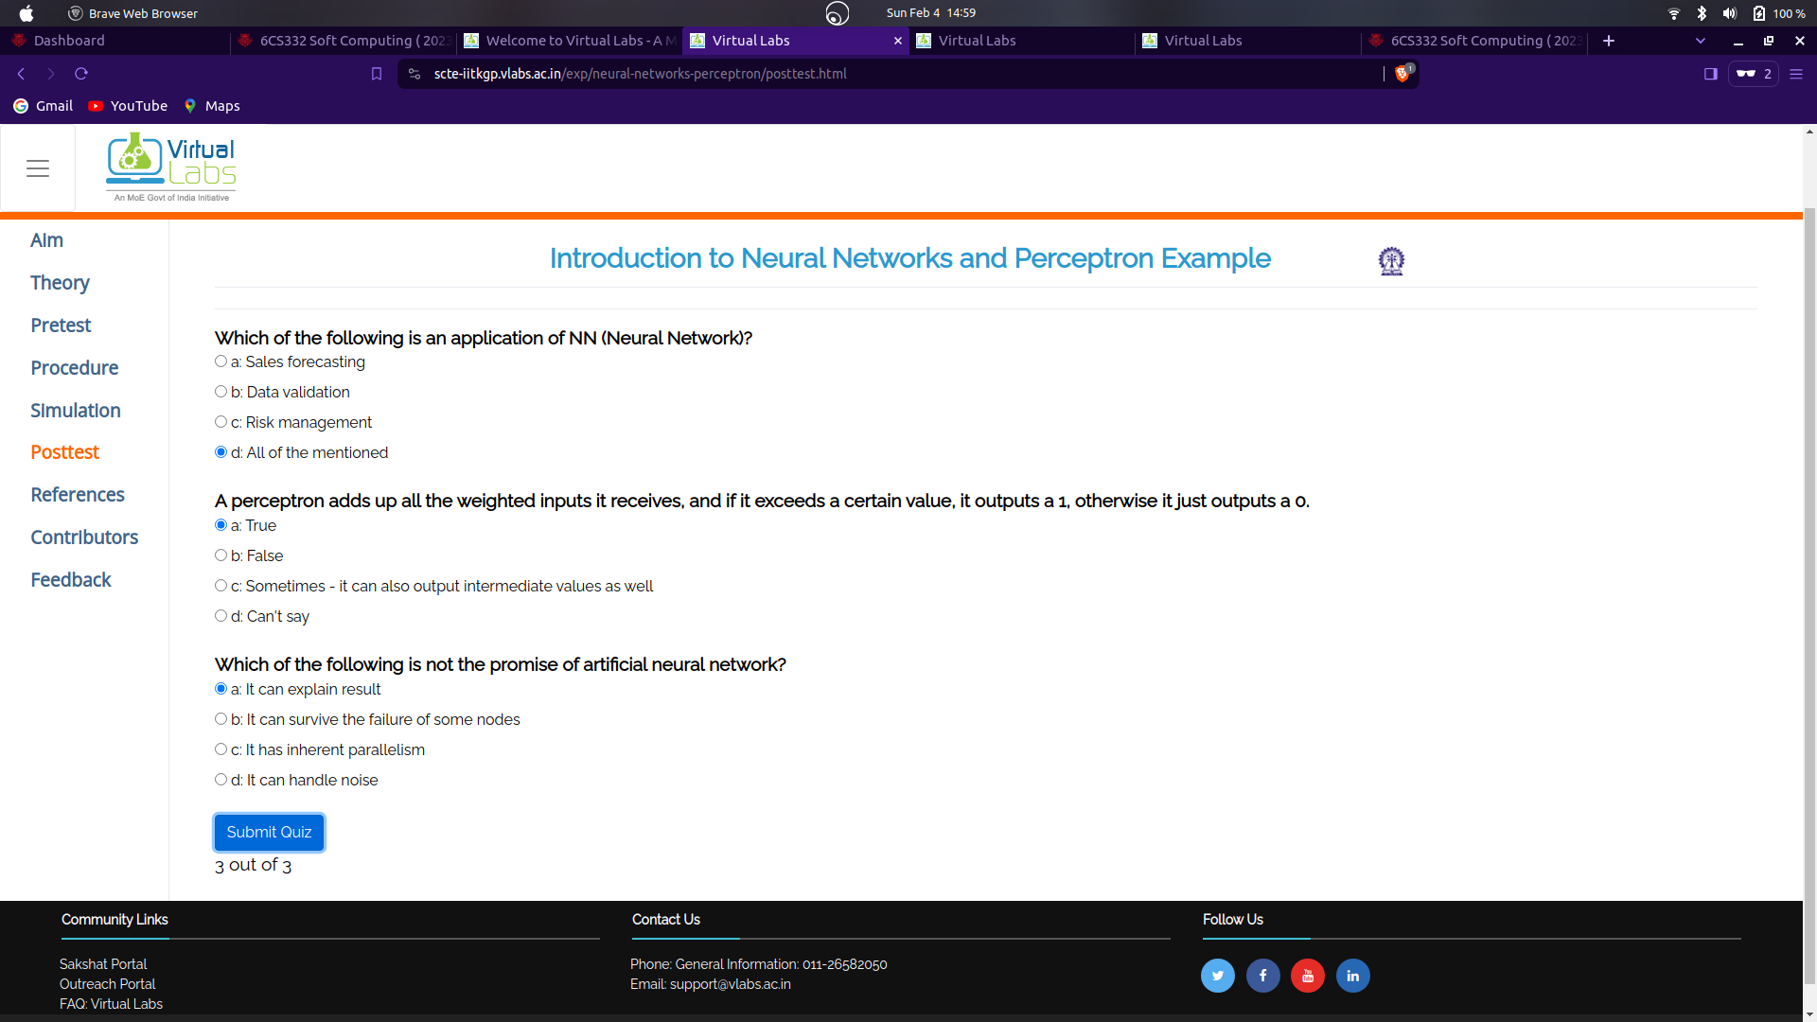

2. M[ultilayer Perceptron and Application](https://scte-iitkgp.vlabs.ac.in/exp/multilayer-perceptron/)

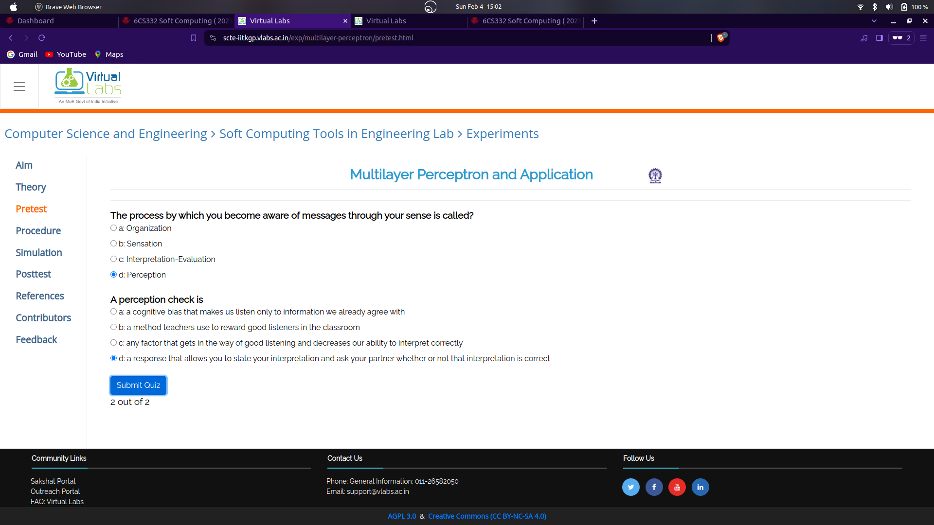

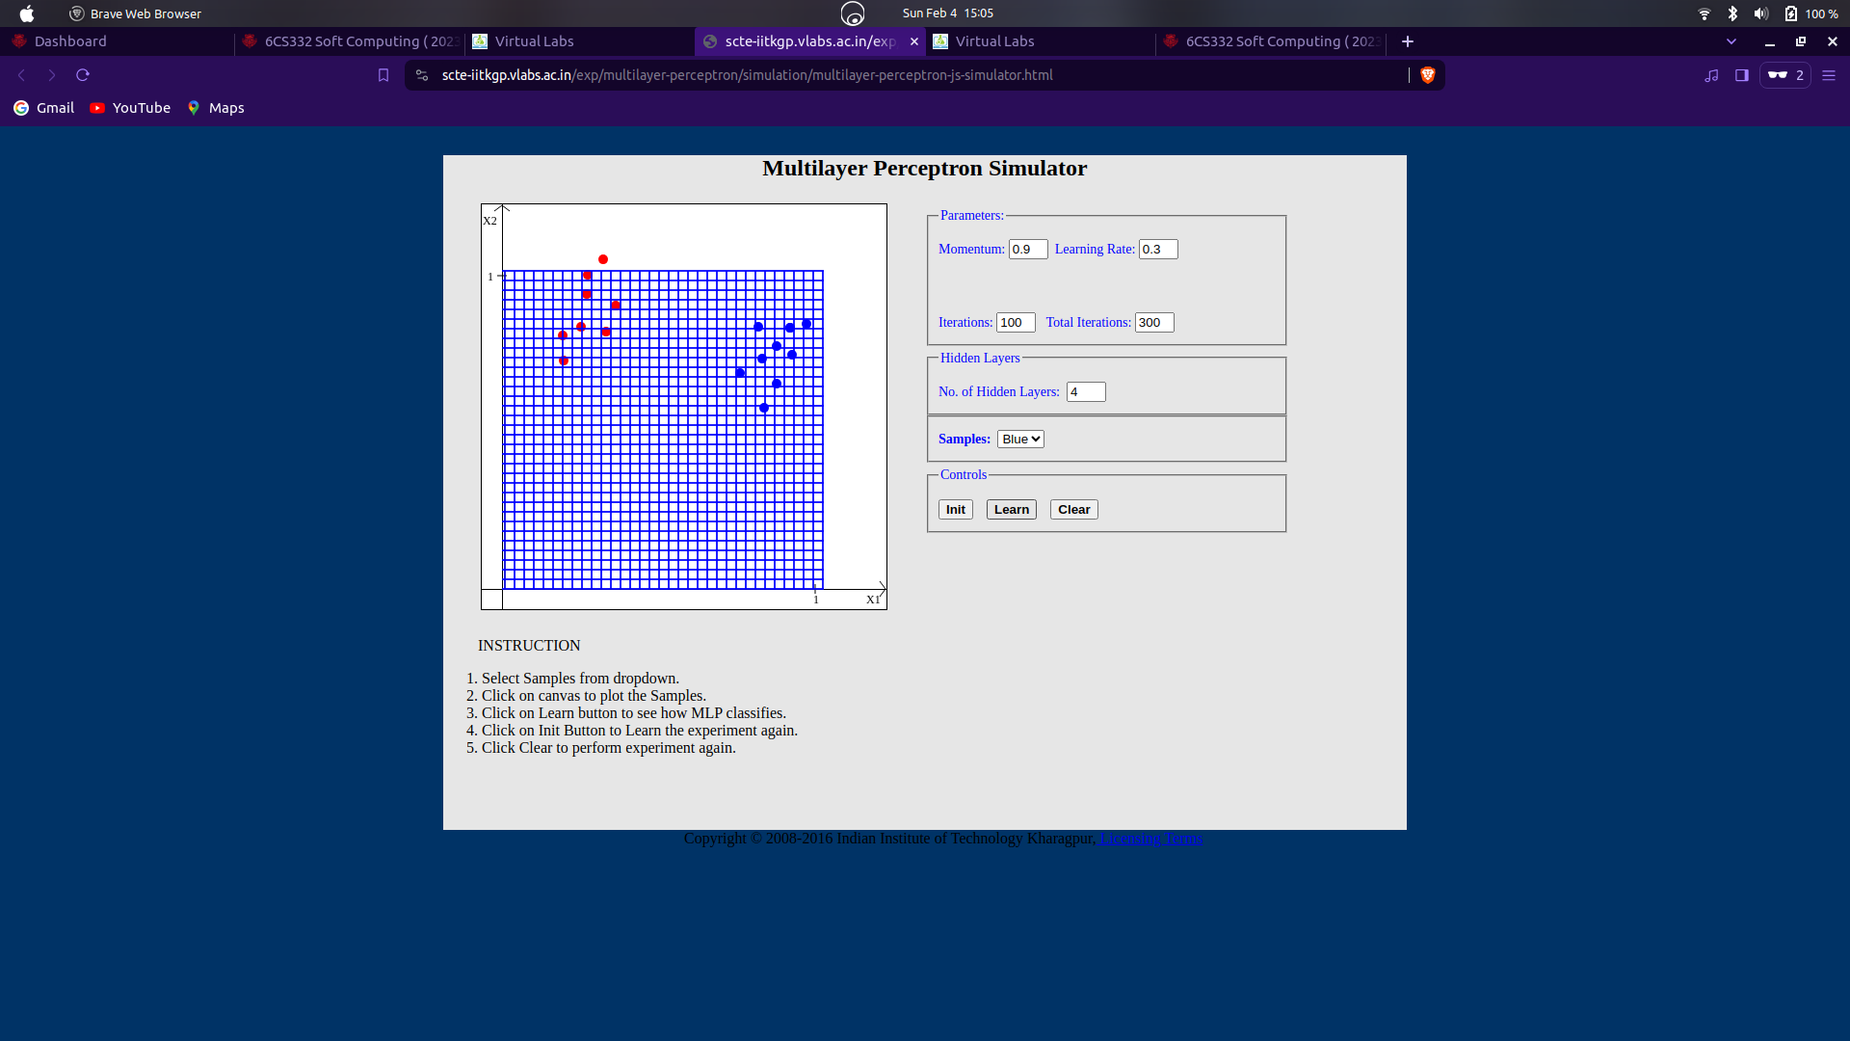

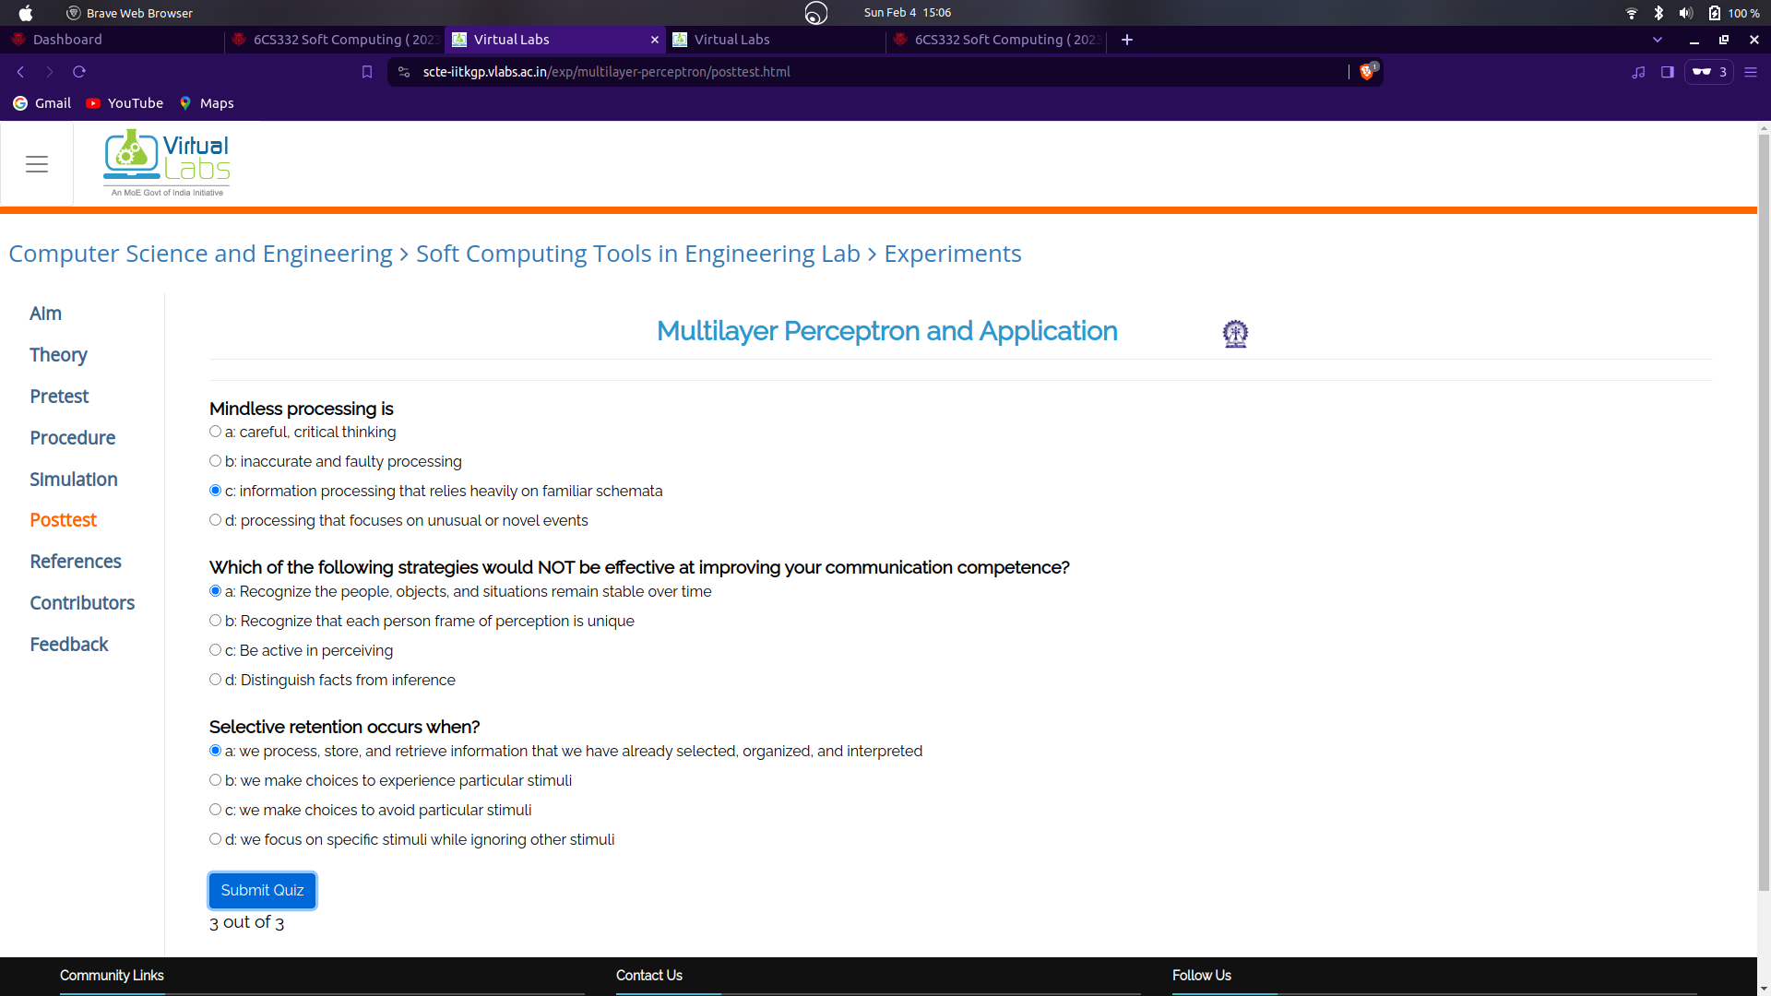

3. [Probabilistic Neural Networks and Application](https://scte-iitkgp.vlabs.ac.in/exp/probabilistic-neural-networks/)

