Assignment No. 2

PRN: 21510097

Name: Viraj Patil

Batch: T5

1. **Multilayer Feedforward Neural Networks**

Aim:The objective of this experiment is to demonstrate the ability of a multilayer feedforward neural network (MLFFNN) in solving linearly inseparable pattern classification problems.





1. **Hopfield Model for Pattern Storage Task**

Aim: The objective in a pattern storage task is to store a given set of patterns, so that any of them can be recalled exactly, even when an approximate version of the corresponding pattern is presented to the network.

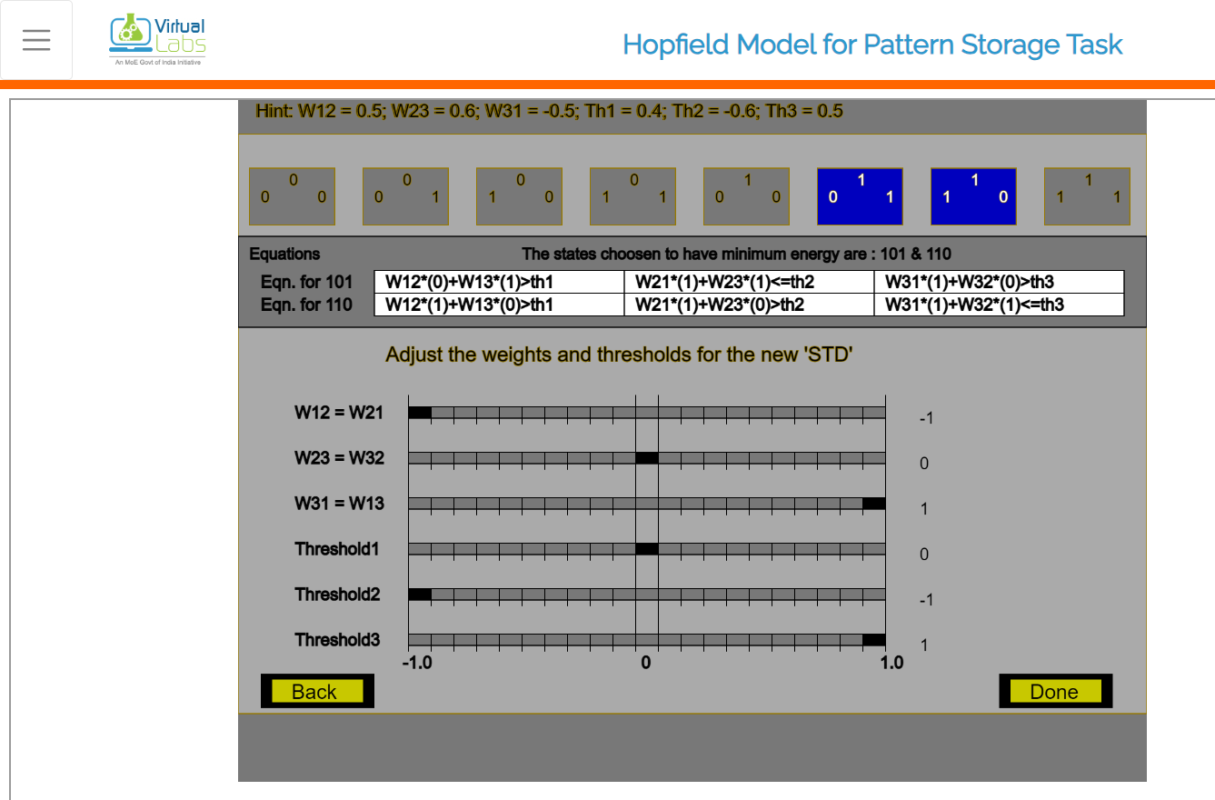

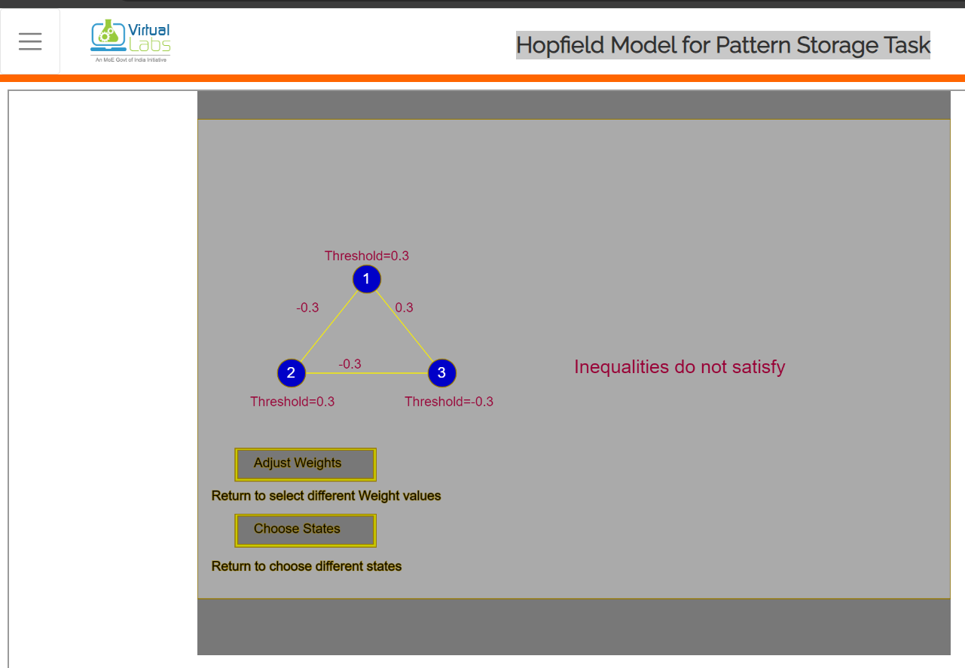

1. **Hopfield model with stochastic update**

Aim: The objective of this experiment is to illustrate the problem of false minima in the energy landscape and the concept of probabilistic update in Hopfield model to overcome the effect of false minima.

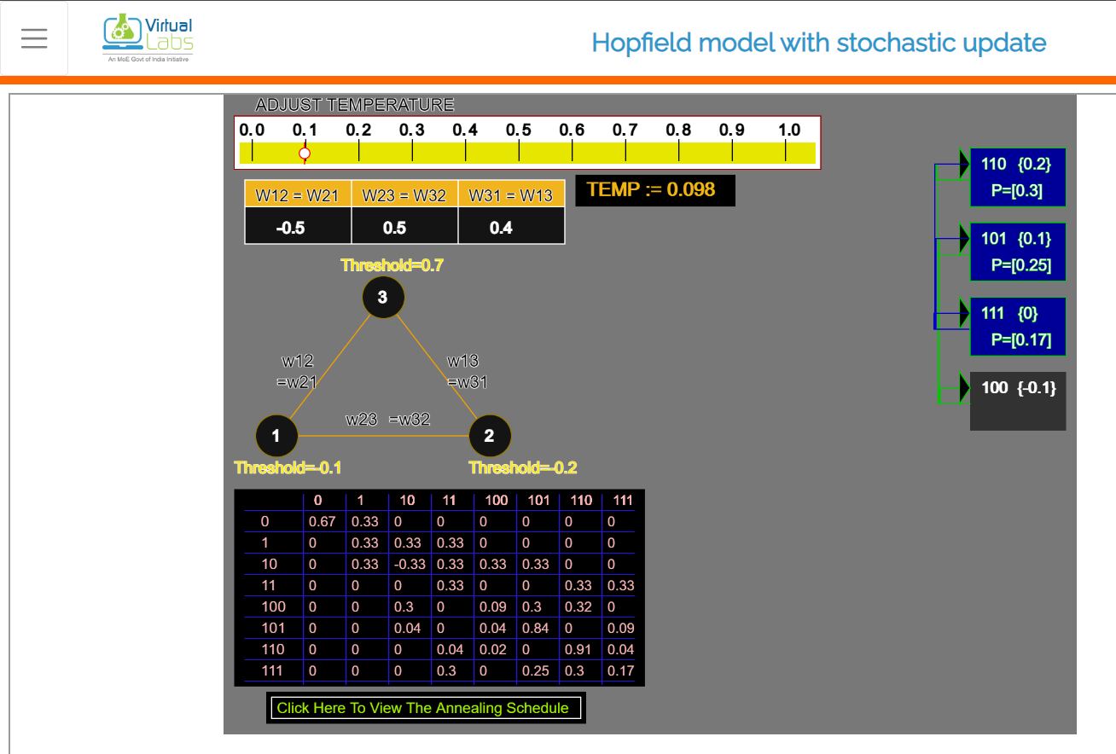



1. **Solution to Travelling Salesman Problem Using Self Organizing Maps**

Aim: The objective of this experiment is to provide a suboptimal solution to the Travelling Salesman Problem (TSP), using the properties of self-organization feature maps (SOM). The focus is:

1. To illustrate the principle of self-organization for addressing the travelling salesman problem
2. To observe the suboptimal nature of the solution provided by SOM
3. To study the effect of structure of SOM on the solution

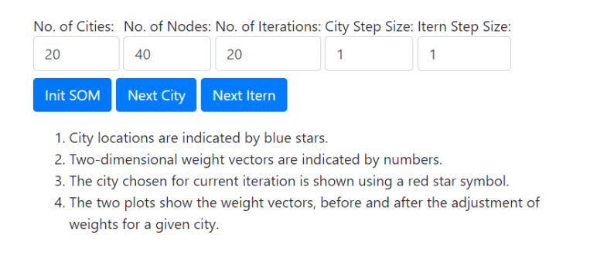

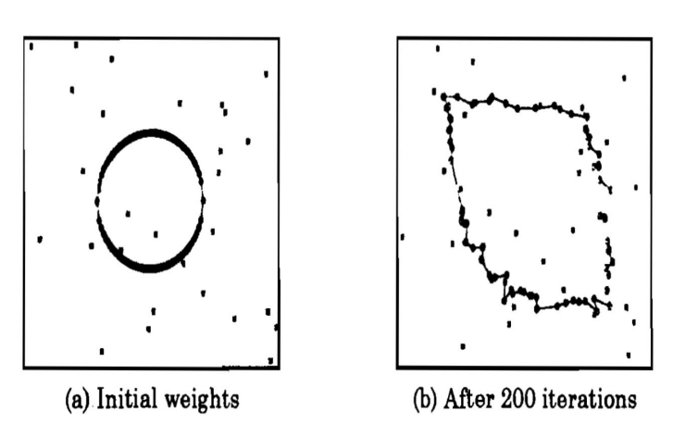

1. **Hopfield Models for Solution to Optimization Problems**

Aim: The objective of this experiment is to demonstrate the use of Hopfield models for solving optimization problems. The main issue in solving optimization problems using neural networks is mapping of the problem to a neural network architecture. This experiment demonstrates how an optimization problem such as the graph bipartition problem, can be mapped on to an Hopfield model (feedback neural network).



