**Class:** Final Year (Computer Science and Engineering)

**Year:** 2024-25 **Semester:** 1

**Course:** High Performance Computing Lab

**Practical No. 6**

**Exam Seat No:**

**Title of practical: Implementation of OpenMP programs.**

Implement following Programs using OpenMP with C:

1. Implementation of Matrix-Matrix Multiplication.
2. Implementation of Matrix-vector Multiplication.

**Problem Statement 1:**

**Screenshots:**

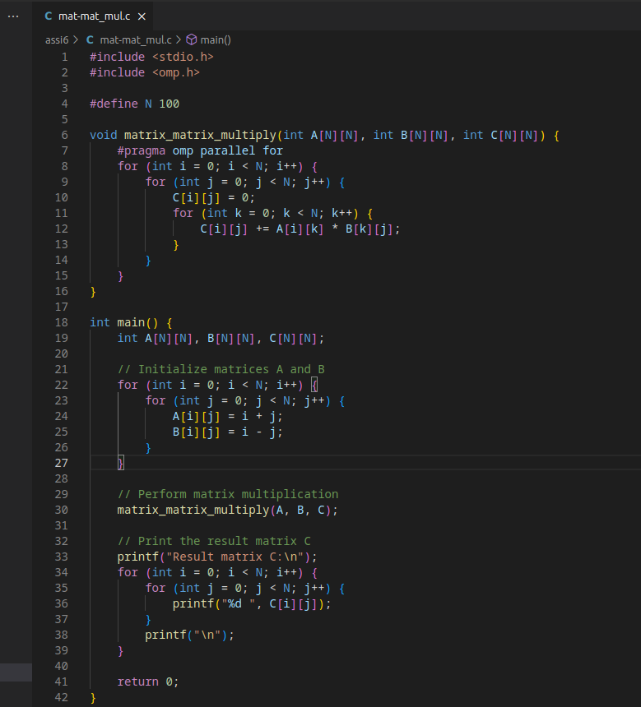

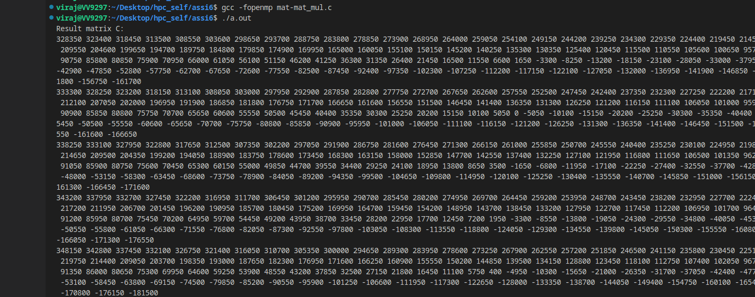

**Information and Analysis:**

**This C program performs matrix multiplication using OpenMP for parallel processing. The matrix_matrix_multiply function multiplies two N x N matrices, A and B, storing the result in matrix C. The #pragma omp parallel for directive parallelizes the outermost loop, distributing the computation of each row of C across multiple threads. The main function initializes matrices A and B, calls the multiplication function, and prints the resulting matrix C. This approach leverages parallelism to potentially speed up the matrix multiplication process on multi-core systems.**

**Problem Statement 2:**

**Screenshots:**

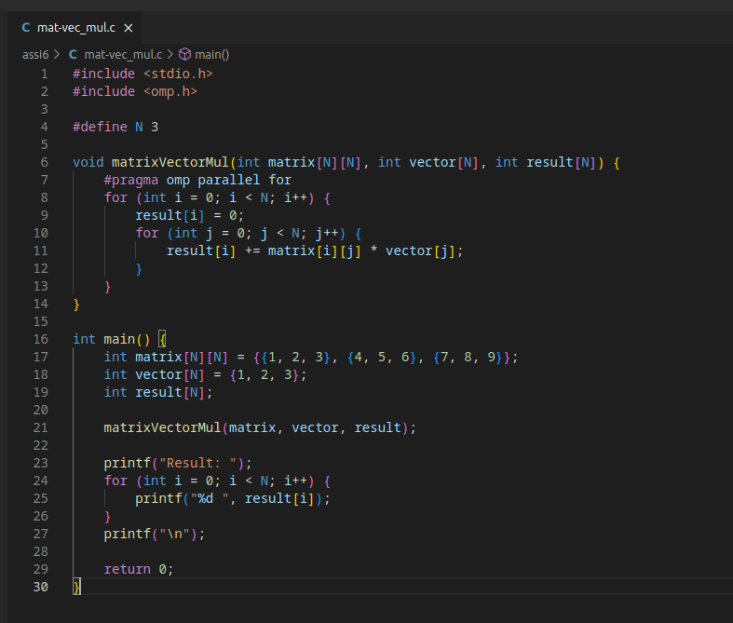

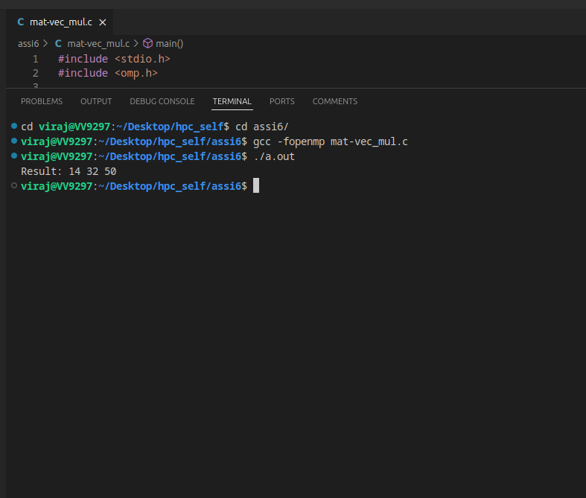

This C program performs matrix-vector multiplication using OpenMP for parallel processing. It includes stdio.hfor standard input/output functions and omp.hfor OpenMP directives. The program initializes a matrix and a vector, then uses the #pragma omp parallel fordirective to parallelize the loop that computes the result vector, distributing the computation of each element across multiple threads. This approach leverages multi-core systems to potentially speed up the matrix-vector multiplication process. The main function initializes the data, calls the multiplication function, and prints the resulting vector.

**Github Link:**