NCERT Mathematics · Class 10 · Chapter 7 · Coordinate Geometry (2026–27 reprint)

Sample Solutions for Verification
Five questions chosen to cover different solution types. Each solution gives the main method, an alternate method and a verification. Question wording is copied from the textbook.
Points to check: (1) the step layout (Given, Formula, Substitution, Simplification, Conclusion); (2) whether the alternate and verification sections are useful; (3) the coordinates read from Fig. 7.8: A(3, 4), B(6, 7), C(9, 4), D(6, 1); (4) only methods taught in this chapter are used, so slope and area-of-triangle methods do not appear.

Exercise 7.1 · Question 1 (iii)
Type: general derivation, no numbers · Figure: optional sketch · Answer: an expression
Find the distance between the following pairs of points :
(iii) (a, b), (– a, – b)
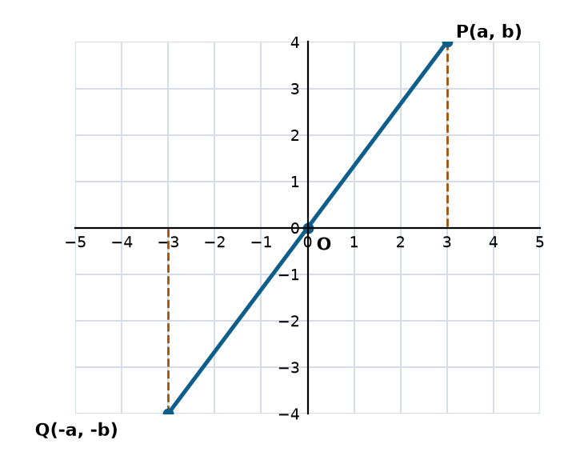
Sketch for a = 3, b = 4. The result holds for any a and b.

Main method: distance formula
Let: P(a, b) and Q(–a, –b), so (x₁, y₁) = (a, b) and (x₂, y₂) = (–a, –b).
Formula: $PQ = \sqrt{{(x₂ – x₁)}^{2} + {(y₂ – y₁)}^{2}}$
Substitution: $PQ = \sqrt{{(–a – a)}^{2} + {(–b – b)}^{2}} = \sqrt{{(–2a)}^{2} + {(–2b)}^{2}}$
Simplification: $PQ = \sqrt{4a^{2} + 4b^{2}} = \sqrt{4(a^{2} + b^{2})} = 2\sqrt{a^{2} + b^{2}}$
Answer: The distance is $2\sqrt{a^{2} + b^{2}}$ units.

Alternate method: use the origin
The midpoint of PQ is $(\frac{a + (−a)}{2}, \frac{b + (−b)}{2}) = (0, 0)$, so O is the midpoint of PQ and PQ = 2 × OP.
$OP = \sqrt{{(a – 0)}^{2} + {(b – 0)}^{2}} = \sqrt{a^{2} + b^{2}}$, so $PQ = 2\sqrt{a^{2} + b^{2}}$.

Verification
Take a = 3, b = 4, so P(3, 4) and Q(–3, –4).
$PQ = \sqrt{{(–3 – 3)}^{2} + {(–4 – 4)}^{2}} = \sqrt{36 + 64} = 10$, and $2\sqrt{3^{2} + 4^{2}} = 2 × 5 = 10$. The two values agree.

Exercise 7.1 · Question 3
Type: verify yes / no · Figure: sketch recommended · Answer: conclusion with reason
Determine if the points (1, 5), (2, 3) and (– 2, – 11) are collinear.
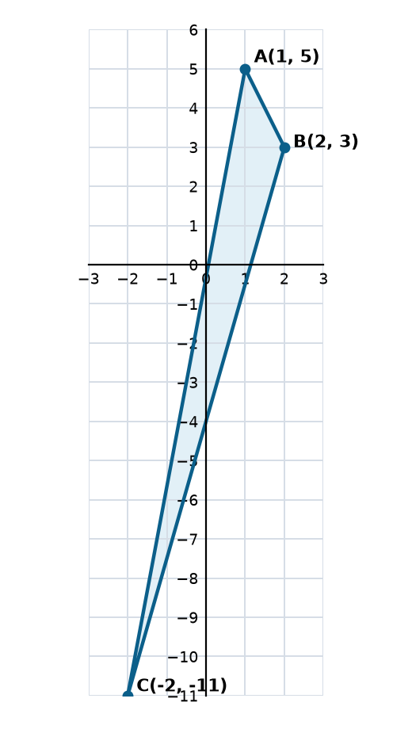
Sketch of the three points. C lies far from line AB.

Main method: distance formula
Given: A(1, 5), B(2, 3), C(–2, –11).
Idea: Three points are collinear only if the largest of the three distances equals the sum of the other two.
AB: $AB = \sqrt{{(2 – 1)}^{2} + {(3 – 5)}^{2}} = \sqrt{1 + 4} = \sqrt{5}$
BC: $BC = \sqrt{{(–2 – 2)}^{2} + {(–11 – 3)}^{2}} = \sqrt{16 + 196} = \sqrt{212} = 2\sqrt{53}$
AC: $AC = \sqrt{{(–2 – 1)}^{2} + {(–11 – 5)}^{2}} = \sqrt{9 + 256} = \sqrt{265}$
Compare: $AB + BC = \sqrt{5} + \sqrt{212} ≈ 2.24 + 14.56 = 16.80$, while $AC ≈ 16.28$.
AC is the largest and AB + BC ≠ AC. (Also AB + AC ≠ BC and BC + AC ≠ AB.)
Conclusion: The points (1, 5), (2, 3) and (–2, –11) are not collinear.

Alternate method: section formula
If C lay on line AB, it would divide AB in some ratio k : 1 (k is negative for a point outside the segment). Then $C = (\frac{2k + 1}{k + 1}, \frac{3k + 5}{k + 1})$.
x-coordinate: $\frac{2k + 1}{k + 1} = −2$ gives 2k + 1 = –2k – 2, so $k = −\frac{3}{4}$.
y-coordinate: $\frac{3k + 5}{k + 1} = −11$ gives 3k + 5 = –11k – 11, so $k = −\frac{8}{7}$.
The two values of k differ, so no single ratio works and C is not on line AB.

Verification
Exact check without decimals: if AB + BC = AC then $\sqrt{5} + \sqrt{212} = \sqrt{265}$. Squaring both sides gives $5 + 212 + 2\sqrt{1060} = 265$, so $\sqrt{1060} = 24$, which needs 1060 = 576. This is false, so the result agrees with the decimal check.

Exercise 7.1 · Question 5
Type: word problem with a given figure · Figure: read coordinates from it · Answer: decision with reasons
In a classroom, 4 friends are seated at the points A, B, C and D as shown in Fig. 7.8. Champa and Chameli walk into the class and after observing for a few minutes Champa asks Chameli, “Don’t you think ABCD is a square?” Chameli disagrees. Using distance formula, find which of them is correct.
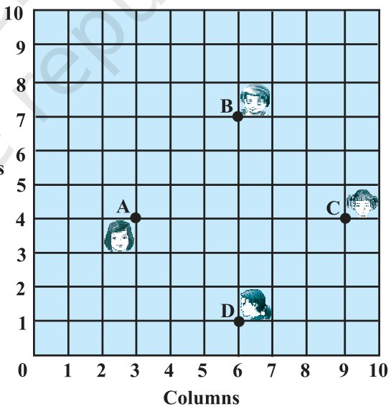
Fig. 7.8 (from the textbook)
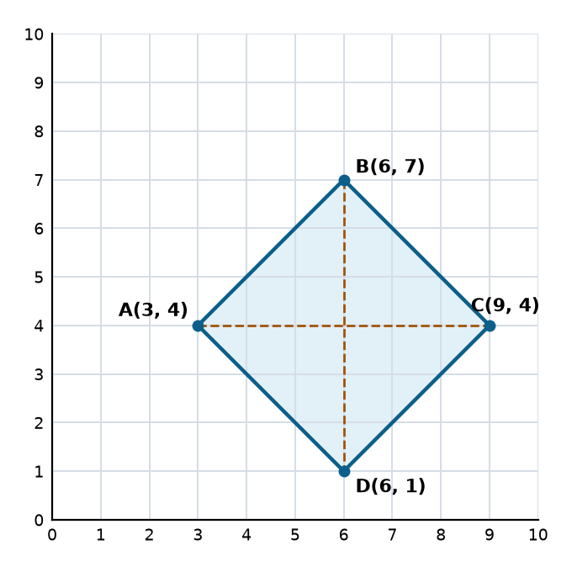
Redrawn with the coordinates read from the grid

Main method: all sides and both diagonals
From the figure: A(3, 4), B(6, 7), C(9, 4), D(6, 1). Columns are the x-values and rows are the y-values.
Sides: $AB = \sqrt{{(6 – 3)}^{2} + {(7 – 4)}^{2}} = \sqrt{9 + 9} = \sqrt{18} = 3\sqrt{2}$
$BC = \sqrt{{(9 – 6)}^{2} + {(4 – 7)}^{2}} = \sqrt{18} = 3\sqrt{2}$
$CD = \sqrt{{(6 – 9)}^{2} + {(1 – 4)}^{2}} = \sqrt{18} = 3\sqrt{2}$
$DA = \sqrt{{(3 – 6)}^{2} + {(4 – 1)}^{2}} = \sqrt{18} = 3\sqrt{2}$
Diagonals: $AC = \sqrt{{(9 – 3)}^{2} + {(4 – 4)}^{2}} = \sqrt{36} = 6$
$BD = \sqrt{{(6 – 6)}^{2} + {(1 – 7)}^{2}} = \sqrt{36} = 6$
Reason: All four sides are equal, so ABCD is a rhombus. The diagonals AC and BD are also equal. A rhombus with equal diagonals is a square.
Conclusion: ABCD is a square, so Champa is correct and Chameli is wrong.

Alternate method: midpoints and adjacent sides
Midpoint of AC = $(\frac{3 + 9}{2}, \frac{4 + 4}{2}) = (6, 4)$. Midpoint of BD = $(\frac{6 + 6}{2}, \frac{7 + 1}{2}) = (6, 4)$.
The diagonals bisect each other, so ABCD is a parallelogram. The diagonals are equal (6 each), so it is a rectangle. Adjacent sides AB and BC are equal ($\sqrt{18}$ each), so it is a square.

Verification
$AB^{2} + BC^{2} = 18 + 18 = 36 = AC^{2}$. By the converse of the Pythagoras theorem, angle B = 90°. Four equal sides with one right angle confirms a square.

Exercise 7.1 · Question 8
Type: find the unknown, two answers · Figure: sketch shows both cases · Answer: two values
Find the values of y for which the distance between the points P(2, – 3) and Q(10, y) is 10 units.
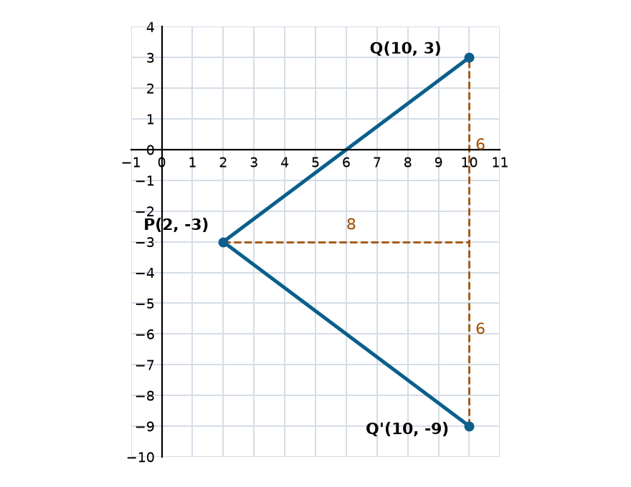
Q can lie above or below the horizontal line through P, giving two positions.

Main method: distance formula
Given: P(2, –3), Q(10, y), PQ = 10.
Formula: $PQ = \sqrt{{(10 – 2)}^{2} + {(y – (–3))}^{2}} = 10$
Square both sides: $64 + {(y + 3)}^{2} = 100$
Simplify: ${(y + 3)}^{2} = 36$, so y + 3 = 6 or y + 3 = –6
Solve: y = 3 or y = –9
Answer: y = 3 or y = –9. Both values are valid.

Alternate method: right triangle
The horizontal gap between P and Q is 10 – 2 = 8. In the right triangle with hypotenuse PQ = 10, the vertical side is $\sqrt{10^{2} − 8^{2}} = 6$. So y differs from –3 by 6, giving y = –3 + 6 = 3 or y = –3 – 6 = –9.

Verification
For y = 3: $PQ = \sqrt{8^{2} + 6^{2}} = \sqrt{100} = 10$.
For y = –9: $PQ = \sqrt{8^{2} + {(–6)}^{2}} = \sqrt{100} = 10$.

Exercise 7.2 · Question 6
Type: find unknowns using a property · Figure: sketch recommended · Answer: x and y
If (1, 2), (4, y), (x, 6) and (3, 5) are the vertices of a parallelogram taken in order, find x and y.
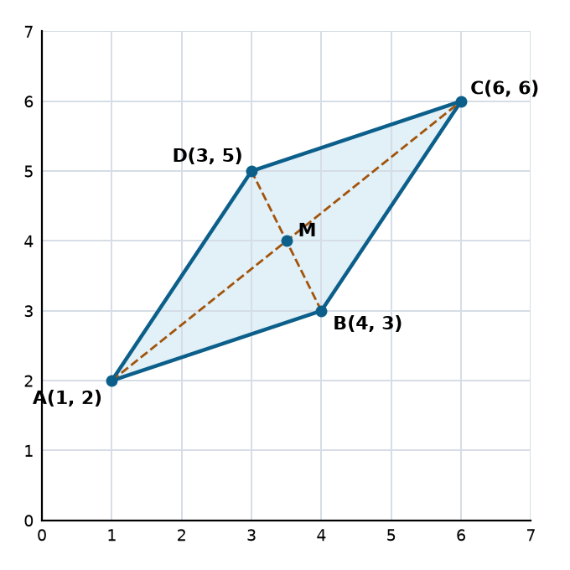
Parallelogram with x = 6 and y = 3 applied. M is where the diagonals meet.

Main method: diagonals bisect each other
Let: A(1, 2), B(4, y), C(x, 6), D(3, 5). The diagonals are AC and BD.
Idea: In a parallelogram the diagonals bisect each other, so they have the same midpoint.
Midpoints: Midpoint of AC = $(\frac{1 + x}{2}, \frac{2 + 6}{2}) = (\frac{1 + x}{2}, 4)$
Midpoint of BD = $(\frac{4 + 3}{2}, \frac{y + 5}{2}) = (\frac{7}{2}, \frac{y + 5}{2})$
Equate: $\frac{1 + x}{2} = \frac{7}{2}$, so x = 6
$4 = \frac{y + 5}{2}$, so y = 3
Answer: x = 6 and y = 3.

Alternate method: opposite sides AB and DC
In parallelogram ABCD, going from A to B is the same shift as going from D to C. From A(1, 2) to B(4, y) the x-value changes by 3 and the y-value by y – 2. From D(3, 5) to C(x, 6) the x-value changes by x – 3 and the y-value by 1.
x – 3 = 3 gives x = 6, and y – 2 = 1 gives y = 3.

Verification
With x = 6 and y = 3 the vertices are A(1, 2), B(4, 3), C(6, 6), D(3, 5).
$AB^{2} = 9 + 1 = 10$ and $DC^{2} = 9 + 1 = 10$. $BC^{2} = 4 + 9 = 13$ and $AD^{2} = 4 + 9 = 13$. Both pairs of opposite sides are equal, so ABCD is a parallelogram.
Types not yet sampled: classify a quadrilateral (7.1 Q6), ratio questions (7.2 Q4, Q5), an applied section-formula problem with a figure (7.2 Q3), and area using diagonals (7.2 Q10).

