**Name: SHUBHAM MISHRA**

**ID: EMPH2276**

1. **Screenshots of Connections:**

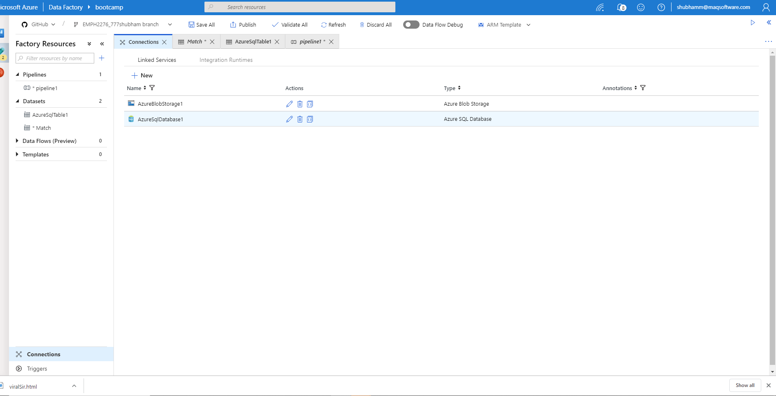

**2.Screenshot of Datasets with successful Test connection**

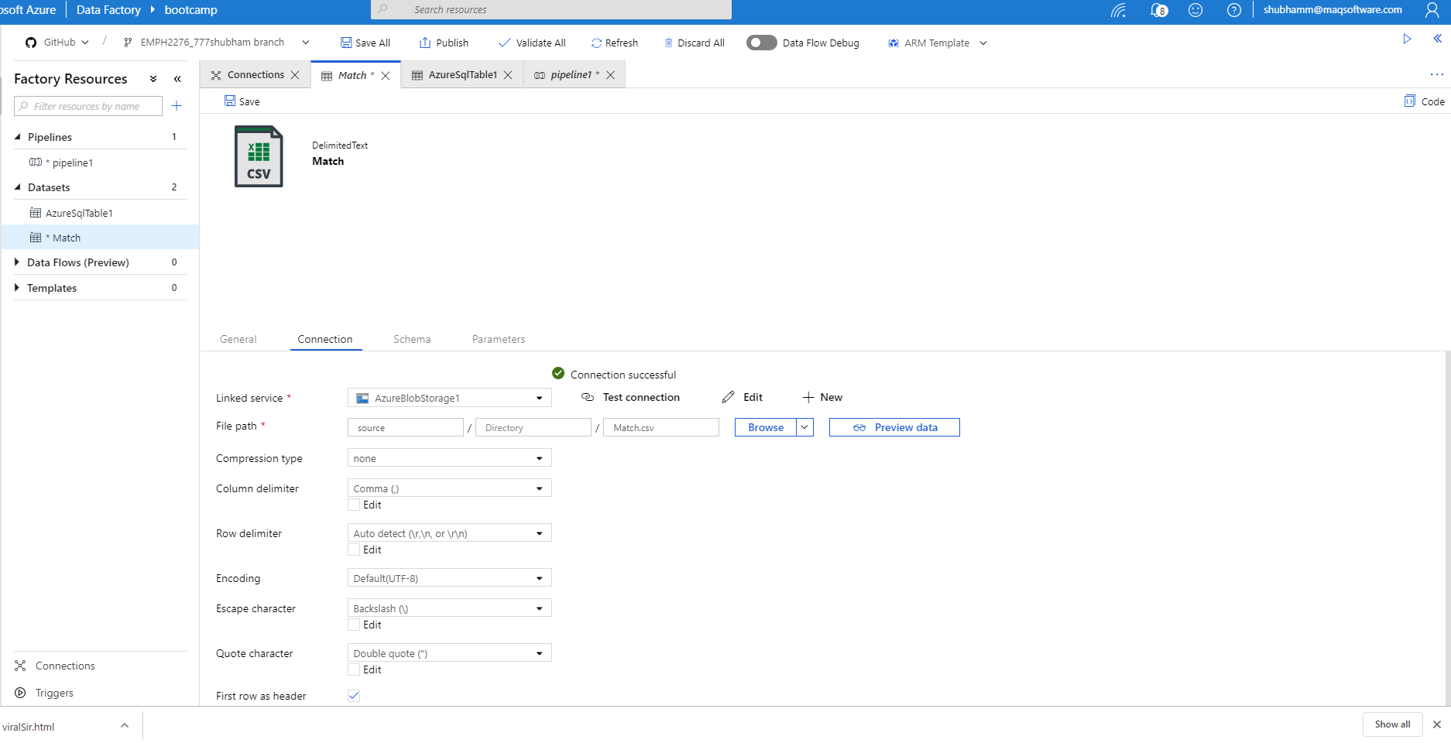

**3.Connection**

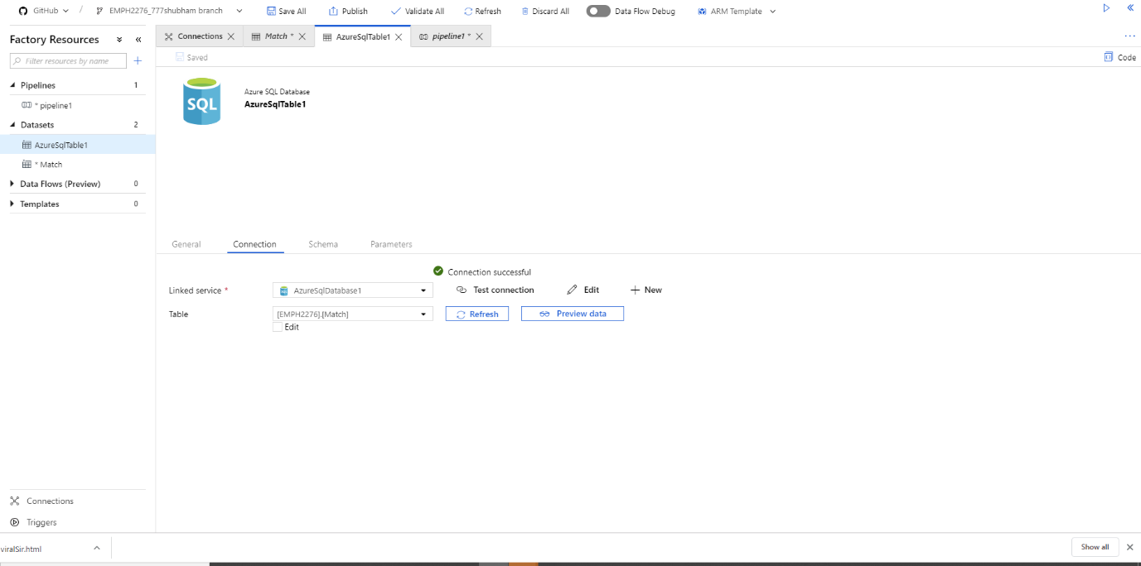

4. **Screenshot of at least one successful run of pipeline**

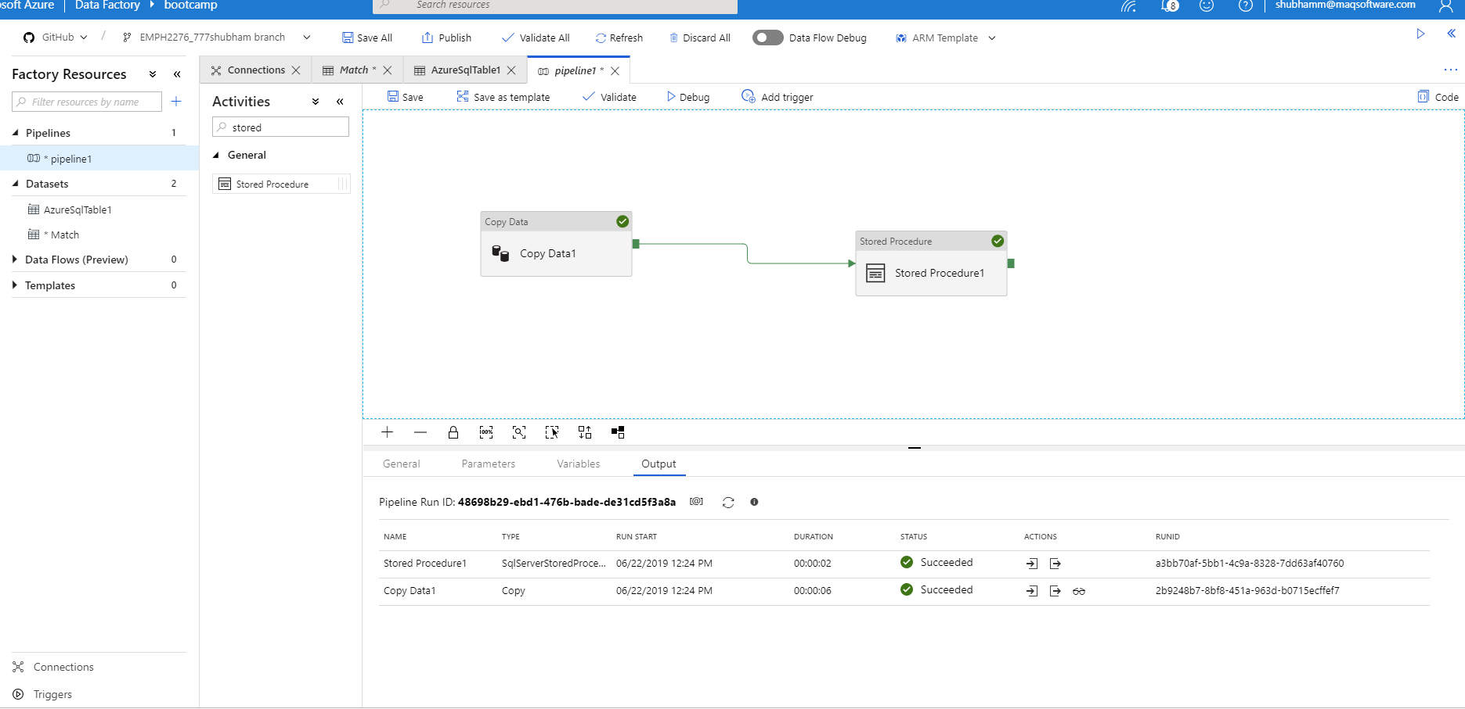

**5.Screenshot of Result in SSMS**