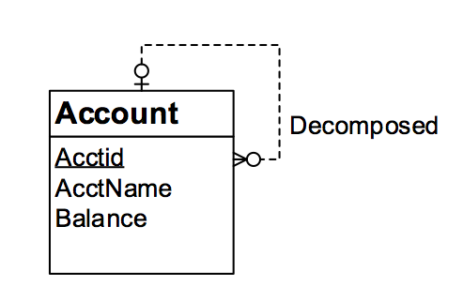

Tables:

Account (AcctID, DecomposedAcctID, AcctName, Balance)

FOREIGN KEY (DecomposedAcctID) REFERENCES Account