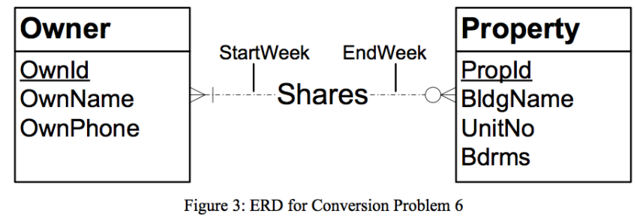

Tables from given ERD:

* Owner (OwnID, OwnName, OwnPhone)
* Property (PropID, BldgName, UnitNo, Bdrms)
* Shares (OwnID, PropID, StartWeek, EndWeek)
  + FOREIGN KEY (OwnID) REFERENCES Owner
  + FOREIGN KEY (PropID) REFERENCES Property