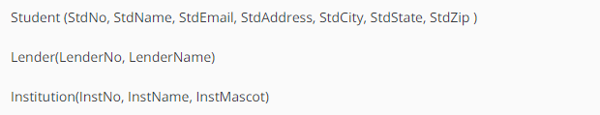

Student table is not in BCNF because we can determine StdState and StdCity from StdZip.

Refined Tables:

* Student

StdNo, StdName, StdZip, StdAddressLine, StdZip

StdZip, StdState, StdCity

* Institution

InstitutionName, InstitutionMascot