**Issues in Given ERD:**

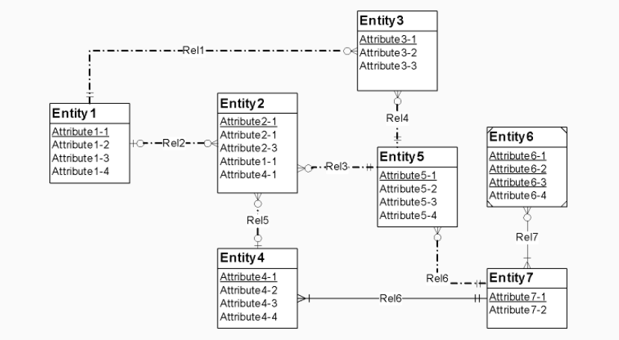

1. Redundant attributes for Entity 2 (‘Attribute 2-1’).
2. Two relationships are named as ‘Rel6’.
3. Entity 6 has three primary keys. Instead make other attributes unique and keep only one primary key.