**Ans1:**

**Complete Transformation with Preview Data:**

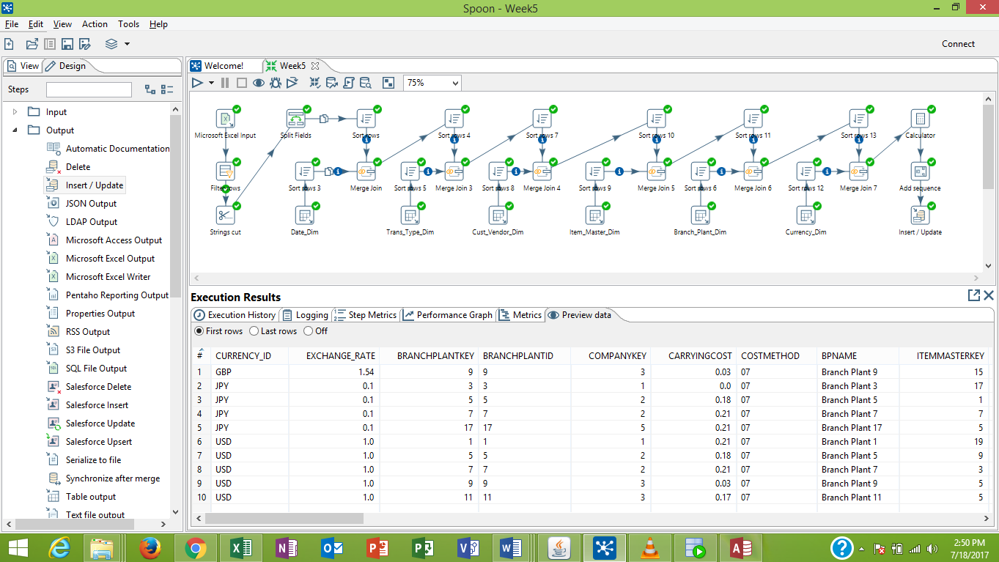

**Transformations Only:**

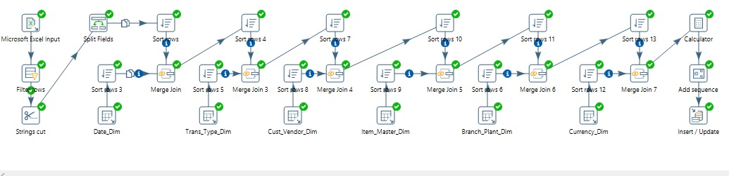

**Filter Rows:**

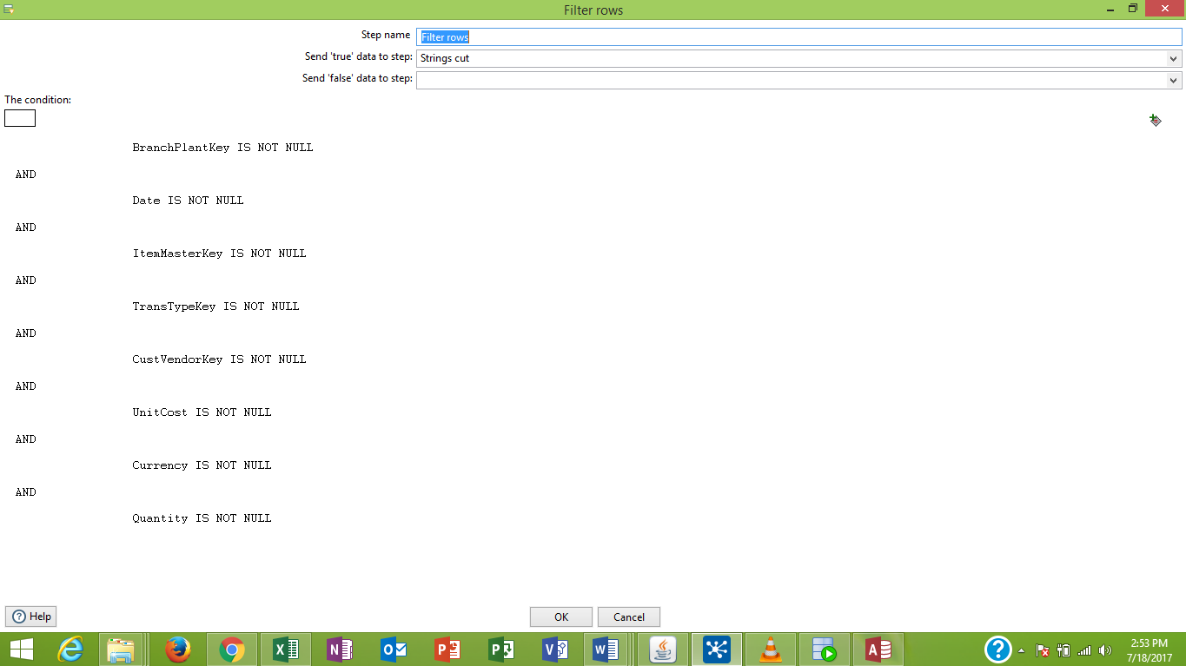

**String Cut:**

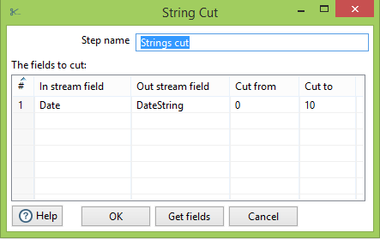

**Field Split**

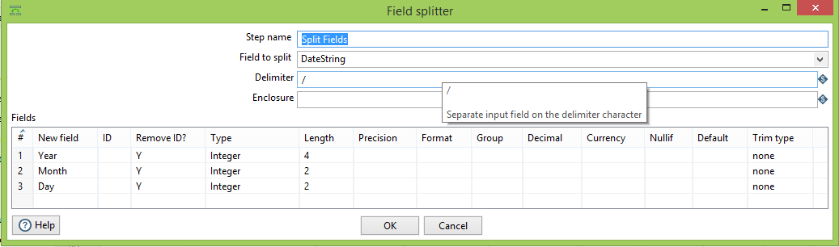

**Sorting: (For simplicity only one snapshot of sorting is kept here; all other data are sorted based on respective key ids)**

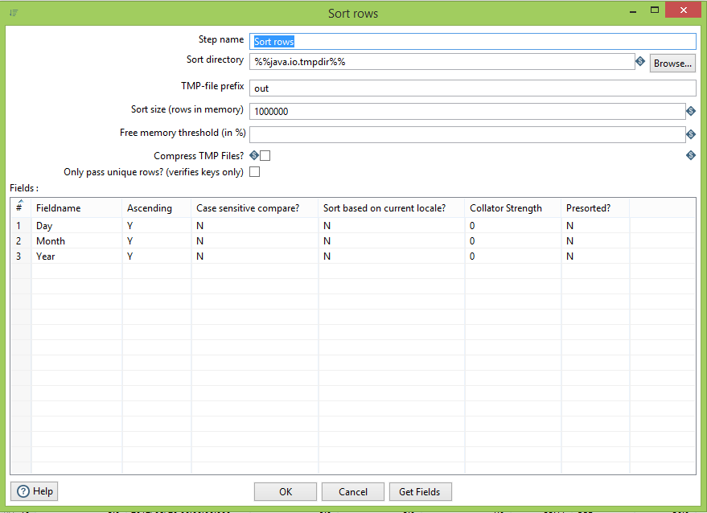

**Merge Join: (For simplicity only one snapshot of merge join is kept here; all other data are sorted based on respective key ids)**

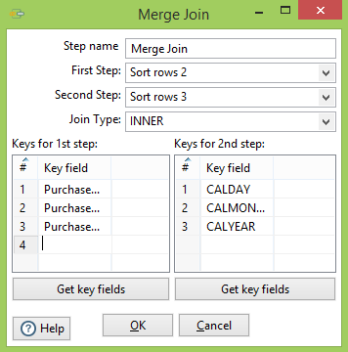

**Preview Data:**

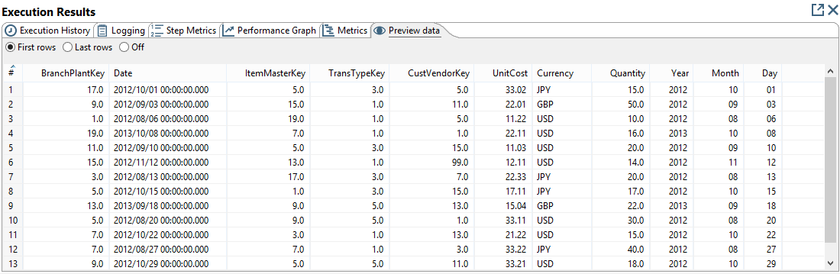

**Sequence:**

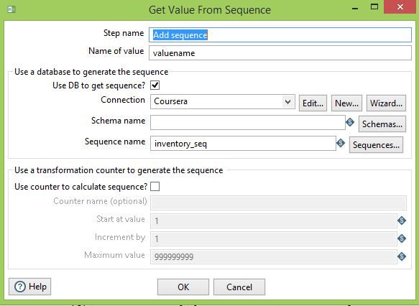

**Insert/Update:**

