**Ans 1: Emissions per capita of Canada is 17.72**

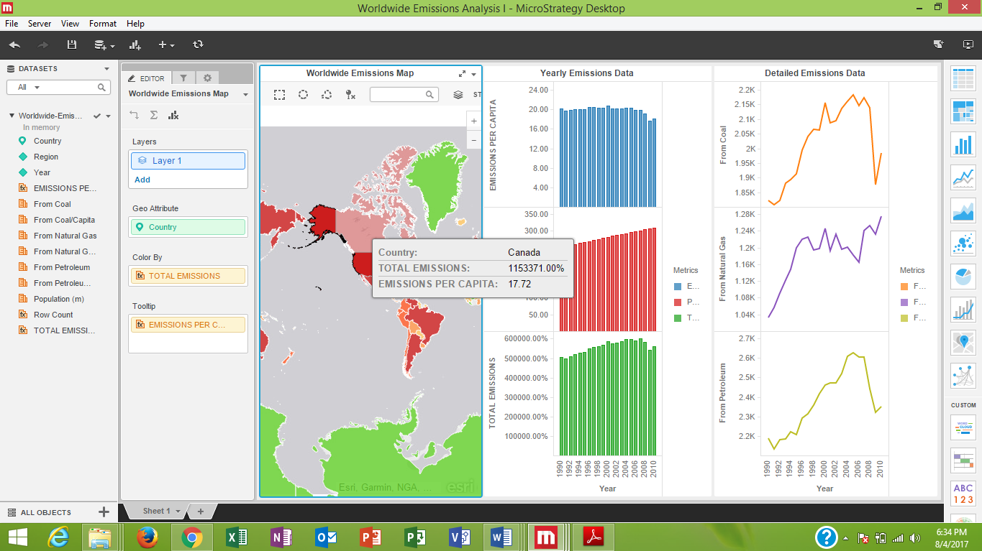

**Ans 2: Noticing the trend in Overall Emissions we can say that it is constantly increasing. There are also few exceptions in which Overall Emission is decreased from previous years. (i.e. Year:2008,2009)**

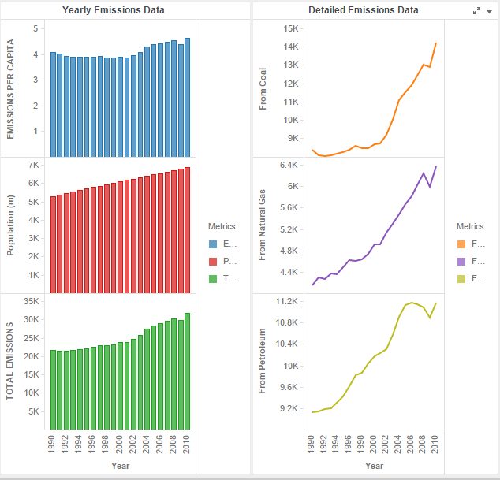

**Ans 3:**

**Reason for declined Overall Emissions in year 2009 is the economic slowdown during year 2008-2009 which shows decrease in emissions. Due to economic slowdown, there were many industries which reduced their production. Ultimately emission for coal, gas and petroleum was reduced.**

**Declined Overall Emissions in year 2009 may suggest that the countries of whole world are targeting to save the natural resources for future and try to reduce consumption as less as possible. The overall reduction due to political organizations such as UN which collaborate all countries of world and try to save resources for future.**

**Visualizations for Canada:**



**Visualizations for USA:**

