A

SUMMER INTERNSHIP PROJECT REPORT

ON

**“UNIVERSITY EVENT CALENDAR AND EVENT NOTIFIER SYSTEM”**

As A Partial Fulfilment Requirement for the award of Degree of

MASTER OF COMPUTER APPLICATION

[M.C.A]

Submitted to

**MIT-WPU SCHOOL OF COMPUTER SCIENCE, PUNE**

ACADEMIC YEAR: 2020-21

**Submitted By: Internal Guide:**

**Shastri Viral Prof. Surabhi Thatte**

**Mithaiwala Akshit**

**Jagtap Shrushti**

**Mourya Rajan**

**Tayyeb Abdul**

**Porwal Tushar**

**ACKNOWLEDGEMENT**

It was highly eventful session at the **MIT-WPU SCHOOL OF COMPUTER SCIECNE, PUNE**, working with highly devoted computer teacher’s community, and will probably remain the most memorable experience of our life. Hence this acknowledgement is a humble an attempt to earnestly thank are all those who were directly and indirectly involved in our project work and where of immense help to us.

We are thankful to our summer internship project guide **Prof. Surabhi Thatte** has been an exceptional teacher and motivator. His inspirational ideas and advise have kept us going during the training period.

We are thankful to faculty of the institute for their constant guidance not only during training period but also throughout college career.

Finally, we are thankful to all the individuals whose names are not included here. All of these have made our project a success.

**Thanks to All.**

**Shastri Viral**

**Mithaiwala Akshit**

**Jagtap Shrushti**

**Mourya Rajan**

**Tayyeb Abdul**

**Porwal Tushar**

**INDEX**

|  |  |
| --- | --- |
| Sr.No. | Chapter Name |
| 1. | Introduction |
|  | 1.1 About eVentes |
|  | 1.2 Project Profile |
|  |  |
| 2. | Tools and Environment |
|  | 2.1 Hardware and software requirement |
|  | 2.2 Tools and environment used |
|  |  |
| 3. | Analysis Report |
|  | 3.1 Proposed System |
|  | 3.2 List of Tables |
|  | 3.3 Table Structure of eVentes |
|  |  |
| 4. | Design Report |
|  | 4.1 Control Flow System |
|  | 4.2 Use Case Diagram |

**INTRODUCTION**

**About eVentes:**

University Event Calendar and Event Notifier System (eVentes) is a web application developed for Universities facing many problems regarding event related issues.

The main Objective of this project is to help Universities manage the event related issues like:

Club Duplication: This problem refers to some unnecessary club formation which will perform same tasks which were already handled by some other clubs in the university. To handle this issue, our web application will provide a registration form and only on the approval of admin the club will be formed.

Time clash: This problem refers to events happening on the same date and time and if the venue also clashes it becomes a mess to handle at that particular moment. The web application will notify about the event organized at particular date time and location.

Many times for Big Universities like MIT WPU there are many courses so many of the students are unaware of ample of clubs and events organized by other courses due to this, club member have to visit classes to promote the events which becomes a very hectic task, so this web application will also help students to get notified about a particular event organized by particular club of any branch.

Many Times the winner of any particular event be it be a college level or Inter College level doesn’t get the credits so, the website will also display the achievements of that particular event winner.

The web application will maintain a student database so that the student just has to login once registered for any other “club join “or “event participation”. This reduces the all-time manual data gathering and also the results of a particular event can be notified on the web application.

**Project Profile:**

|  |  |
| --- | --- |
| **Project Title** | : University event calendar and event notifier system |
| **Front End** | : JavaScript, AJAX, JQuery, CSS, HTML, Bootstrap |
| **Framework** | : Django |
| **Back End** | : Python |
| **Database** | : PostgreSQL |
| **Tools used for DFD** | : [www.draw.io](http://www.draw.io) |
| **Operating System** | : Windows 10 Home Single Language  (64 bits) |
| **Submitted to** | : MIT-WPU School of Computer Science, Pune |
| **Developed by** | : 1) Shastri Viral  2) Mithaiwala Akshit  3) Jagtap Shrushti  4) Mourya Rajan  5) Tayyeb Abdul  6) Porwal Tushar |

**TOOLS AND ENVIRONMENT**

**Hardware and Software Requirements:**

* **For Admin**

|  |  |
| --- | --- |
| Software | Visual Studio Code, Python, Django |
| Web Browser | Google Chrome, Mozilla Firefox |
| Database | PostgreSQL |
| Operating System | Windows 10 |
| Microprocessor | Any but latest is good for performance |
| Memory | 2 GB |
| Hard Disk Space | Minimum 1 GB |

* **For User**

|  |  |
| --- | --- |
| Web Browser | Google Chrome, Mozilla Firefox |
| Database | PostgreSQL |
| Operating System | Linux, Windows XP, Windows 2007, Windows Vista, Windows 2008, Windows 10 |
| Microprocessor | Any but latest is good for performance |
| Memory | Minimum 512 MB |
| Hard Disk Space | Minimum 1 GB |

**Tools and Environment used:**

* **Front End**
  + HTML 5
  + CSS 3
  + Bootstrap 4
  + JavaScript
  + JQuery
* **Back End**
  + Python
  + Django
  + PostgreSQL
* **Dependencies**
  + University Database
  + Web Server

**ANALYSIS REPORT**

**Proposed System:**

Our Proposed System states that an automated event management and club creation module takes place.

The user module will include the registration and login formalities and after the student has successfully logged in they can participate in any event by registering in that specific event and, if it is a paid event then they will be redirected to the payment gateway and once the payment is successful they will be redirected to that event participation details.

Through this web application the upcoming and ongoing event dates will also be displayed through the event notifier calendar so that students are aware about the events so, that the event organizers don’t have to visit classes for their promotions.

As the event dates are displayed on the calendar there won’t be any clash of the events so, it will reflect in an effective time management regarding all the events as the web application will display all the details of the events organized by the clubs. In this way the students will get the information regarding all the ongoing and upcoming events. The application will also display the details of the new clubs formed.

The web application will also include the club module through which the club members can handle all the activities regarding their clubs.

The club creation takes place only when the new club to be formed is registered and approved by the sub-admin which will prevent from duplication of clubs who will perform same tasks which are already handled by existing clubs.

Along with the information regarding the events and clubs all the registered users will also get the results of those events in which they have participated in through their registered email-id.

**Table structure of eVentes:**

* **List of Tables**
  + Admin Table
  + Student Table
  + Department Table
  + Sub Department Table
  + Employee Table
  + Club Table
  + Event Table
  + Achievement Table
  + Payment Table
  + Club Member Table
  + Achiever Table

1. **Admin Table**

|  |  |  |  |
| --- | --- | --- | --- |
| Field Name | Type | Constraint | Description |
| AdminId | Int | Primary Key | Unique and Not NULL |
| AdminUserName | Varchar | - | Admin name |
| AdminPassword | Varchar | - | Admin password |
| AdminType | Varchar | - | Admin type |
| EmployeeId | Int | Foreign Key | Employee id from Employee table |
| Status | Boolean | - | Active / Not Active |

1. **Student Table**

|  |  |  |  |
| --- | --- | --- | --- |
| Field Name | Type | Constraint | Description |
| StudentId | Int | Primary Key | Unique and Not NULL |
| StudentName | Varchar | - | Student name |
| StudentPassword | Varchar | - | Student password |
| SubDepartmentName | Varchar | Foreign Key | Sub department name from sub department table |
| DepartmentName | Varchar | Foreign Key | Department name from Department table |
| StudentDateOfReg | TimeStamp | - | Current date and time for registration |
| StudentDateOfComp | TimeStamp | - |  |
| Gender | Varchar | - | Student gender |
| StudentImage | Varchar | - | Student image url |
| StudentImageName | Varchar | - | Student image name |
| StundentPhoneNo | BigInt | - | Student phone no |
| StudentEmail | Varchar | - | Student email |
| StudentAddress | Text | - | Student address |
| City | Varchar | - | Student city |
| Status | Boolean | - | Approve / Pending |

1. **Department Table**

|  |  |  |  |
| --- | --- | --- | --- |
| Field Name | Type | Constraint | Description |
| DepartmentName | Varchar | Primary Key | Unique and Not NULL |

1. **Sub Department Table**

|  |  |  |  |
| --- | --- | --- | --- |
| Field Name | Type | Constraint | Description |
| SubDepartmentName | Varchar | Primary Key | Unique and Not NULL |
| DepartmentName | Varchar | Foreign Key | Department name from Department table |

1. **Employee Table**

|  |  |  |  |
| --- | --- | --- | --- |
| Field Name | Type | Constraint | Description |
| EmpolyeeId | Int | Primary Key | Unique and Not NULL |
| EmpolyeeName | Varchar | - | Employee name |
| EmpolyeeUserName | Varchar | - | Employee user name |
| EmpolyeePassword | Varchar | - | Employee password |
| SubDepartmentName | Varchar | Foreign Key | Sub department name from sub department table |
| DepartmentName | Varchar | Foreign Key | Department name from Department table |
| City | Varchar | - | Current date and time for registration |
| Status | Boolean | - | Approve / Pending |
| Gender | Varchar | - | Student gender |
| StudentImage | Varchar | - | Employee image url |
| StudentImageName | Varchar | - | Employee image name |
| StundentPhoneNo | BigInt | - | Employee phone no |
| StudentEmail | Varchar | - | Employee email |
| StudentAddress | Text | - | Employee address |

1. **Club Table**

|  |  |  |  |
| --- | --- | --- | --- |
| Field Name | Type | Constraint | Description |
| ClubName | Varchar | Primary Key | Unique and Not NULL |
| ClubType | Varchar | - | Club type |
| DepartmentName | Varchar | Foreign Key | Department name from Department table |
| ClubStatus | Boolean | - | Approve / Pending |
| ClubApproval | Boolean | - | Approve / Pending |
| ClubImage | Varchar | - | Club image url |
| ClubImageName | Varchar | - | Club image name |

1. **Event Table**

|  |  |  |  |
| --- | --- | --- | --- |
| Field Name | Type | Constraint | Description |
| EventId | Int | Primary Key | Unique and Not NULL |
| EventName | Varchar | - | Event name |
| ClubName | Varchar | Foreign Key | Club name from Club table |
| EventType | Varchar | - | Event type |
| EventEligibility | Boolean | - | Free / Paid |
| EventStatus | Boolean | - | Approve / Pending |
| EventApproval | Boolean | - | Approve / Pending |
| EventStartDate | DateTime | - | Starting date and time of event |
| EventEndDate | DateTime | - | Ending date and time of event |
| EventDescription | Text | - | Event Description |
| RegistrationAmount | BigInt | - | Event fees |

1. **Achievement Table**

|  |  |  |  |
| --- | --- | --- | --- |
| Field Name | Type | Constraint | Description |
| AchievementId | Int | Primary Key | Unique and Not NULL |
| AchievementName | Varchar | - | Achievement name |
| SubDepartmentName | Varchar | Foreign Key | Sub department name from sub department table |
| DepartmentName | Varchar | Foreign Key | Department name from Department table |
| AchievementDescription | Text | - | Achievement Description |

1. **Club Member Table**

|  |  |  |  |
| --- | --- | --- | --- |
| Field Name | Type | Constraint | Description |
| ClubName | Varchar | - | Club name |
| StudentId | Int | Foreign Key | Student id from student table |
| MemberRole | Varchar | - | Student role in club |

**10. Achiever Table**

|  |  |  |  |
| --- | --- | --- | --- |
| Field Name | Type | Constraint | Description |
| AchievementId | Int | Foreign Key | Achievement id from Achievement table |
| StudentId | Int | Foreign Key | Student id from student table |
| MemberRole | Varchar | - | Student role in club |

**DESIGN REPORT**

**Control Flow System:**

* **User Module**

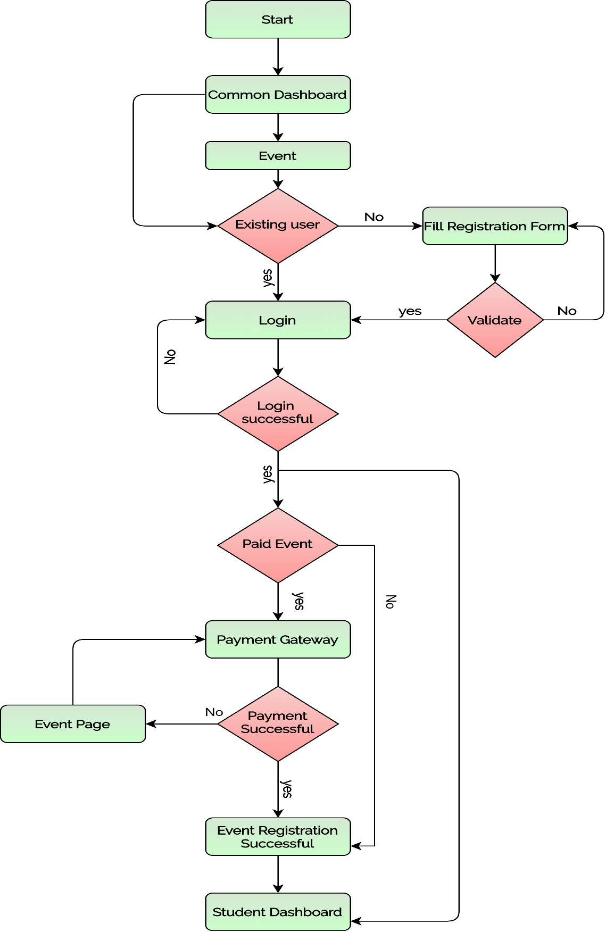

* **Club Module**

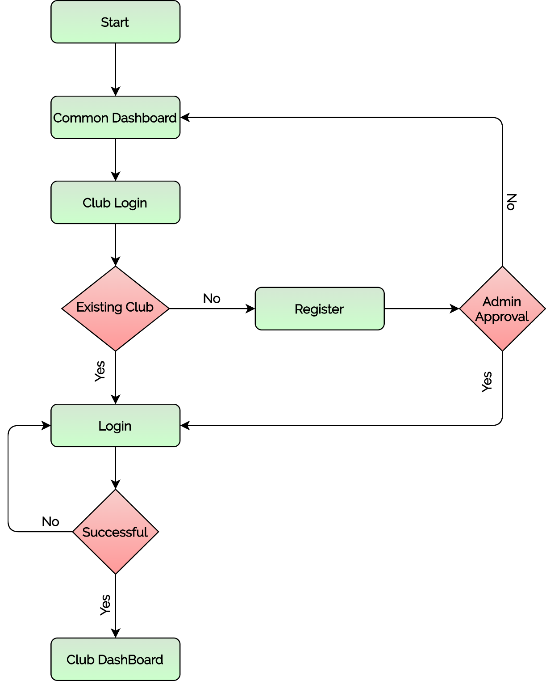

**Use Case Diagram:**

