ME 594 – Numerical Methods - HW01

Viral Panchal | Due date: 09/21

‘I pledge my honor that I have abided by the stevens honor system’

Matlab Program:

## Q1.B

% f_cal --> F using calculator  
% f_mat --> F using Matlab  
% TSE --> True relative error  
  
format long  
x = 0.007;  
f_mat = (1 - cos(x))/sin(x);  
fprintf('f_mat =');  
disp(f_mat)  
  
f_cal = 0.003429;  
TRE = abs((f_mat - f_cal)/f_cal);  
fprintf('TRE =');  
disp(TRE)

f_mat = 0.003500014291730  
  
TRE = 0.020709913015556

## Q1.C

f_cal2 = 0.003499;  
TRE_2 = abs((f_mat - f_cal2)/f_cal2);  
fprintf('TRE_2 = ');  
disp(TRE_2)

TRE_2 = 2.898804602291635e-04

[*Published with MATLAB® R2021a*](https://www.mathworks.com/products/matlab)

# Driver for Q2

function file name - intTObina.m

% Test case 1 | d = 81  
fprintf('Binary when d = 81 \n');  
b = intTObina(81);  
  
% Test case 2 | d = 30952  
fprintf('Binary when d = 30952 \n');  
b = intTObina(30952);  
  
% Test case 3 | d = 1500000  
fprintf('Binary when d = 1500000 \n');  
b = intTObina(1500000);

Function Program;

% Function to convert integer to binary

% Q2

function b = intTObina(d)

b = [];

while d > 0

r = rem(d,2);

if (r ==0 || r==1)

b = [r b];

else

fprintf('Error')

end

q = floor(d/2);

d = q;

end

if (length(b) <= 20)

fprintf('b = ');

disp(b)

else

fprintf('Error: Type a smaller number \n');

end

end

Matlab Output:

Binary when d = 81   
b = 1 0 1 0 0 0 1  
  
Binary when d = 30952   
b = Columns 1 through 13  
  
 1 1 1 1 0 0 0 1 1 1 0 1 0  
  
 Columns 14 through 15  
  
 0 0  
  
Binary when d = 1500000   
Error: Type a smaller number

[*Published with MATLAB® R2021a*](https://www.mathworks.com/products/matlab)

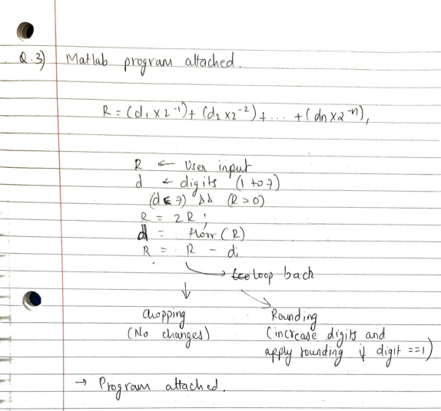

# Driver for Q3

function file name - binfrac.m

%Test case 1 | R = 0.40625  
fprintf('when R = 0.40625 \n');  
[chopped_number_1,rounded_number_1] = binfrac(0.40625)  
  
fprintf('---------------------------------------------------------\n');  
  
%Test case 2 | R = 0.7  
fprintf('when R = 0.7 \n');  
[chopped_number_2,rounded_number_2] = binfrac(0.7)  
  
fprintf('---------------------------------------------------------\n');  
  
%Test case 3 | R = 0.12109375  
fprintf('when R = 0.121090375 \n');  
[chopped_number_3,rounded_number_3] = binfrac(0.12109375)

Function program:

% Binary fractions

% Q3

function [chopped,rounded] = binfrac(R)

format long

i = 1;

i_max = 7;

a = [];

while (i<=i_max) && (R > 0)

R = 2 * R;

d = floor(R);

a = [a d];

R = R - d;

i = i + 1;

end

% printing in 0.dddd way

chopped = '0.';

for j = 1:i-1

chopped = strcat(chopped,(int2str(a(j))));

end

% When the number can be represented exactly

rounded = 'Rounding is not required';

% When the number requires additional unavailable digits

if (R > 0)

fprintf('Failed to store the entire number \n');

R = 2 * R;

d = floor(R);

b = a;

c = i_max;

while (d==1)

f = d + b(c);

b(c) = mod(f,2);

d = f - d;

c = c - 1;

end

% printing the new rounded value in 0.ddddd format

rounded = '0.';

for j = 1:i-1

rounded = strcat(rounded,(int2str(b(j))));

end

% Computing the decimal representations after chooping and rounding

chopped_dec = 0;

rounded_dec = 0;

for j = 1:i_max

chopped_dec = chopped_dec + a(j)/2^j;

rounded_dec = rounded_dec + b(j)/2^j;

end

%printing the decimal values

fprintf('\n Decimal representation after chopping = ');

disp(chopped_dec)

fprintf('\n Decimal representation after rounding = ');

disp(rounded_dec)

end

Matlab Output:

when R = 0.40625   
  
chopped_number_1 =  
  
 '0.01101'  
  
  
rounded_number_1 =  
  
 'Rounding is not required'  
  
---------------------------------------------------------  
when R = 0.7   
Failed to store the entire number   
  
 Decimal representation after chopping = 0.695312500000000  
  
  
 Decimal representation after rounding = 0.703125000000000  
  
  
chopped_number_2 =  
  
 '0.1011001'  
  
  
rounded_number_2 =  
  
 '0.1011010'  
  
---------------------------------------------------------  
when R = 0.121090375   
Failed to store the entire number   
  
 Decimal representation after chopping = 0.117187500000000  
  
  
 Decimal representation after rounding = 0.125000000000000  
  
  
chopped_number_3 =  
  
 '0.0001111'  
  
  
rounded_number_3 =  
  
 '0.0010000'

[*Published with MATLAB® R2021a*](https://www.mathworks.com/products/matlab)

*

# Q4 - part 2

plotting the three approximations solved in part 1

x = linspace(0,pi,1000);  
f_x = cos(x);  
  
f_3 = 1 - (x.^2/2);  
f_5 = 1 - (x.^2/2) + (x.^4/24);  
f_7 = 1 - (x.^2/2) + (x.^4/24) - (x.^6/720);  
plot(x,f_x,x,f_3,'--',x,f_5,'-',x,f_7,'-.');  
title('Cos(x) & Taylor series')  
xlabel('x');  
ylabel('y');  
legend('cos(x)','f_3','f_5','f_7');

[*Published with MATLAB® R2021a*](https://www.mathworks.com/products/matlab)