ME 594 - Numerical Methods – HW03

Viral Panchal | Due Date: 10/12

‘I pledge my honor that I have abided by the stevens honor system’

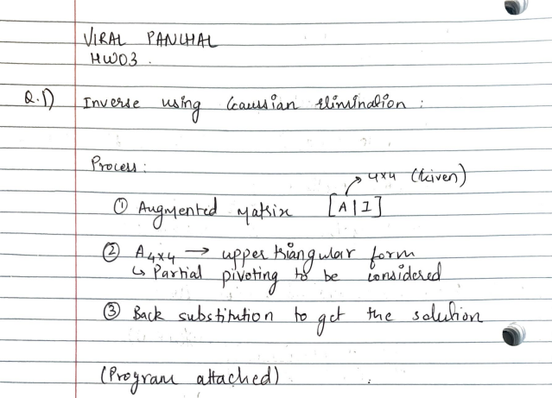

# Q1. Programs

* ***Program to compute inverse of a square matrix:***

% Making a function to get inverse of a matrix using Gaussian elimination (considering pivoting)

function A_inv = get_inv(A)

[p,q] = size(A);

if (p ~= q)

fprintf('Error: Given matrix is not a suqare matrix \n');

return

end

A_aug = [A eye(p)]; % Augmented matrix

for i = 1:p-1

[max_value, r] = max(abs(A_aug(i:p,i)));

if (r>1) % pivoting condition

temp_row = A_aug(i,:);

A_aug(i,:) = A_aug(i+r-1,:);

A_aug(i+r-1,:) = temp_row;

end

for j = i+1:p

pivot = A_aug(j,i)/A_aug(i,i);

A_aug(j,:) = A_aug(j,:)-pivot.*(A_aug(i,:));

end

end

% Checking if matrix in not singular

if (norm(A_aug(p,1:p),'inf')< eps)

fprintf('Error: Given matrix is singular \n');

return

end

for k=1:p

A_inv(p,k) = A_aug(p,p+k)/A_aug(p,p);

for l=p-1:-1:1

A_inv(l,k) = (A_aug(l,p+k) - A_aug(l,l+1:p) * A_inv(l+1:p,k))/A_aug(l,l);

end

end

error = norm(A*A_inv - eye(p));

if (error < 10^(-10))

fprintf('Inverse matrix achieved');

end

* ***Driver to run the above function:***

% Driver Q1  
  
% Part A - 4x4 matrix  
fprintf('Part A \n');  
A = [1 2 0 0  
 1 3 -1 0  
 0 -1 1 3  
 0 0 2 3]  
  
A_inv = get_inv(A)  
fprintf('Confirming result: A*A_inv = \n');  
A*A_inv  
  
% Part B - 10x10 matrix  
fprintf('Part B \n');  
A = [1.000000 0.500000 0.333333 0.250000 0.200000 0.166667 0.142857 0.125000 0.111111 0.100000  
 0.500000 0.333333 0.250000 0.200000 0.166667 0.142857 0.125000 0.111111 0.100000 0.090909  
 0.333333 0.250000 0.200000 0.166667 0.142857 0.125000 0.111111 0.100000 0.090909 0.083333  
 0.250000 0.200000 0.166667 0.142857 0.125000 0.111111 0.100000 0.090909 0.083333 0.076923  
 0.200000 0.166667 0.142857 0.125000 0.111111 0.100000 0.090909 0.083333 0.076923 0.071429  
 0.166667 0.142857 0.125000 0.111111 0.100000 0.090909 0.083333 0.076923 0.071429 0.066667  
 0.142857 0.125000 0.111111 0.100000 0.090909 0.083333 0.076923 0.071429 0.066667 0.062500  
 0.125000 0.111111 0.100000 0.090909 0.083333 0.076923 0.071429 0.066667 0.062500 0.058824  
 0.111111 0.100000 0.090909 0.083333 0.076923 0.071429 0.066667 0.062500 0.058824 0.055556  
 0.100000 0.090909 0.083333 0.076923 0.071429 0.066667 0.062500 0.058824 0.055556 0.052632]  
  
A_inv = get_inv(A)  
fprintf('Confirming result: A*A_inv = \n');  
A*A_inv

* ***Matlab output:***
* Part A   
    
  A =  
    
   1 2 0 0  
   1 3 -1 0  
   0 -1 1 3  
   0 0 2 3  
    
  Inverse matrix achieved  
  A_inv =  
    
   2.0000 -1.0000 1.0000 -1.0000  
   -0.5000 0.5000 -0.5000 0.5000  
   0.5000 -0.5000 -0.5000 0.5000  
   -0.3333 0.3333 0.3333 0  
    
  Confirming result: A*A_inv =   
    
  ans =  
    
   1 0 0 0  
   0 1 0 0  
   0 0 1 0  
   0 0 0 1  
    
  Part B   
    
  A =  
    
   Columns 1 through 7  
    
   1.0000 0.5000 0.3333 0.2500 0.2000 0.1667 0.1429  
   0.5000 0.3333 0.2500 0.2000 0.1667 0.1429 0.1250  
   0.3333 0.2500 0.2000 0.1667 0.1429 0.1250 0.1111  
   0.2500 0.2000 0.1667 0.1429 0.1250 0.1111 0.1000  
   0.2000 0.1667 0.1429 0.1250 0.1111 0.1000 0.0909  
   0.1667 0.1429 0.1250 0.1111 0.1000 0.0909 0.0833  
   0.1429 0.1250 0.1111 0.1000 0.0909 0.0833 0.0769  
   0.1250 0.1111 0.1000 0.0909 0.0833 0.0769 0.0714  
   0.1111 0.1000 0.0909 0.0833 0.0769 0.0714 0.0667  
   0.1000 0.0909 0.0833 0.0769 0.0714 0.0667 0.0625  
    
   Columns 8 through 10  
    
   0.1250 0.1111 0.1000  
   0.1111 0.1000 0.0909  
   0.1000 0.0909 0.0833  
   0.0909 0.0833 0.0769  
   0.0833 0.0769 0.0714  
   0.0769 0.0714 0.0667  
   0.0714 0.0667 0.0625  
   0.0667 0.0625 0.0588  
   0.0625 0.0588 0.0556  
   0.0588 0.0556 0.0526  
    
    
  A_inv =  
    
   1.0e+06 *  
    
   Columns 1 through 7  
    
   0.0000 -0.0002 0.0000 0.0020 -0.0051 0.0057 -0.0046  
   -0.0002 0.0014 0.0056 -0.0543 0.1316 -0.1544 0.1270  
   0.0000 0.0056 -0.0855 0.3983 -0.8356 0.9632 -0.7794  
   0.0020 -0.0543 0.3983 -1.2578 2.0448 -1.9935 1.4756  
   -0.0051 0.1316 -0.8356 2.0448 -2.0202 0.5374 0.1014  
   0.0057 -0.1544 0.9632 -1.9935 0.5374 2.5822 -2.6077  
   -0.0046 0.1270 -0.7794 1.4756 0.1014 -2.6077 1.8736  
   0.0033 -0.0845 0.4825 -0.8152 -0.1963 1.4445 -1.0701  
   -0.0006 0.0202 -0.1188 0.1075 0.6221 -1.7442 2.1819  
   -0.0005 0.0076 -0.0308 0.0931 -0.3799 0.9676 -1.2997  
    
   Columns 8 through 10  
    
   0.0033 -0.0006 -0.0005  
   -0.0845 0.0202 0.0076  
   0.4825 -0.1188 -0.0308  
   -0.8152 0.1075 0.0931  
   -0.1963 0.6221 -0.3799  
   1.4445 -1.7442 0.9676  
   -1.0701 2.1819 -1.2997  
   1.3844 -2.2440 1.0960  
   -2.2440 1.8692 -0.6938  
   1.0960 -0.6938 0.2412  
    
  Confirming result: A*A_inv =   
    
  ans =  
    
   Columns 1 through 7  
    
   1.0000 -0.0000 -0.0000 0.0000 -0.0000 0.0000 0.0000  
   0.0000 1.0000 -0.0000 0.0000 0.0000 0.0000 0.0000  
   -0.0000 0.0000 1.0000 0.0000 -0.0000 0.0000 0.0000  
   0.0000 -0.0000 0.0000 1.0000 -0.0000 0.0000 0.0000  
   0.0000 -0.0000 -0.0000 0.0000 1.0000 0.0000 -0.0000  
   -0.0000 0.0000 -0.0000 0.0000 0.0000 1.0000 0.0000  
   0.0000 -0.0000 -0.0000 0.0000 0 0.0000 1.0000  
   -0.0000 0.0000 0.0000 0.0000 0.0000 0.0000 0.0000  
   -0.0000 0 0 0 0.0000 0 0  
   0.0000 0 0.0000 0.0000 -0.0000 0.0000 -0.0000  
    
   Columns 8 through 10  
    
   -0.0000 -0.0000 0.0000  
   0.0000 -0.0000 0.0000  
   0.0000 -0.0000 -0.0000  
   0.0000 0.0000 -0.0000  
   0.0000 -0.0000 0.0000  
   -0.0000 0.0000 -0.0000  
   -0.0000 0 -0.0000  
   1.0000 0.0000 -0.0000  
   0 1.0000 0  
   0 0 1.0000
* [*Published with MATLAB® R2021a*](https://www.mathworks.com/products/matlab)

Q2.

# Q2. Programs

* ***Program to perform LU decomposition without pivoting:***

% Function for LU decomposition

% No pivoting in this case

function [L,U] = LU_decompose(A)

[p,p] = size(A);

% lower triangle matrix

L = zeros(p,p);

L(1,1) = 1;

% Upper triangle matrix

U = A;

for i = 1:p-1

if U(i,i) == 0

fprintf('Pivoting required to reduce A to U(upper traingular matrix form)\n');

break

end

L(i+1,i+1) = 1;

for j = i+1:p

L(j,i) = U(j,i)/U(i,i);

U(j,i:p) = U(j,i:p) - L(j,i) * U(i,i:p);

end

end

k = norm(L*U-A);

if (k < (10^(-10)))

fprintf('No issues in performing LU decomposition');

end

* ***Driver to run the above function:***

% Q2 driver  
  
% Matrix A given  
A = [4 -1 3 2  
 -8 0 -3 -3.5  
 2 -3.5 10 3.75  
 -8 -4 1 -0.5]  
  
[L,U] = LU_decompose(A)

* ***Matlab output:***

A =  
  
 4.0000 -1.0000 3.0000 2.0000  
 -8.0000 0 -3.0000 -3.5000  
 2.0000 -3.5000 10.0000 3.7500  
 -8.0000 -4.0000 1.0000 -0.5000  
  
No issues in performing LU decomposition  
L =  
  
 1.0000 0 0 0  
 -2.0000 1.0000 0 0  
 0.5000 1.5000 1.0000 0  
 -2.0000 3.0000 -0.5000 1.0000  
  
  
U =  
  
 4.0000 -1.0000 3.0000 2.0000  
 0 -2.0000 3.0000 0.5000  
 0 0 4.0000 2.0000  
 0 0 0 3.0000

[*Published with MATLAB® R2021a*](https://www.mathworks.com/products/matlab)

Q3.

# Q3. Programs

* ***Truss problem to compute the required forces:***

% Making a function to compute the forces necessary to hold the trusses in

% quilibirum

function x = truss(A,B)

[p,q] = size(A);

r = length(B);

x = zeros(q,1);

if (p ~= q)

fprintf('Given matrix is not square \n');

return

end

if (r ~= q)

fprintf('Given matrix and vector is not compatible \n');

return

end

A_aug = [A B];

for i=1:q-1

[max_value,j] = max(abs(A_aug(i:q,i)));

if (j>1)

temp_row = A_aug(i,:);

A_aug(i,:) = A_aug(i+j-1,:);

A_aug(i+j-1,:) = temp_row;

end

for k = i+1:q

pivot = A_aug(k,i)/A_aug(i,i);

A_aug(k,:) = A_aug(k,:) - pivot.*A_aug(i,:);

end

end

if (norm(A_aug(q,1:q),'inf') < eps)

fprintf('Given matrix in not singluar');

return

end

x(q) = A_aug(q,q+1)/A_aug(q,q);

for l = q-1:-1:1

x(l) = (A_aug(l,q+1)-A_aug(l,l+1:q)*x(l+1:q))/A_aug(l,l);

end

* ***Driver to run the above function:***

% Q3 driver  
  
theta_1 = 48.4 * (pi/180);  
theta_2 = 66.0 * (pi/180);  
theta_3 = 26.6 * (pi/180);  
theta_4 = 56.3 * (pi/180);  
  
A = [0 0 0 1 0 cos(theta_1) 0 0 0 0 0 0  
 1 0 0 0 0 sin(theta_1) 0 0 0 0 0 0  
 0 0 0 -1 1 0 -cos(theta_2) 0 0 0 0 0  
 0 0 0 0 0 0 sin(theta_2) 0 0 0 0 0  
 0 0 0 0 -1 0 0 -cos(theta_3) 1 0 0 cos(theta_4)  
 0 0 0 0 0 0 0 sin(theta_3) 0 0 0 sin(theta_4)  
 0 0 0 0 0 -cos(theta_1) cos(theta_2) cos(theta_3) 0 0 1 0  
 0 0 0 0 0 -sin(theta_1) -sin(theta_2) -sin(theta_3) 0 0 0 0  
 0 1 0 0 0 0 0 0 -1 0 0 0  
 0 0 1 0 0 0 0 0 0 1 0 0  
 0 0 0 0 0 0 0 0 0 0 -1 -cos(theta_4)  
 0 0 0 0 0 0 0 0 0 -1 0 -sin(theta_4)]  
  
B = [0  
 0  
 0  
 2000  
 0  
 2500  
 0  
 0  
 0  
 0  
 0  
 0]  
  
x = truss(A,B)

* ***Matlab output:***

A =  
  
 Columns 1 through 7  
  
 0 0 0 1.0000 0 0.6639 0  
 1.0000 0 0 0 0 0.7478 0  
 0 0 0 -1.0000 1.0000 0 -0.4067  
 0 0 0 0 0 0 0.9135  
 0 0 0 0 -1.0000 0 0  
 0 0 0 0 0 0 0  
 0 0 0 0 0 -0.6639 0.4067  
 0 0 0 0 0 -0.7478 -0.9135  
 0 1.0000 0 0 0 0 0  
 0 0 1.0000 0 0 0 0  
 0 0 0 0 0 0 0  
 0 0 0 0 0 0 0  
  
 Columns 8 through 12  
  
 0 0 0 0 0  
 0 0 0 0 0  
 0 0 0 0 0  
 0 0 0 0 0  
 -0.8942 1.0000 0 0 0.5548  
 0.4478 0 0 0 0.8320  
 0.8942 0 0 1.0000 0  
 -0.4478 0 0 0 0  
 0 -1.0000 0 0 0  
 0 0 1.0000 0 0  
 0 0 0 -1.0000 -0.5548  
 0 0 -1.0000 0 -0.8320  
  
  
B =  
  
 0  
 0  
 0  
 2000  
 0  
 2500  
 0  
 0  
 0  
 0  
 0  
 0  
  
  
x =  
  
 1.0e+03 *  
  
 1.7188  
 0  
 2.7812  
 1.5260  
 2.4165  
 -2.2984  
 2.1893  
 -0.6281  
 0  
 -2.7812  
 -1.8548  
 3.3430

[*Published with MATLAB® R2021a*](https://www.mathworks.com/products/matlab)

***Q4.***

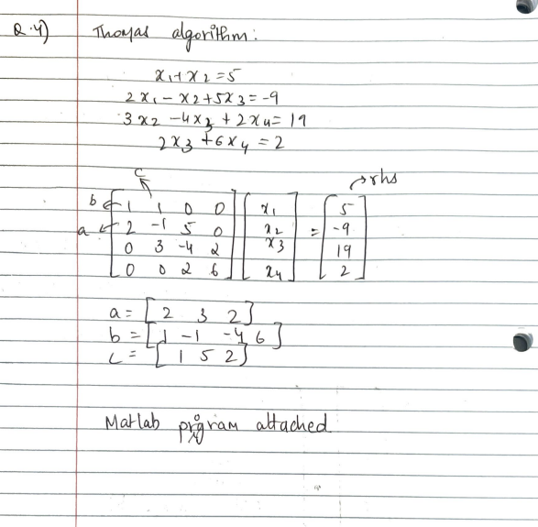

# Q4. Programs

* ***Script for Thomas algorithm:***

% Making a function for Thomas algorithm

function x = thomas_alg(a,b,c,rhs)

p = length(rhs);

c(1) = c(1)/b(1);

rhs(1) = rhs(1)/b(1);

b(1) = 1;

for i = 2:p

b(i) = b(i) - a(i-1)*c(i-1);

rhs(i) = rhs(i) - (a(i-1) * rhs(i-1));

if (i < p)

c(i) = c(i)/b(i);

end

rhs(i) = rhs(i)/b(i);

b(i) = 1;

end

% Gaussian elimination done.

% performing back substitution now

x(p) = rhs(p);

for j = p-1:-1:1

x(j) = (rhs(j)-(c(j)*x(j+1)));

end

x = x';

* ***Driver to run the above function***

% Q4 driver  
  
a = [2 3 2];  
b = [1 -1 -4 6];  
c = [1 5 2];  
rhs = [5 -9 19 2];  
  
x = thomas_alg(a,b,c,rhs)

* ***Matlab Output:***

x =  
  
 2.0000  
 3.0000  
 -2.0000  
 1.0000

[*Published with MATLAB® R2021a*](https://www.mathworks.com/products/matlab)