ME 594 - Numerical Methods

Fall 2022

Curve fitting IMU data.

Report by,

Viral Panchal

Introduction

Inertial measurement unit – IMU is a highly used sensor in robotics. By using accelerometer, gyroscope and magnetometer, it can measure angular velocity, orientation, acceleration, and a body’s specific force as well. This sensor is useful to maneuver modern vehicles, either ground or aerial. It is used in missiles, aircrafts, satellites, to measure altitude and heading reference systems. This useful device has been miniaturized in size in past few decades. Today it is available in extremely small packages which makes its application further wide. Because of the small packages, it can be used in manipulator robotics, indoor drones, bio-robotic systems, etc.

Figure 1 shows a sample IMU sensor available in the market. Sensors from different manufacturers have some difference but typically an IMU sensor, as it is switched on starts measuring several physics parameters like angular velocity (in X,Y,Z), acceleration (in X,Y,Z), orientation, etc. and saves the quaternion data either on an onboard storage memory or connected control station. The frequency of data being measured very high and hence for a 60 second testing, user may end up with a hundreds of data readings.

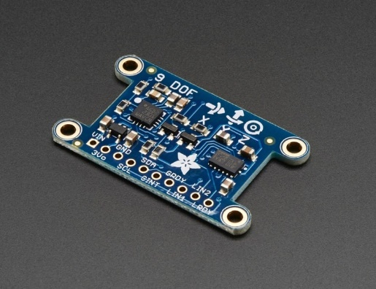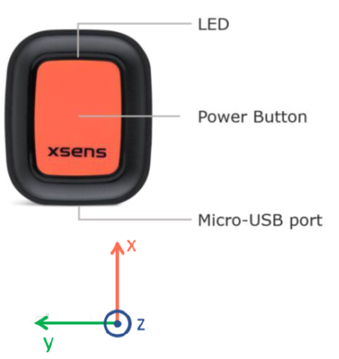

Figure 1: [a][b]

In this project, a comparison between curve fitting techniques, mainly Least Squares Methods and Cubic Splines method will be carried out. The idea is to implement the least squares method and cubic splines method to fit a curve for the sample data collected using a “Xsens dot” IMU sensor, See figure 1[b]. The purpose of doing this comparison is to understand the performance of these algorithms when the sample size is extremely huge and complex. Moreover, sample data and examples done in class had a particular trend of either increase or decreasing. In this project, the goal is to determine which algorithm is best suited when the data is similar to a sinusoidal/ repeating periodically kind of trend.

The figure below is a plot of raw data which gives an idea the kind of data that will be considered for this project. Increasing and decreasing magnitudes, area crowded with large number of readings, and complicated magnitudes.

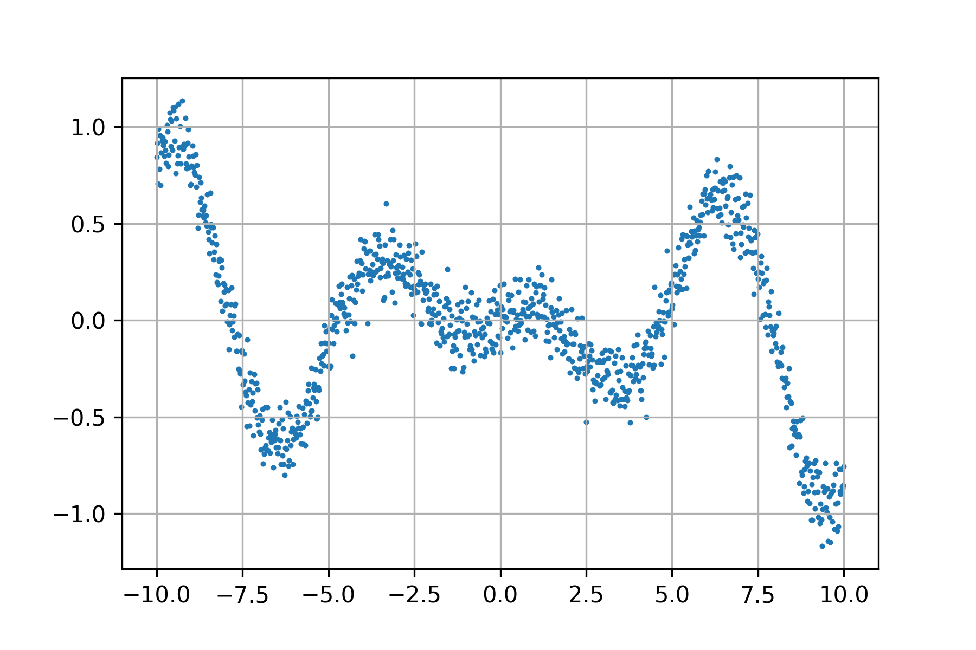

Figure 2

Looking at the data and the algorithms, an initial hypothesis was made, least squares method would be an easier approach, but the result achieved may be highly inaccurate and useless. For which an experiment could be done to increase the order of the polynomial and come up with an order which gives a good output, i.e., results to a plot which is not very far from the original raw plot. On the other hand, it was clear that a program for cubic splines would be difficult, but the output would be immaculate and very similar to the original raw plot.

In the following sections, literature on the applied numerical methods and discussion on concepts, algorithm, and implementation will be covered. Finally, results achieved will be discussed and a conclusion made from the whole project will be presented.

Numerical Methods

# Least Squares Method

This is a highly used method to find the best fit for a set of data points. In this approach, the sum of the offsets or residuals are minimized and plotted. This is a useful technique to predict the behavior of a dependent variable if some of the training data is with input and output is known to the user.

As mentioned above, in this project the sample size is huge, and the trend is repetitive as seen from the raw plot. Considering a line equation as the go-to function and plotting it would make it easier to reach to a solution, but it is highly unlikely that the solution will be of any help to predict any behavior.

And hence, a sample test with a line equation (Y = mx + c) as the function was done but immediately the focus was shifted towards making a generic least squares algorithm which could increase the order of the polynomial by one in every attempt and determine an order which would have the error less than the tolerance and provide a plot finally.

This idea of making a generic least squares algorithm was influenced by looking at patterns of similarity in the equations and matrices being generated as the order was increase manually and as the program was modified every time when the order was increased.

**Concept – Simple least squares for line equation**

Let’s consider a simple line equation/ linear least square. The process reduces to two equations,

= A * + B * N …. Eq.1

= A * + B * .…Eq.2

The above two equations can then be converted to matrices to compute the A and B variables. The matrices are as follows,

= ……Eq.3

**“X” matrix**

**“RHS” / “Y function” matrix**

**“C” / “Coefficient” matrix**

The above matrix could be easily solved in MATLAB where,

N 🡪 Number of data points

🡪 Sum of all “X” data points

🡪 Sum of all “” data points

🡪 Sum of all “Y” data points

🡪 Sum of product of all “X” and “Y” data points

To find the coefficient variables, an inverse of “X” matrix is computed and is pre-multiplied with the “RHS”/”Y function” matrix.

**C = * RHS**

The “X” matrix is always square since the rows increase as the order of the polynomial is increased.

**Concept – Generic least squares method.**