ME 635: Modeling and Simulation   
Homework 5

Finite Element method

10/11/2022

I pledge my honor that I have abided by the Stevens Honor System

Submitted by,

Viral Panchal

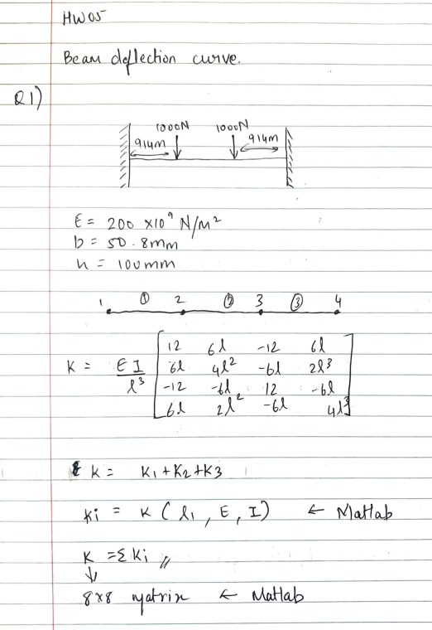

# **Q1 MATLAB program:**

%ME635 - HW05 - Q1  
%Viral Panchal  
  
close all  
clear all  
clc  
  
l = 3048*(10^-3);  
x = 0:0.001:l;  
E = 200*(10^9);  
I = (50.8*(10^-3))*((100*(10^-3))^3)/12;  
l1 = 914*(10^-3);  
l3 = 914*(10^-3);  
l2 = l-l1-l3;  
  
p2 = -1000;  
m2 = 0;  
p3 = -1000;  
m3 = 0;  
  
k1 = global_stiff(l1,E,I);  
fprintf('k1 = \n');  
disp(k1)  
k2 = global_stiff(l2,E,I);  
fprintf('k2 = \n');  
disp(k2)  
k3 = global_stiff(l3,E,I);  
fprintf('k3 = \n');  
disp(k3)  
  
fprintf('K = k1 + k2 + k3 \n\n');  
k_final = zeros(8);  
k_final(1:4,1:4) = k1;  
k_final(3:6,3:6) = k_final(3:6,3:6) + k2;  
k_final(5:8,5:8) = k_final(5:8,5:8) + k3;  
fprintf('K =\n');  
disp(k_final)  
  
% Calculation forces and displacements  
force_vec = [p2 m2 p3 m3]';  
displacement_vec = [0; 0; k_final(3:6,3:6)\force_vec; 0;0];  
force_vec = k_final*displacement_vec;  
fprintf('Force = \n');  
disp(force_vec)  
  
% Caculating the points on the equation  
eq_1 = displacement(displacement_vec(1),displacement_vec(2),displacement_vec(3),displacement_vec(4),l1,0:0.01:1);  
eq_2 = displacement(displacement_vec(3),displacement_vec(4),displacement_vec(5),displacement_vec(6),l2,0:0.01:1);  
eq_3 = displacement(displacement_vec(5),displacement_vec(6),displacement_vec(7),displacement_vec(8),l3,0:0.01:1);  
plot(linspace(0,l1,101),eq_1)  
hold on  
plot(linspace(l1,l1+l2,101),eq_2)  
hold on  
plot(linspace(l1+l2,l1+l2+l3,101),eq_3)  
legend('Eq_1','Eq_2','Eq_3')  
grid on

## **Global_stiff – function**

function K = global_stiff(l,E,I)

K = ((E*I)/(l^3))* [12 6*l -12 6*l

6*l 4*l^2 -6*l 2*l^2

-12 -6*l 12 -6*l

6*l 2*l^2 -6*l 4*l^2];

end

## **Displacement – function**

function V = displacement(V1,tet1,V2,tet2,Lin,zet)

V = (1-3*zet.*zet+2*zet.*zet.*zet)*V1 + Lin*(zet-2*zet.*zet+zet.*zet.*zet)*tet1+(3*zet.*zet-2*zet.*zet.*zet)*V2+Lin*(zet.*zet.*zet-zet.*zet)*tet2;

end

## **Matlab Output:**

k1 =   
 1.0e+07 *  
  
 1.3306 0.6081 -1.3306 0.6081  
 0.6081 0.3705 -0.6081 0.1853  
 -1.3306 -0.6081 1.3306 -0.6081  
 0.6081 0.1853 -0.6081 0.3705  
  
k2 =   
 1.0e+06 *  
  
 5.5952 3.4131 -5.5952 3.4131  
 3.4131 2.7760 -3.4131 1.3880  
 -5.5952 -3.4131 5.5952 -3.4131  
 3.4131 1.3880 -3.4131 2.7760  
  
k3 =   
 1.0e+07 *  
  
 1.3306 0.6081 -1.3306 0.6081  
 0.6081 0.3705 -0.6081 0.1853  
 -1.3306 -0.6081 1.3306 -0.6081  
 0.6081 0.1853 -0.6081 0.3705  
  
K = k1 + k2 + k3   
  
K =  
 1.0e+07 *  
  
 Columns 1 through 7  
  
 1.3306 0.6081 -1.3306 0.6081 0 0 0  
 0.6081 0.3705 -0.6081 0.1853 0 0 0  
 -1.3306 -0.6081 1.8901 -0.2668 -0.5595 0.3413 0  
 0.6081 0.1853 -0.2668 0.6481 -0.3413 0.1388 0  
 0 0 -0.5595 -0.3413 1.8901 0.2668 -1.3306  
 0 0 0.3413 0.1388 0.2668 0.6481 -0.6081  
 0 0 0 0 -1.3306 -0.6081 1.3306  
 0 0 0 0 0.6081 0.1853 -0.6081  
  
 Column 8  
  
 0  
 0  
 0  
 0  
 0.6081  
 0.1853  
 -0.6081  
 0.3705  
  
Force =   
 1.0e+03 *  
  
 1.0000  
 0.6399  
 -1.0000  
 0.0000  
 -1.0000  
 0  
 1.0000

-0.6399

[*Published with MATLAB® R2021a*](https://www.mathworks.com/products/matlab)

# **Q2 MATLAB Program:**

% ME635 - HW05 - Q2  
% ViralPanchal  
  
close all  
clear all  
clc  
  
l = 3048*(10^-3);  
x = 0:0.001:l;  
E = 200*(10^9);  
I = (50.8*(10^-3))*((100*(10^-3))^3)/12;  
l1 = 914*(10^-3);  
l3 = 914*(10^-3);  
l2 = l - l1 - l3;  
  
q = -1640;  
p2 = q*l2/2;  
m2 = q*l2^2/12;  
p3 = q*l2/2;  
m3 = -q*l2^2/12;  
  
k1 = global_stiff(l1,E,I);  
fprintf('k1 = \n');  
disp(k1)  
k2 = global_stiff(l2,E,I);  
fprintf('k2 = \n');  
disp(k2)  
k3 = global_stiff(l3,E,I);  
fprintf('k3 = \n');  
disp(k3)  
  
fprintf('K = k1 + k2 + k3 \n\n');  
k_final = zeros(8);  
k_final(1:4,1:4) = k1;  
k_final(3:6,3:6) = k_final(3:6,3:6) + k2;  
k_final(5:8,5:8) = k_final(5:8,5:8) + k3  
  
% Calculation forces and displacements  
force_vec = [p2 m2 p3 m3]';  
displacement_vec = [0; 0; k_final(3:6,3:6)\force_vec; 0;0];  
force_vec = k_final*displacement_vec;  
fprintf('Force = \n');  
disp(force_vec)  
  
% Caculating the points on the equation  
eq_1 = displacement(displacement_vec(1),displacement_vec(2),displacement_vec(3),displacement_vec(4),l1,0:0.01:1);  
eq_2 = displacement(displacement_vec(3),displacement_vec(4),displacement_vec(5),displacement_vec(6),l2,0:0.01:1);  
eq_3 = displacement(displacement_vec(5),displacement_vec(6),displacement_vec(7),displacement_vec(8),l3,0:0.01:1);  
plot(linspace(0,l1,101),eq_1)  
hold on  
plot(linspace(l1,l1+l2,101),eq_2)  
hold on  
plot(linspace(l1+l2,l1+l2+l3,101),eq_3)  
legend('Eq_1','Eq_2','Eq_3')  
grid on  
  
% Slope  
slope_eq = zeros();  
for r = 1:(length(eq_1)-1)  
 slope_eq(r,1) = ((eq_1(1,r+1)-eq_1(1,r))/l1)*100;  
 slope_eq(r,2) = ((eq_2(1,r+1)-eq_2(1,r))/l2)*100;  
 slope_eq(r,3) = ((eq_3(1,r+1)-eq_3(1,r))/l3)*100;  
end  
  
figure  
plot(linspace(0,l1,100),slope_eq(:,1))  
hold on  
plot(linspace(l1,l1+l2,100),slope_eq(:,2))  
hold on  
plot(linspace(l1+l2,l1+l2+l3,100),slope_eq(:,3))  
legend('eq_1','eq_2','eq_3')  
grid on  
title('Slope plot');

## **Global_stiff – function**

function K = global_stiff(l,E,I)

K = ((E*I)/(l^3))* [12 6*l -12 6*l

6*l 4*l^2 -6*l 2*l^2

-12 -6*l 12 -6*l

6*l 2*l^2 -6*l 4*l^2];

end

## **Displacement – function**

function V = displacement(V1,tet1,V2,tet2,Lin,zet)

V = (1-3*zet.*zet+2*zet.*zet.*zet)*V1 + Lin*(zet-2*zet.*zet+zet.*zet.*zet)*tet1+(3*zet.*zet-2*zet.*zet.*zet)*V2+Lin*(zet.*zet.*zet-zet.*zet)*tet2;

end

## **Matlab Output:**

k1 =   
 1.0e+07 *  
  
 1.3306 0.6081 -1.3306 0.6081  
 0.6081 0.3705 -0.6081 0.1853  
 -1.3306 -0.6081 1.3306 -0.6081  
 0.6081 0.1853 -0.6081 0.3705  
  
k2 =   
 1.0e+06 *  
  
 5.5952 3.4131 -5.5952 3.4131  
 3.4131 2.7760 -3.4131 1.3880  
 -5.5952 -3.4131 5.5952 -3.4131  
 3.4131 1.3880 -3.4131 2.7760  
  
k3 =   
 1.0e+07 *  
  
 1.3306 0.6081 -1.3306 0.6081  
 0.6081 0.3705 -0.6081 0.1853  
 -1.3306 -0.6081 1.3306 -0.6081  
 0.6081 0.1853 -0.6081 0.3705  
  
K = k1 + k2 + k3   
  
  
k_final =  
  
 1.0e+07 *  
  
 Columns 1 through 7  
  
 1.3306 0.6081 -1.3306 0.6081 0 0 0  
 0.6081 0.3705 -0.6081 0.1853 0 0 0  
 -1.3306 -0.6081 1.8901 -0.2668 -0.5595 0.3413 0  
 0.6081 0.1853 -0.2668 0.6481 -0.3413 0.1388 0  
 0 0 -0.5595 -0.3413 1.8901 0.2668 -1.3306  
 0 0 0.3413 0.1388 0.2668 0.6481 -0.6081  
 0 0 0 0 -1.3306 -0.6081 1.3306  
 0 0 0 0 0.6081 0.1853 -0.6081  
  
 Column 8  
  
 0  
 0  
 0  
 0  
 0.6081  
 0.1853  
 -0.6081  
 0.3705  
  
Force =   
 1.0e+03 *  
  
 1.0004  
 0.7216  
 -1.0004  
 -0.2034  
 -1.0004  
 0.2034  
 1.0004  
 -0.7216

[*Published with MATLAB® R2021a*](https://www.mathworks.com/products/matlab)