% ME635 - HW05 - Q2
% ViralPanchal
close all
clear all
clc
l = 3048*(10^-3);
x = 0:0.001:l;
E = 200*(10^9);
I = (50.8*(10^-3))*((100*(10^-3))^3)/12;
l1 = 914*(10^-3);
l3 = 914*(10^-3);
l2 = l - l1 - l3;
q = -1640;
p2 = q*l2/2;
m2 = q*l2^2/12;
p3 = q*l2/2;
m3 = -q*l2^2/12;
k1 = global_stiff(l1,E,I);
fprintf('k1 = \n');
disp(k1)
k2 = global_stiff(l2,E,I);
fprintf('k2 = \n');
disp(k2)
k3 = global_stiff(l3,E,I);
fprintf('k3 = \n');
disp(k3)
fprintf('K = k1 + k2 + k3 \n\n');
k_final = zeros(8);
k_final(1:4,1:4) = k1;
k_final(3:6,3:6) = k_final(3:6,3:6) + k2;
k_final(5:8,5:8) = k_final(5:8,5:8) + k3
% Calculation forces and displacements
force_vec = [p2 m2 p3 m3]';
displacement_vec = [0; 0; k_final(3:6,3:6)\force_vec; 0;0];
force_vec = k_final*displacement_vec;
fprintf('Force = \n');
disp(force_vec)
% Caculating the points on the equation
eq_1 = displacement(displacement_vec(1),displacement_vec(2),displacement_vec(3),displacement_vec(4),l1,0:0.01:1);
eq_2 = displacement(displacement_vec(3),displacement_vec(4),displacement_vec(5),displacement_vec(6),l2,0:0.01:1);
eq_3 = displacement(displacement_vec(5),displacement_vec(6),displacement_vec(7),displacement_vec(8),l3,0:0.01:1);
plot(linspace(0,l1,101),eq_1)
hold on
plot(linspace(l1,l1+l2,101),eq_2)
hold on
plot(linspace(l1+l2,l1+l2+l3,101),eq_3)
legend('Eq_1','Eq_2','Eq_3')
grid on
% Slope
slope_eq = zeros();
for r = 1:(length(eq_1)-1)
slope_eq(r,1) = ((eq_1(1,r+1)-eq_1(1,r))/l1)*100;
slope_eq(r,2) = ((eq_2(1,r+1)-eq_2(1,r))/l2)*100;
slope_eq(r,3) = ((eq_3(1,r+1)-eq_3(1,r))/l3)*100;
end
figure
plot(linspace(0,l1,100),slope_eq(:,1))
hold on
plot(linspace(l1,l1+l2,100),slope_eq(:,2))
hold on
plot(linspace(l1+l2,l1+l2+l3,100),slope_eq(:,3))
legend('eq_1','eq_2','eq_3')
grid on
title('Slope plot');
k1 =
1.0e+07 *
1.3306 0.6081 -1.3306 0.6081
0.6081 0.3705 -0.6081 0.1853
-1.3306 -0.6081 1.3306 -0.6081
0.6081 0.1853 -0.6081 0.3705
k2 =
1.0e+06 *
5.5952 3.4131 -5.5952 3.4131
3.4131 2.7760 -3.4131 1.3880
-5.5952 -3.4131 5.5952 -3.4131
3.4131 1.3880 -3.4131 2.7760
k3 =
1.0e+07 *
1.3306 0.6081 -1.3306 0.6081
0.6081 0.3705 -0.6081 0.1853
-1.3306 -0.6081 1.3306 -0.6081
0.6081 0.1853 -0.6081 0.3705
K = k1 + k2 + k3
k_final =
1.0e+07 *
Columns 1 through 7
1.3306 0.6081 -1.3306 0.6081 0 0 0
0.6081 0.3705 -0.6081 0.1853 0 0 0
-1.3306 -0.6081 1.8901 -0.2668 -0.5595 0.3413 0
0.6081 0.1853 -0.2668 0.6481 -0.3413 0.1388 0
0 0 -0.5595 -0.3413 1.8901 0.2668 -1.3306
0 0 0.3413 0.1388 0.2668 0.6481 -0.6081
0 0 0 0 -1.3306 -0.6081 1.3306
0 0 0 0 0.6081 0.1853 -0.6081
Column 8
0
0
0
0
0.6081
0.1853
-0.6081
0.3705
Force =
1.0e+03 *
1.0004
0.7216
-1.0004
-0.2034
-1.0004
0.2034
1.0004
-0.7216
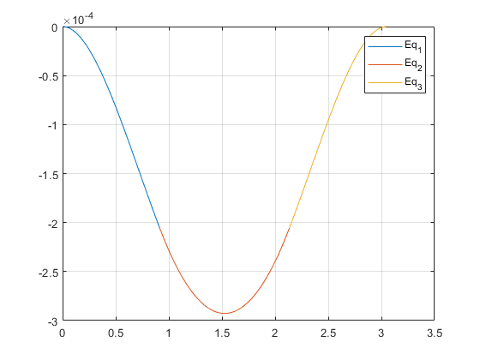
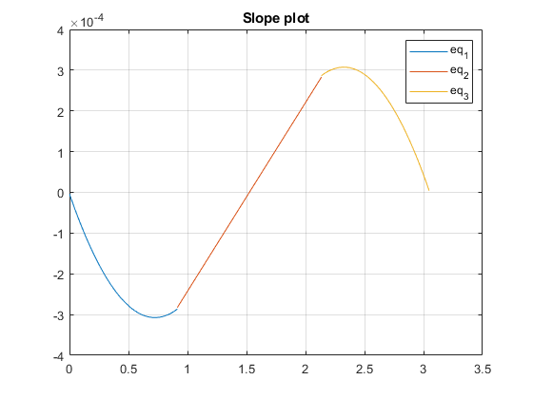
Published with MATLAB® R2021a

