MongoDB is a document-oriented open-source NoSQL database. It is one of the most popular and widely used NoSQL databases.
The following command switch to the "humanResouredb" database. If it does not exist then creates it.
use humanResourceDB

To check all the databases, use the show dbs command.

To delete a database, use the db.dropDatabase() method which deletes a current database.

MongoDB Collections
A collection in MongoDB is similar to a table in RDBMS. MongoDB collections do not enforce schemas. Each MongoDB collection can have multiple documents. A document is equilant to row in a table in RDBMS.
To create a collection, use the db.createCollection() command.

For example: db.createCollection(“Employees”) creates employee collection in your current database.

Use the show collections commands to list all the collections in a database.

To delete a collection, use the db.<collection-name>.drop() method.
Example: db.employee.drop()

MongoDB Documents: Document, Array, Embedded Document
In the RDBMS database, a table can have multiple rows and columns. Similarly in MongoDB, a collection can have multiple documents which are equivalent to the rows. Each document has multiple "fields" which are equivalent to the columns. So in simple terms, each MongoDB document is a record and a collection is a table that can store multiple documents.
The following chart shows MONGODB’s database, collection, document
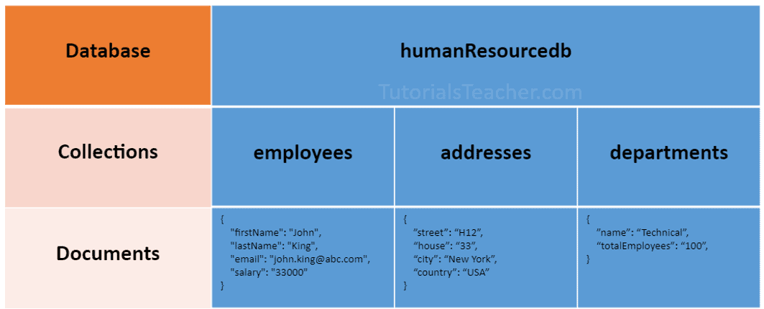

The following is an example of a document that contains an array and an embedded document.
{
"_id": ObjectId("32521df3f4948bd2f54218"),
"firstName": "John",
"lastName": "King",
"email": "john.king@abc.com",
"salary": "33000",
"DoB": new Date('Mar 24, 2011'),
"skills": [ "Angular", "React", "MongoDB" ],
"address": {
"street":"Upper Street",
"house":"No 1",
"city":"New York",
"country":"USA"
}
}

MongoDB stores data in key-value pairs as a BSON document. BSON is a binary representation of a JSON document that supports more data types than JSON. MongoDB drivers convert JSON document to BSON data.

Points to remember:
- MongoDB reserves _id name for use as a unique primary key field that holds ObjectId type. However, you are free to give any name you like with any data type other than the array.
- A document field name cannot be null but the value can be.
- Most MongoDB documents cannot have duplicate field names. However, it depends on the driver you use to store a document in your application.
- A document fields can be without quotation marks " " if it does not contain spaces, e.g. { name: "Steve"}, { "first name": "Steve"} are valid fields.
- Use the dot notation to access array elements or embedded documents.
- MongoDB supports maximum document size of 16mb. Use GridFS to store more than 16 MB document.
- Fields in a BSON document are ordered. It means fields order is important while comparing two documents, e.g. {x: 1, y: 2} is not equal to {y: 2, x: 1}
- MogoDB keeps the order of the fields except _id field which is always the first field.
- MongoDB collection can store documents with different fields. It does not enforce any schema.
The following is an embedded document where the department and address field contains another document.
{
_id: ObjectId("32521df3f4948bd2f54218"),
firstName: "John",
lastName: "King",
department: {
_id: ObjectId("55214df3f4948bd2f8753"),
name:"Finance"
},
address: {
phone: { type: "Home", number: "111-000-000" }
}
}

MongoDB - Insert Single Document in a Collection using insertOne()
In MongoDB, a collection represents a table in RDBMS and a document is like a record in a table. Learn how to insert a single document into a collection.
MongoDB provides the following methods to insert documents into a collection:
- insertOne() - Inserts a single document into a collection.
- insert() - Inserts one or more documents into a collection.
- insertMany() - Insert multiple documents into a collection.
Example:
db.employees.insertOne({
firstName: "John",
lastName: "King",
email: "john.king@abc.com"
})

Use the find() to list all data of a collection, and the pretty() method to format resulted data.
db.employees.find().pretty()

Insert _id Manually
It is not necessary to insert auto-generated _id value. You can manually specify a unique value for the _id field, as shown below.
db.employees.insertOne({
_id:"1",
firstName: "John",
lastName: "King",
email: "john.king@abc.com"
})

MongoDB - Insert Multiple Documents in a Collection
The db.<collection>.insert() method inserts one document or an array of documents into a collection.
db.employees.insertMany([
{
_id:1,
firstName: "John",
lastName: "King",
email: "john.king@abc.com",
salary: 5000
},
{
_id:2,
firstName: "Sachin",
lastName: "T",
email: "sachin.t@abc.com",
salary: 8000
},
{
_id:3,
firstName: "James",
lastName: "Bond",
email: "jamesb@abc.com",
salary: 7500
},
{
_id:4,
firstName: "Steve",
lastName: "J",
email: "steve.j@abc.com",
salary: 9000

},
{
_id:5,
firstName: "Kapil",
lastName: "D",
email: "kapil.d@abc.com",
salary: 4500

},
{
_id:6,
firstName: "Amitabh",
lastName: "B",
email: "amitabh.b@abc.com",
salary: 11000
}
])

MongoDB: Find Single Document from Collection using findOne()

findOne()
The findOne() method returns the first document that is matched with the specified criteria.
db.employees.findOne()

db.employees.findOne({firstName: "Kapil"})

db.employees.findOne({_id:10})

Projection
Use the projection parameter to specify the fields to be included in the result.

db.employees.findOne({firstName: "Sachin"}, {firstName:1, lastName:1})

MongoDB: Find Documents in Collection using find()
db.employees.find({salary: 7000})

db.employees.find({salary: {$gt: 7000}})

db.employees.find({salary: {$gt: 7000, $lt: 8000}})

db.employees.find({ "department.name": "Finance"})

PROJECTION
db.employe
es.find({salary: 7000}, {firstName:1, lastName:1})

db.employees.findOne({firstName: "Sachin"}, {_id: 0, firstName:1, lastName:1})

Sort Documents in MongoDB Collection
Syntax
db.collection.find().sort(document)

Example:
The following example sorts the employees collection in the ascending order of the firstName field.

db.employees.find().sort({ firstName:1 })

In MONGO DB, we can use CURSOR also to iterate.
You can use the cursor object to sort the result. The following returns the same result as above.
Example:
var cursor = db.employees.find()
cursor.sort({ firstName:1 })

What is the output of the following queries:
db.employees.find().sort({ _id: -1 })// sorts by descending order of _id

db.employees.find().sort({ salary: -1 })// sorts by descending order of salary

db.employees.find({salary: {$gt:5000}}).sort({ salary: -1 })// find where salary > 5000 and sorts the result by descending order of salary

db.employees.find().sort({ firstName:1, salary: -1 })// sorts by ascending order of firstName and descending order of salary
db.employees.find().sort({"department.name":1}) // sorts by embedded doc department.name

Update Single Document using updateOne() in MongoDB

The following updates a single field in a single document in employees collection.
db.employees.updateOne({_id:1}, { $set: {firstName:'Morgan'}})

The updateOne() method adds the specified field if it does not exist in a matching document. For example, the following will add the location field.

db.employees.updateOne({firstName:"Steve"}, { $set: {location: "USA"}})

Use the $inc update operator to increase the value of the field by the specified amount.
db.employees.updateOne({firstName:"Steve"}, { $inc: {salary: 500}})

You can also specify multiple fields to update. The following updates email and lastName fields.
db.employees.updateOne({_id:2}, { $set: {lastName:"Tendulkar", email:"sachin.tendulkar@abc.com"}})

db.employees.updateOne({salary:7000}, { $set: {salary:7500}})

Update Multiple Documents using updateMany() in MongoDB
The following modifies matching documents using the updateMany() method in employees collection.

db.employees.updateMany({ salary:7000 }, { $set: { salary:8500 }})

db.employees.updateMany({firstName:"Steve"}, { $set: {location: "USA"}})

Overwrite Arrays
The $set operator overwrites the specified array instead of adding, removing, and updating array elements.
db.employees.updateMany({_id:5},{$set:{ skills:["Sales Tax"]}})

Update Array Elements

The following will update "Marketing" to "Public Speaking" in the skills array field to all the documents.

db.employees.updateMany(
{skills:"Marketing"},
{$set:{"skills.$":"Public Speaking"}})

Add New Element to Arrays

db.employees.updateMany(
{_id:3},
{$push:{"skills":"Sports"}}) // add "Sports" element to skills array

Students are expected to work on how to remove elements from array

MongoDB: Delete Documents in a Collection
MongoDB provides the following methods to delete one or more documents in a collection.
- db.collection.deleteOne() - Deletes the first matching document in a collection.
- db.collection.deleteMany() - Deletes all the matching documents in a collection

db.employees.deleteOne({ salary:7000 })

db.employees.deleteMany({ salary:7000 })

db.employees.deleteMany({ salary: { $lt:7000} })

db.employees.deleteMany({ }) //deletes all documents

Aggregation in MongoDB
Aggregation is the process of selecting data from a collection in MongoDB. It processes multiple documents and returns computed results.

- Using Aggregation Pipeline.
- Using single purpose aggregation methods: db.collection.estimatedDocumentCount(), db.collection.count() and db.collection.distinct().

Aggregation Pipelines
The aggregation pipeline is an array of one or more stages passed in the db.aggregate() or db.collection.aggregate() method.
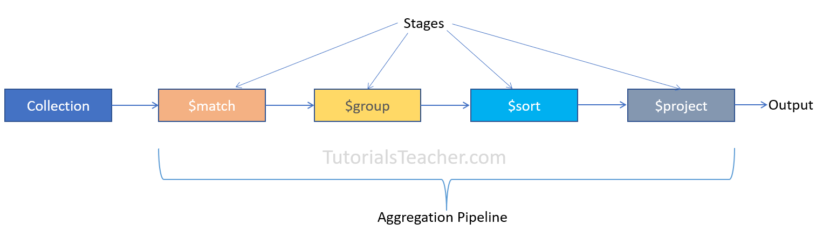
Aggregation pipeline includes stages, $match, $group, $sort, $project.

$match Stage

The $match stage is usually the first stage to select only the matching documents from a collection. It is equivalent to the Find() method. The following example demonstrates an aggregation pipeline with a single $match stage.

db.employees.aggregate([ {$match:{ gender: 'female'}} ])

$group Stage
Use the $group stage to group the input documents by the specified _id expression and returns a single document containing the accumulated values for each distinct group. Consider the following example.

db.employees.aggregate([
{ $group:{ _id:'$department.name'} }
])

Now, let's calculate the accumulated values for each group. The following calculates the number of employees in each department.

db.employees.aggregate([
{ $group:{ _id:'$department.name', totalEmployees: { $sum:1 } }
}])

Here, { $sum} is an accumulator operator and{ $sum:1 } adds 1 for each document that falls under the same group.

db.employees.aggregate([
{ $match:{ gender:'male'}},
{ $group:{ _id:{ deptName:'$department.name'}, totalSalaries: { $sum:'$salary'} }
}])

$sort Stage

The $sort stage is used to sort the documents based on the specified field in ascending or descending order. The following sorts all male employees.
db.employees.aggregate([
{ $match:{ gender:'male'}},
{ $sort:{ firstName:1}}
])

1 indicates the ascending order and -1 indicates descending order.

The following pipeline contains three stages to sort the groupped documents.

db.employees.aggregate([
{ $match:{ gender:'male'}},
{ $group:{ _id:{ deptName:'$department.name'}, totalEmployees: { $sum:1} } },
{ $sort:{ deptName:1}}
])

The operators in Mongo are:
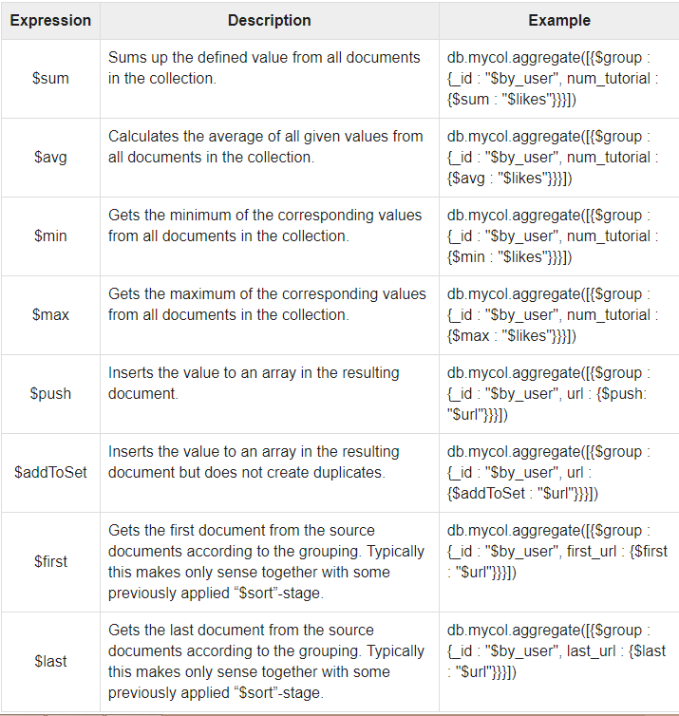

Indexing:

Indexes support the efficient execution of queries in MongoDB. Without indexes, MongoDB must perform a collection scan, i.e. scan every document in a collection, to select those documents that match the query statement. If an appropriate index exists for a query, MongoDB can use the index to limit the number of documents it must inspect.

Indexes are special data structures that store a small portion of the collection's data set in an easy to traverse form. The index stores the value of a specific field or set of fields, ordered by the value of the field.
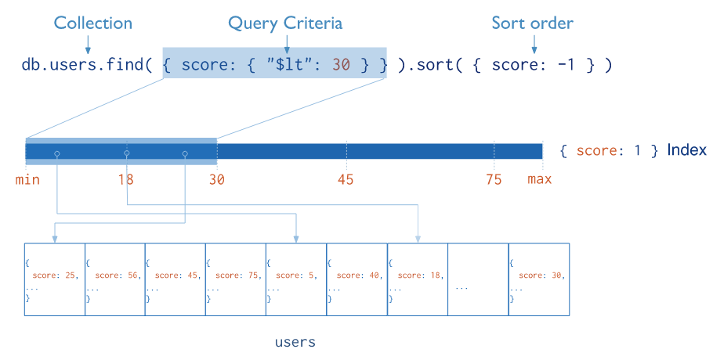

To create an index, we write
db.collection.createIndex( { name: -1 } )
1 and -1 indicate the sorted order to create indexes.

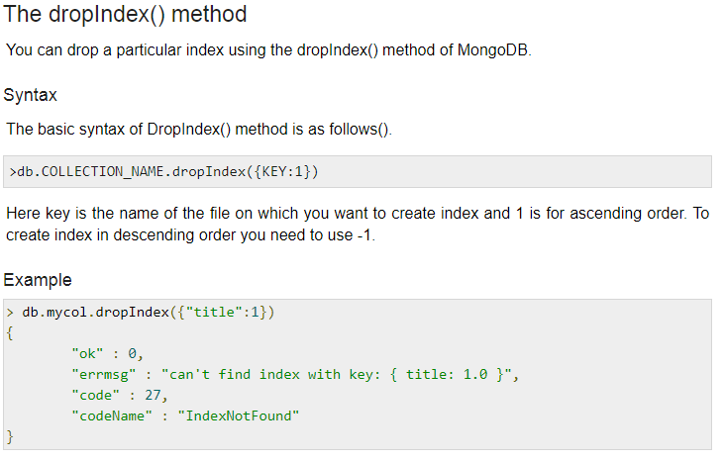

Exercises to complete:

- Create employee database.
- Insert many documents that has string, integer, date, array and embedded document.
- Retrieve all employees whose
- Salary is greater than 8000 and less than 10000
- All employees whose firstname starts with “A”. Project only id and firstname.
- All employees who belong to department “HR”
- All employees who have skillset as “C”,”C++”
- Highest salary of each department
- Average salary of each department. Sort department name in descending order
- No of employees in “HR” department
- Average of all the salaries.
- Update employee firstname of employee with _id: 3
- Update department name of employee with _id:5
- Update skillset of employee with _id:5
- Delete employee details of _id:6
- Create an index on salary field in employee collection. Retrieve the employee details whose salary is more than 8000.

Upload the above solution with screenshots in EXP:10 in lab experiments.

