Program No.08
PART A
(PART A: TO BE REFFERED BY STUDENTS)
A.1 Aim: Create an application with Node JS and mysql to perform CRUD operations

A.2 Prerequisite:

Javascript

A.3 Outcome:
After successful completion of these applications students will be able to
Understand and implement integrating Node JS with mysql.
A.4 Theory:
- Node.js is an open-source server side runtime environment built on Chrome's V8 JavaScript engine.
- It provides an event driven, non-blocking (asynchronous) I/O and cross-platform runtime environment for building highly scalable server-side application using JavaScript.
- Node.js can be used to build different types of applications such as command line application, web application, real-time chat application, REST API server etc.
- download a free MySQL database at https://www.mysql.com/downloads/
- To download and install the "mysql" module, open the Command Terminal and execute the following: C:\Users\Your Name>npm install mysql
- Now you have downloaded and installed a mysql database driver.
- Node.js can use the module to manipulate the MySQL database. var mysql = require('mysql');
- Start by creating a connection to the database. Use the username and password from your MySQL database.
- Implement CRUD operations
Tasks to be completed:
- Write a Node.js program to insert multiple student records into a MySQL table. Take name and age from the user. Auto increment ID.
- display all records from the students table.
- update student age where id=2.
- delete all students whose age < 18.
- Take student ID from user and delete the record.

PART B
(PART B: TO BE COMPLETED BY STUDENTS)
(Students must submit the soft copy as per following segments within two hours of the practical. The soft copy must be uploaded on the Blackboard or emailed to the concerned lab in charge faculties at the end of the practical in case the there is no Black board access available)
Roll No.A006 | Name: Aksh Soni
Program :MCA | Division:
Batch: 1 | Date of Experiment: 30-03-26
Date of Submission: 30-03-26 | Grade :

B.1 Output
Code:
const mysql = require('mysql');
const readline = require('readline');

// Create connection
const con = mysql.createConnection({
host: "localhost",
user: "root",
password: "",
database: "studentdb"
});

// Connect to MySQL
con.connect(function(err) {
if (err) throw err;
console.log("Connected to MySQL!");
startApp();
});

// Read input from user
const rl = readline.createInterface({
input: process.stdin,
output: process.stdout
});

// Main menu
function startApp() {
console.log("\n--- MENU ---");
console.log("1. Insert Students");
console.log("2. Display All Students");
console.log("3. Update Age where ID=2");
console.log("4. Delete Students Age < 18");
console.log("5. Delete Student by ID");
console.log("6. Exit");

rl.question("Choose option: ", function(choice) {
switch(choice) {
case '1': insertStudents(); break;
case '2': displayStudents(); break;
case '3': updateStudent(); break;
case '4': deleteYoungStudents(); break;
case '5': deleteById(); break;
case '6': rl.close(); break;
default: startApp();
}
});
}

function insertStudents() {
rl.question("How many students? ", function(num) {
let count = 0;

function insertOne() {
if (count == num) {
console.log("Inserted successfully!");
return startApp();
}

rl.question("Enter name: ", function(name) {
rl.question("Enter age: ", function(age) {

let sql = "INSERT INTO students (name, age) VALUES (?, ?)";
con.query(sql, [name, age], function(err) {
if (err) throw err;
console.log("Record inserted");
count++;
insertOne();
});
});
});
}

insertOne();
});
}

function displayStudents() {
con.query("SELECT * FROM students", function(err, result) {
if (err) throw err;
console.table(result);
startApp();
});
}

function updateStudent() {
rl.question("Enter new age for ID=2: ", function(newAge) {
let sql = "UPDATE students SET age=? WHERE id=2";
con.query(sql, [newAge], function(err, result) {
if (err) throw err;
console.log("Updated successfully!");
startApp();
});
});
}

function deleteYoungStudents() {
let sql = "DELETE FROM students WHERE age < 18";
con.query(sql, function(err, result) {
if (err) throw err;
console.log("Deleted students with age < 18");
startApp();
});
}

function deleteById() {
rl.question("Enter student ID to delete: ", function(id) {
let sql = "DELETE FROM students WHERE id=?";
con.query(sql, [id], function(err, result) {
if (err) throw err;
console.log("Student deleted!");
startApp();
});
});
}

Output:
Insert Students
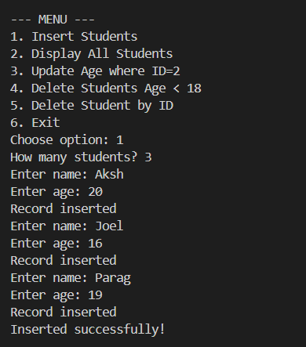
Display
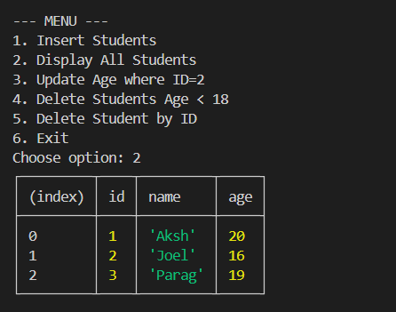

Update
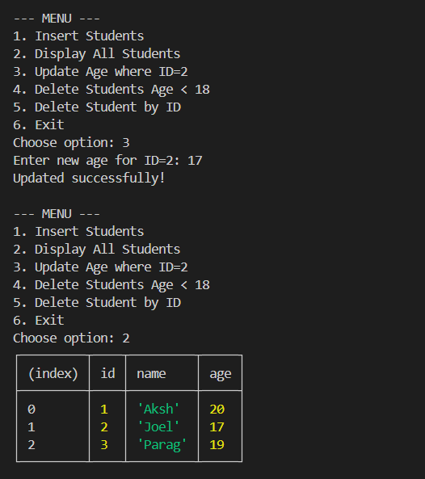

Delete (Age < 18)
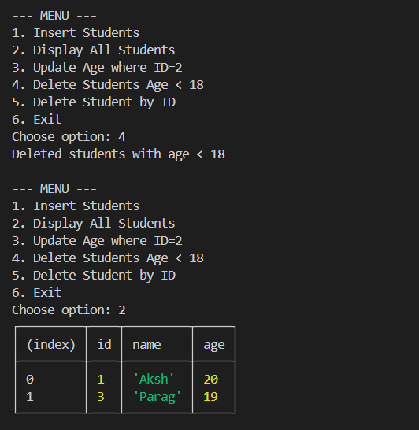
Delete
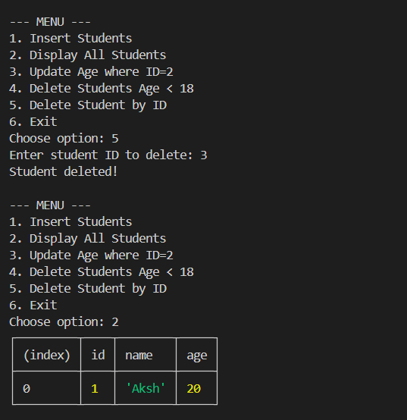

B.2 Observations/Learning
- Node.js uses an event-driven and non-blocking I/O model, which allows efficient handling of database operations.
- The MySQL createConnection() method is essential to establish communication between Node.js and the database.
- SQL queries such as INSERT, SELECT, UPDATE, and DELETE can be executed seamlessly from Node.js using the MySQL module.
- Proper error handling is necessary to ensure the application does not crash during database failures.
- The readline module allows interactive command-line input, making the application user-friendly.
- Auto-incrementing primary keys in MySQL simplify record insertion without manually managing IDs.

B.3Conclusion:
In this assignment, a Node.js application was successfully developed and integrated with a MySQL database to perform CRUD (Create, Read, Update, Delete) operations. The application demonstrated how Node.js can be used as a server-side runtime environment to interact with a relational database using the MySQL module. By implementing operations such as inserting multiple student records, displaying all records, updating data based on conditions, and deleting records using both predefined conditions and user input, the assignment fulfilled its objective of understanding database-driven application development. Overall, this experiment proved that Node.js provides an efficient, scalable, and flexible approach for backend development with MySQL.

