Lab - Week 2_A

PART A
(PART A: TO BE REFERRED BY STUDENTS)

Objective Students will learn the foundations of React, build simple functional and class components, and apply basic props and styling.

Expected Outcome

Students will build a React application that:
  - Utilizes functional and class components.
  - Handles props effectively and renders lists dynamically.

  - Applies dynamic styling based on user data. By the end, students will have a functional app showcasing user profiles with React's core features.
Write about your learnings and conclusions.

Theory:
- What is React?
  - A JavaScript library for building user interfaces, primarily for single-page applications.
  - Purpose: Simplify UI development by leveraging reusable components.

Key Concepts:
  - Component-based Architecture: Breaks UI into independent, reusable pieces.
  - Virtual DOM: Efficiently updates and renders UI changes.
  - Reusability: Promotes modular design with reusable components.

Pre Requisites:
Node and react project created with vite

- Functional and Class Components
- A component is a small, reusable piece of the UI. React applications are made by combining multiple components. One component can be used multiple times with different data.
  - Types:
  - Functional Components: Simplified syntax, focuses on props and hooks.
  - Class Components: Traditional React components with state and lifecycle methods.

Example: Can receive data using props.
function Greeting({ name }) {
return <h2>Hello, {name}</h2>;
}

Example: • Must include a render() method. • Access props using this.props
class WelcomeMessage extends React.Component {
render() {
return <h3>Welcome {this.props.title}</h3>;
}
}

- Props and List Rendering
  - Props: Pass data from parent to child components.
  - .map(): Loop through arrays to render lists dynamically.

Example:

<Book title="React Basics" author="John" />

Inside the component you write:

function Book({ title, author }) {
return <p>{title} by {author}</p>;
}

PART B
(PART B: TO BE COMPLETED BY STUDENTS)
Students must submit the soft copy as per following segments within two hours of the practical. The soft copy must be uploaded on the portal at the end of the practical. The filename should be AWT_batch_rollno_experimentno Example: AWT_A1_A001_P1

Roll No.:A006 | Name: Aksh Soni
Prog/Yr/Sem: 2 | Batch: 1
Date of Experiment: 27/01/2026 | Date of Submission: 07/02/2026

Question 1: Greeting Application
- Create a functional component named Greeting that accepts a name prop and displays a greeting message.
- Create a class component named WelcomeMessage that accepts a title prop and displays a welcome message.
- Use both components inside a parent App component.
- Set default props for the WelcomeMessage component.
Ans1: Code-
import React from "react";
const Greeting = ({ name }) => {
return <h2>Hello, {name}!</h2>;
};
class WelcomeMessage extends React.Component {
render() {
return <h1>Welcome, {this.props.title}!</h1>;
}
}
WelcomeMessage.defaultProps = {
title: "Guest",
};

const App = () => {
return (
<div>
<Greeting name="Student" />
<WelcomeMessage title="Developer" />
<WelcomeMessage /> {/* Uses default prop */}
</div>
);
};

export default App;

Output:
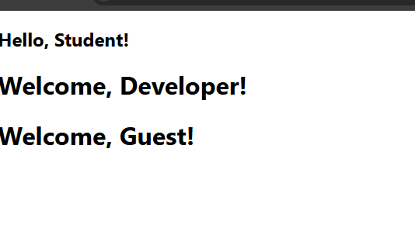

Question 2: Book and BookStore Components
- Create a functional component named Book that accepts the following props:
  - title
  - author
  - image
- Display the book title, author name, and image inside the Book component.
- Create a class component named BookStore that renders multiple Book components by passing props.
- Use the BookStore component inside the App component.
Ans: Code:
import React from "react";
function Book({ title, author, image }) {
return (
<div style={{ border: "1px solid #ccc", margin: "10px", padding: "10px" }}>
<img src={image} alt={title} width="120" />
<h3>{title}</h3>
<p>Author: {author}</p>
</div>
);
}
class BookStore extends React.Component {
render() {
return (
<div>
<h2>Book Store</h2>

<Book
title="React Basics"
author="John Doe"
image="https://m.media-amazon.com/images/I/81aBPehEf1L._UF1000,1000_QL80_.jpg"
/>

<Book
title="Exploring Javascript"
author="Dr. Axel Rauschmayer"
image="https://exploringjs.com/js/img/cover-homepage.jpg"
/>
<Book
title="Effective Javascript"
author="David Herman"
image="https://www.interviewbit.com/blog/wp-content/uploads/2022/01/Effective-JavaScript.jpg"
/>
</div>
);
}
}

function App() {
return (
<div>
<BookStore />
</div>
);
}

export default App;

Output:
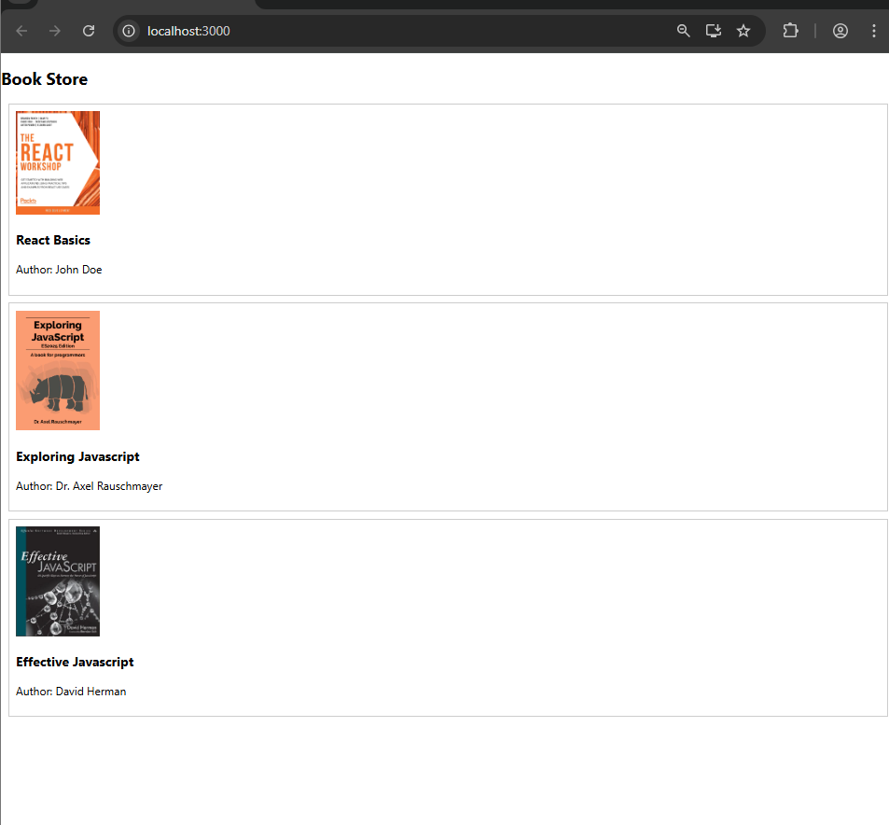

Question 3: Props and Component Reusability
- Explain how props are used to pass data from a parent component to a child component.
Ans1: Props (short for properties) are used to pass data from a parent component to a child component in component-based frameworks like React.
A parent component passes data to a child component by adding attributes to the child component when it is rendered. These attributes become props. The child component receives the props as an argument and uses them to display or process data.
Props allow data to flow in one direction, from parent to child, and they are read-only, meaning the child component cannot modify them.
This mechanism makes components reusable, since the same child component can be used with different data provided by different parent component.
Example: function Parent() {
return <Child message="Hello World" />;
}

function Child(props) {
return <p>{props.message}</p>;
}

- Demonstrate component reusability by rendering the Book component more than once with different prop values.
Ans2: Example
=>Book component
function Book(props) {
return (
<div>
<h3>{props.title}</h3>
<p>Author: {props.author}</p>
</div>
);
}

=> Rendering the Book component multiple times with different props
function Library() {
return (
<div>
<Book title="1984" author="George Orwell" />
<Book title="Harry Potter" author="J.K. Rowling" />
<Book title="The Alchemist" author="Paulo Coelho" />
</div>
);
}

Explanation
- The same Book component is reused multiple times.
- Each instance receives different prop values (title and author).
- This shows component reusability, as the component’s structure stays the same while the displayed data changes.

