Node JS with Mongo Code
Step 1: importing mongo module into node js file and specifying mongo server URL to connect to. remember, 27017 is the port no on which mongo runs.
var MongoClient = require('mongodb').MongoClient;
var url = "mongodb://localhost:27017/mydb";
Step 2:
- Connect nodejs program to mongo database.
- Create database: for example: mydb.
- create collection inside the database: for example: “student”
- insert documents in the collection. insertOne() and insertMany() are two functions used to insert documents in collection.
- retrieve documents from collection using find(). findOne() will retrieve first document from collection.
- find({}, {projection:{ _id: 0, name: 1,address:1} }), will display all documents from collection, but _id will not be displayed, name and address of all students will be printed.
- updateMany({name:"xyz"},{$set:{address:"delhi"}}, this will update student address to all student documents where name is “xyz”

To run the program.
Open cmd, go to the path where this program is saved. TYPE
npm install mongodb
this will install mongodb instance.
Then execute the program by typing node nameoftheprograms.js
The below code snippet will connect to database mydb

var MongoClient = require('mongodb').MongoClient;
var url = "mongodb://localhost:27017/mydb";
MongoClient.connect(url, function(err, db)
{
var dbo = db.db("mydb");
if (err) throw err;
console.log("Database created!");});

- The below code snippet will connect to database and inserts one document into the collection. the obj “myobj” has key value pairs to insert into collection.
var MongoClient = require('mongodb').MongoClient;
var url = "mongodb://localhost:27017/mydb";
//CRUD- CREATE, READ, UPDATE, DELETE
MongoClient.connect(url, function(err, db)
{
var dbo = db.db("student_db");
if (err) throw err;
console.log("Database created!");
var myobj = { name: "xyz", address: "mumbai",marks:74};
dbo.collection("student").insertOne(myobj, function(err, res) {
if (err) throw err;
console.log("1 document inserted");
});
});
- The following code snippet inserts multiple documents into collection. I have created an array of objects to insert into collection.
var MongoClient = require('mongodb').MongoClient;
var url = "mongodb://localhost:27017/mydb";
//CRUD- CREATE, READ, UPDATE, DELETE
MongoClient.connect(url, function(err, db)
{
var dbo = db.db("student_db");
if (err) throw err;
console.log("Database created!");
var myobj = { name: "xyz", address: "mumbai",marks:74};
//insert, insertOne,insertMany
dbo.collection("student").insertOne(myobj, function(err, res) {
if (err) throw err;
console.log("1 document inserted");
});
var myobj =[{ name: "xyz4", address: "mumbai",course:"awp",marks:90 },{ name: "xyz1", address: "mumbai",course:"awp",marks:87 },{ name: "xyz2", address: "mumbai",course:"awp",marks:40 },{ name: "xyz3", address: "mumbai",course:"awp",marks:65}];
dbo.collection("student").insertMany(myobj, function(err, res) {
if (err) throw err;
console.log("Many documents inserted");
});
});
- The following code snippet will retrieve document from collection
var MongoClient = require('mongodb').MongoClient;
var url = "mongodb://localhost:27017/mydb";
//CRUD- CREATE, READ, UPDATE, DELETE
MongoClient.connect(url, function(err, db)
{
var dbo = db.db("student_db");
if (err) throw err;
console.log("Database created!");
var myobj = { name: "xyz", address: "mumbai",marks:74};
dbo.collection("student").insertOne(myobj, function(err, res) {
if (err) throw err;
console.log("1 document inserted");
});
var myobj =[{ name: "xyz4", address: "mumbai",course:"awp",marks:90 },{ name: "xyz1", address: "mumbai",course:"awp",marks:87 },{ name: "xyz2", address: "mumbai",course:"awp",marks:40 },{ name: "xyz3", address: "mumbai",course:"awp",marks:65}];
dbo.collection("student").insertMany(myobj, function(err, res) {
if (err) throw err;
console.log("Many documents inserted");
});
dbo.collection("student").findOne({}, function(err, result) {
if (err) throw err;
console.log(result); //result will have id,name, address
});
});
- Similary update and delete (the final code)
var MongoClient = require('mongodb').MongoClient;
var url = "mongodb://localhost:27017/mydb";
//CRUD- CREATE, READ, UPDATE, DELETE
MongoClient.connect(url, function(err, db)
{
var dbo = db.db("mydb");
//var collection="student";
if (err) throw err;
console.log("Database created!");
var myobj = { name: "xyz", address: "mumbai",marks:74};
//insert, insertOne,insertMany

dbo.collection("student").insertOne(myobj, function(err, res) {
if (err) throw err;
console.log("1 document inserted");
});
var myobj =[{ name: "xyz4", address: "mumbai",course:"awp",marks:90 },{ name: "xyz1", address: "mumbai",course:"awp",marks:87 },{ name: "xyz2", address: "mumbai",course:"awp",marks:40 },{ name: "xyz3", address: "mumbai",course:"awp",marks:65}];
dbo.collection("student").insertMany(myobj, function(err, res) {
if (err) throw err;
console.log("Many documents inserted");
});
dbo.collection("student").find({}, {projection:{ _id: 0, name: 1,address:1} }).toArray(function(err, result) {
if (err) throw err;
console.log(result);
});
dbo.collection("student").updateMany({name:'xyz'},{$set:{address:"delhi"}},function(err, result){
if (err) throw err;
console.log("document updated");
});
var myquery = {address: /^d/};
dbo.collection("student").deleteMany(myquery, function(err, obj) {
if (err) throw err;
console.log("document(s) deleted");
});

});

Roll No.: A006 | Name: Aksh Soni
Prog/Yr/Sem: MCA Sem 2 | Batch: B1
Date of Experiment: | Date of Submission: 18/04/2026

Step 1:
- npm init -y
- npm i mongodb
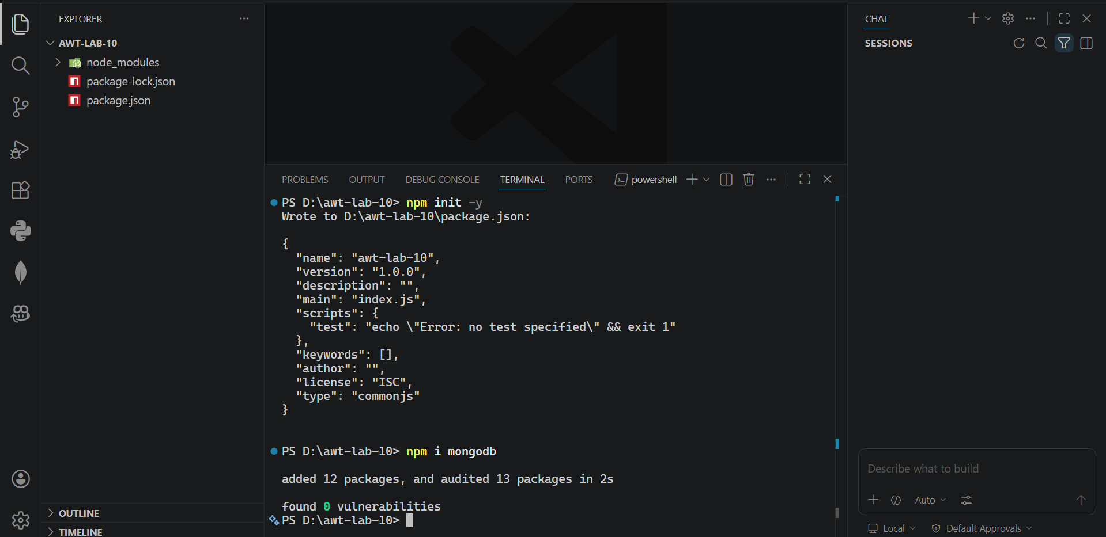

Step 2:
app.js
const { MongoClient } = require("mongodb");

const url = "mongodb://localhost:27017/mydb";

async function main() {
const client = new MongoClient(url);
try {
await client.connect();
console.log("Database created!");
} catch (err) {
console.error("Connection failed:", err.message);
} finally {
await client.close();
}
}

main();
O/P –
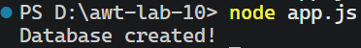

Step 3:
app.js
const { MongoClient } = require("mongodb");

const url = "mongodb://localhost:27017/mydb";

async function main() {
const client = new MongoClient(url);
try {
await client.connect();

const dbo = client.db("mydb");

console.log("Database connected!");

// INSERT ONE
const obj = { name: "xyz", address: "mumbai", marks: 74 };
await dbo.collection("student").insertOne(obj);
console.log("1 document inserted");

// INSERT MANY
const many = [
{ name: "xyz1", address: "mumbai", course: "awp", marks: 87 },
{ name: "xyz2", address: "mumbai", course: "awp", marks: 40 },
{ name: "xyz3", address: "mumbai", course: "awp", marks: 65 }
];

await dbo.collection("student").insertMany(many);
console.log("Multiple documents inserted");

// READ
const result = await dbo.collection("student")
.find({}, { projection: { _id: 0, name: 1, address: 1 } })
.toArray();
console.log("Data:", result);

// UPDATE
await dbo.collection("student").updateMany(
{ name: "xyz" },
{ $set: { address: "delhi" } }
);
console.log("Document updated");

// DELETE
await dbo.collection("student").deleteMany({ address: /^d/ });
console.log("Document(s) deleted");
} catch (err) {
console.error("Connection failed:", err.message);
} finally {
await client.close();
}
}

main();

O/P ----
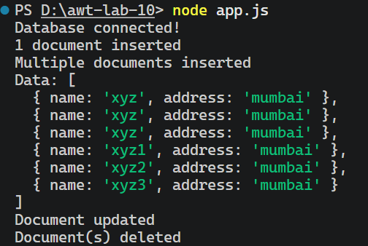

DB –
