Lab - Week 6

PART A
(PART A: TO BE REFERRED BY STUDENTS)

Objective Work with JSON data in a React application.

Theory:

JSON (JavaScript Object Notation) is a lightweight data interchange format that is easy to read and write. It is widely used for transmitting data between a server and a client in web applications. In this lab, we will parse JSON data, display it in a tabular format, and convert form inputs into a JSON object.

Key Concepts:

- JSON Parsing: Extracting data from a JSON object and using it within a React component.
- Rendering JSON in a Table: Mapping through JSON data and displaying it in an organized tabular format.
- Handling Form Data: Capturing user input and converting it into a JSON object.

- Console Output: Displaying the JSON object in the browser console for debugging and verification.
- Real-Time Use Cases: Implementing scenarios like handling employee or product JSON data.

Sample JSON program using javascript:
Example: 1
<!DOCTYPE html>
<html>
<body>

<h2>JSON Object Creation in JavaScript</h2>

<p id="demo"></p>
<p id="demo1"></p>
<p id="demo2"></p>
<script>
var mbatech_class =
{
"student":[
{
"name":"xyz",
"rollno":23,
"email":["xyz@gmail.com","xyz@nmims.edu"]
},
{
"name":"abc",
"rollno":24,
"email":["abc@gmail.com","abc@nmims.edu"]
},
{
"name":"stu",
"rollno":26,
"email":["stu@gmail.com","stu@nmims.edu"]
},
{
"name":"uvw",
"rollno":30,
"email":["uvw@gmail.com","uvw@nmims.edu"]
}
]

}
document.write("Array 1"+mbatech_class.student[1].name);
for(x in mbatech_class.student)
{
document.write("<br>names"+mbatech_class.student[x].name);
if(mbatech_class.student[x].name=="abc")
{
mbatech_class.student[x].rollno=89;
}
}
document.write("<br>"+mbatech_class.student[1].rollno);
delete mbatech_class.student[1];
x="";
for (i in mbatech_class.student)
{
x += mbatech_class.student[i].rollno + "<br>";
}
document.write("<br>rollno"+x);

</script>
</body>
</html>

Example 2: Using methods: parse() and stringify()

<!DOCTYPE html>
<html>
<body>
<h2>JSON Object Creation in JavaScript</h2>
<p id="demo"></p>
<p id="demo1"></p>
<p id="demo2"></p>
<script>
var text = '{"name":"John Johnson","street":"Oslo West 16","phone":"555 1234567"}'
var obj = JSON.parse(text);
/*document.getElementById("demo").innerHTML =
obj.name + "<br>" + obj.street + "<br>" +obj.phone;*/
document.write(obj);
var text1 = {name:"John Johnson",street:"Oslo West 16",phone:"555 1234567"}
var obj1=JSON.stringify(text1);
document.getElementById("demo1").innerHTML = obj1;
</script>
</body>
</html>

Example 3: Using API’S in React and retrieving in JSON

You can use weatherstack API from https://github.com/public-apis/public-apis. Just create a free account for API key.
Points to note:
- When using API key directly with http://weatherstack.com browser throws cors policy error. It is a cross domain error. Like you are accessing from localhost to weatherstack.
- We need to make changes in vite.config.js file
export default defineConfig({
plugins: [react()],
server: {
proxy: {
'/weatherapi': {
target: 'http://api.weatherstack.com',
changeOrigin: true,
rewrite: (path) => path.replace(/^\/weatherapi/, '')
}
}
}
})

- Now we will write one component called weather.jsx. This code uses fetch =, async and await as discussed in class. Displaying current temperature. React useState to hold temperature state (Note that the best way to avoid cors policy is form backend. May be creating a proxy express server. But this way around – changing vite config is local not suitable in deployment)
import React, { useState, useEffect } from "react";

function Weather() {
const [temp, setTemp] = useState(null);
const [condition, setCondition] = useState("");
const [error, setError] = useState("");

useEffect(() => {
const fetchWeather = async () => {
try {
const QUERY = 'New York';
const API_KEY='paste your key here';
const response = await fetch(
`/weatherapi/current?access_key=${API_KEY}&query=${encodeURIComponent(QUERY)}`
);
const data = await response.json();

// Simple error check
if (!response.ok || data.error) {
throw new Error("Unable to fetch weather");
}

setTemp(data.current.temperature);
setCondition(data.current.weather_descriptions[0]);

} catch (err) {
setError("Something went wrong!");
}
};

fetchWeather();
}, []);

return (
<div>
<h2>Weather Report</h2>

{error && <p>{error}</p>}

{temp !== null && !error && (
<>
<p>Temperature: {temp}°C</p>
</>
)}
</div>
);
}

export default Weather;

- Now in app.jsx: render Weather component inside return like other components done in previous lectures.
import Weather from './components/Weather';
<h1>My Weather App</h1>
<Weather /> {/* Calling Weather component */}

PART B
(PART B: TO BE COMPLETED BY STUDENTS)
Students must submit the soft copy as per following segments within two hours of the practical. The soft copy must be uploaded on the portal at the end of the practical. The filename should be AWT_batch_rollno_experimentno Example: AWT_A1_A001_P1

Roll No. : A006 | Name: Aksh Soni
Prog/Yr/Sem: MCA Sem 2 | Batch: 1
Date of Experiment: | Date of Submission: 15/03/2026

Task 1:

- Data Storage Scenario (School Management System)

  - Store 3 student details such as name, roll number, subjects, and grades in JSON format.
  - Display the student details in a table.
  - Extract and display a student’s Math marks using JavaScript.

StudentTable.jsx
export default function StudentTable() {
const students = [
{ name: "Aksh", roll: 1, subjects: ["Math", "Science"], math: 85 },
{ name: "Parag", roll: 2, subjects: ["Math", "English"], math: 90 },
{ name: "Joel", roll: 3, subjects: ["Math", "Computer"], math: 78 }
];

return (
<>
<h2>Student details</h2>
<table border={"1"} align="center">
<tr>
<th>Name</th>
<th>Rollno</th>
<th>Subjects</th>
<th>Math Marks</th>
</tr>

{students.map((s, index) => (
<tr key={index}>
<td>{s.name}</td>
<td>{s.roll}</td>
<td>{s.subjects.join(', ')}</td>
<td>{s.math}</td>
</tr>
))}
</table>

<h3>Math marks of {students[0].name}: {students[0].math}</h3>

<h3>Second subject of {students[1].name} : {students[1].subjects[1]}</h3>
</>
)
}

App.jsx
import StudentTable from "./components/StudentTable";

function App() {
return (
<div>
<h1>School Management System</h1>

<StudentTable />
</div>
)
}

export default App

O/P -----------------
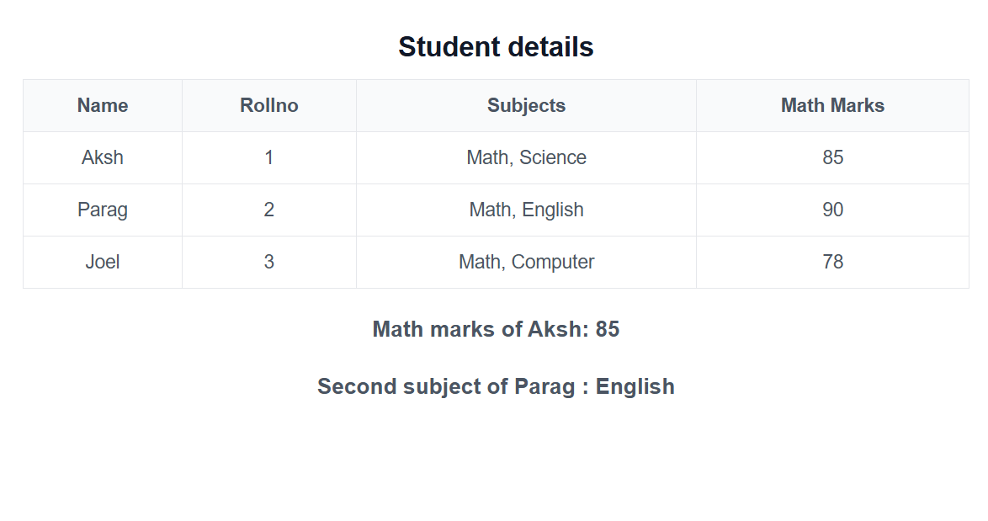

- Product Catalog for E-commerce

  - Define a JSON structure for three products (name, price, stock, category).
  - Write JavaScript code to convert this data into a JSON string and display it dynamically on a webpage.

ProductCatalog.jsx
export default function ProductCatalog() {

const products = [
{ name: "Laptop", price: 50000, stock: 10, category: "Electronics" },
{ name: "Shoes", price: 2000, stock: 25, category: "Fashion" },
{ name: "Book", price: 500, stock: 50, category: "Education" }
];

// Convert to JSON string
const jsonData = JSON.stringify(products, null, 2);

return (
<div>

<h2>Product Catalog</h2>

<table border="1" align="center">
<tr>
<th>Name</th>
<th>Price</th>
<th>Stock</th>
<th>Category</th>
</tr>

{products.map((p, index) => (
<tr key={index}>
<td>{p.name}</td>
<td>{p.price}</td>
<td>{p.stock}</td>
<td>{p.category}</td>
</tr>
))}

</table>

<h3>JSON String</h3>
<pre>{jsonData}</pre>

</div>
);

}

App.jsx
import ProductCatalog from "./components/ProductCatalog"

function App() {
return (
<div>
<ProductCatalog />
</div>
)
}

export default App

O/P ---------------
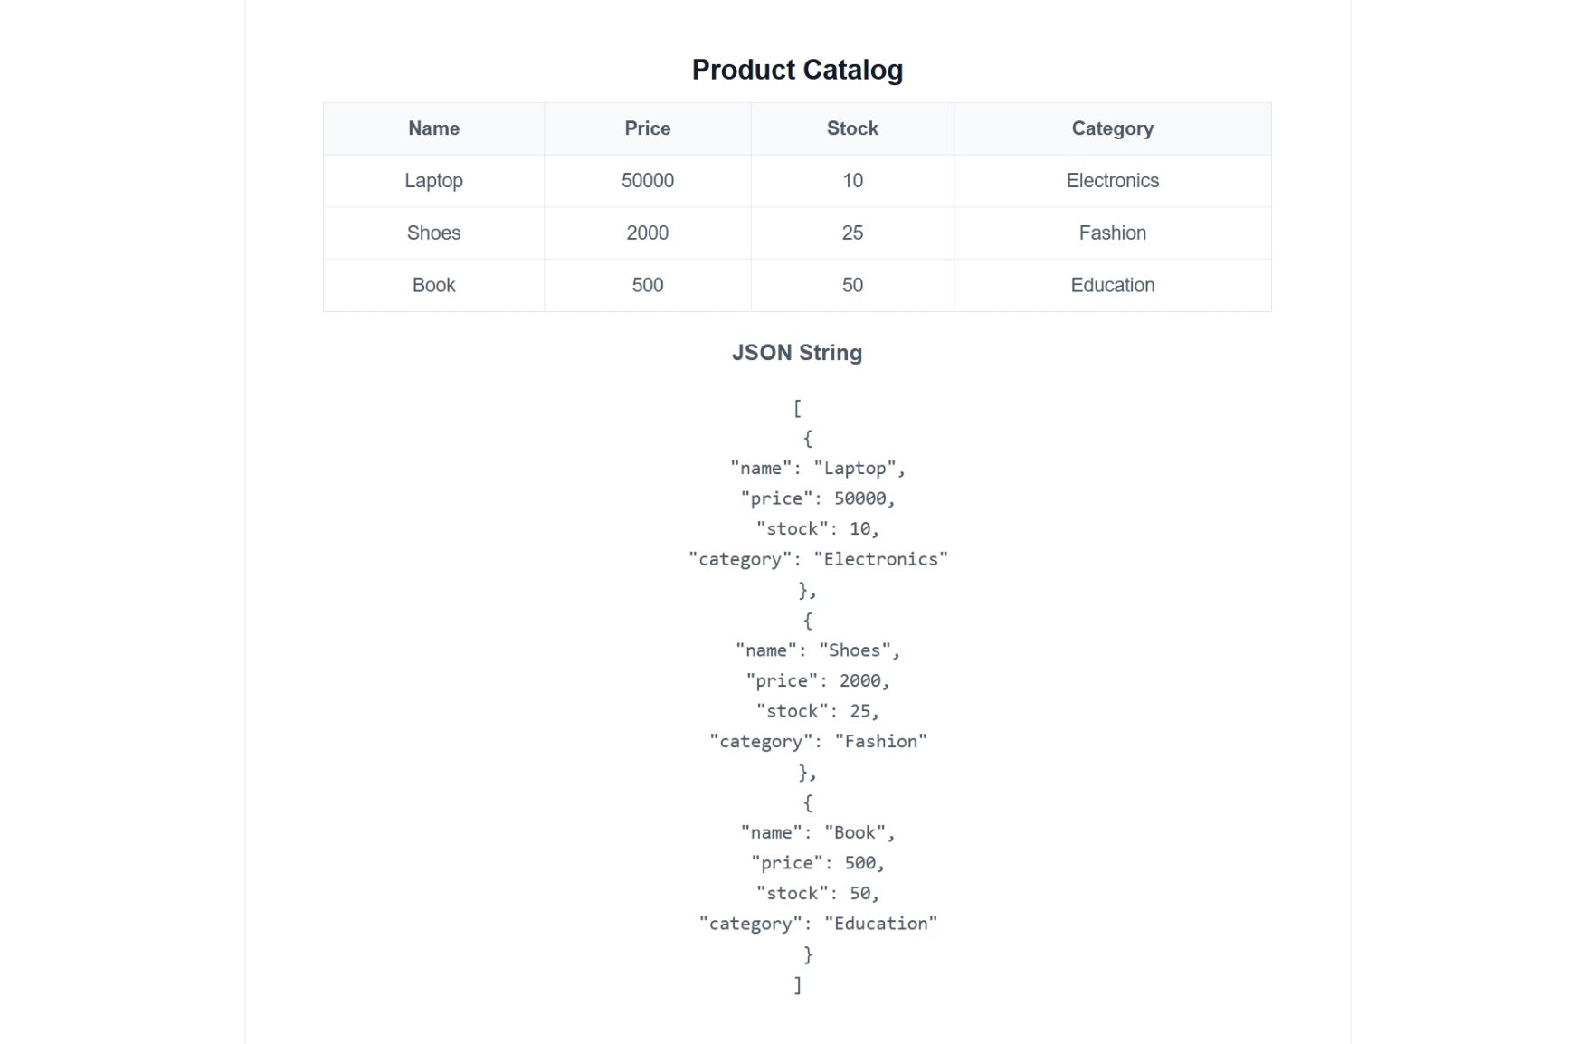

- User Authentication System

  - Store a list of users in JSON format.
  - Write a JavaScript function to validate login credentials against the stored JSON data.

UserLogin.jsx
import React, { useState } from "react";

function UserLogin() {

const users = [
{ username: "admin", password: "1234" },
{ username: "aksh", password: "aksh },
{ username: "user", password: "1111" }
];

const [username, setUsername] = useState("");
const [password, setPassword] = useState("");
const [message, setMessage] = useState("");

function checkLogin() {

for (let i in users) {
if (users[i].username === username && users[i].password === password) {
setMessage("Login Successful");
return;
}
}

setMessage("Invalid Username or Password");

}

return (
<div>

<h2>User Login</h2>

<input
type="text"
placeholder="Enter Username"
onChange={(e) => setUsername(e.target.value)}
/>

<br /><br />

<input
type="password"
placeholder="Enter Password"
onChange={(e) => setPassword(e.target.value)}
/>

<br /><br />

<button onClick={checkLogin}>Login</button>

<h3>{message}</h3>

</div>
);

}

export default UserLogin;

App.jsx
import UserLogin from "./components/UserLogin"

function App() {
return (
<div>
<UserLogin />
</div>
)
}

export default App

O/P ----------
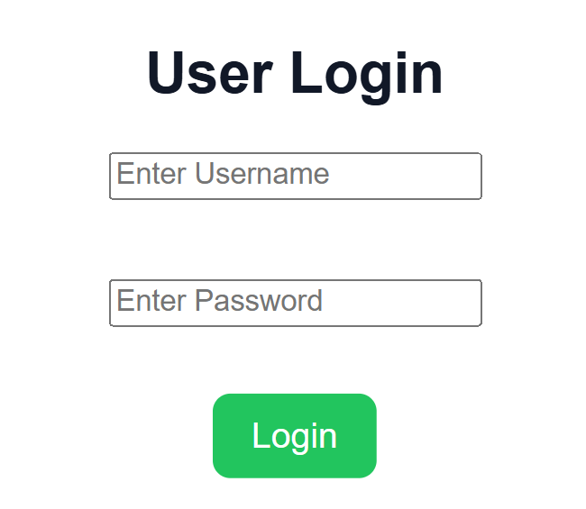

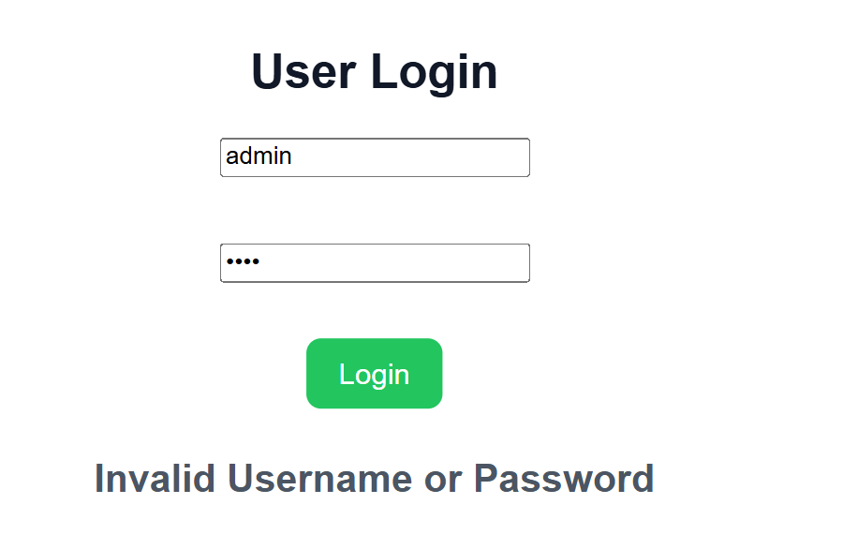

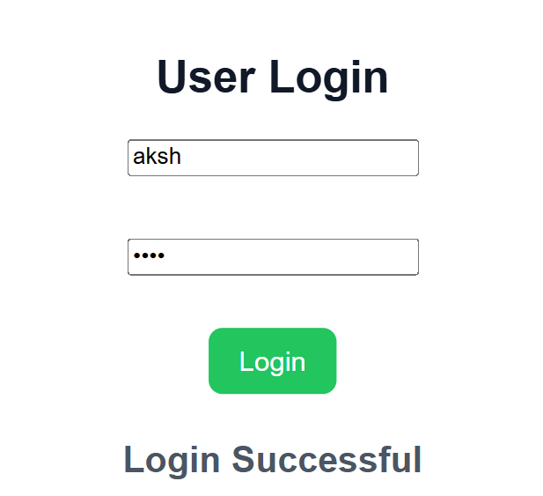

- Weather API Response Parsing

  - Given a JSON response from a weather API, extract and display the temperature and weather condition.
  - Implement this in React using the useEffect hook.

Weather.jsx
import React, { useState, useEffect } from "react";

function Weather() {
const [city, setCity] = useState("Mumbai"); // Default city
const [searchInput, setSearchInput] = useState("");
const [weatherData, setWeatherData] = useState({
temp: "",
code: "",
cityName: ""
});
const [error, setError] = useState("");

async function fetchWeather(cityName) {
try {
setError("");
// 1. Get Coordinates using Geocoding API
const geoRes = await fetch(
`https://geocoding-api.open-meteo.com/v1/search?name=${cityName}&count=1&language=en&format=json`
);
const geoData = await geoRes.json();

if (!geoData.results || geoData.results.length === 0) {
setError("City not found");
return;
}

const { latitude, longitude, name, country } = geoData.results[0];

// 2. Get Weather using Latitude and Longitude
const weatherRes = await fetch(
`https://api.open-meteo.com/v1/forecast?latitude=${latitude}&longitude=${longitude}&current_weather=true`
);
const data = await weatherRes.json();

setWeatherData({
temp: data.current_weather.temperature,
code: data.current_weather.weathercode,
cityName: `${name}, ${country}`
});
} catch (err) {
setError("Failed to fetch weather data");
}
}

// Fetch default city weather on load
useEffect(() => {
fetchWeather(city);
}, []);

const handleSearch = () => {
if (searchInput.trim()) {
fetchWeather(searchInput);
}
};

return (
<div style={{ textAlign: "center", marginTop: "20px" }}>
<h2>Weather Report</h2>

<input
type="text"
placeholder="Enter city name..."
value={searchInput}
onChange={(e) => setSearchInput(e.target.value)}
/>
<button onClick={handleSearch} style={{ marginLeft: "10px" }}>
Search
</button>

{error && <p style={{ color: "red" }}>{error}</p>}

{weatherData.cityName && !error && (
<div style={{ marginTop: "20px" }}>
<h3>{weatherData.cityName}</h3>
<p>Temperature: {weatherData.temp} °C</p>

</div>
)}
</div>
);
}

export default Weather;

App.jsx
import Weather from "./components/Weather"

function App() {
return (
<div>
<Weather />
</div>
)
}

export default App

O/P --------------
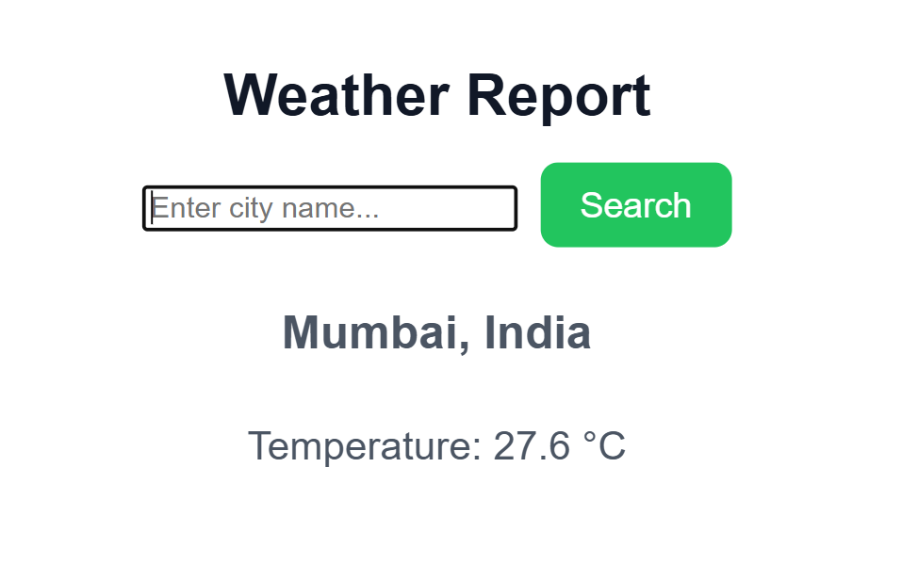
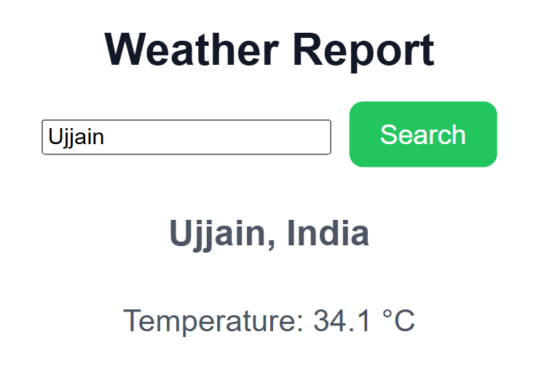

- JSON in React (Fetching and Displaying Data)

  - Create a React component to display JSON data in a structured format.
  - Fetch JSON data from an API using the fetch method and display it in a component.

JsonDisplay.jsx
import React, { useState, useEffect } from "react";

function JsonDisplay() {

const [users, setUsers] = useState([]);

useEffect(() => {

fetch("https://jsonplaceholder.typicode.com/users")
.then(response => response.json())
.then(data => setUsers(data));

}, []);

return (
<div>

<h2>User Data (Fetched from API)</h2>

<table border="1">
<tr>
<th>ID</th>
<th>Name</th>
<th>Email</th>
<th>City</th>
</tr>

{users.map((user) => (
<tr key={user.id}>
<td>{user.id}</td>
<td>{user.name}</td>
<td>{user.email}</td>
<td>{user.address.city}</td>
</tr>
))}

</table>

</div>
);

}

export default JsonDisplay;

App.jsx
import JsonDisplay from "./components/JsonDisplay"

function App() {
return (
<div>
<JsonDisplay />
</div>
)
}

export default App

O/P -------------
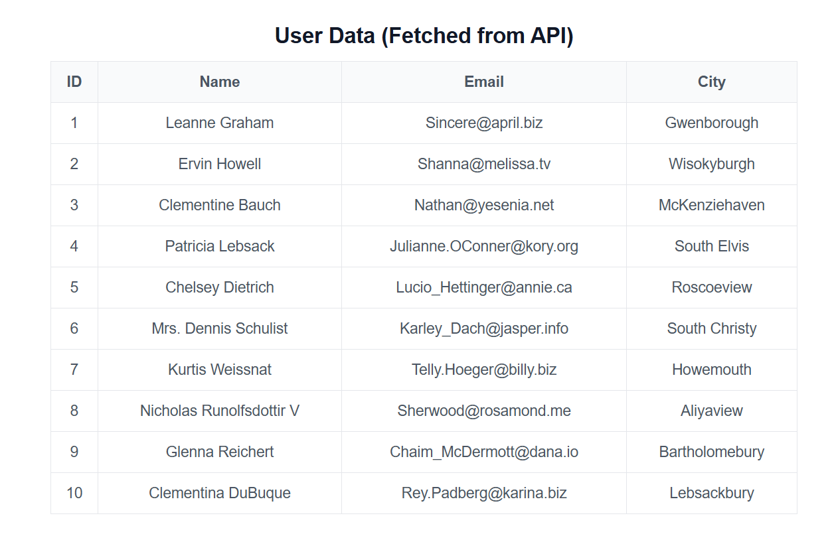
- Using JSON in Local Storage

  - Save user details in localStorage in JSON format.
  - Retrieve and display user data from localStorage upon page reload.

LocalStorageUser.jsx
import React, { useState, useEffect } from "react";

function LocalStorageUser() {

const [name, setName] = useState("");
const [email, setEmail] = useState("");
const [storedUser, setStoredUser] = useState(null);

// Save data to localStorage
function saveUser() {

const user = {
name: name,
email: email
};

localStorage.setItem("userData", JSON.stringify(user));
setStoredUser(user);

}

// Load data when page reloads
useEffect(() => {

const data = JSON.parse(localStorage.getItem("userData"));

if (data) {
setStoredUser(data);
}

}, []);

return (
<div>

<h2>Local Storage Example</h2>

<input
type="text"
placeholder="Enter Name"
onChange={(e) => setName(e.target.value)}
/>

<br /><br />

<input
type="email"
placeholder="Enter Email"
onChange={(e) => setEmail(e.target.value)}
/>

<br /><br />

<button onClick={saveUser}>Save User</button>

{storedUser && (
<div>

<h3>Stored User Data</h3>

<p>Name: {storedUser.name}</p>
<p>Email: {storedUser.email}</p>

</div>
)}

</div>
);

}

export default LocalStorageUser;

App.jsx
import LocalStorageUser from "./components/LocalStorageUser"

function App() {
return (
<div>
<LocalStorageUser />
</div>
)
}

export default App

O/P ------------
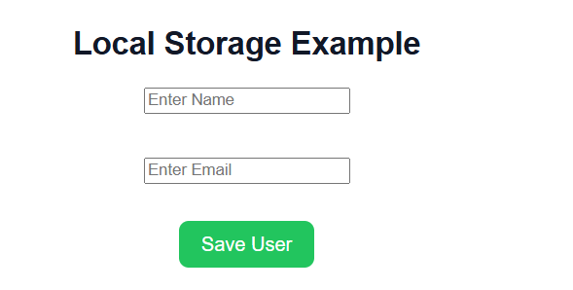

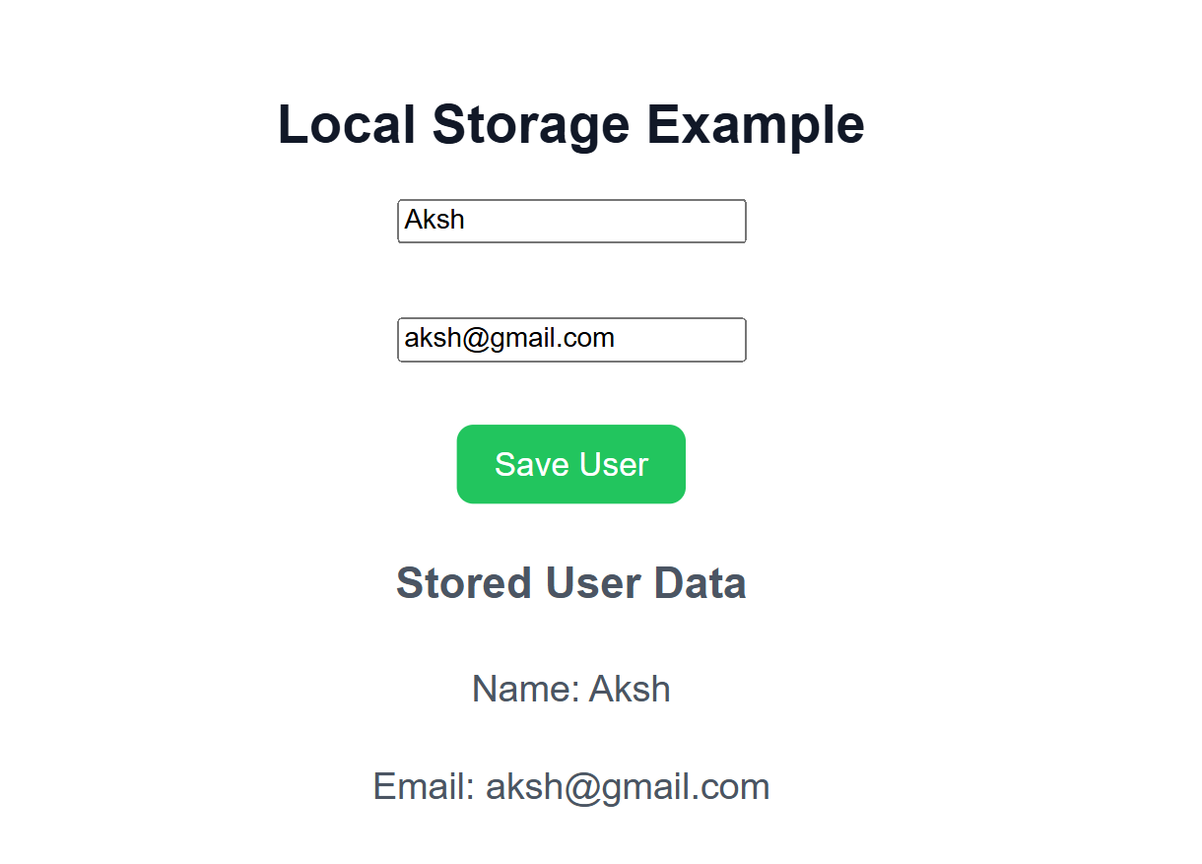

After reload
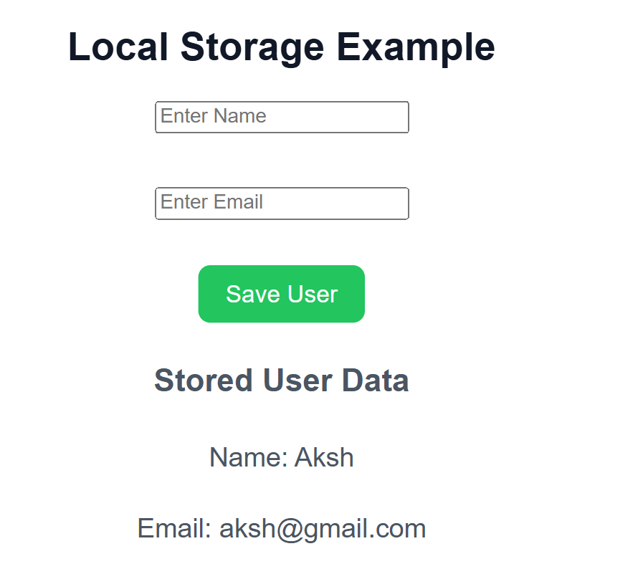

Deliverables:

  - Functional React app handling JSON data.
  - JSON object parsed and displayed in a table.
  - Form data converted into JSON and logged in the console.

Submission Checklist:

  - Source code with appropriate comments.
  - Screenshot of the application in the browser.
  - Explanation of JSON parsing and handling in React.

Expected Learning Outcomes:

By the end of this practical, students will be able to:

  - Work with JSON data in React.
  - Parse and display JSON data in a structured format.
  - Handle form data and convert it into a JSON object.
  - Implement real-world scenarios using JSON in applications.

