Lab - Week 3

PART A
(PART A: TO BE REFERRED BY STUDENTS)

Objective Implement React forms and events.

Expected Learning Outcomes:

By the end of this practical, students will be able to:

- Create and manage React forms.
- Implement validation logic for user inputs.
- Handle events like onChange and onSubmit effectively.

Theory:

Forms are an integral part of web applications. React provides a flexible way to handle forms using controlled components, where form inputs are tied to the component state, and event handlers are used to manage changes and submissions.
Key Concepts:

- Controlled Components: Form inputs like <input> and <textarea> maintain their state in the component’s state.
- Validation: Ensuring user input adheres to rules such as format, length, and required fields.
- Event Handling: Managing form events like onChange and onSubmit to collect and process user data.
- Dynamic Rendering: Displaying results or feedback dynamically based on user actions.

PART B
(PART B: TO BE COMPLETED BY STUDENTS)

Roll No: A006 | Name: Aksh Soni
Prog/Yr/Sem: Mca / 2026 / Sem-2 | Batch: B1
Date of Experiment: 02/02/2026 | Date of Submission: 05/02/2026

Task 1: User Registration Form
- Set up a React project using Vite (as done in Week 1).
- Create a functional component named RegistrationForm that displays a user registration form with the following fields:
  - Name (text input)
  - Email (text input)
  - Password (password input)
- Add basic validation rules:
  - Name should not be empty.
  - Email should be in a valid format (example: name@example.com).
  - Password should contain at least 8 characters.
- Handle form events:
  - Use onChange events to read user input values.
  - Use an onSubmit event to prevent the default form submission behavior.
- On successful submission, display the entered user details below the form.
Code:
import { useState } from "react";

function RegistrationForm() {
// State for inputs
const [name, setName] = useState("");
const [email, setEmail] = useState("");
const [password, setPassword] = useState("");

// State for submitted data
const [submitted, setSubmitted] = useState(false);

// State for errors
const [error, setError] = useState("");

const handleSubmit = (e) => {
e.preventDefault(); // stop page reload

// Basic validation
if (name === "") {
setError("Name cannot be empty");
return;
}

if (!email.includes("@")) {
setError("Enter a valid email");
return;
}

if (password.length < 8) {
setError("Password must be at least 8 characters");
return;
}

// If validation passes
setError("");
setSubmitted(true);
};

return (
<div style={{ width: "300px", margin: "50px auto" }}>
<h2>User Registration</h2>

<form onSubmit={handleSubmit}>
<input
type="text"
placeholder="Name"
value={name}
onChange={(e) => setName(e.target.value)}
/>
<br /><br />

<input
type="text"
placeholder="Email"
value={email}
onChange={(e) => setEmail(e.target.value)}
/>
<br /><br />

<input
type="password"
placeholder="Password"
value={password}
onChange={(e) => setPassword(e.target.value)}
/>
<br /><br />

<button type="submit">Register</button>
</form>

{/* Error message */}
{error && <p style={{ color: "red" }}>{error}</p>}

{/* Display submitted data */}
{submitted && (
<div>
<h3>Registered User</h3>
<p>Name: {name}</p>
<p>Email: {email}</p>
<p>Password: ********</p>
</div>
)}
</div>
);
}

export default RegistrationForm;

Output:
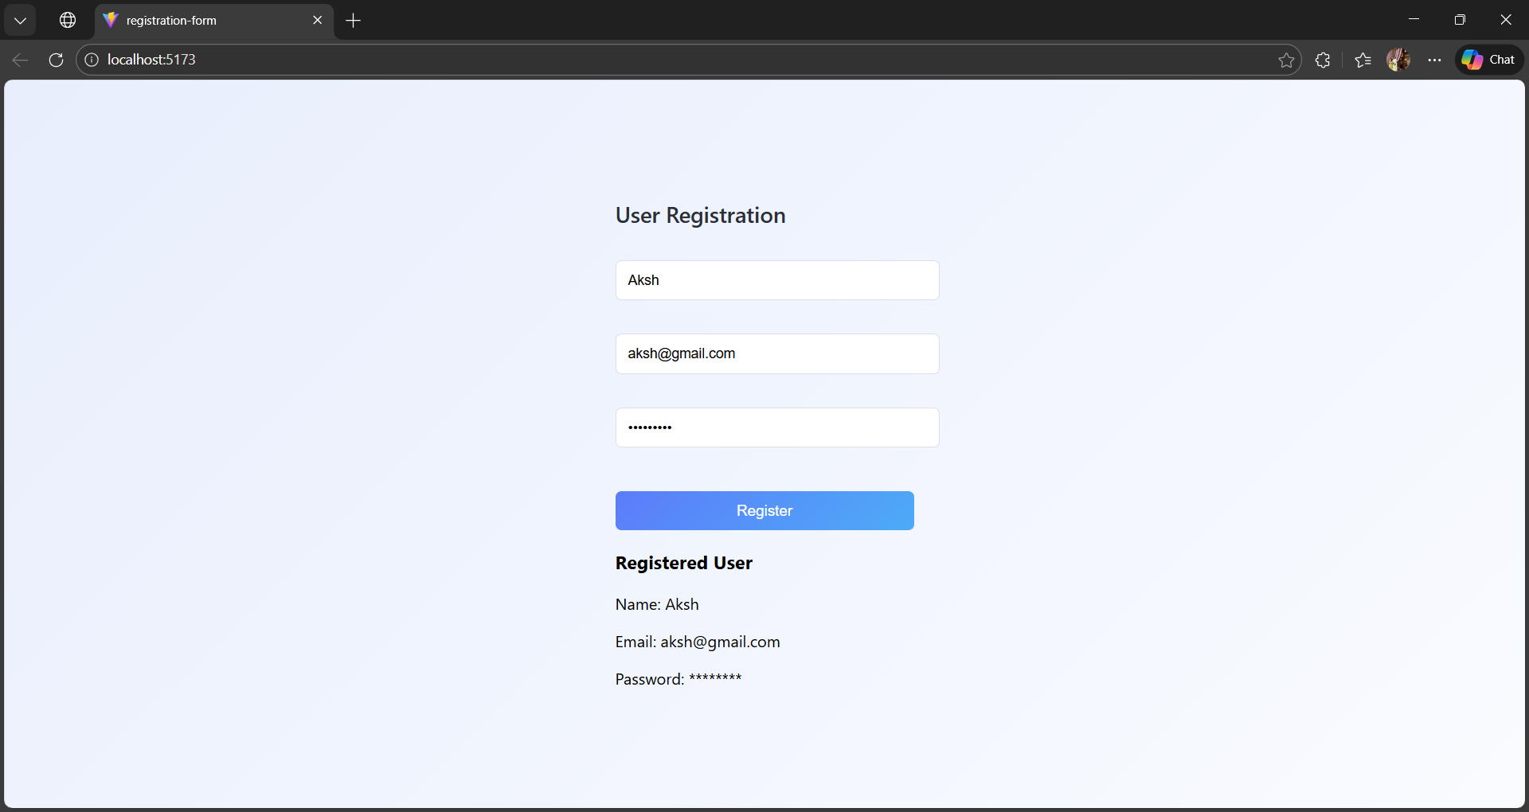
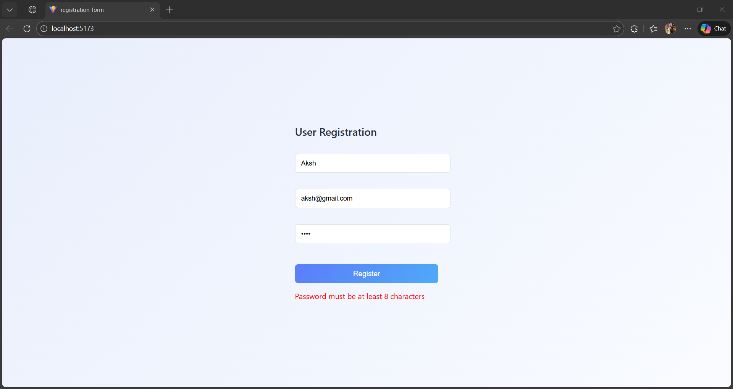

Task 2: Contact and Subscription Forms

1. Contact Form
- Create a functional component named ContactForm with the following fields:
  - Full Name
  - Email
  - Message
  - Topic (Dropdown: General Inquiry, Feedback, Support)
- Display the submitted contact details below the form after submission.
Code:
import { useState } from "react";

function ContactForm() {
const [fullName, setFullName] = useState("");
const [email, setEmail] = useState("");
const [topic, setTopic] = useState("General Inquiry");
const [message, setMessage] = useState("");
const [submitted, setSubmitted] = useState(false);

const handleSubmit = (e) => {
e.preventDefault();
setSubmitted(true);
};

return (
<div className="form-container">
<h2>Contact Form</h2>

<form onSubmit={handleSubmit}>
<input
type="text"
placeholder="Full Name"
value={fullName}
onChange={(e) => setFullName(e.target.value)}
/>

<input
type="email"
placeholder="Email"
value={email}
onChange={(e) => setEmail(e.target.value)}
/>

<select value={topic} onChange={(e) => setTopic(e.target.value)}>
<option>General Inquiry</option>
<option>Feedback</option>
<option>Support</option>
</select>

<textarea
placeholder="Message"
value={message}
onChange={(e) => setMessage(e.target.value)}
></textarea>

<button type="submit">Submit</button>
</form>

{submitted && (
<div className="result">
<h3>Submitted Details</h3>
<p><strong>Name:</strong> {fullName}</p>
<p><strong>Email:</strong> {email}</p>
<p><strong>Topic:</strong> {topic}</p>
<p><strong>Message:</strong> {message}</p>
</div>
)}
</div>
);
}

export default ContactForm;

Output:
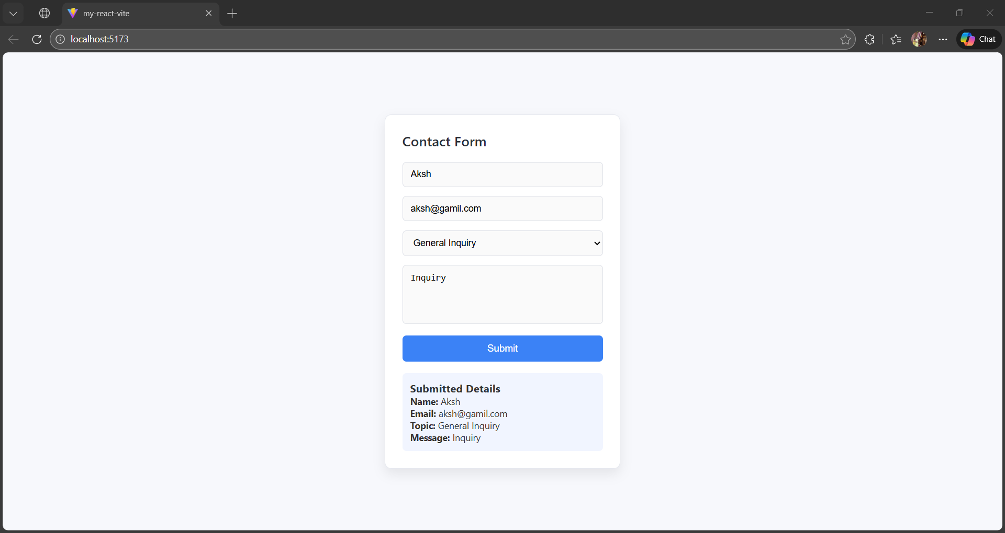

2. Newsletter Subscription
- Create a functional component named SubscriptionForm with:
  - Email input
  - Checkbox to agree to terms and conditions
- Display a confirmation message after successful subscription.
CODE:
SubscriptionForm.jsx
import { useState } from "react";

function SubscriptionForm() {
const [email, setEmail] = useState("");
const [agree, setAgree] = useState(false);
const [message, setMessage] = useState("");

const handleSubmit = (e) => {
e.preventDefault();

if (agree) {
setMessage("Subscription successful for " + email);
} else {
setMessage("Please agree to the terms and conditions");
}
};

return (
<div className="form-container">
<h2>Newsletter Subscription</h2>

<form onSubmit={handleSubmit}>
<input
type="email"
placeholder="Enter your email"
value={email}
onChange={(e) => setEmail(e.target.value)}
/>

<label>
<input
type="checkbox"
checked={agree}
onChange={(e) => setAgree(e.target.checked)}
/>
&nbsp;I agree to the terms and conditions
</label>

<button type="submit">Subscribe</button>
</form>

{message && <p className="result">{message}</p>}
</div>
);
}

export default SubscriptionForm;

App.jsx
import SubscriptionForm from "./SubscriptionForm";
import "./index.css";

function App() {
return <SubscriptionForm />;
}

export default App;

OUTPUT:
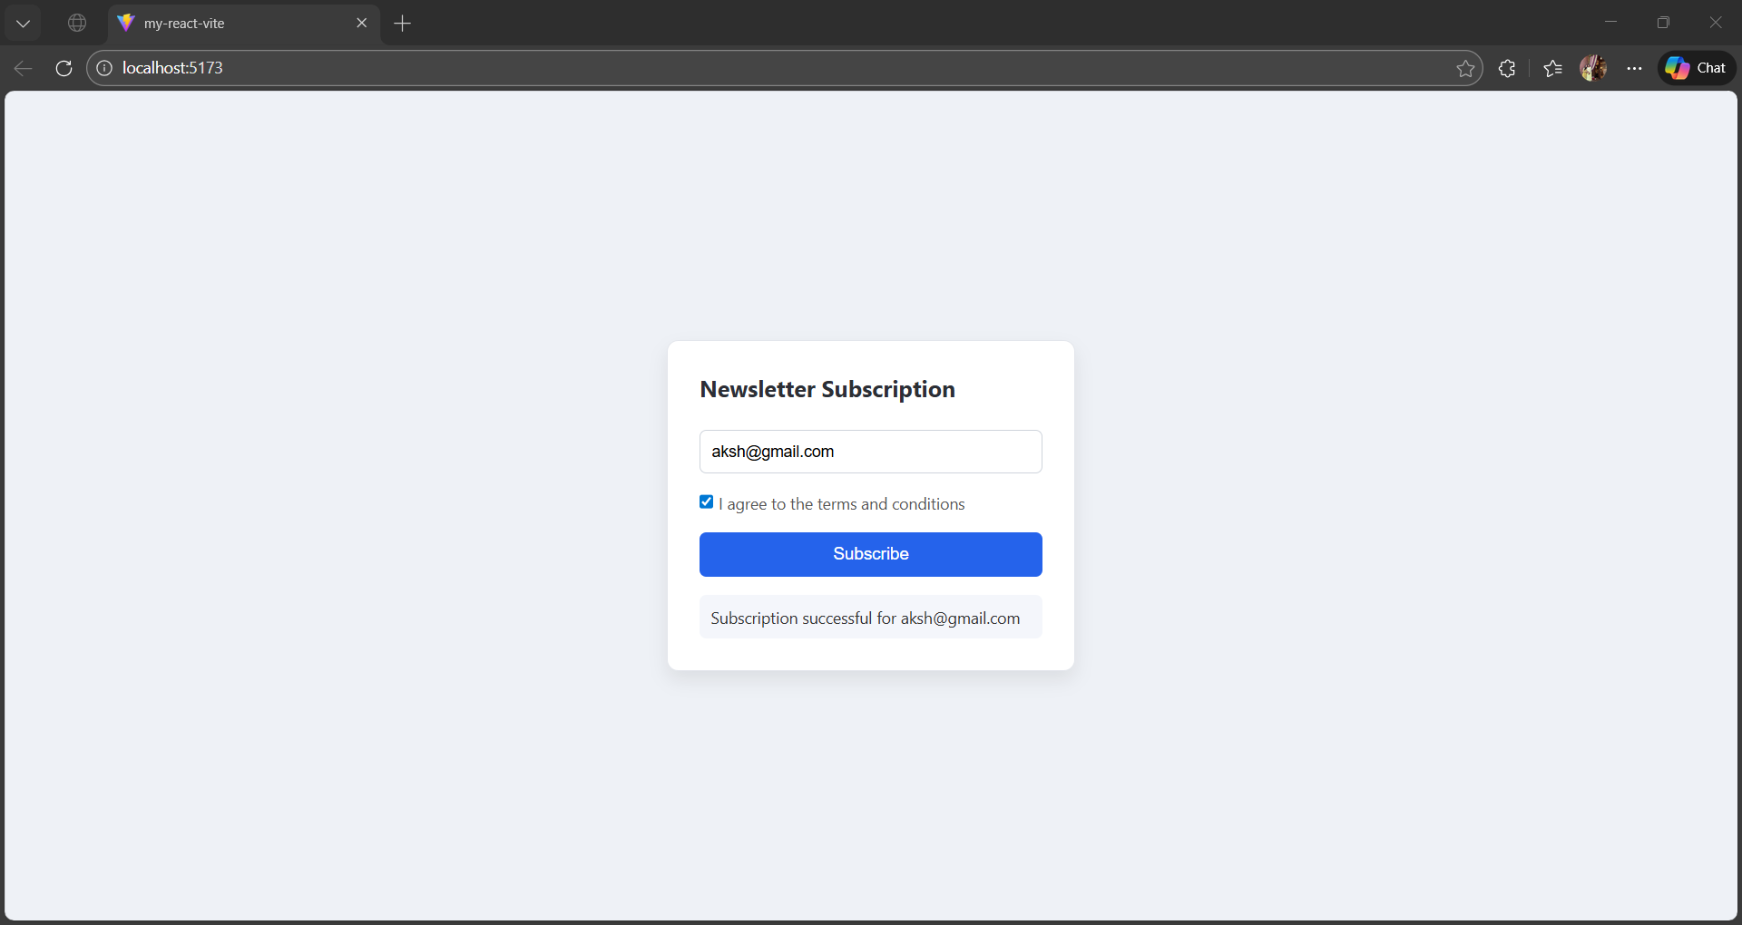

Task 3: Form Validation Messages
- Display validation error messages when the user enters invalid data.
- Show error messages such as:
  - “Name is required”
  - “Email format is invalid”
  - “Password must be at least 8 characters”
- Error messages should appear only when validation fails.

Deliverables:

- Functional forms with proper validations.
- Submitted user data displayed dynamically below the forms.

Code:
import { useState } from "react";
import "./index.css";

function App() {
const [name, setName] = useState("");
const [email, setEmail] = useState("");
const [password, setPassword] = useState("");

const [errors, setErrors] = useState({});
const [submitted, setSubmitted] = useState(false);

const handleSubmit = (e) => {
e.preventDefault();

let newErrors = {};

// Validation rules
if (name === "") {
newErrors.name = "Name is required";
}

if (!email.includes("@")) {
newErrors.email = "Email format is invalid";
}

if (password.length < 8) {
newErrors.password = "Password must be at least 8 characters";
}

setErrors(newErrors);

// If no errors, submit form
if (Object.keys(newErrors).length === 0) {
setSubmitted(true);
} else {
setSubmitted(false);
}
};

return (
<div className="form-container">
<h2>User Registration</h2>

<form onSubmit={handleSubmit}>
<input
type="text"
placeholder="Name"
value={name}
onChange={(e) => setName(e.target.value)}
/>
{errors.name && <p className="error">{errors.name}</p>}

<input
type="text"
placeholder="Email"
value={email}
onChange={(e) => setEmail(e.target.value)}
/>
{errors.email && <p className="error">{errors.email}</p>}

<input
type="password"
placeholder="Password"
value={password}
onChange={(e) => setPassword(e.target.value)}
/>
{errors.password && <p className="error">{errors.password}</p>}

<button type="submit">Register</button>
</form>

{/* Display submitted data */}
{submitted && (
<div className="result">
<h3>Submitted Details</h3>
<p><strong>Name:</strong> {name}</p>
<p><strong>Email:</strong> {email}</p>
<p><strong>Password:</strong> ********</p>
</div>
)}
</div>
);
}

export default App;

OUTPUT
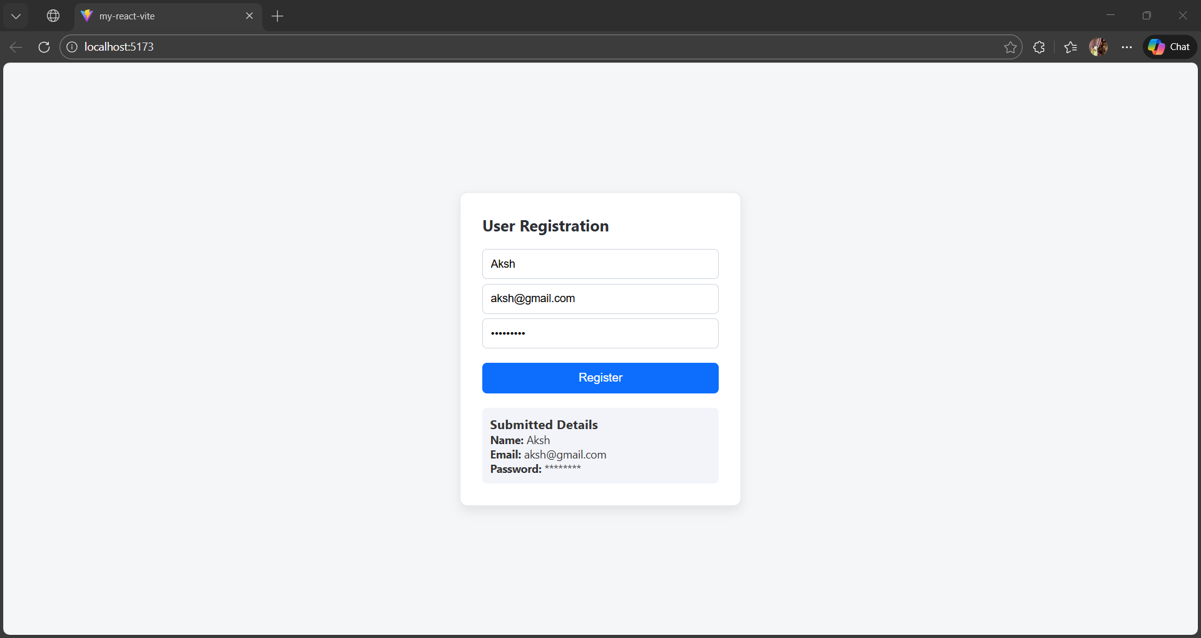
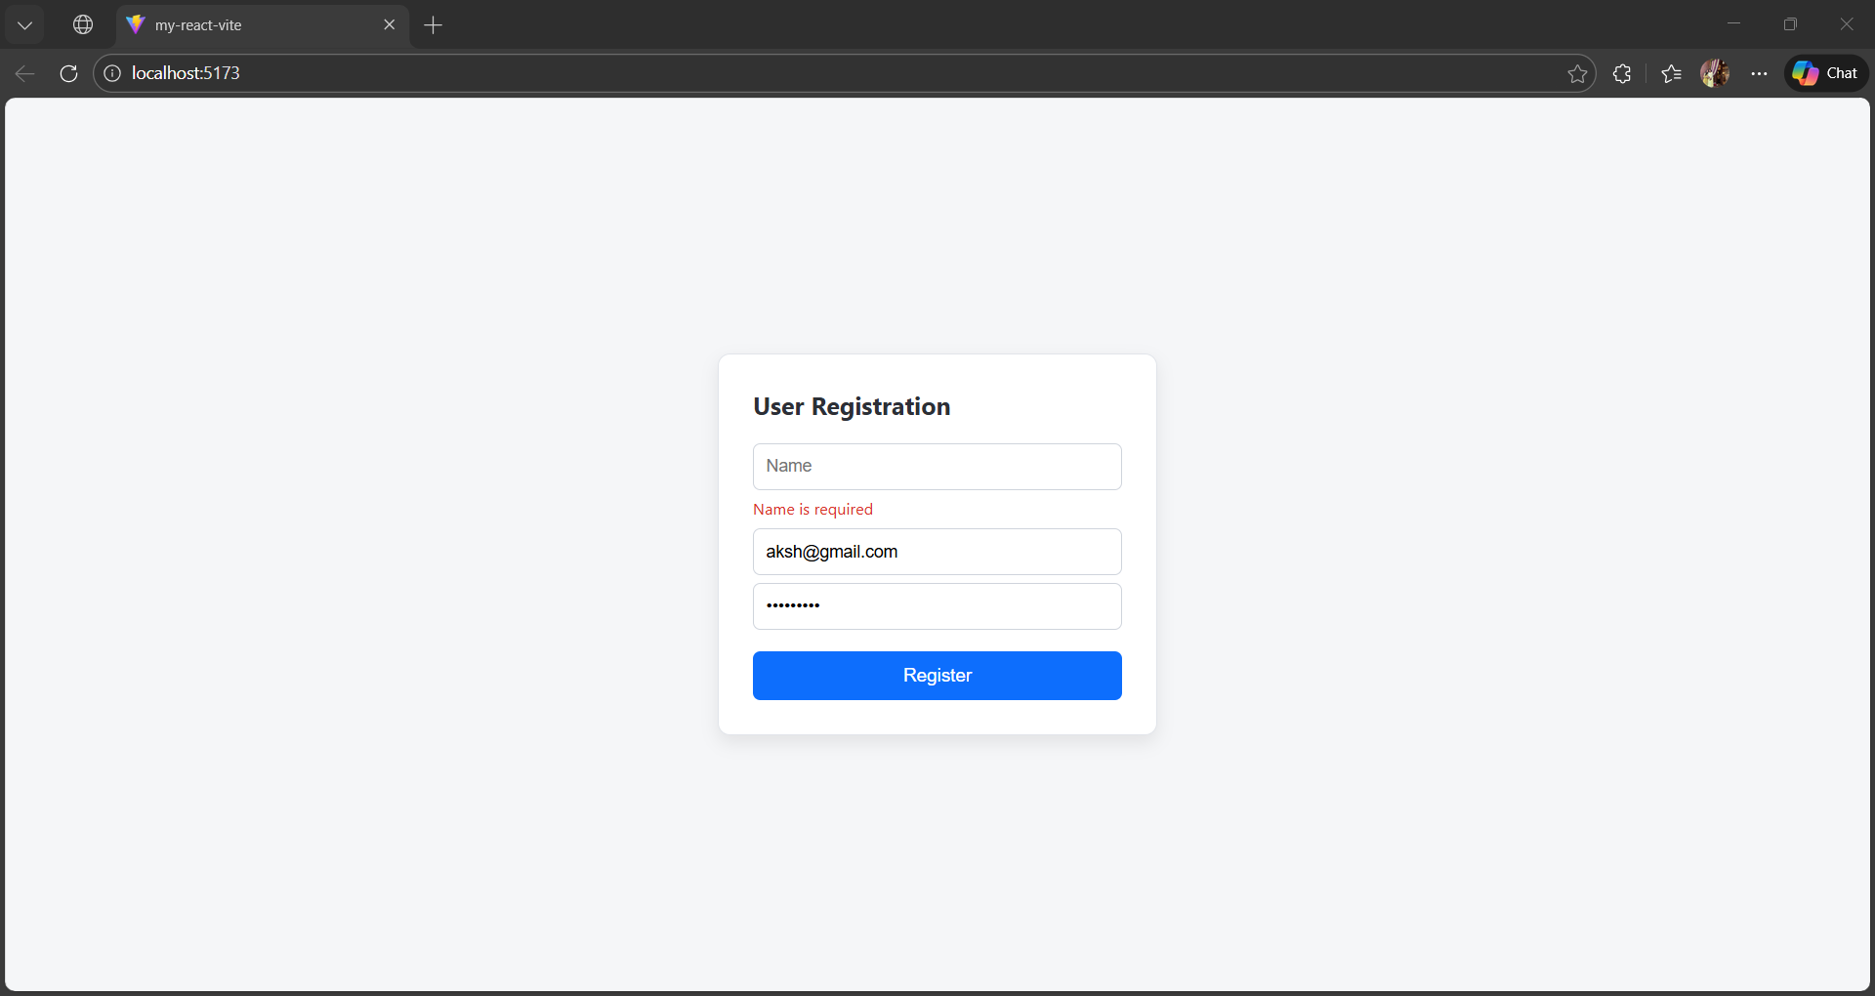
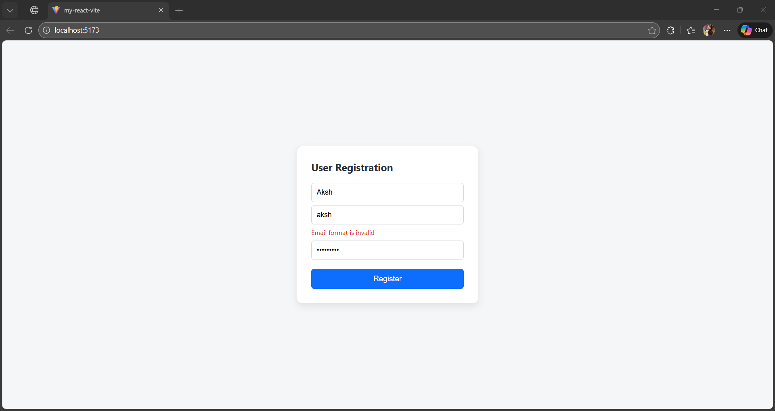

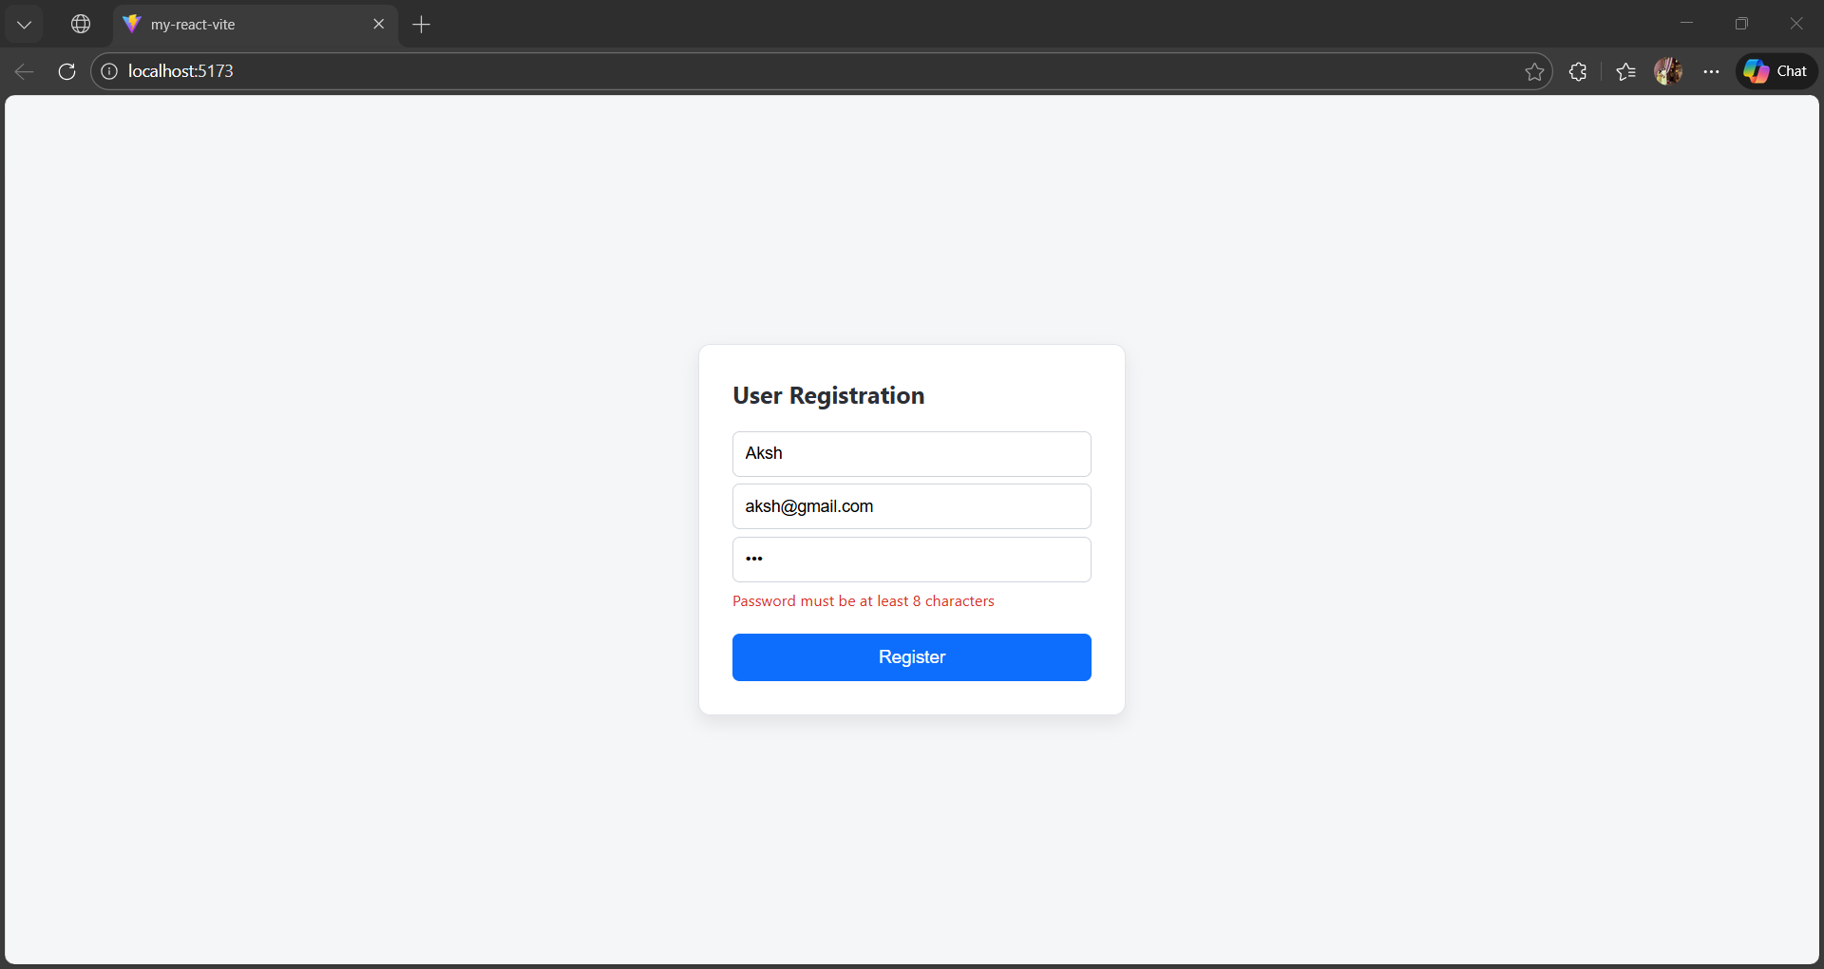

Submission Checklist:
  - Source code with appropriate comments.
  - Screenshot of the application in the browser.
  - Explanation of the validation logic implemented.

