Lab - Week 5

PART A
(PART A: TO BE REFERRED BY STUDENTS)

Objective Develop a multi-page React app using React Router.
Create a registration form in react

Theory:

React Router is a standard library for routing in React. It enables the creation of single-page applications with navigation among multiple views without reloading the page. In this lab, we will use React Router to build a multi-page application.
Key Concepts:

- React Router: A library to manage routes and navigation in a React application.
- URL Parameters: Used to pass dynamic data in the URL and display specific content on a page.
- Navigation Links: Components like <Link> and <NavLink> enable smooth navigation.
- Dynamic Content Rendering: Use URL parameters to render content based on the user’s navigation.
PART B
(PART B: TO BE COMPLETED BY STUDENTS)
Students must submit the soft copy as per following segments within two hours of the practical. The soft copy must be uploaded on the portal at the end of the practical. The filename should be AWT_batch_rollno_experimentno Example: AWT_A1_A001_P1

Roll No.: A006 | Name: Aksh Soni
Prog/Yr/Sem: MCA(Sem2) | Batch: 01
Date of Experiment: | Date of Submission:

Task 1: Build a Multi-Page React App

Create Pages:
  - Home Page: A welcome page with some basic content.
  - About Page: A page describing the application or developer.
  - Contact Page: A form to collect user inquiries (name, email, and message).

Navigation Links:
  - Add a navigation bar or menu with links to Home, About, and Contact pages.
  - Use the <Link> or <NavLink> components for navigation.

Code –
Home.jsx
function Home() {
return (
<div>
<h2>Welcome to Home Page</h2>
<p>This is a simple multi-page React app using routing.</p>
</div>
);
}

export default Home;

About.jsx
function About() {
return (
<div>
<h2>About Page</h2>
<p>This application is created using Vite + React Router.</p>
</div>
);
}

export default About;

Contact.jsx
import { useState } from "react";

function Contact() {
const [name, setName] = useState("");
const [email, setEmail] = useState("");
const [message, setMessage] = useState("");

const handleSubmit = (e) => {
e.preventDefault();
alert("Form Submitted!");
};

return (
<div>
<h2>Contact Page</h2>

<form onSubmit={handleSubmit}>
<input
type="text"
placeholder="Enter Name"
value={name}
onChange={(e) => setName(e.target.value)}
/>
<br /><br />

<input
type="email"
placeholder="Enter Email"
value={email}
onChange={(e) => setEmail(e.target.value)}
/>
<br /><br />

<textarea
placeholder="Enter Message"
value={message}
onChange={(e) => setMessage(e.target.value)}
/>
<br /><br />

<button type="submit">Submit</button>
</form>
</div>
);
}

export default Contact;

Nav.jsx
import { Link } from "react-router-dom";

function Nav() {
return (
<nav>
<ul style={{ display: "flex", gap: "20px", listStyle: "none" }}>
<li><Link to="/">Home</Link></li>
<li><Link to="/about">About</Link></li>
<li><Link to="/contact">Contact</Link></li>
</ul>
<hr />
</nav>
);
}

export default Nav;

App.jsx
import { Routes, Route } from "react-router-dom";
import Nav from "./Nav";
import Home from "./Home";
import About from "./About";
import Contact from "./Contact";

function App() {
return (
<>
<Nav />

<Routes>
<Route path="/" element={<Home />} />
<Route path="/about" element={<About />} />
<Route path="/contact" element={<Contact />} />
</Routes>
</>
);
}

export default App;

main.jsx
import { StrictMode } from 'react'
import { createRoot } from 'react-dom/client'
import { BrowserRouter } from 'react-router-dom'
import App from './App.jsx'

createRoot(document.getElementById('root')).render(
<StrictMode>
<BrowserRouter>
<App />
</BrowserRouter>
</StrictMode>,
)

Output –
Home
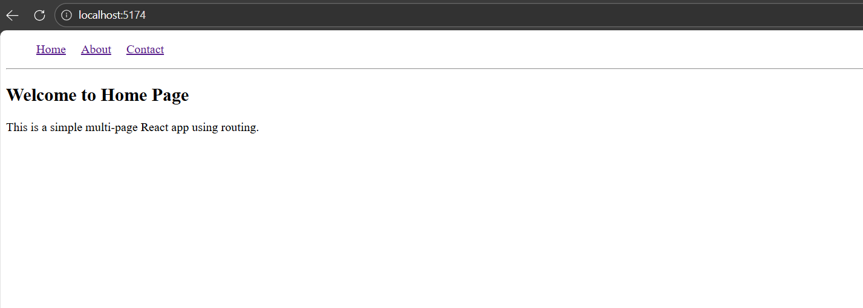
About
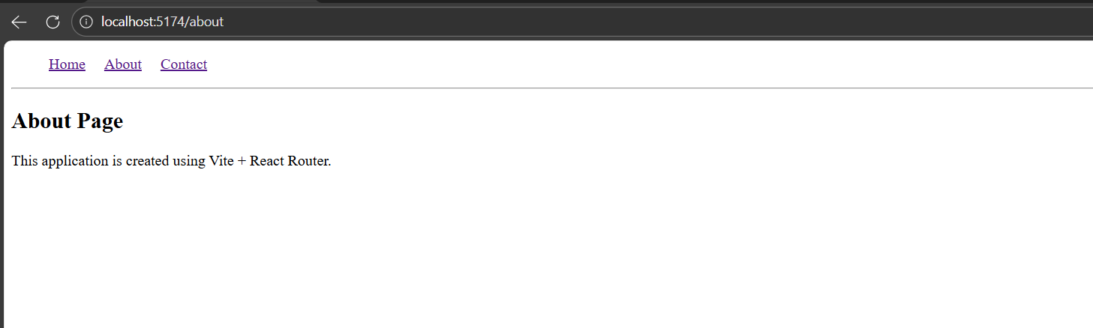
Contact
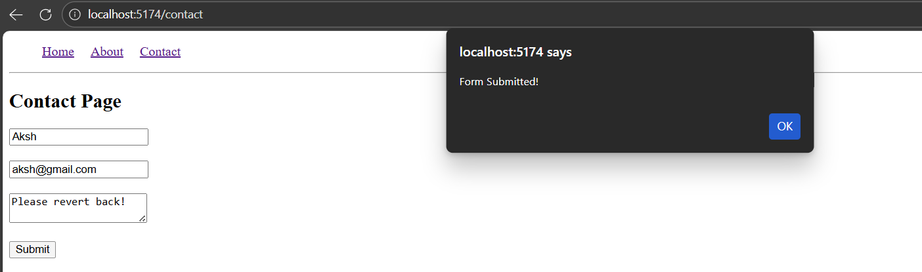

Task 2: Registration form- Fields to include- Username, password, email, checkboxes, radiobuttons, drop downs, textarea, file upload, buttons.

Code –

User.jsx
import { useParams } from "react-router-dom";

function User() {
const { name } = useParams();

return (
<div>
<h2>Welcome {name}!</h2>
<p>This content is dynamic using URL parameter.</p>
</div>
);
}

export default User;

Registration.jsx
import { useState } from "react";

function Registration() {
const [formData, setFormData] = useState({
username: "",
email: "",
password: "",
gender: "",
course: "",
about: "",
agree: false,
file: null,
});

const handleChange = (e) => {
const { name, value, type, checked, files } = e.target;

setFormData({
...formData,
[name]: type === "checkbox" ? checked :
type === "file" ? files[0] :
value
});
};

const handleSubmit = (e) => {
e.preventDefault();
alert("Registration Successful!");
console.log(formData);
};

return (
<div>
<h2>Registration Form</h2>

<form onSubmit={handleSubmit}>

Username:
<input type="text" name="username" onChange={handleChange} />
<br /><br />

Email:
<input type="email" name="email" onChange={handleChange} />
<br /><br />

Password:
<input type="password" name="password" onChange={handleChange} />
<br /><br />

Gender:
<input type="radio" name="gender" value="Male" onChange={handleChange}/> Male
<input type="radio" name="gender" value="Female" onChange={handleChange}/> Female
<br /><br />

Course:
<select name="course" onChange={handleChange}>
<option value="">Select Course</option>
<option value="MCA">MCA</option>
<option value="BCA">BCA</option>
<option value="BTech">BTech</option>
</select>
<br /><br />

About You:
<textarea name="about" onChange={handleChange}></textarea>
<br /><br />

Upload File:
<input type="file" name="file" onChange={handleChange}/>
<br /><br />

<input type="checkbox" name="agree" onChange={handleChange}/>
I agree to terms and conditions
<br /><br />

<button type="submit">Register</button>
<button type="reset">Reset</button>

</form>
</div>
);
}

export default Registration;

App.jsx
import { Routes, Route } from "react-router-dom";
import Registration from "./Registration";
import User from "./User";

function App() {
return (
<Routes>
<Route path="/" element={<Registration />} />
<Route path="/user" element={<User />} />
</Routes>
);
}

export default App;

main.jsx
import { StrictMode } from 'react'
import { createRoot } from 'react-dom/client'
import { BrowserRouter } from 'react-router-dom'
import App from './App.jsx'

createRoot(document.getElementById('root')).render(
<StrictMode>
<BrowserRouter>
<App />
</BrowserRouter>
</StrictMode>,
)

Output –
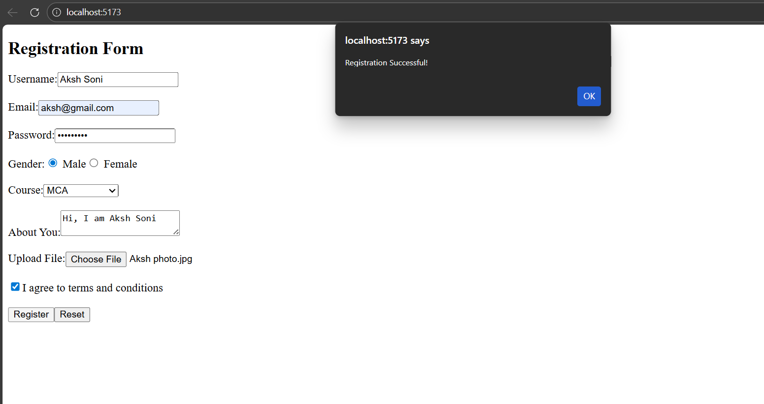

Deliverables:

- Functional multi-page React app with routing and navigation.
- Dynamic content displayed using URL parameters.
- Implement Task 2.

Submission Checklist:
  - Source code with appropriate comments.
  - Screenshot of the application in the browser.
  - Explanation of the use of React Router and URL parameters.

Expected Learning Outcomes:

By the end of this practical, students will be able to:

- Use React Router to create a multi-page React application.
- Implement navigation using <Link> and <NavLink>.
- Utilize URL parameters to render dynamic content.
- Extend React applications with routing capabilities for real-world scenarios.

