Game Design Document

Fill up the following document

1. Write the title of your project.

The Adventures of Super Mario

1. What is the goal of the game?

There are 3 levels in the game.

1st Level – The aim for the first level is to help Super Mario get all the gold coins and escape the maze while also saving him from his enemies, the Cactuses.

2nd Level – In the second level the goal is to help Super mario in a infinite runner game, saving him from dangers and his enemies while also collecting goodies like gold coins at the same time.

3rd Level – Level 3 is going to be the toughest. Super Mario is a hero.

He is in space fighting bad alieans who are in spaceships trying to destroy earth. You have to help Super Mario by helping him shoot spaceships and also save himself at the same time.

1. Write a brief story of your game.

Super Mario is a really adventurous and good person. He does many risky and dangerous mission. So this time he has asked you to help him in his top 3 missions!!!!

1. Which are the playing characters of this game?

* Playing characters are the ones who respond to the user based on the input from the user.
* Cars, monkeys, dinos, wizards, etc., are the playing characters in the game.

|  |  |  |
| --- | --- | --- |
| Number | Character Name | What can this character do? |
| 1 | Mario | He can move with arrow keys,shoot,collect coins and his main goal is to save earth. |
| 2 | Spaceships | Alieans are inside these spaceships and want to destroy Super Mario and earth.They can shoot bullets and move around. |
| 3 |  |  |
| 4 |  |  |
| 5 |  |  |
| 6 |  |  |
| 7 |  |  |
| 8 |  |  |

1. Which are the Non-Playing Characters of this game?

* Non-Playing characters are the ones that don't have an action or behavior when the user interacts with the game.
* Hurdles, stones, bananas, coins, etc., are non-playing characters in the game.

|  |  |  |
| --- | --- | --- |
| Number | Character Name | What can this character do? |
| 1 | Cactuses | Can kill the player if they touch it. |
| 2 | Bricks | For the player to move on and for boundries. |
| 3 | Coins | For collecting and getting more money |
| 4 | Walls | To make the maze |
| 5 | Treasure | To collect after finishing the maze |
| 6 |  |  |
| 7 |  |  |
| 8 |  |  |

Draw your imagination of this game. What does this game look like?

* Draw the game either on your computer or on paper.
* Add images of the game scenes to show each of the playing and non-playing characters at least once.

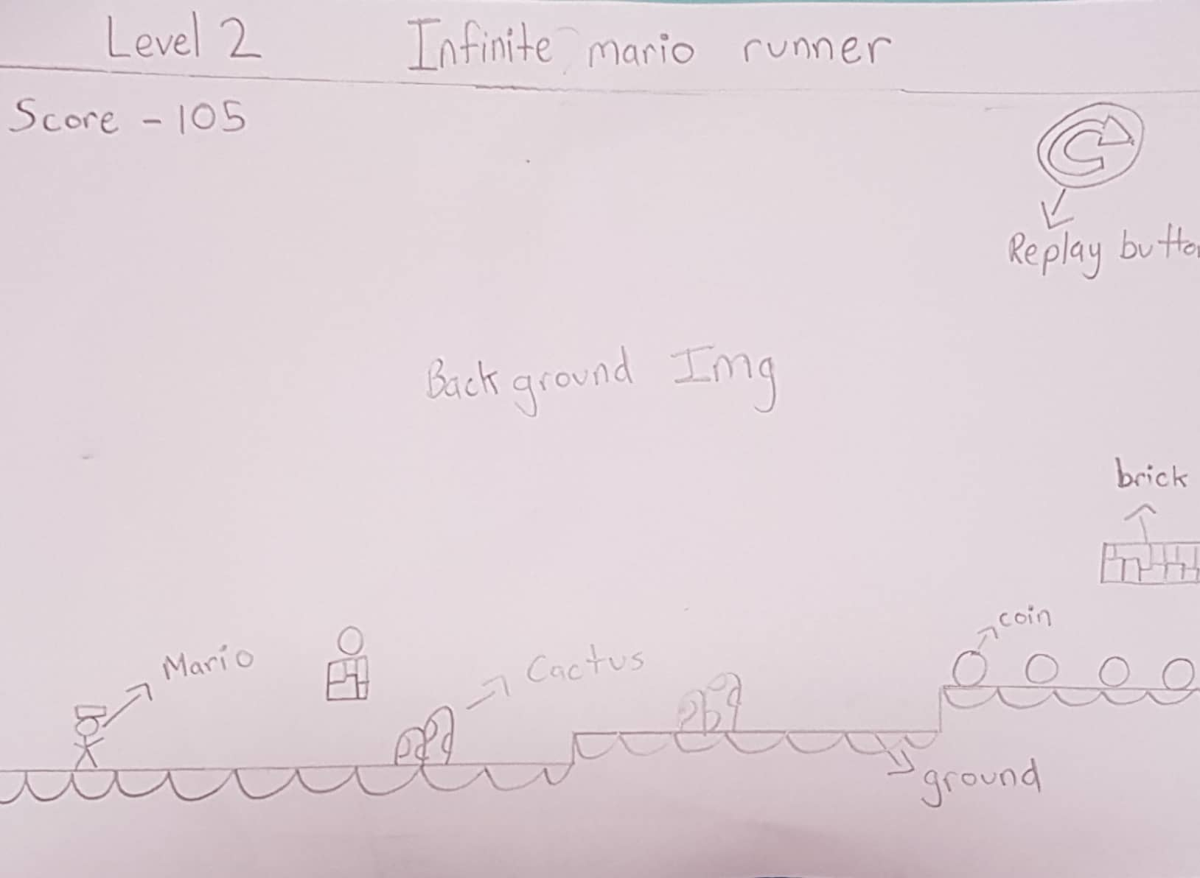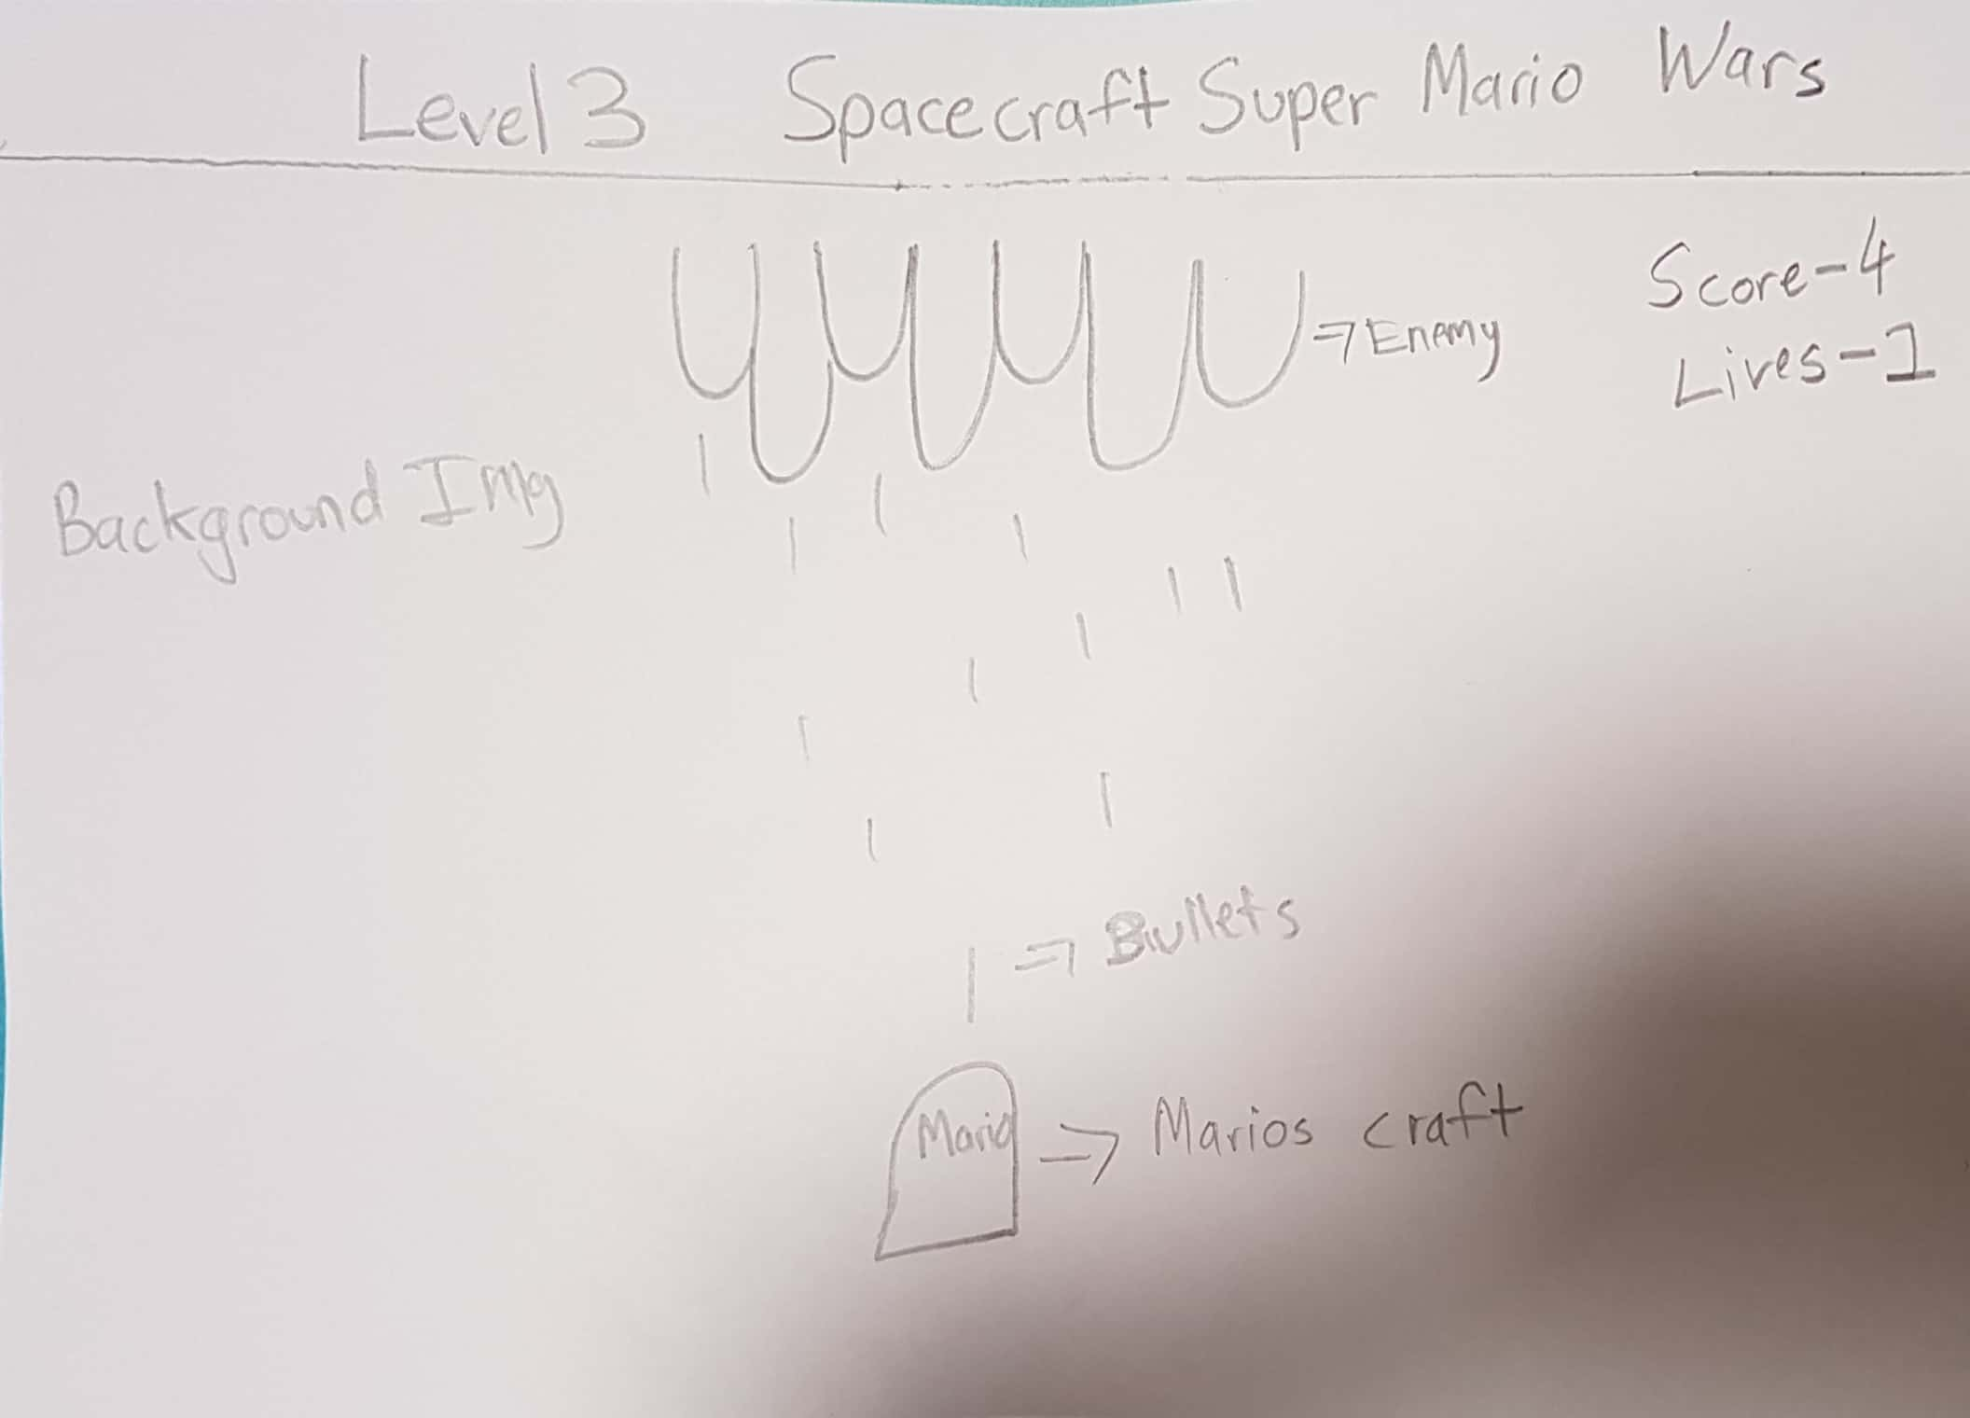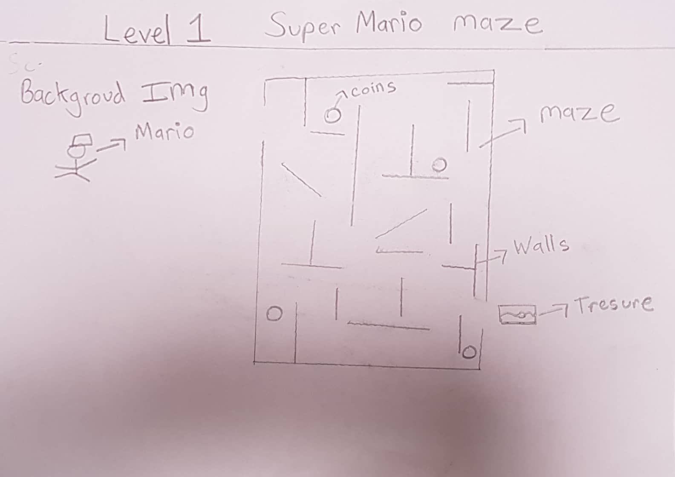

How do you plan to make your game engaging?

I have added levels, speed changes, scores and treasures to make my game interesting and engaging for people to play.