**602-01:Data Visualization**

**Project: Data visualization of “Boston City Crime Records”**

**Virbhadrasinh Kumpavat**

**Umassd Id:01592422**

**Table of contents**

**1.Introduction :**

**2.My Dataset :**

**3.Questions :**

**4.Visualization Designs:**

* **Line graph**
* **Bar graph**
* **Map projection**

**Introduction:**

Data visualization -“**Boston City Crime Records**” is represent the crime records data which are reported in Boston city police department that conducted in Boston city during the year of 2013 and 2014 . In this project we illustrate the different type of visualization designs to show different types of Offence and Address for specific crime site locations.

**Dataset:**

I get the data for Boston city crime incidents from <cityofboston.gov> website; it’s a official website of Boston city government. They provide the annual data of crime incidents occurs in Boston.

The main URL for data :

<https://data.cityofboston.gov/Public-Safety/Crime-Incident-Reports/7cdf-6fgx>

My original Dataset contain the information of different types of crime reported in police department. I Use this data set as CSV file in my project .Its contain the following fields.

* Compnos- it shows complain number of crime- Categorical.
* Nature code- code for particular type of crime – Categorical
* Incidents- It represent the type of incident(crime) ,- Categorical
* Date_Time-Shows the date and time when incident occurred, -Ordered
* Weapon= Types of weapon use in crime ,-Categorical
* Shooting- During crime shooting occurs or not
* Shift-It shows like crime conducted in which shift ,- Categorical
* Year ,Month ,Day – present year and month in which crime happen.-Ordered ,
* Address- Address for crime site,-Text
* lat and long- its shows latitude and longitude for crime site location.

I make some changes on my original data set with help of different filters to remove irrelevant and not useful data for my visualizations. I have large number of data for many years so I filter that data for year 2013 and 2014 (175072 lines).also remove some irrelevant columns (like Nature code, shift, shooting ) form data and make csv file Boston.csv.

After all filters and modification my csv file looks like.

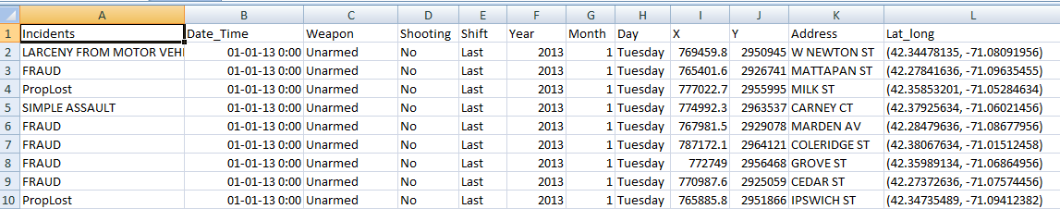

**Questions**

I make the list of following questions is planning to answer in my project during my project proposal.

1.How many crime incidents are occurred in different months over different year?

2) How many crimes occurred on particular days of the week over the years?

3) How to find number of crime of different types occurred in different months for particular year?

4) How to show locations of same type of crime occurred in different part of city?

After professor review my project proposal and give suggestions than I make some changes in my questions that provide more information about the data with visualization designs. So here is my questions list which answers are providing by my visualization designs.

1. How many total number of crime occurs in different month over the year 2013 vs 2014?

1. How many total number of Same types of crime occurred in particular year ? 2013 and 2014.
2. Which type of crime highest take place in particular year ?
3. At which place the particular type of crime incident Take place in Boston city?

**Visualization Designs.**

**Line Graph**

Here line graph design provides information about the total number of all types crimes take place in Boston city in different month for year 2013 and 2014.

So people can easily understand and evaluate the **total number** of crime in particular month also compare different year to each other. So carry out the data about maximum and minimum crime recorded month in the year.

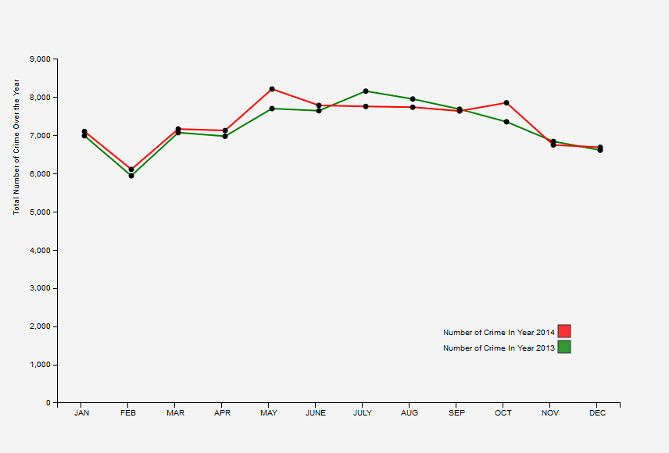

In this simple line graph design **Green** line provides data for year **2013** and **Red** line shows data for year **2014** from January to December. Black dot provide the value for total number of crime in that particular month which plotted on x-axis. So User can easily understand the trend of total number of crime over the year.

Here for **Line Graph** **Mark : Points, Lines** and **Channel** :**Position , Color hue**

**Bar Chart**

Here Bar chart provide the information about the total number of specific types of crime come across in whole year 2013 and 2014. Also provide info about **highest** and **lowest** type of crime take place in Boston city.

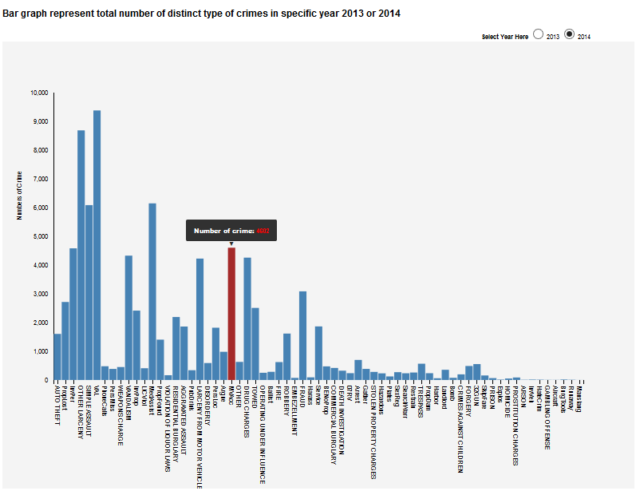

I put **radio button** on top of the bar to select the year 2013 or 2014. With change in year on radio button my bar chart change and give Bar Graph for selected year. Also I provide mouse hover and tooltip on all bar that show total number of crime in tool tip with changing in color in bar when mouse pointer hover on bar. So User can easily figure out which type of crime have maximum number and minimum number in year and compare with other types of crimes.

**BAR chart: Marks: Area** and **Channels: Position,color.**

**Projection On Boston City Map**

In this design I provide the particular Addresses for Crime site locations for All types of crime which take place in Boston city .I provide projection with latitude and longitude to show specific Crime site location and with special effect of mouse on its provide crime site locations **street address.**

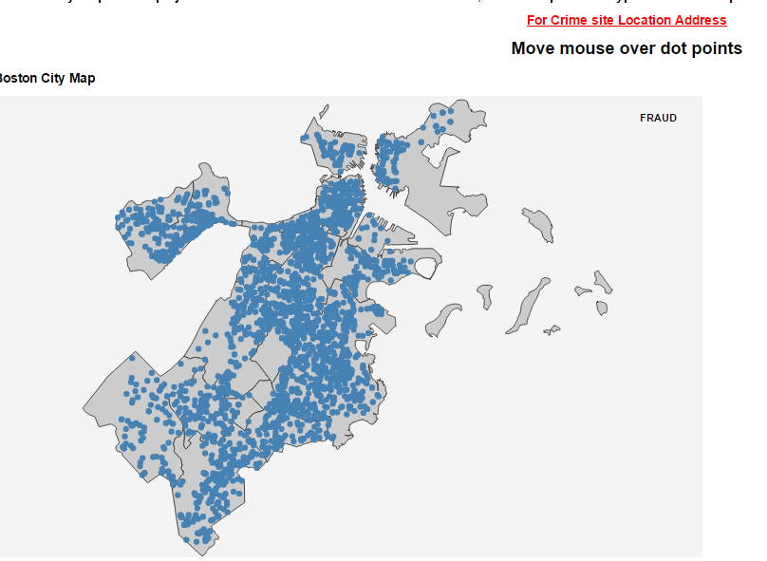

Boston city map provide the crime site locations for particular type of crime happen during the year. The Arrow show the crime type which is selected from bar graph by on click.

With on click on specific type of crime in bar graph the Boston city map provide all crime site locations in map also show which type of crime type **selected** in bar graph at **top right side** pointed by arrow.

When user move mouse on specific blue point of crime site it’s turned into red point and also give the address of crime site location at the top of map. Below the line “for crime site location Address”. **For MAP : Mark:Points and channels :Position**

**\*\*Interaction and Linking between the designs.\*\***

**Here I provide interaction and linking between Bar graph and Map. (Example)**

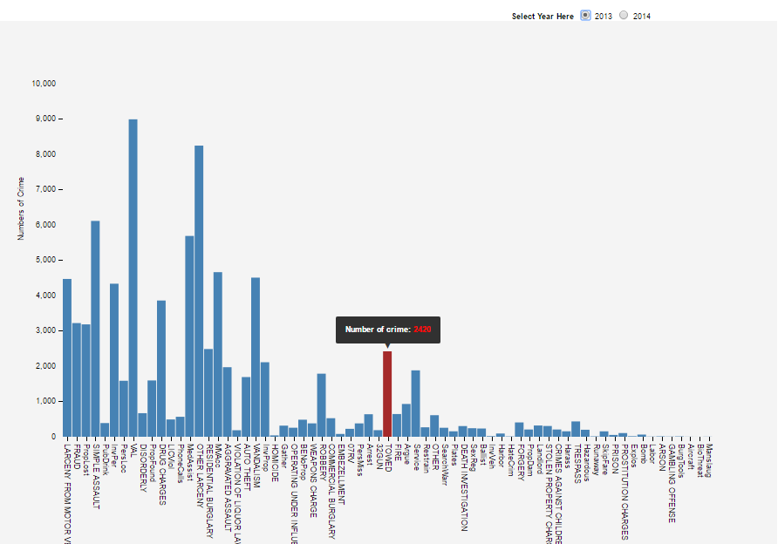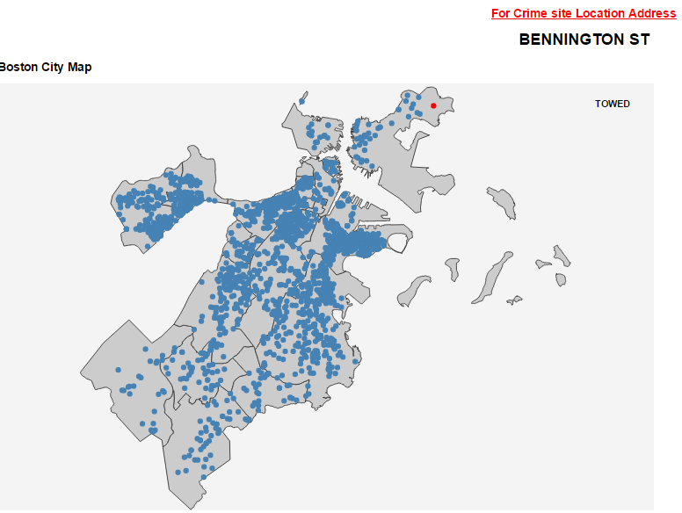

Here both designs are interconnected. -For **Example above**

When User **select** the year from **Radio button** which are on the top of Bar Graph the design shows Total Different types of crime for **selected** year (Here 2013).

- When user **hover on bars** in graph it provide value for specific type of crime.(Towed)

When User **click on** specific type of crime on Bar chart ,at bottom Map provide all crime site locations for selected crime (EX.Towed) .selected crime type show on right top in map design. Now user when **move mouse** pointer on specific crime site location(**blue dot**) its turned in **red** color and provide the **street address** for particular crime site location.(Here: Bennington Street.

Answer for questions:

My visualization provide all question’s answer which I provided during project proposal and after professor suggestions..line graph provide both two years 2013 and 2014 comparisons for total number of crime and provide answers on trending over year for different month

My bar chart provide the answers of questions like How many total number of Same types of crime occurred in particular year ? and Which type of crime highest take place in particular year ? With radio button u can select the year and mouse hovers effect provide the value for total number of specific crime for that year .

My Boston city map provide the location information for selected crime type from bar chart also provide specific information about that location like street address so user easily understand that this type of crime occurs in which street or which area in Boston.

**This visualization helpful for police department to take action Again specific type of crime which highest take place during the year. Also helpful to figure out which area of city is most influence with specific type of crime. which month crime rate is high than another months!! and many more information.**.

**Reference:**

<http://bl.ocks.org/ZJONSSON/3918369> for multiline graph understanding and implimentation.

<http://codepen.io/dakoop/pen/aNJaPz> proffessor koops example for legends <http://bl.ocks.org/Caged/6476579> for Bar chart tool tip and hover <http://duspviz.mit.edu/d3-workshop/mapping-data-with-d3/> for boston city map and effects.

I also Use Stack overflow and W3school.com for my project coding to understand different function.