<Quick-Shoppe>

# System Design Document

Version 1.0

11/27/2017

## Introduction

The System Design Document (SDD) describes how the functional and nonfunctional requirements recorded in the Requirements Document, the preliminary user-oriented functional design recorded in the High Level Technical Design Concept/Alternatives document, and the preliminary data design documented in the Logical Data Model (LDM) transform into more technical system design specifications from which the system is built. The SDD documents the high-level system design and the low-level detailed design specifications.General Overview and Design Guidelines/Approach

### 1.1 Assumptions/Constraints/Risks

#### Assumptions

* The store owner must keep all the data of the available products in the database of our system like cost,quantity,barcode etc.
* Users must use smartphones with andoid version of atleast 4.4 having camera, internet connection.

#### Risks

* We have used firebase database. So if firebase stops working, our application will be affected significantly.
* We use google api to find the nearby shops and route. If these api’s get depreciated, then our application will need revision.

## System Architecture and Architecture Design

Block Diagram

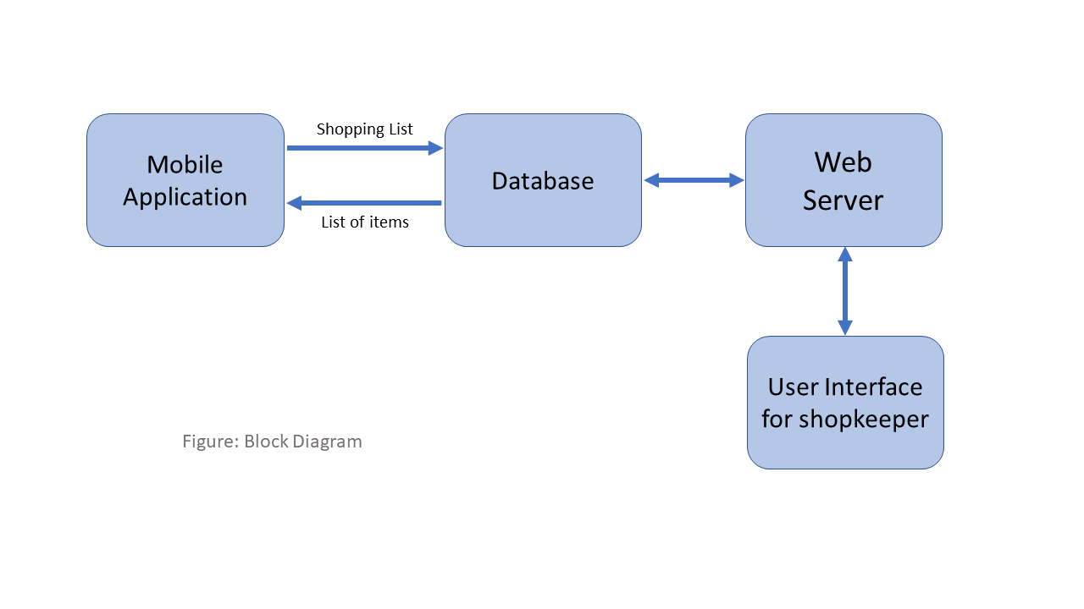

Mobile Application:

This is the medium which helps the user to add , delete items and interact with the products. This contains the cart of items and interacts with the database. This is an android application.

Database:

This is the firebase database which stores the customer and shop data in json format. It is the central unit with which all modules interact.

Web Server:

This is the shop portal which takes in all the orders and helps the shopkeeper manage the orders and database items.

### Logical View

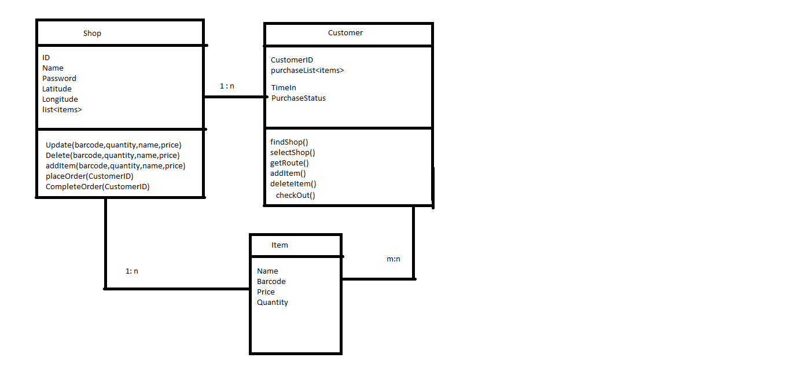

### Software Architecture

* Firebase Database :

We use Google firebase to store data. This provides us real time updates in our application.

* Google Maps :

This is used to show the route and navigate to the selected shop

* Google Direction API:

Given two positions on the map, it gives several locations in the route of these positions to draw the route.

* Google Vision API

To scan the barcode of the product

* Android OS

Our application requires android smartphone with minimum version – 4.4

* Bootstrap libraries:

These are used to design the web portal of the shop.

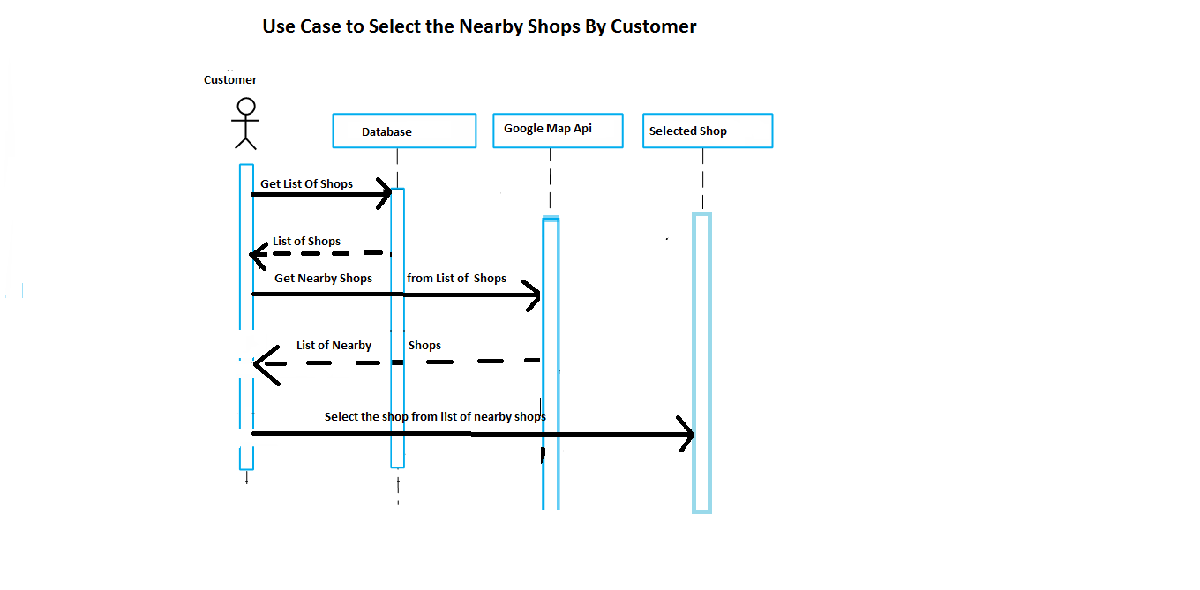

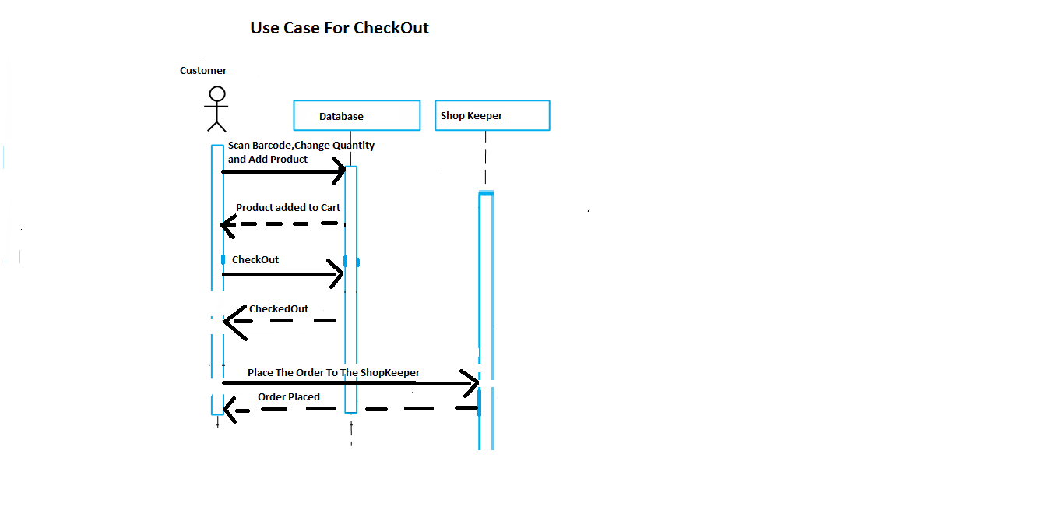

### Information Architecture

In the shared preferences of local mobile storage, we store the shopID in which the customer has entered , customerID and the items of cart so that if the customer reopens the app, his previous information is restored. Also the customer id and his cart items is stored in the database.

## System Design

### Database Design

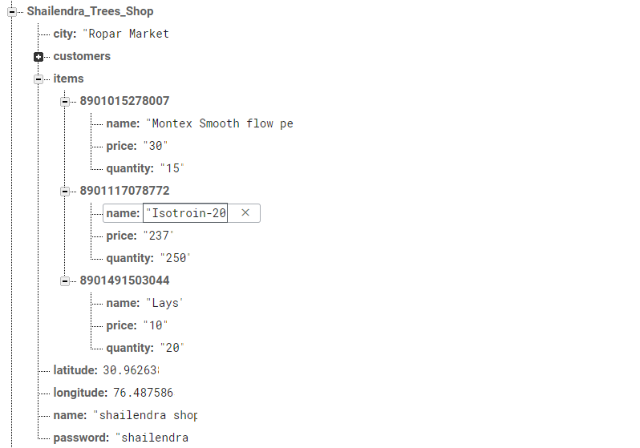

Database design for shops

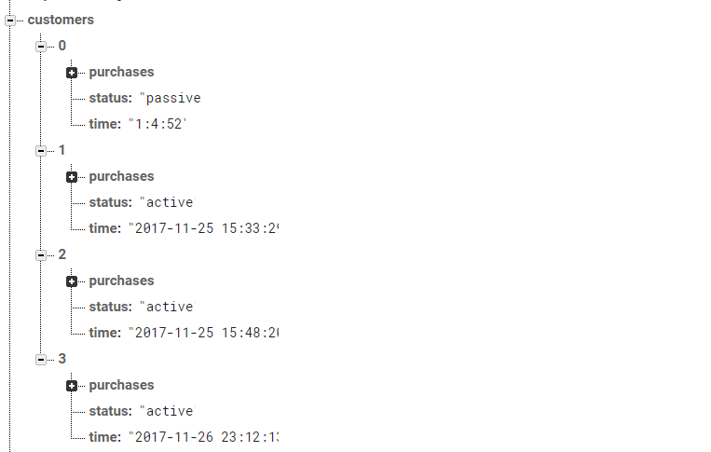

Database design for customers.

### User Interfaces mockups:

