# Mini Project Title

Submitted in partial fulfillment of the requirements of the degree

### BACHELOR OF ENGINEERING IN COMPUTER ENGINEERING

By

**Hriday Keswani 2003088**

**Viren Keswani 2003089**

**Atharva Kadam 2003075**

Supervisor

Ms.Manisha Dumbre



**Computer Engineering Department Thadomal Shahani Engineering College**

**Bandra(w), Mumbai - 400 050**

## University of Mumbai

**(AY 2021-22)**

# CERTIFICATE

This is to certify that the Mini Project entitled **“PC builder”** is a bonafide work of **Hriday Keswani (2003088), Viren Keswani (2003089), Atharva Kadam (2003075)** submitted to the University of Mumbai in partial fulfillment of the requirement for the award of the degree of **“Bachelor of Engineering”** in **“Computer Engineering”.**

#### (Prof.Manisha Dumbre)

Supervisor

#### (Prof. Tanuja Sarode) (Prof. G.T. Thampi)

Head of Department Principal

# Mini Project Approval

This Mini Project entitled “PC builder**”** by **Hriday Keswani (2003088), Viren Keswani (2003089), Atharva Kadam (2003075)** is approved for the degree of **Bachelor of Engineering** in **Computer Engineering.**

**Examiners**

**1………………………………………**

(Internal Examiner Name & Sign)

#### 2…………………………………………

(External Examiner name & Sign)

Date:

Place:

# Contents

#### Abstract ii

#### Acknowledgments iii

#### List of Abbreviations iv

#### List of Figures v

#### fig(a) – Website Arhitecture

#### fig(b) – Working of the algorithm

#### fig(c) – Homepage

#### fig(d) – Choosing components

#### fig(e) – Output

#### fig(f) – **Accessing documentation**

#### List of Tables vi

#### List of Symbols vii

#### Introduction 1

* 1. Introduction
  2. Motivation
  3. Problem Statement & Objectives
  4. Organization of the Report

1. **Literature Survey 4**
   1. Survey of Existing System
   2. Limitation Existing system or research gap
   3. Mini Project Contribution

#### Proposed System (eg New Approach of Data Summarization ) 5

* 1. Introduction
  2. Architecture/ Framework
  3. Algorithm and Process Design
  4. Details of Hardware & Software
  5. Experiment and Results
  6. Conclusion and Future work.

**References 32**

# Acknowledgement

We would like to express our gratitude and thanks to **Prof. Manisha Dumbre** for her valuable guidance and help. We are indebted for her guidance and constant supervision as well as for providing necessary information regarding the project. We would like to express our greatest appreciation to our principal **Dr. G.T. Thampi** and head of the department **Dr. Tanuja Sarode** for their encouragement and tremendous support. We take this opportunity to express our gratitude to the people who have been instrumental in the successful completion of the project.

Hriday Keswani

Viren Keswani

Atharva Kadam

# Chapter 1

### 1.1 Introduction

Our topic “PC Builder” is project aimed at first time PC builders in helping them with an all in one platform to remove the noise of overwhelming options and misinformation that a first time builder experiences.

### 1.2 Motivation

The Indian market for electronic components in general is not in the best condition for a consumer, when it comes to PC building a lot of consumers end up overspending on overpowered PCs assembled by third parties with unethical profit motives, the incompetent high pricing in the markets has become a major barrier for an average Indian to be able to buy one, due to this lack of personal computing power in an average Indian household the economy is missing on a new and highly lucrative market of digital goods and the simultaneously missing on the opportunity of producing equally attractive multi-bagging digital products and experiences.

### 1.3 Problem Statement & Objectives

Problem statement:

To make a website that helps people learn how to build PCs and search for cost effective builds.

Objectives:

- To improve technical know how on the consumer’s end.

- The project aims to provide cost effective and power effective builds to prevent the consumer from overspending

- To encourage independent decision making on the consumer end so that third parties cannot misinform them and overcharge them.

### 1.4 Organization of the Report

This report consists of three chapters. The first chapter deals with introduction of the topic, problem statement, motivation behind the topic and objectives. The second chapter is the Literature Survey. It includes all the research work done related to this topic. All information related to study of existing systems as well as learning of new tools is mentioned in this chapter. The third chapter is about the proposed system which is used in this project. The block diagram, techniques used, hardware and software used screenshots of the project are presented in this chapter. All the documents related to development of this project are mentioned in References

# Chapter 2

## Literature Survey

### 2.1 Survey of Existing System

Existing systems that help people build PCs are primarily offered as tools in several e-commerce websites to the likes of:

- NZXT

- MD Compters

- ibuy-power

- pcpartpicker

Individual components can also be bought from several mainstream e-commerce websites like:

- Flipkart

- Amazon

- Snapdeal

### 2.2 Limitation of existing system

There are certain flaws in the existing system that if solved by existing entities will go against their business model. All existing products offering this are e-commerce stores.

Given their motives, by design a consumer gets products that are often over-prized or are beyond what the consumer requires, the existing systems do not keep the best interests of the end consumer in India’s PC markets. Major factors that have caused this unfair practice is lack of know how on the consumer end, taking advantage of high taxes levied on the components by the government as an excuse for overpricing their products.

### 2.3 Mini Project Contribution

Our project promotes independent decision making and spreads awareness on how to select components and providing working build configurations based on the user’s applications, so that the consumer can independently make decisions and not depend on a third party to make all the decisions.

We offer different cost effective configurations as well as an interact guide on how to go about building one’s own personal computer. We aim to bring change in the consumer behavior in order to compel the market forces to act in a competitive manner.

# Chapter 3

## Proposed System

### Introduction

The programming language and tools used are:

- Node.js

- Express.js

- EJS

- HTML

- CSS

- Javascript

- Python

### Architecture

### 

### figure(a)

### Algorithm and Process Design

The problem being faced was being able to deliver correct information based on the type of component selected, and also to be able to deliver all possible components that could be compatible with it. This was seemingly a complex task because it required us to be able to scrap through 1000s of components in JSON files and needed intense research to be able to filter the correct components and their alternatives

The project uses Node.JS at the backend with express as the middleware. JSON files are parsed to retrieve data on components and they are passed onto the page and processed as per input to give appropriate components as the output by taking advantage of EJS which allows to seamlessly integrate javascript with HTML and makes it easier to append elements to the window.

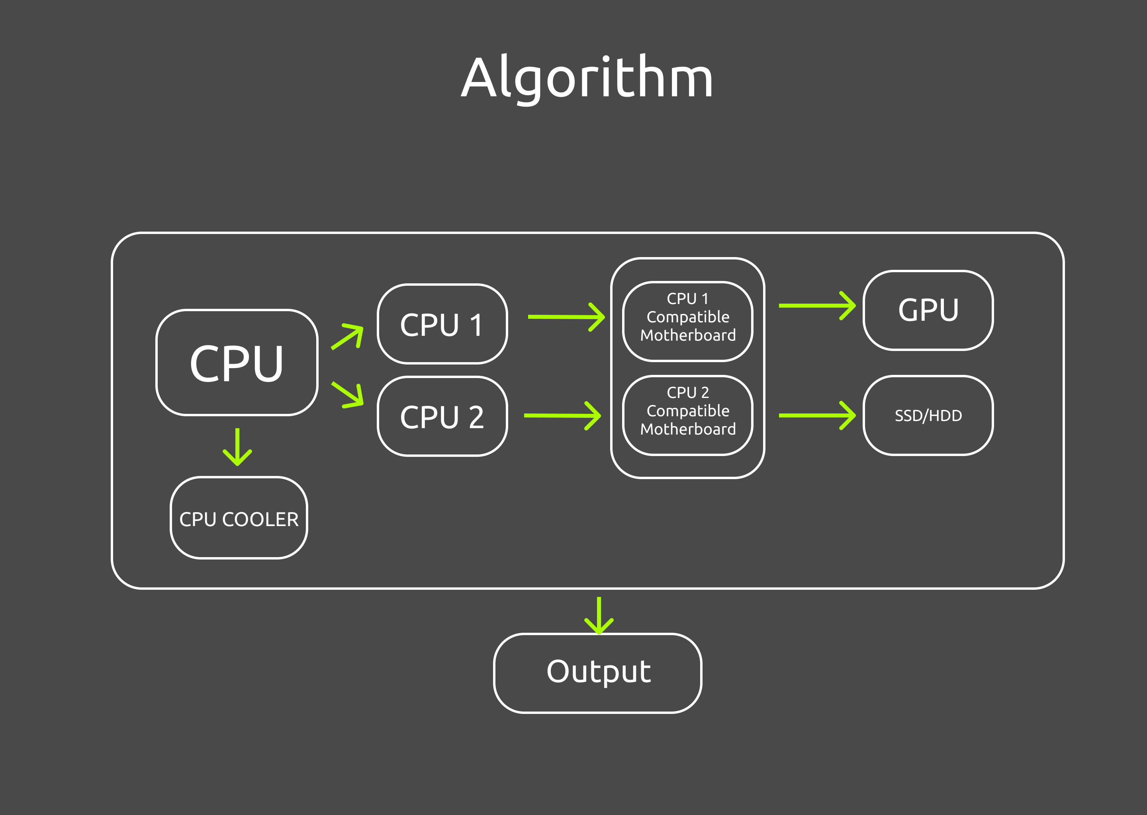

figure(b)

Working of the algorithm is presented in the above picture.

The features which were decided to be included were an interactive way to choose your own components and in the end get an output and be able to download the list as a PDF, A documentation which guides an individual through building their own PC and a set of custom PC builds that

The project was developed using in htmls css and javascript with node.js and express in the backend.

Testing for the project was done by checking pre-existing builds and if our inputs were able to generate the correct components as output

### Details of Hardware & Software

The project was developed in the average configuration of:

8 GB RAM

Intel i5 9th generation processor

Windows 10/11

VS Code text editor

and it can run on any device capable of rendering a website

### Results

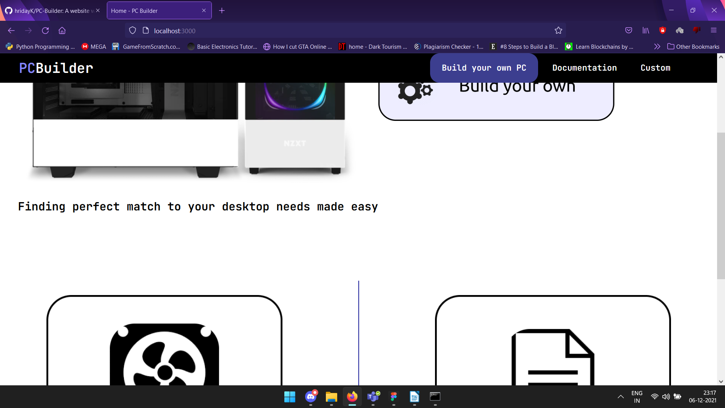

fig(c)-Homepage

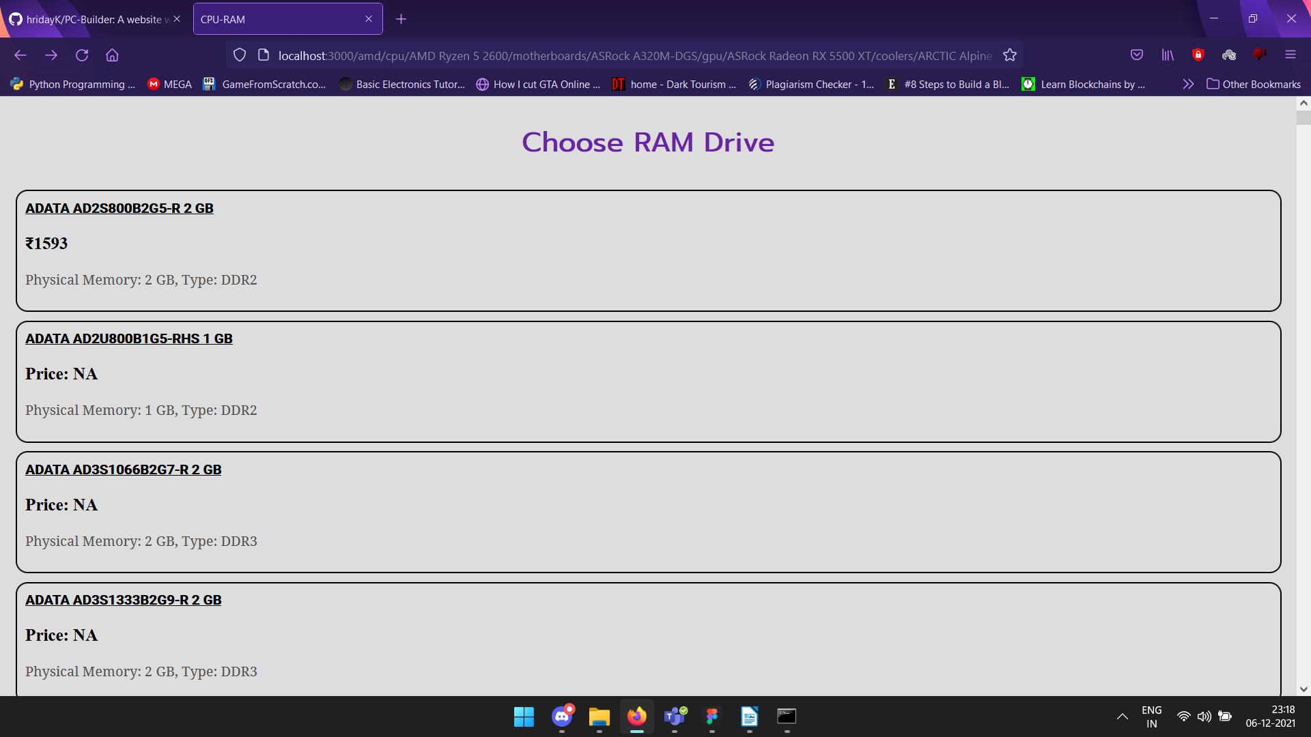

fig(d) - choosing components

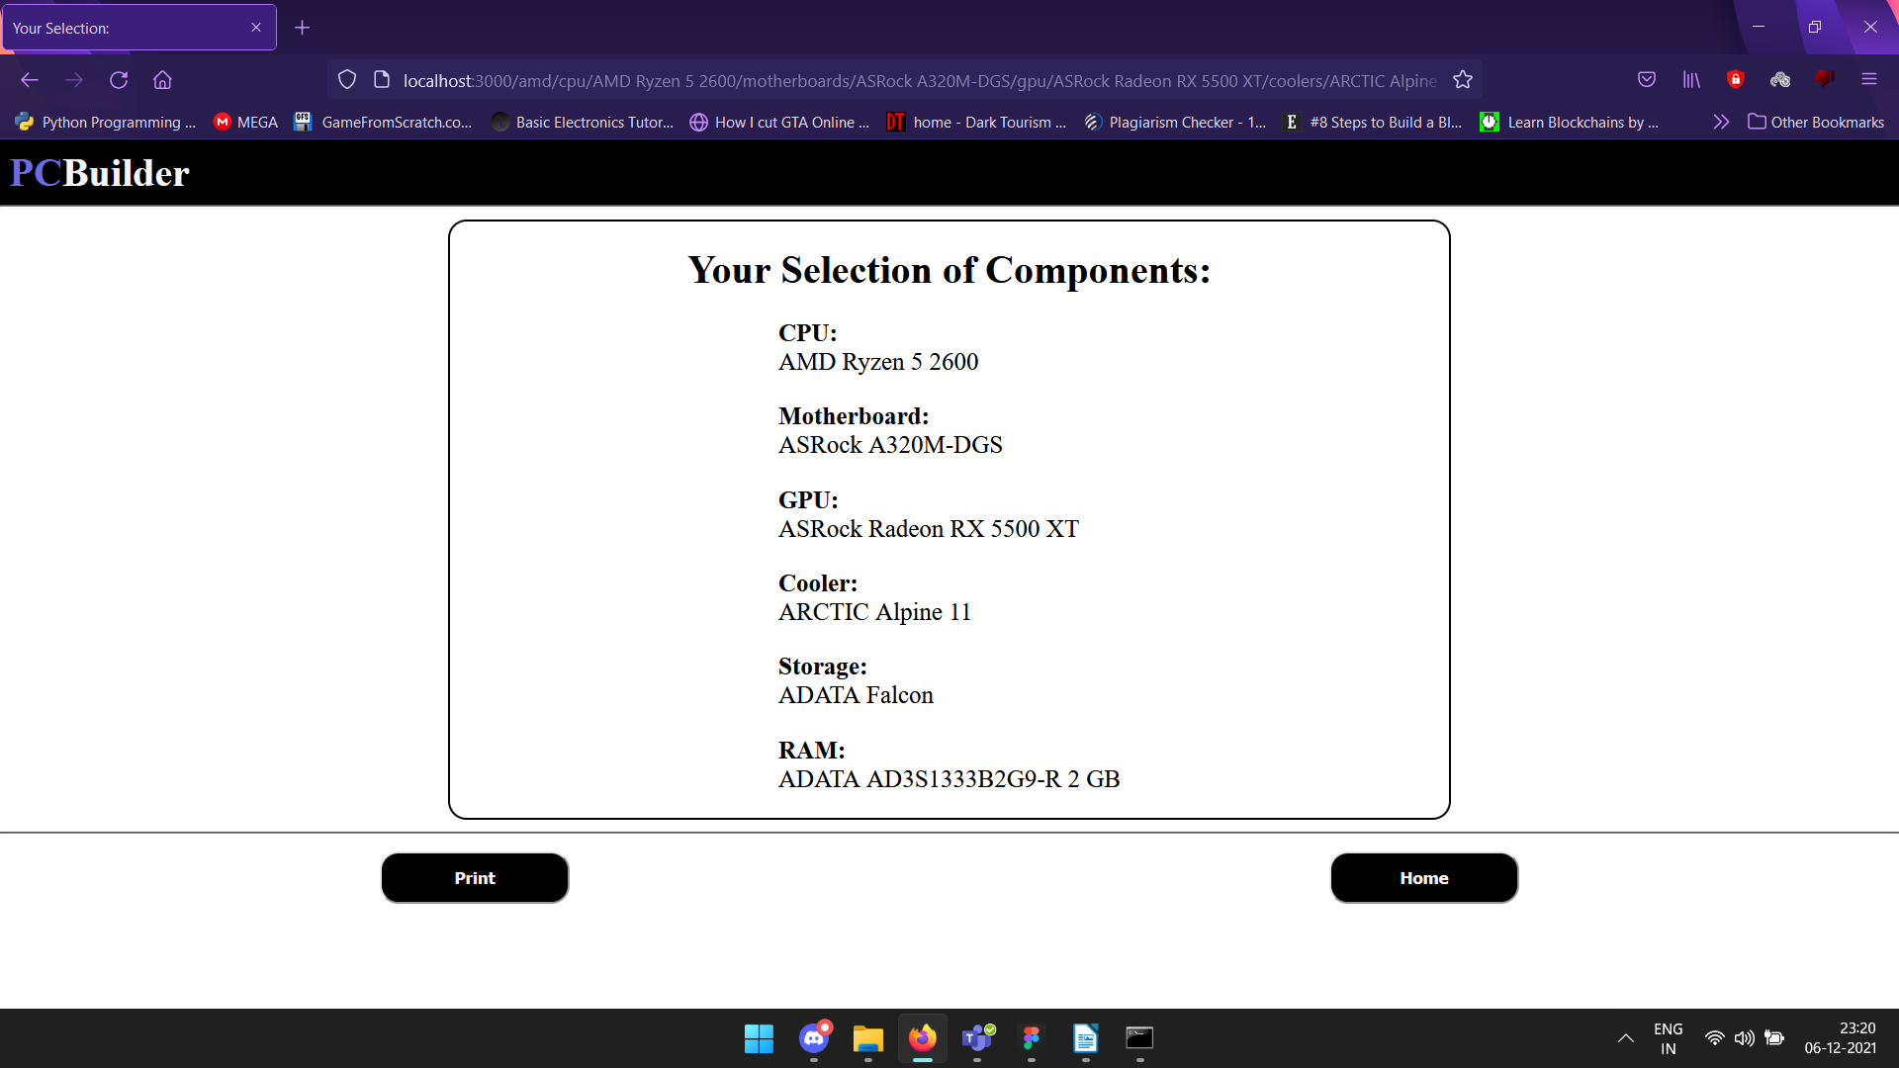

fig(e) - Output

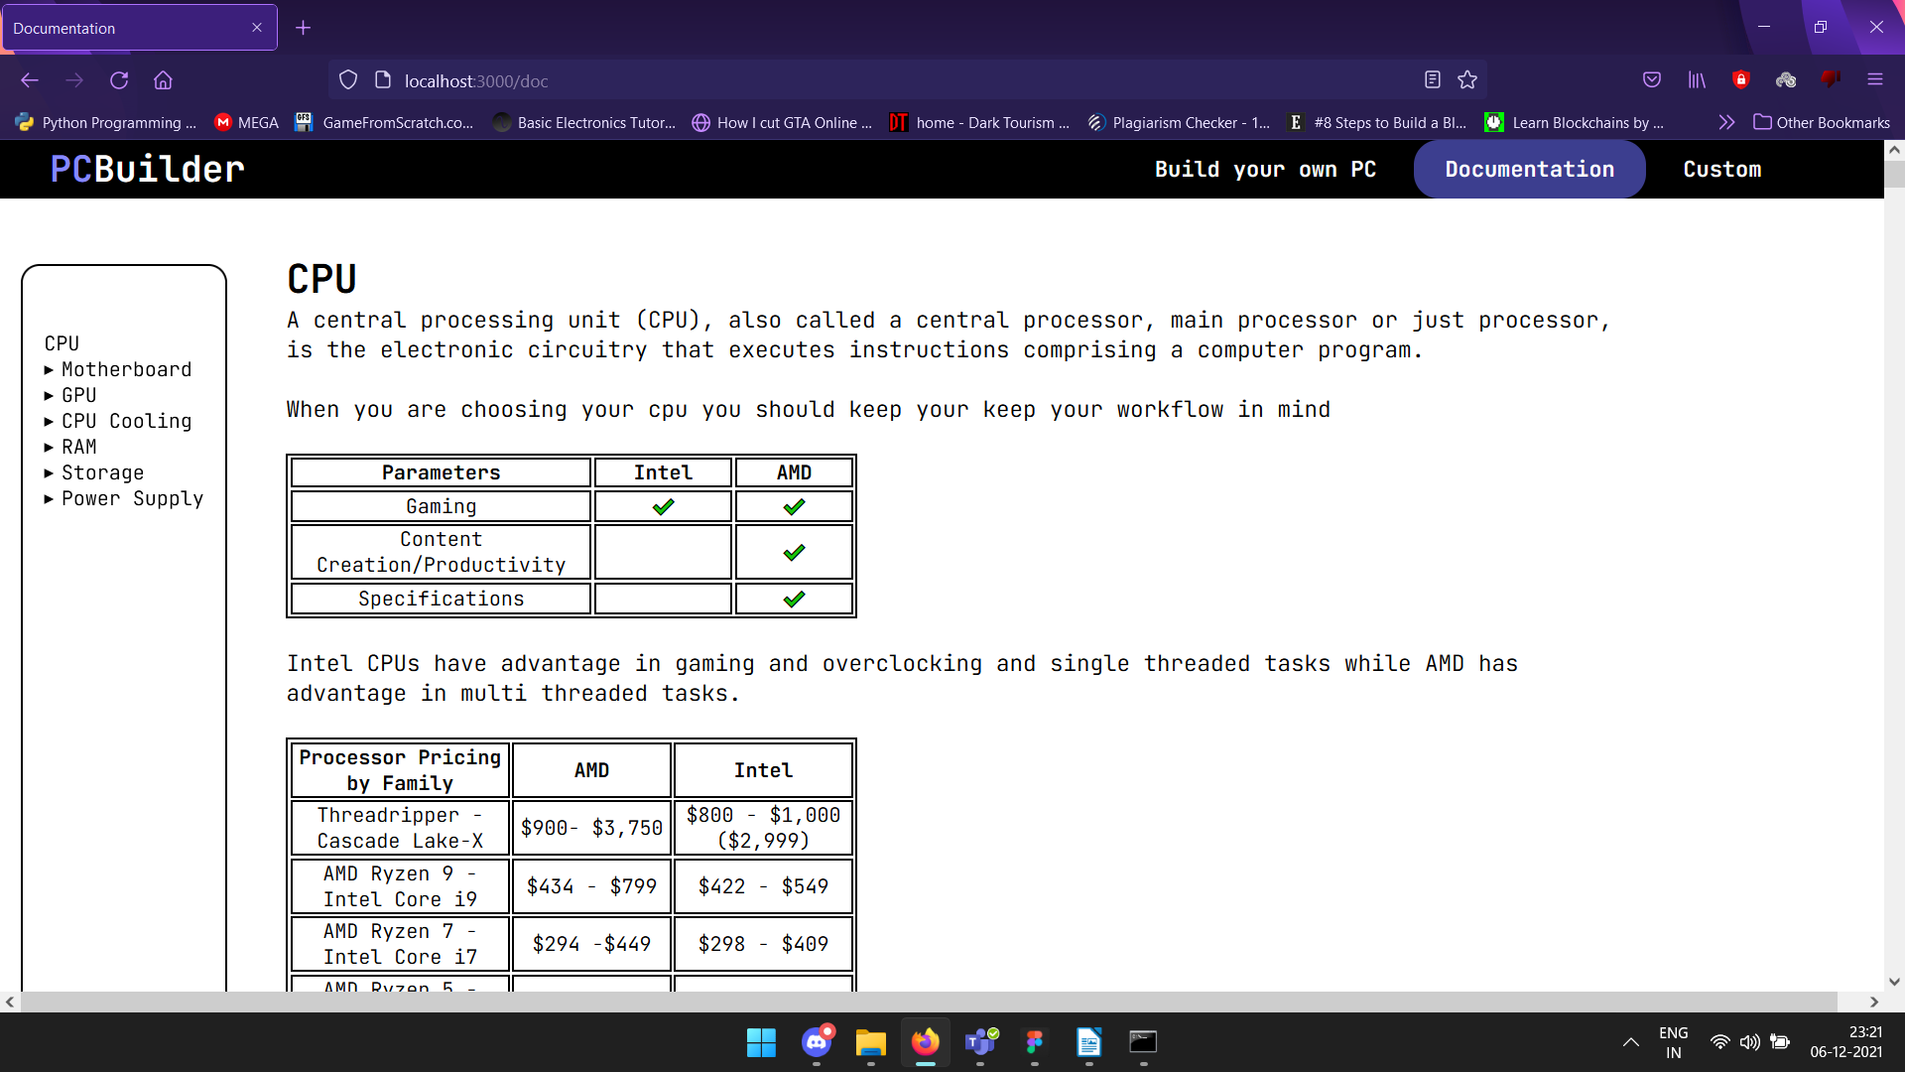

fig(f) - The documentation with an easy navigation index at the left

### Conclusion and Future Work

The project has a documentation on choosing components for a CPU and a custom component selector that aids people in selection of the right components and also it has a curation of existing builds that are battle tested as per a user’s needs

For future work we wish to try to add filters to narrow down the components like e-commerce websites and also be able to fetch live rates of those components and automate the building process with just the input of user’s budget.

### References

https://nzxt.com/

https://mdcomputers.in/

https://www.primeabgb.com/

https://pcpartpicker.com/

<https://www.ibuypower.com/>