Npx create-react-app <frontend| name>

npm i --save react-router-dom react-toastify axios

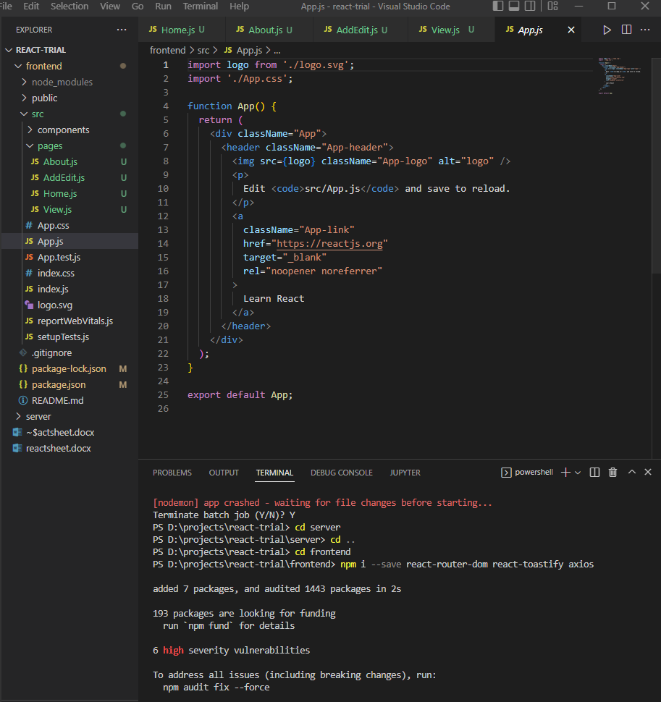

File structure

(rfce to make elements)