Q1) Use Java do program to demonstrate it.

package exa;

import java.util.Scanner;

/**

*

* @author Viren

*/

public class Example {

    /**

* This is a program for adding two numbers in java.

    * @param args

*/

    public static void main(String[] args)

    {

        /**

        * This is the main method

        * which is very important for

        * execution for a java program.

        */

        int x, y;

        Scanner sc = new Scanner(System.in);

        /**

        * Declared two variables x and y.

        * And taking input from the user

        * by using Scanner class.

        *

        */

        x = sc.nextInt();

        y = sc.nextInt();

        /**

        * Storing the result in variable sum

        * which is of the integer type.

        */

        int sum = x + y;

        /**

        * Using standard output stream

        * for giving the output.

        * @return null

        */

        System.out.println("Sum is: " + sum);

    }

}

Q2 )

**package** arrayofobjects;

**import** java.util.Scanner;

**public** **class** sports {

**static** **int** *Acc_id*;

String des;

**int** quant;

**int** rate;

sports(**int** a, String b,**int** c,**int** d){

*Acc_id*=a;

des=b;

quant=c;

rate=d;

}

**public** **void** display() {

System.***out***.println(*Acc_id*++ +" " + des + " "+ quant + " "+ rate);

}

**public** **static** **void** main(String[] args) {

sports []ts = **new** sports [10];

**int** a1;

String b1;

**int** c1;

**int** d1;

Scanner sc=**new** Scanner(System.***in***);

**for**(**int** i = 0; i<ts.length;i++) {

System.***out***.println("enter acc_id ");

a1 =sc.nextInt();

System.***out***.println("enter enter description ");

b1= sc.next();

System.***out***.println("enter quantity");

c1= sc.nextInt();

System.***out***.println("enter rate");

d1=sc.nextInt();

ts[i]=**new** sports(a1,b1,c1,d1);

}

System.***out***.println("\nrecords \n");

**for**(**int** i=0;i<ts.length;i++)

ts[i].display();

}

}

OUTPUT:-

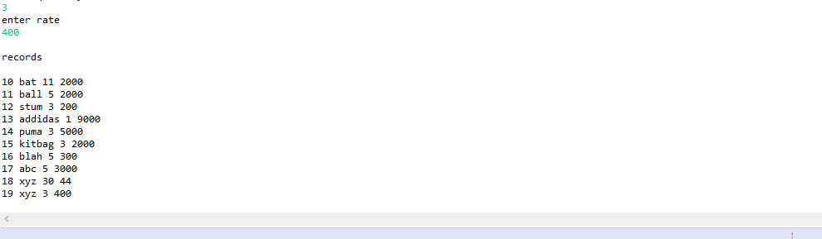

Q3)-----------------------------------------------------------------------------------------------------------------------------------------------------------------------------------------------------------------------------------------------------------------------------

package employee;

import java.io.BufferedReader;

import java.io.IOException;

import java.io.InputStreamReader;

public class Employee {

static int num;

String name;

String des;

double salary;

Employee(){

System.out.println("\nObject Created : Obj No :"+num);

name = "No Name Assigned";

des = "not assigned";

salary = 0;

}

Employee(String a, String b,double c){

System.out.println("\nObject created.\nobject no:"+num);

name=a;

des=b;

salary=c;

}

void display(){

System.out.println("\n name: "+name+"\ndesignation : "+des+"\nsalary : "+salary);

}

public String toString(){

String string="Name : "+name+"designation : "+des+" "+"salary : "+salary;

return(string);

public static void main(String[] args) {

try

{

int n1;

String a1;

String b1;

double c1;

System.out.println("\nEnter No Of Employees: ");

BufferedReader br=new BufferedReader(new InputStreamReader(System.in));

n1=Integer.parseInt(br.readLine());

Employee o[]=new Employee[n1];

System.out.println("\nEnter The Data : ");

for(int i=0;i<n1;i++)

{

System.out.print("\n Name : ");

a1=br.readLine();

System.out.print("\n designation : ");

b1=br.readLine();

System.out.print("\nsalary:");

c1=Double.parseDouble(br.readLine());

Employee.num++;

o[i]=new Employee(a1,b1,c1);

}

System.out.println("\nTotal No Of Students : "+ Employee.num+"\nData : \n");

for(int i=0;i<n1;i++)

o[i].display();

System.out.println("\ntoString : ");

for(int i=0;i<n1;i++)

System.out.println("\nConversion toString : "+o[i].toString());

}

catch(IOException e)

{

System.out.println(e);

}

}

}

OUTPUT:-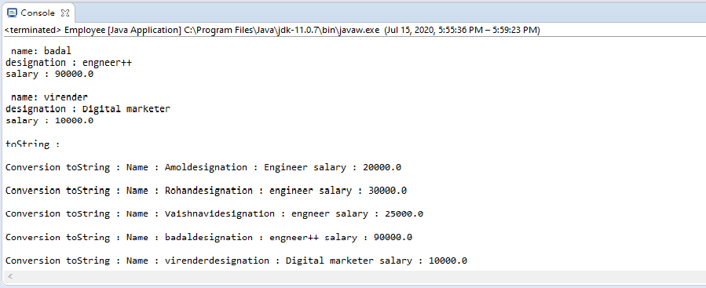

Q4)---------------------------------------------------------------------------------------------------------------------------------------------------------------------------------------------------

**package** studentclass;

**import** java.util.Scanner;

**import** arrayofobjects.sports;

**public** **class** Student {

**public** **int** roll;

**public** String name;

**int** s1,s2,s3,s4,s5,s6;

**int** sum=0;

Student(**int** a, String b,**int** s1,**int** s2,**int** s3,**int** s4, **int** s5, **int** s6){

roll=a;

name=b;

**this**.s1=s1;

**this**.s2=s2;

**this**.s3=s3;

**this**.s4=s4;

**this**.s5=s5;

**this**.s6=s6;

sum = s1+s2+s3+s4+5+s6;

}

/*

public void setData() {

Scanner sc = new Scanner(System.in);

System.out.print("Enter Roll no:= ");

roll = sc.nextInt();

System.out.print("Enter Name:= ");

name = sc.next();

System.out.print("Enter 6 sub mark:= ");

s1 = sc.nextInt();

s2 = sc.nextInt();

s3 = sc.nextInt();

s4 = sc.nextInt();

s5 = sc.nextInt();

s6 = sc.nextInt();

sum = s1+s2+s3+s4+5+s6;

}

*/

**public** **void** display()

{

System.***out***.println("Roll_no : "+roll);

System.***out***.println("Name : "+name);

System.***out***.println("-----MARKS-------");

System.***out***.println("Sub 1 : "+s1);

System.***out***.println("Sub 2 : "+s2);

System.***out***.println("Sub 3 : "+s3);

System.***out***.println("Sub 3 : "+s4);

System.***out***.println("Sub 3 : "+s5);

System.***out***.println("Sub 3 : "+s6);

System.***out***.println("Total : "+sum);

System.***out***.println("percentage: "+sum/6);

System.***out***.println("------------------");

}

**public** **static** **void** main(String[] args) {

Student s [] = **new** Student [10];

**int** r;

String n;

**int** s1,s2,s3,s4,s5,s6;

Scanner sc=**new** Scanner(System.***in***);

**for**(**int** i = 0; i<s.length;i++) {

System.***out***.println("enter roll no ");

r =sc.nextInt();

System.***out***.println("enter name ");

n= sc.next();

System.***out***.println("enter subject marks sub 1");

s1= sc.nextInt();

System.***out***.println("enter subject marks sub 2");

s2= sc.nextInt();

System.***out***.println("enter subject marks sub 3");

s3= sc.nextInt();

System.***out***.println("enter subject marks sub 4");

s4= sc.nextInt();

System.***out***.println("enter subject marks sub 5");

s5= sc.nextInt();

System.***out***.println("enter subject marks sub 6");

s6= sc.nextInt();

s[i]=**new** Student(r,n,s1,s2,s3,s4,s5,s6);

}

**for**(**int** i=0;i<s.length;i++) {

s[i].display();

}

}

}

OUTPUT:-

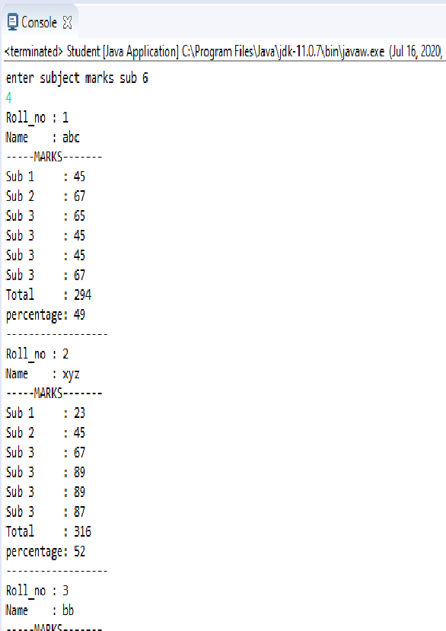

Q5)-------------------------------------------------------------------------------------------------------------------------------------------------------------------------------------------------

**package** stringclass;

**public** **class** Stringclasses {

**public** **static** **class** StringMethodsDemo {

**public** **static** **void** main(String[] args) {

String targetString = "Java is fun to learn";

String s1= "JAVA";

String s2= "Java";

String s3 = " Hello Java ";

System.***out***.println("Char at index 2(third position): " + targetString.charAt(2));

System.***out***.println("After Concat: "+ targetString.concat("-Enjoy-"));

System.***out***.println("Checking equals ignoring case: " +s2.equalsIgnoreCase(s1));

System.***out***.println("Checking equals with case: " +s2.equals(s1));

System.***out***.println("Checking Length: "+ targetString.length());

System.***out***.println("Replace function: "+ targetString.replace("fun", "easy"));

System.***out***.println("SubString of targetString: "+ targetString.substring(8));

System.***out***.println("SubString of targetString: "+ targetString.substring(8, 12));

System.***out***.println("Converting to lower case: "+ targetString.toLowerCase());

System.***out***.println("Converting to upper case: "+ targetString.toUpperCase());

System.***out***.println("Triming string: " + s3.trim());

System.***out***.println("searching s1 in targetString: " + targetString.contains(s1));

System.***out***.println("searching s2 in targetString: " + targetString.contains(s2));

**char** [] charArray = s2.toCharArray();

System.***out***.println("Size of char array: " + charArray.length);

System.***out***.println("Printing last element of array: " + charArray[3]);

}

}

}

OUTPUT:-

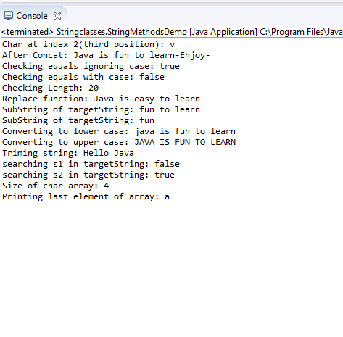

Q6)---------------------------------------------------------------------------------------------------------------------------------------------------------------------------------------------------------------------------------------------------------------------------------------------------------

package arrays;

import java.util.ArrayList;

import java.util.Collection;

import java.util.HashSet;

import java.util.Set;

public class Arrays {

public void declareArray() {

String[] aArray = new String[5];

String[] bArray = {"a","b","c", "d", "e"};

String[] cArray = new String[]{"a","b","c","d","e"};

}

public void printArraysInJava() {

int[] intArray = { 1, 2, 3, 4, 5 };

String intArrayString = Arrays.toString();

// print directly will print reference value

System.out.println(intArray);

// [I@7150bd4d

System.out.println(intArrayString);

}

public void createArrayList() {

String[] stringArray = { "a", "b", "c", "d", "e" };

ArrayList<String> arrayList = new ArrayList<String>(Arrays.asList(stringArray));

System.out.println(arrayList);

}

public void concateToArray() {

int[] intArray = { 1, 2, 3, 4, 5 };

int[] intArray2 = { 6, 7, 8, 9, 10 };

// Apache Commons Bang library

int[] combinedIntArray = Arrays.addAll(intArray, intArray2);

}

public void DeclareAnArrayInline() {

method(new String[]{"a", "b", "c", "d", "e"});

}

public void jonArrayIntoSingl() {

// containing the provided list of elements

// Apache common lang

String j = StringUtils.join(new String[] { "a", "b", "c" }, ", ");

System.out.println(j);

}

public void convertArrays() {

String[] stringArray = { "a", "b", "c", "d", "e" };

ArrayList<String> arrayList = new ArrayList<String>(Arrays.asList(stringArray));

String[] stringArr = new String[arrayList.size()];

arrayList.toArray(stringArr);

for (String s : stringArr)

System.out.println(s);

}

public void ArrayToSet() {

Object stringArray;

Set<String> set = new HashSet<String>(Arrays.asList(stringArray));

System.out.println(set);

//[d, e, b, c, a]

}

public static void main(String[] args) {

Arrays a = new Arrays();

}

}