**Mahendra Kumar Yadav**

Delhi NCR,Delhi 110096, 110096 | 9768317488 | vvy97683@gmail.com

**PROFESSIONAL SUMMARY**

Profile Summary I have total 4.1 years of IT Experience in Software Testing exposed to Automation Testing approaches for various web based applications. Involved in offshore assignments for providing software services to the finest global organizations. almost 2 years of Automation Experience in

Automation using Selenium WebDriver with Java, TestNG, Apache POI, POM. About 1 years of

Experience in Manual testing and Smoke Testing, Sanity Testing, Re-testing, and Regression testing etc. Extensive Experience in implementation of Selenium's Page Object Model Automation to achieve high reusability and modularity in Automation Scripts. Experience in creating Page Object Model based automation framework using selenium and TestNG .

**EXPERIENCE**

**06/2021 to 11/2022** **Info CRM : QA (Automation-Manual Test Eng.)**

**SM WEB SOLUTIONS** － New Delhi, India

Good knowledge and understanding of QA processes and the Testing  
industry Good knowledge of JIRA defect tracking tool.

Extensive Experience in implementation of Selenium’s Page Object Model Automation to achieve high re-usability and modularity in Automation Scripts.

Experience in creating Page Object Model based automation framework using selenium and Test NG.

Experience in Automation of Object Repository & Test Data Management From Different Data Sources excel with different APIs POI.

Experience in Designing, Creation and maintenance of Automation Frameworks using Test NG, Customized Framework with various type of user friendly reporting including Excel Reporting with snapshot, Test Reporting with Snapshot.

Conducted performance tests, assessing features including functionality, reliability, performance and quality.

**01/2019 to 04/2020** **konga.com : Test Automation Engineer**

**Pr. N. Ekeh** － New Delhi, India

Customized Hybrid Framework using POM (Page Object Model)

Project Descriptions: Konga is essentially one of Africa's largest online shops for Fashion, Electronics,Home appliances and more.

The website offers a wide selection of products including Men & Women's Fashion, Mobile Phones, Computers, Electronics, Home Appliances and many more, bringing them right to your doorstep Apart from Ghana, Konga is also available in Nigeria, Egypt, Morocco, Kenya and Ivory Coast

According to the company, it offers consumers a wide selection of styles and brands, 100% convenience with our 24/7 online access from your home or office, secure payment such as Bank Deposit/Online banking and Cash on Delivery, exceptional customer care service, fast next-day delivery and returns after 7 days

Automation team member & an individual contributor responsible for creating Automation Scripts Involved in code reviews there by ensuring high quality and optimized code

Following Test Plan, Test Cases and testing scenarios Executing test cases and preparing daily execution report

**05/2020 to 06/2021** **Route4Me : QA Engineer(Manual Tester) SM WEB SOLUTIONS** New Delhi , India

1/

|  |  |  |  |  |  |
| --- | --- | --- | --- | --- | --- |
|  | |  |  |  |  |
|  |  |  |  | store all testing results, metrics, created Test Cases, |  |
|  |  |  |  |  |
|  |  | Used Quality Center to |  |
|  |  |  | and Reporting. | |  |
|  |  |  | Reviewed Business requirements, IT Design documents and prepared Test | |  |
|  |  |  | Plans which involved various Test Cases for all assigned module/projects; | |  |
|  |  |  | Review Test Requirements, Creating Test Plans and Test Strategy | |  |
|  |  |  | documents. | |  |
|  |  |  | Daily update and managed Offshore team. | |  |
|  |  |  | Interact with Developers and Business Analysts to perform various types of | |  |
|  |  |  | testing throughout Software Testing Life Cycle (STLC) and Bug Life Cycle | |  |
|  |  |  | (BLC). | |  |
|  |  |  | Good interact with peers and team mates. | |  |

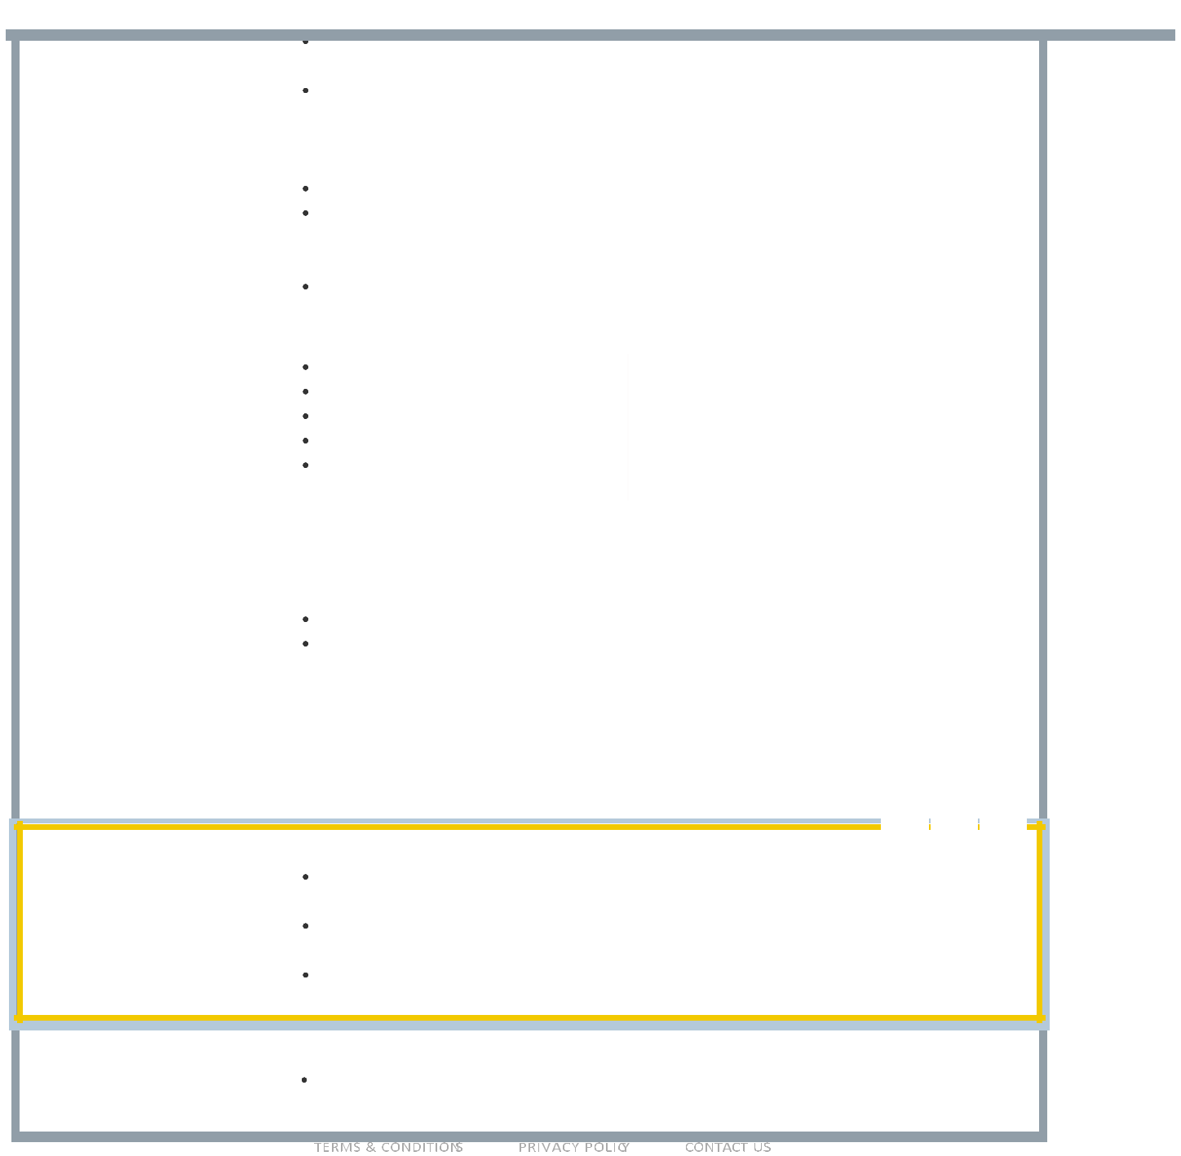

**CORE QUALIFICATIONS**

Selenium Web Driver

Core Java Language

Postman Tool

SQL -DB

Manual testing

Mobile Testing

API Testing

Performance Testing(jmeter)

Agile Methodology

POM (BDD,TDD) Hybrid framwork

Test NG Framwork

Excel Read Write

BLS(Bug Life Cycle),STLC(softwere

testing life cycle).

**EDUCATION**

|  |  |
| --- | --- |
| **2018** | **B.Sc** : Chemistry |
|  | **Thakur College Of Science & Commerce** － Kandivali (W), Mumbai |
|  | It was a great experience of my life to build my skill and knowledge . |
|  | I was wonder about my quality of teacher and staffs to motivate me and |
|  | help to develop my skills. |
| **2015** | **Intermediate** : Science |
|  | **Lokmanya Junior college** － Nallasopara (E) , Palghar 401209. |
| **2013** | **10 th** : Science |
|  | **SMPDIC college** － Manikpur,UP |

**ACCOMPLISHMENTS**

Automation team member & an individual contributor responsible for creating Automation Scripts

Involved in code reviews there by ensuring high quality and optimized code

Following Test Plan, Test Cases and testing scenarios Executing test cases and preparing daily execution report.

**LANGUAGES**

English, Hindi.

2/2