**K.E. SOCIETY’S**

**Rajarambapu Institute of Technology, Rajaramnagar, Sakhrale, Tal – Walwa, Sangli.**



**An**

**Abstract of Software Engineering Course**

**For**

**www.Eventify.com**

**Submitted By**

Patil Virendra R. (1403042)

Maske Vishal D. (1403035)

Jadhav Ganesh V. (1403034)

**Under the guidance of**

Mr. Sandeep Mane Sir.

**Department Of Computer Science and Engineering**

Year 2015-2016, Semester –IV

**Project Title:** Government Scheme Info.

**Problem Statement:**

Today there are schemes related to each person, related to farming land and various subsidies on other facilities. But people lives in villages they don’t know about their schemes. Even according to nationality certificate some schemes are sanctioned automatically but they don’t know about that schemes. And their subsidies automatically submitted to government.

Solution for this is that every person can get information about their schemes and subsidies on single application. They get information on old schemes and new schemes. Status information of that scheme.

The queries related to the event can be discussed over a forum for the particular scheme. This idea can be expanded to national level also, where anyone from any village under a particular state can get access to the schemes in government.

**Objectives:**

Our main objectives include the following things:

* Creating a Web App, wherein people can log in and get access to schemes which are to be held in India.
* Old schemes are updated to new schemes and get their information.
* Creating a discussion forum where the queries can discussed related to the schemes with government officers.
* Every people get information about all subsides and schemes.

**Scope:**

The scope of this project is not limited only for a particular region but it can access to state level. It can be expanded to national level as discussed above.

People under a state can host their schemes through the portal. Some people can get information about how they can start new business using new subsidies of government.

**Requirements:**

The requirements given below are according to the requirements of the stakeholders.

1. People:
   1. The main requirement of people are they get information about basic personal schemes such as schemes about their ration card.
   2. They should know about current status of their present scheme.
   3. The full information of the schemes should be uploaded to the website.
   4. They need to browse through variety of events and get full information of it.
   5. Queries about the schemes are also needed to be resolved through forums and direct contact with the government people.
   6. Schedule information must be clear.
   7. All discussion forums must be working.
2. Government Officers:
   1. People should tell only those queries which are feasible.
   2. People should keep patience.
   3. Ministers should sanction bills of schemes.
   4. People should demand only those new schemes which are necessary.
3. Network Admin:
   1. He the authority to add and delete user and maintain the databases for the same.
   2. He needs full information of the schemes so that he can design the interface of the website more creatively.
   3. He should maintain the records of people registered to a particular event.

**Software Requirement Specifications:**

1. Project Perspective:

This application gets idea about schemes and subsidies of all people who have nationality of India. We give this application to the all people of India so they can see their upcoming schemes in the database. The other person who will use this application will be citizen of India.They will get the details of the upcoming new schemes by just logging to the application and downloading the desired scheme details. And they can get details of the current schemes.

1. Product Functionality:

This product contains three major users. First the admin will allow the user for accessing the application by giving the permissions, rights and access control.

Second is government who have rights to post their scheme and subsidy information and updates.

And third The End User i.e. People, they can see the list of the events and schedule of event.

1. Performance Requirement:

Better performance will lead to better operating environment. For better environment the user needs a good speed of internet so that upload and download will be better.

1. Feasibility Study:
   1. **Feasibility Analysis:**

A feasibility study is a short focused, which aims to answer a number of questions:

Does the system contribute to the overall objective of the government?

Can the system be implemented using the current technology and within given schedule constraints?

* 1. **Technical Feasibility:**

To develop this application, an internet connection, a database server, a web server and software are required.

* 1. **Behavioral Feasibility:**

The application is behaviorally feasible since it requires no technical guidance, allthe modules are user friendly and execute in a manner they were designed to.

**UML diagrams:**

1. Use Case:

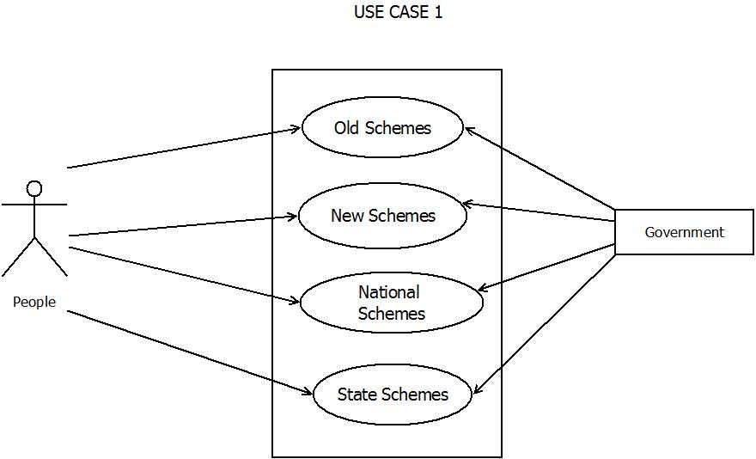

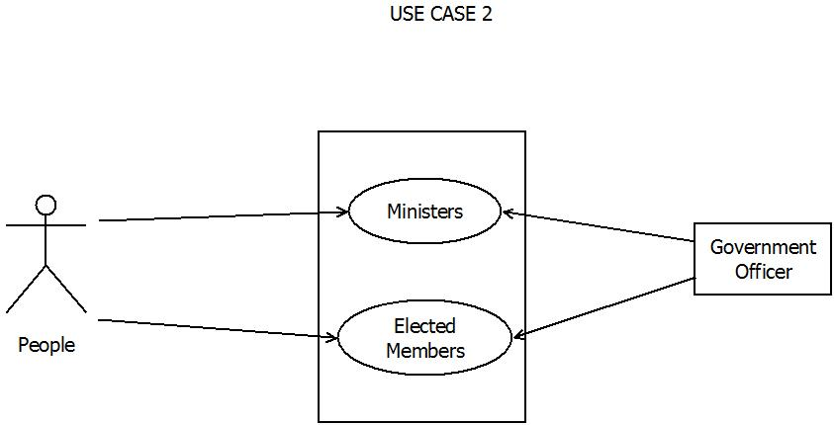

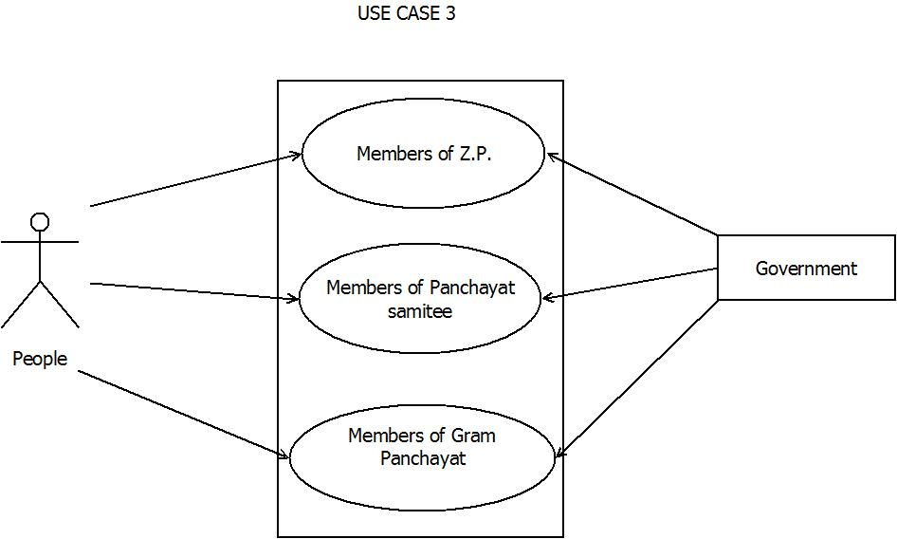

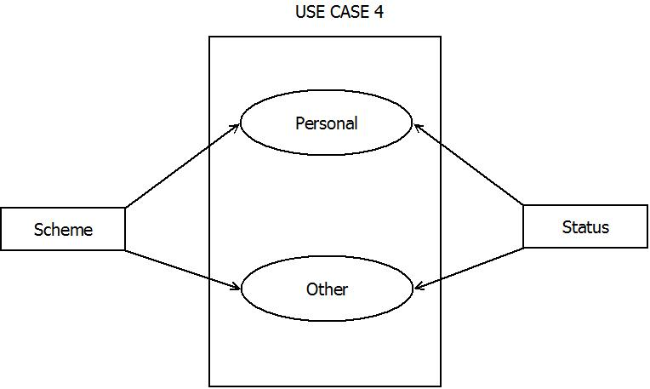

1. Activity Diagram

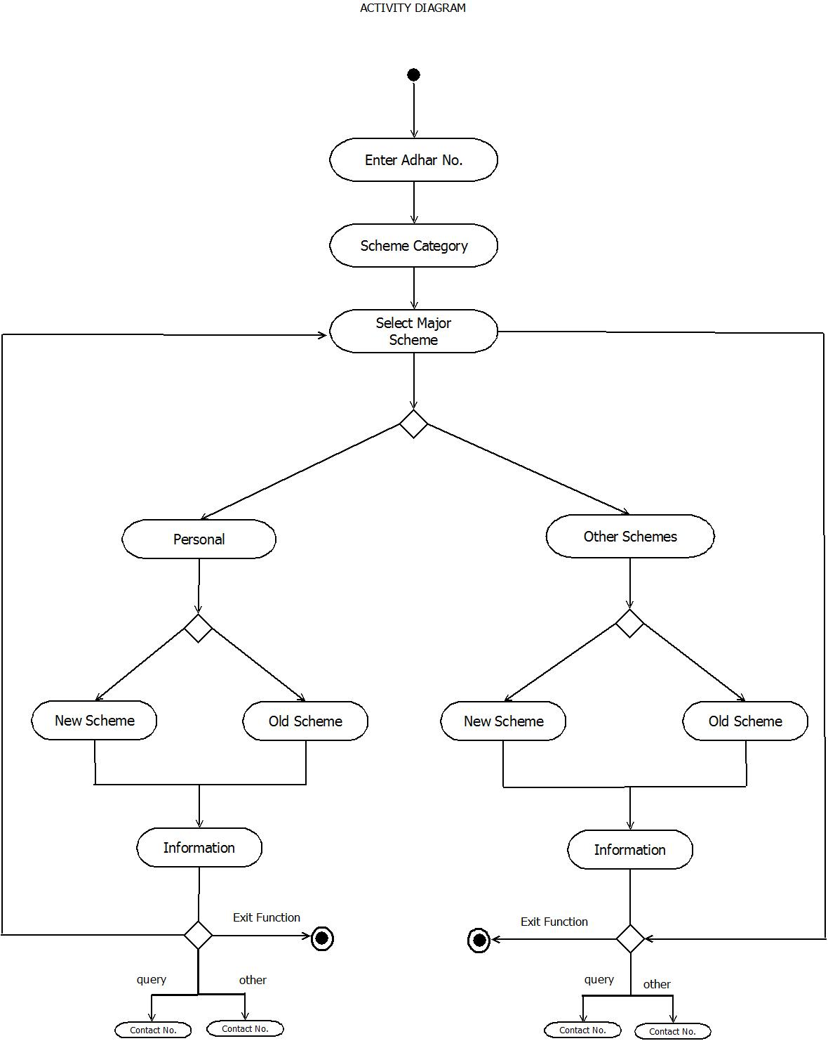

1. DFD Diagram

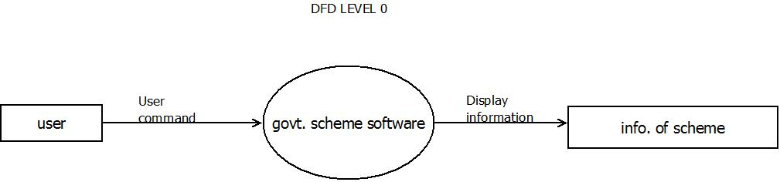

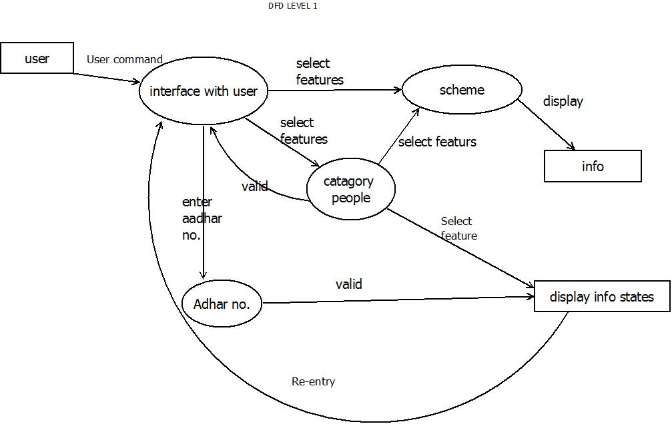

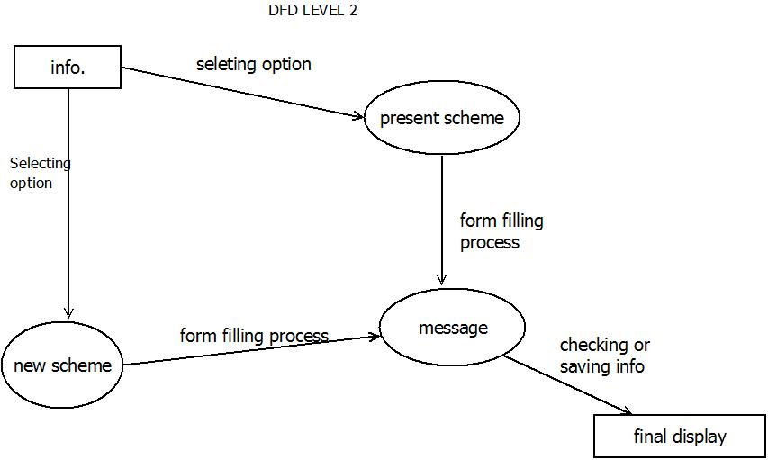

4.State Diagram:-

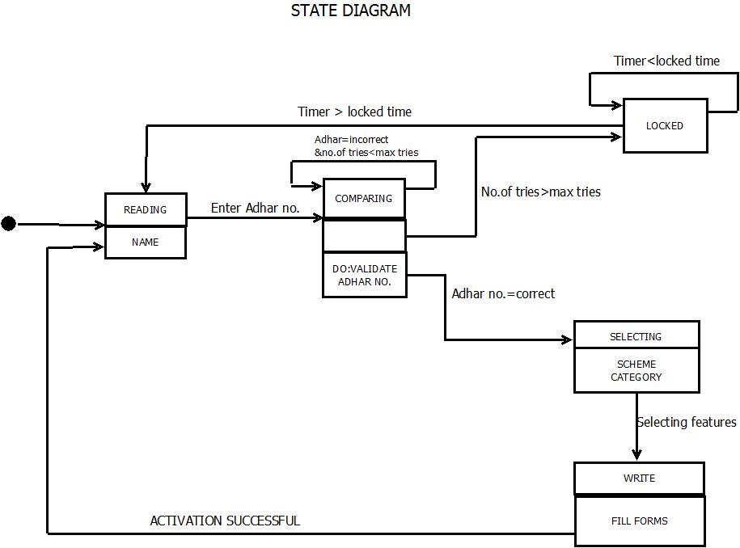

5.Class Diagram:-

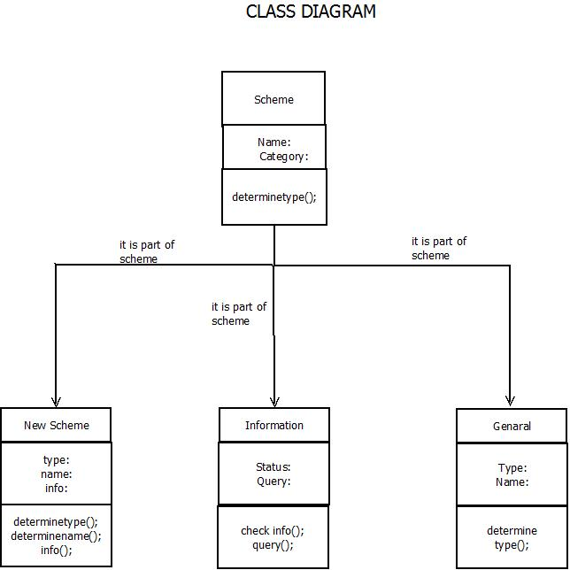

6.Sequence Diagram:-

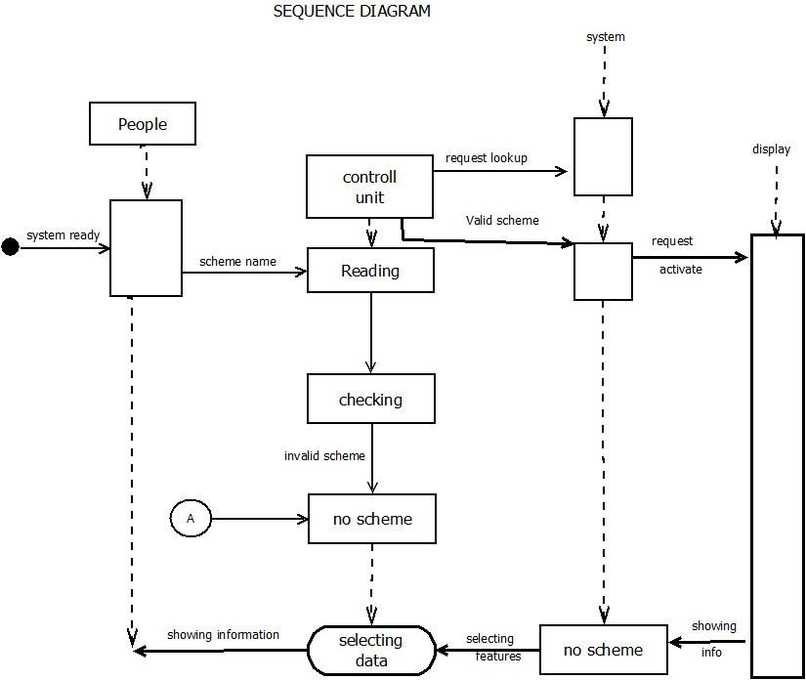

7. Collaberation Diagram

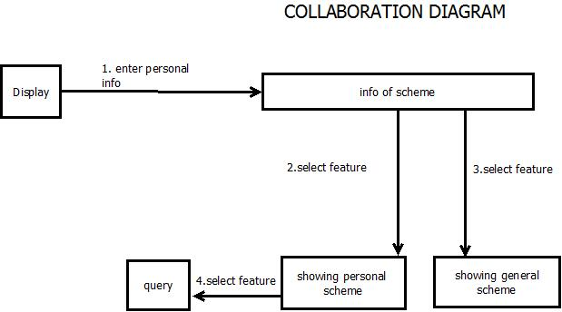

8. Deployment Diagram

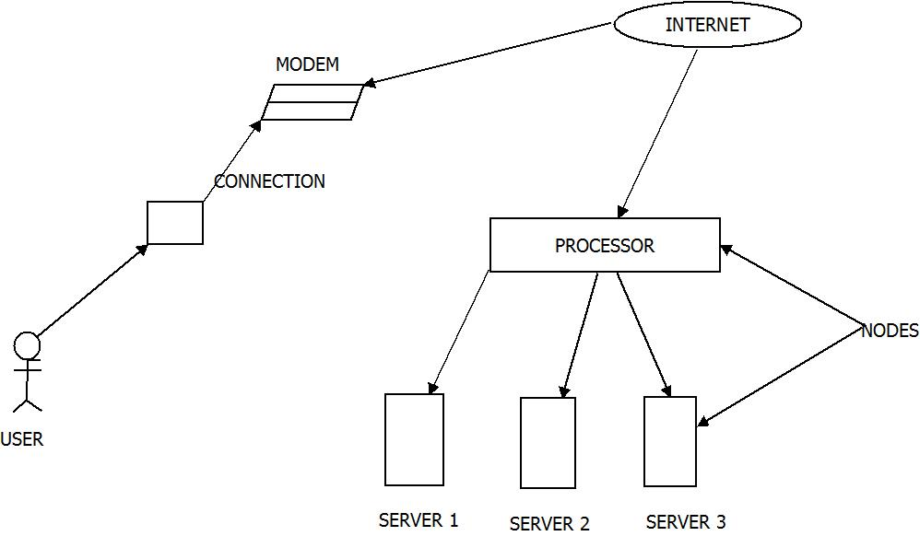

9. Component Diagram

