Assignment-03
Q.1- What are the premitive data type in C language?
Ans.-1 Premitive Data Types are those data types which are already defined. These are following given below: int, char, float, double.
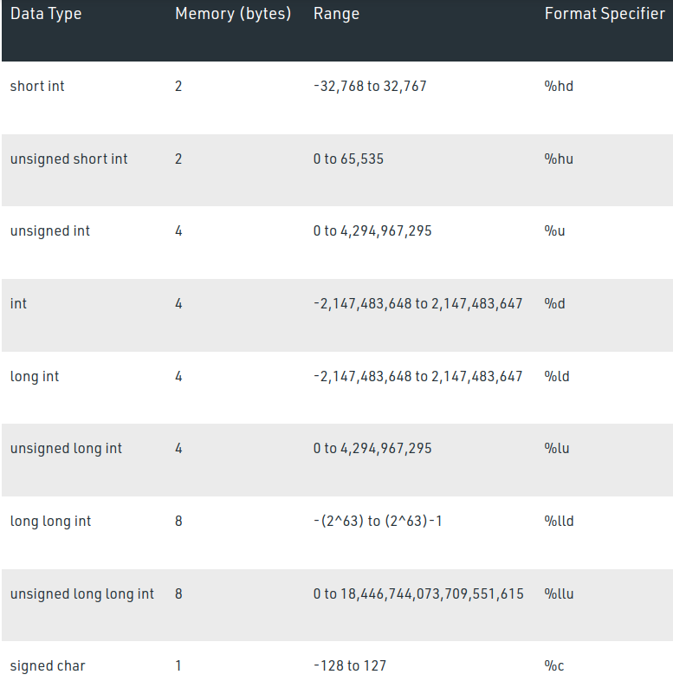
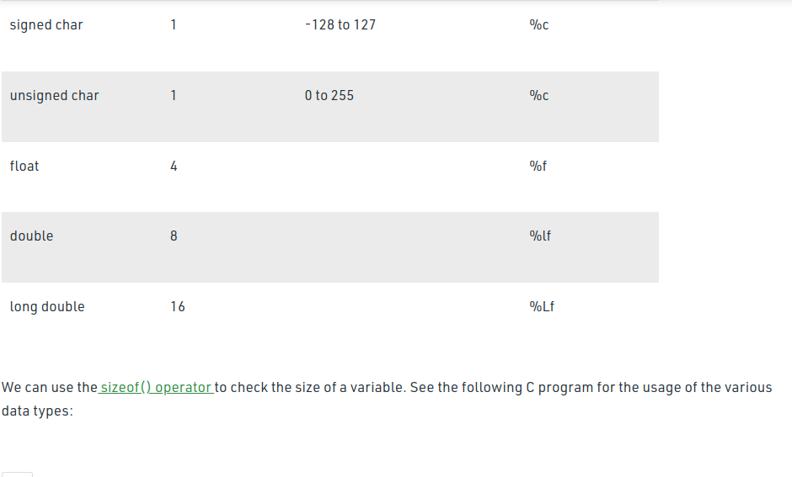
Q.2- What kind of statement can be written outside the function body?
Ans.2- Declairation stsatements can be written outside the function.

Q.3- What is the size of float type variable?
Ans.3- 4 bytes

Q.4- What is the value of an uninitialised variable?
Ans.4- Garvage Value.

Q.5- What is difference between float and double?
Ans.5- 1:- float data variable stores less accurate value than double type variable.
2:- float type variable consumes meomory 4 bytes but double type variable consumes 8 bytes memory.
Example- flaot x= 13/3;
double y= 13/3;
Here will be our output just like this
x= 4.333, y=4.3333333

Q.6 What is full form of ASCII?
Ans.6- ASCII stands for American Standard Code for Information Interchange.

Q.7- What is difference between keyword and function?
Ans.7-A Keywords can be a data type but a funtion can never be data type.

Q.8- Explore the use of type modifier in C?
Ans.8- Modifiers are never used with float type data, it changes the meaning of data types, it is used with int, char, double data types. Some modifiers are: signed, unsigned, long, short
signed and unsigned modifiers are used with int and char type data but long and short are used with int, char, double.

Q.9- Can you assign a char type variable in an int variable?
Ans.9- Yes

Q.10-State the following statement is true or false-”Every block of code is a function.”
Ans.10- True

