1.What are the two values of the Boolean data type? How do you write them?

We used Boolean data type in order to describe logical result and the values of Boolean data type are True and False (We also can use Yes or No)

2. What are the three different types of Boolean operators?

AND, OR, NOT

3. Make a list of each Boolean operator's truth tables (i.e. every possible combination of Boolean values for the operator and what it evaluate ).

For True = 1 and False = 0

For AND

1 1 = 1

0 0 = 0

1 0 = 0

0 1 = 0

For OR

1 1 = 1

0 1 = 1

1 0 = 1

0 0 = 0

For NOT

0 1

1 0

4. What are the values of the following expressions?

(5 > 4) and (3 == 5) = False

not (5 > 4) = False

(5 > 4) or (3 == 5) = True

not ((5 > 4) or (3 == 5)) = False

(True and True) and (True == False) = False

(not False) or (not True) = True

5. What are the six comparison operators?

Less than (<), Greater than (>), Less than equal to (=<), Less than equal to (=<), Equal to (==), Not equal to (!=)

6. How do you tell the difference between the equal to and assignment operators?Describe a condition and when you would use one.

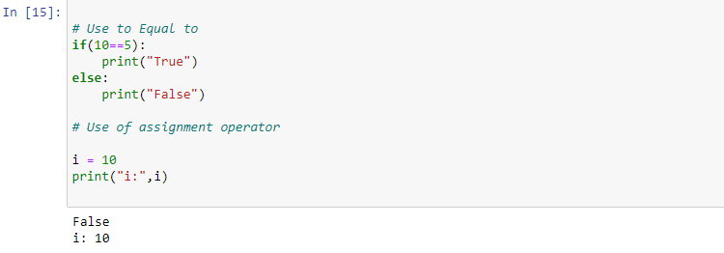

7. Identify the three blocks in this code:

spam = 0

if spam == 10:

print('eggs')

if spam > 5:

print('bacon')

else:

print('ham')

print('spam')

print('spam')

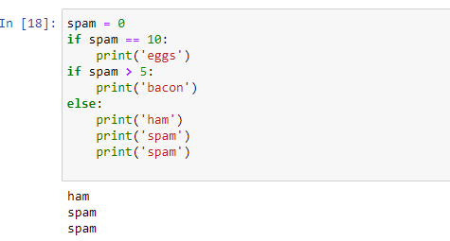

8. Write code that prints Hello if 1 is stored in spam, prints Howdy if 2 is stored in spam, and prints Greetings! if anything else is stored in spam.

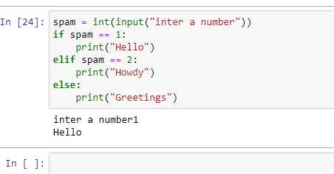

9.If your programme is stuck in an endless loop, what keys you’ll press?

Ctrl +C

10. How can you tell the difference between break and continue?

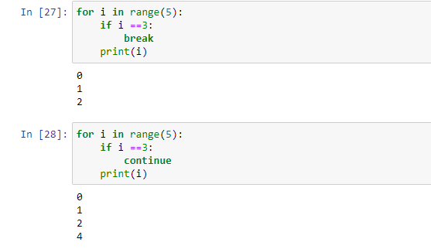

11. In a for loop, what is the difference between range(10), range(0, 10), and range(0, 10, 1)?

In output wise not difference but denotes the different initialization method rang(10) by default start from 0 to 9, range(0,10) we are mentioning the start point and range(0,10,1) we are denoting start point as well as index insertion

12. Write a short program that prints the numbers 1 to 10 using a for loop. Then write an equivalent program that prints the numbers 1 to 10 using a while loop.

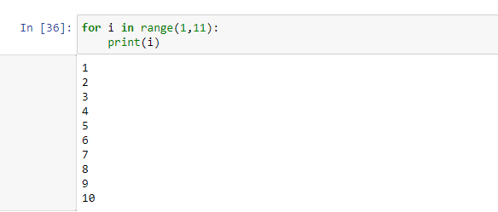

13. If you had a function named bacon() inside a module named spam, how would you call it after importing spam?

Spam.bacon()