MyAVController
By Zewen Li 12/11/2012
OpenCV installation on iOS:
1. Drag opencv2.framework into Projects on Xcode.
2. Set "C++ Standard Library" option on libstdc++ in Building settings.
3. There is confliction for MIN MACRO between opencv and UIKit, so just modify .pch file in the project as below:
1  2  3  4  5  6  7  8  9  10 | #import <Availability.h>  #ifdef __cplusplus  #import <opencv2/opencv.hpp>  #endif  #ifdef __OBJC__  #import <UIKit/UIKit.h>  #import <Foundation/Foundation.h>  #endif
4. Enjoy!

Running Requirements:
System: iOS 5.0
Device: iPhone 4s(any iPhone beyond iPhone 4 include iPhone 4 is OK)
Debug Requirements:
Xcode 4.0 or above (Mine is Xcode 4.5)
Mac OS X or higher (Mine is Mac OS X Mountain Lion)
Deployment and certificate of Apple student developer
(http://its.vanderbilt.edu/apple-iphone-developer-program/dev-dep)
(https://developer.apple.com/ios/manage/overview/index.action)
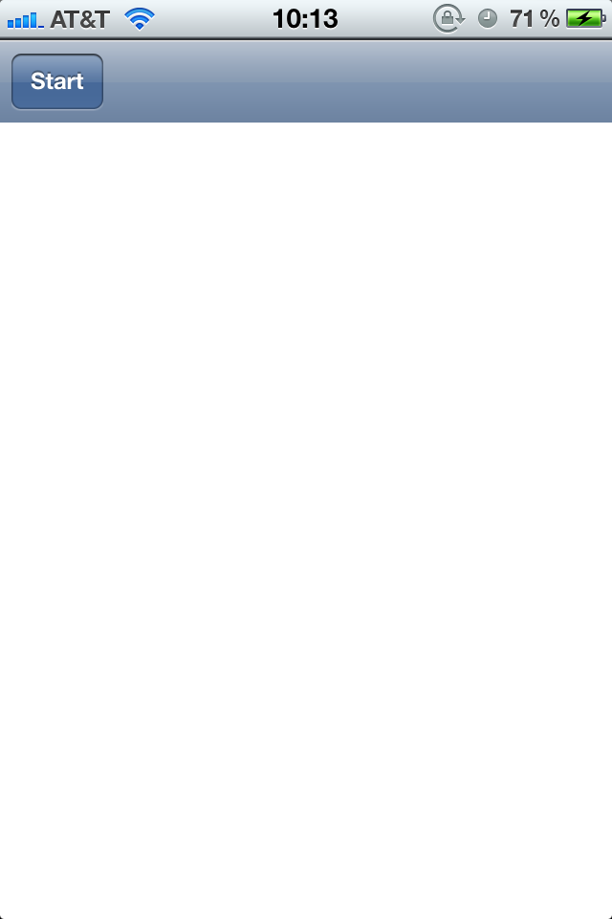
welcome page
- Press "Start" to start video record.
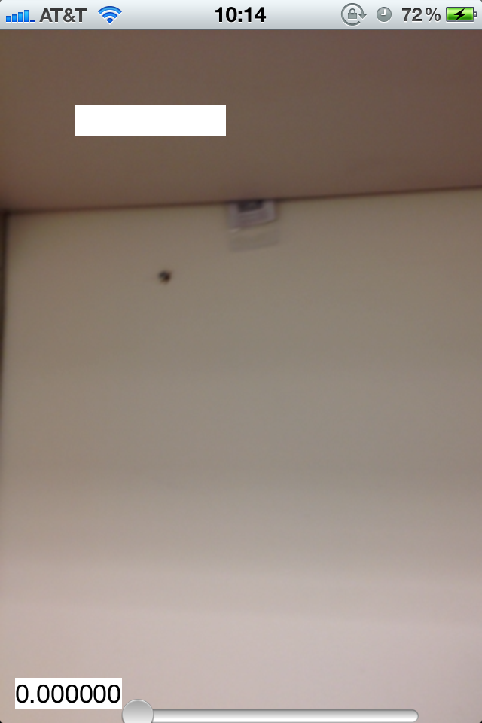
Running page
- Click the white button in the screen to restart record.
- Video record starts as soon as application starts running.

How to get saved video records
- Requirements:
System: Mac OS X
IDE: Xcode 4 or higher
1. Open "Xcode"
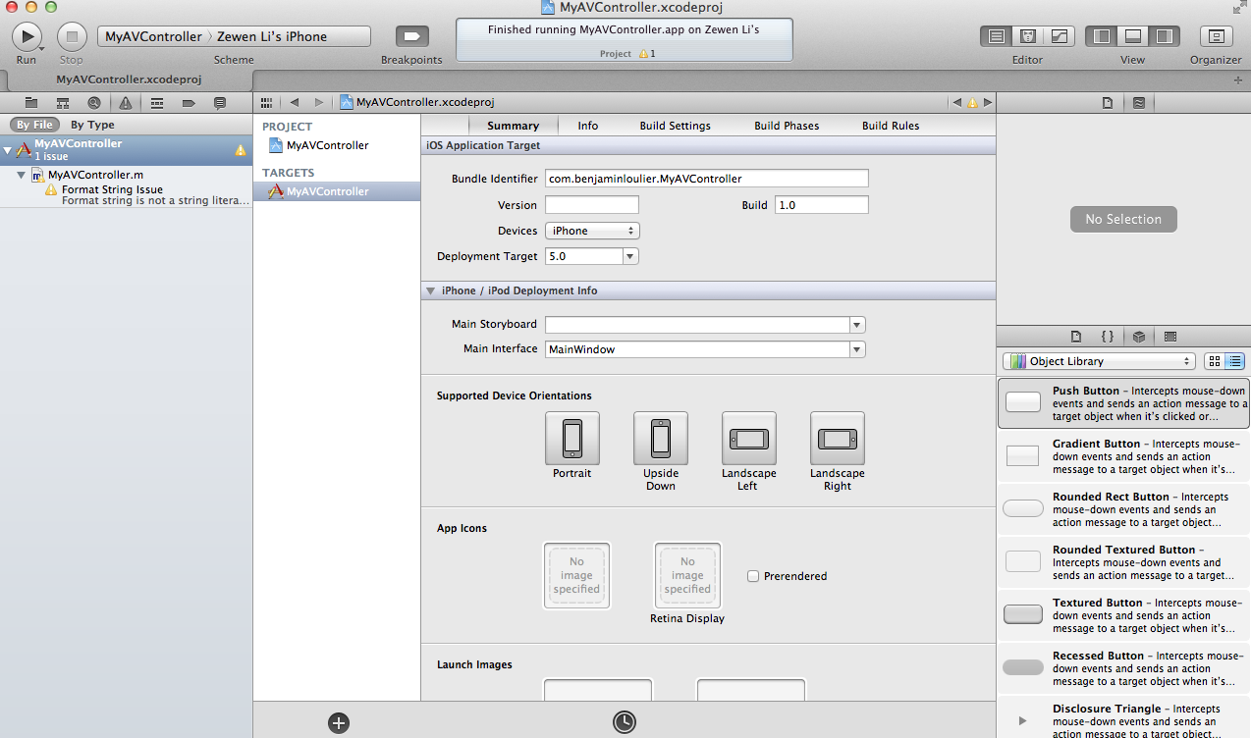
2. Find "Organizer"- "MyAVController 1.0"

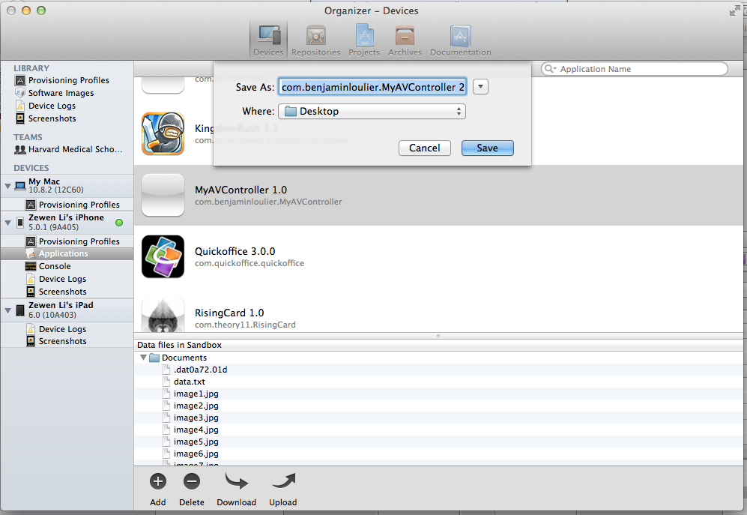
3. Click "Download" to save.
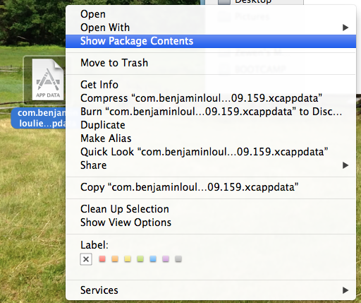
4. Right click on the saved file - "Show Package Contents"
5. Saved images and information are stored in "AppData" - "Documents"
