Change the name of a branch:

EGCJ MINGW64 /c/Venus (bugfix)

$ git branch -m bugfix bugfix/signup-form

git branch -D bugfix # Forced Delete of the bugfix branch

It shows us the changes in the branch:

Admin@DESKTOP-76OEGCJ MINGW64 /c/Venus (master)

$ git diff --name-status bugfix/signup-form

M audience.txt

Admin@DESKTOP-76OEGCJ MINGW64 /c/Venus (master)

$ git switch -C bugfix/login-form

Switched to a new branch 'bugfix/login-form'

The files in the staging area

Admin@DESKTOP-76OEGCJ MINGW64 /c/Projects/Moon (master)

$ git ls-files

file1.txt

file2.txt

Admin@DESKTOP-76OEGCJ MINGW64 /c/Projects/Moon (master)

$ git difftool

warning: LF will be replaced by CRLF in file1.js.

The file will have its original line endings in your working directory

Viewing (1/1): 'file1.js'

Launch 'vscode' [Y/n]?

The files stored in a particular commit

Admin@DESKTOP-76OEGCJ MINGW64 /c/Projects/Moon (master)

$ git ls-tree HEAD~1

100644 blob 51912609ec27972cefdb1287cf1c5c9fe284b0f5 .gitignore

040000 tree 64629cd51ef4a65a9d9cb9e656e1f46e07e1357f bin

100644 blob ce013625030ba8dba906f756967f9e9ca394464a file1.js

Restore the version of the file that has already been committed

Admin@DESKTOP-76OEGCJ MINGW64 /d/Story (master)

$ git checkout chapter3.txt

The situation when you created a local repo and want to push it to a remote repo

Admin@DESKTOP-76OEGCJ MINGW64 /d/Story (master)

$ git remote add origin https://github.com/Virginia-V/Story.git

git branch -M main

Admin@DESKTOP-76OEGCJ MINGW64 /d/Story (master)

$ git push -u origin master

**Collaboration**

**Fetching**

Admin@DESKTOP-76OEGCJ MINGW64 /c

$ git clone https://github.com/Virginia-V/Mars.git

Admin@DESKTOP-76OEGCJ MINGW64 /c/Mars (main)

$ git log --oneline --all --graph

* c98c283 (HEAD -> main, origin/main, origin/HEAD) Initial commit

The README.md file was updated on GitHub.

Admin@DESKTOP-76OEGCJ MINGW64 /c/Mars (main)

$ git fetch

Admin@DESKTOP-76OEGCJ MINGW64 /c/Mars (main)

$ git log --oneline --all --graph

* fab5baa (origin/main, origin/HEAD) Update README.md

* c98c283 (HEAD -> main) Initial commit

Admin@DESKTOP-76OEGCJ MINGW64 /c/Mars (main)

$ git branch -vv

* main c98c283 [origin/main: behind 1] Initial commit

Admin@DESKTOP-76OEGCJ MINGW64 /c/Mars (main)

$ git merge origin/main

Admin@DESKTOP-76OEGCJ MINGW64 /c/Mars (main)

$ git log --oneline --all --graph

* fab5baa (HEAD -> main, origin/main, origin/HEAD) Update README.md

* c98c283 Initial commit

Admin@DESKTOP-76OEGCJ MINGW64 /c/Mars (main)

$ git branch -vv

* main fab5baa [origin/main] Update README.md

**Pulling**

The README.md file was updated on GitHub.

Admin@DESKTOP-76OEGCJ MINGW64 /c/Mars (main)

$ echo hello > file1.txt

Admin@DESKTOP-76OEGCJ MINGW64 /c/Mars (main)

$ git add .

warning: LF will be replaced by CRLF in file1.txt.

The file will have its original line endings in your working directory

Admin@DESKTOP-76OEGCJ MINGW64 /c/Mars (main)

$ git commit -m "Add file1"

[main ea86ceb] Add file1

1 file changed, 1 insertion(+)

create mode 100644 file1.txt

Admin@DESKTOP-76OEGCJ MINGW64 /c/Mars (main)

$ git log --oneline --all --graph

* ea86ceb (HEAD -> main) Add file1

* fab5baa (origin/main, origin/HEAD) Update README.md

* c98c283 Initial commit

Admin@DESKTOP-76OEGCJ MINGW64 /c/Mars (main)

$ git pull

Admin@DESKTOP-76OEGCJ MINGW64 /c/Mars (main)

$ git log --oneline --all --graph

* f0233cf (HEAD -> main) Merge branch 'main' of https://github.com/Virginia-V/Mars

|\

| * 351b189 (origin/main, origin/HEAD) Update README.md

* | ea86ceb Add file1

|/

* fab5baa Update README.md

* c98c283 Initial commit

Admin@DESKTOP-76OEGCJ MINGW64 /c/Mars (main)

$ git reset --hard HEAD~1

HEAD is now at ea86ceb Add file1

Admin@DESKTOP-76OEGCJ MINGW64 /c/Mars (main)

$ git log --oneline --all --graph

* ea86ceb (HEAD -> main) Add file1

| * 351b189 (origin/main, origin/HEAD) Update README.md

|/

* fab5baa Update README.md

* c98c283 Initial commit

Admin@DESKTOP-76OEGCJ MINGW64 /c/Mars (main)

$ git pull --rebase

Successfully rebased and updated refs/heads/main.

Admin@DESKTOP-76OEGCJ MINGW64 /c/Mars (main)

$ git log --oneline --all --graph

* 50d4994 (HEAD -> main) Add file1

* 351b189 (origin/main, origin/HEAD) Update README.md

* fab5baa Update README.md

* c98c283 Initial commit

Admin@DESKTOP-76OEGCJ MINGW64 /c/Mars (main)

$ git push

Admin@DESKTOP-76OEGCJ MINGW64 /c/Mars (main)

$ git log --oneline --all --graph

* 50d4994 (HEAD -> main, origin/main, origin/HEAD) Add file1

* 351b189 Update README.md

* fab5baa Update README.md

* c98c283 Initial commit

**Sharing Branches**

Admin@DESKTOP-76OEGCJ MINGW64 /c/Mars (main)

$ git switch -C feature/change-password

Switched to a new branch 'feature/change-password'

Admin@DESKTOP-76OEGCJ MINGW64 /c/Mars (feature/change-password)

$ git branch -vv

* feature/change-password 50d4994 Add file1

main 50d4994 [origin/main] Add file1

Admin@DESKTOP-76OEGCJ MINGW64 /c/Mars (feature/change-password)

$ git branch -r

origin/HEAD -> origin/main

origin/main

Admin@DESKTOP-76OEGCJ MINGW64 /c/Mars (feature/change-password)

$ git push -u origin feature/change-password

Admin@DESKTOP-76OEGCJ MINGW64 /c/Mars (feature/change-password)

$ git branch -vv

* feature/change-password 50d4994 [origin/feature/change-password] Add file1

main 50d4994 [origin/main] Add file1

Admin@DESKTOP-76OEGCJ MINGW64 /c/Mars (feature/change-password)

$ git branch -r

origin/HEAD -> origin/main

origin/feature/change-password

origin/main

Delete the branch from the remote repo

Admin@DESKTOP-76OEGCJ MINGW64 /c/Mars (feature/change-password)

$ git push -d origin feature/change-password

To https://github.com/Virginia-V/Mars.git

- [deleted] feature/change-password

Admin@DESKTOP-76OEGCJ MINGW64 /c/Mars (feature/change-password)

$ git branch -r

origin/HEAD -> origin/main

origin/main

Admin@DESKTOP-76OEGCJ MINGW64 /c/Mars (feature/change-password)

$ git branch -vv

* feature/change-password 50d4994 [origin/feature/change-password: gone] Add file1

main 50d4994 [origin/main] Add file1

Admin@DESKTOP-76OEGCJ MINGW64 /c/Mars (feature/change-password)

$ git branch

* feature/change-password

Main

Admin@DESKTOP-76OEGCJ MINGW64 /c/Mars (feature/change-password)

$ git switch main

Switched to branch 'main'

Your branch is up to date with 'origin/main'.

Admin@DESKTOP-76OEGCJ MINGW64 /c/Mars (main)

$ git branch -d feature/change-password

Deleted branch feature/change-password (was 50d4994).

**Collaboration Workflow**

On GitHub, it was created the branch feature/change-password.

Admin@DESKTOP-76OEGCJ MINGW64 /c/Mars (main)

$ git fetch

From https://github.com/Virginia-V/Mars

* [new branch] feature/change-password -> origin/feature/change-password

Admin@DESKTOP-76OEGCJ MINGW64 /c/Mars (main)

$ git branch

* main

Admin@DESKTOP-76OEGCJ MINGW64 /c/Mars (main)

$ git branch -r

origin/HEAD -> origin/main

origin/feature/change-password

origin/main

Admin@DESKTOP-76OEGCJ MINGW64 /c/Mars (main)

$ git switch -C feature/change-password origin/feature/change-password

Switched to a new branch 'feature/change-password'

branch 'feature/change-password' set up to track 'origin/feature/change-password'.

Admin@DESKTOP-76OEGCJ MINGW64 /c/Mars (feature/change-password)

$ git branch

* feature/change-password

Main

Simulation on Amy’s workspace

Admin@DESKTOP-76OEGCJ MINGW64 /c/Amy

$ git clone https://github.com/Virginia-V/Mars.git

Admin@DESKTOP-76OEGCJ MINGW64 /c/Amy/Mars (main)

$ git branch

* main

Admin@DESKTOP-76OEGCJ MINGW64 /c/Amy/Mars (main)

$ git switch -C feature/change-password origin/feature/change-password

Switched to a new branch 'feature/change-password'

Admin@DESKTOP-76OEGCJ MINGW64 /c/Amy/Mars (feature/change-password)

$ echo password > file1.txt

Admin@DESKTOP-76OEGCJ MINGW64 /c/Amy/Mars (feature/change-password)

$ git commit -am "Update file1"

Admin@DESKTOP-76OEGCJ MINGW64 /c/Amy/Mars (feature/change-password)

$ git push

Admin@DESKTOP-76OEGCJ MINGW64 /c/Mars (feature/change-password)

$ git pull

Admin@DESKTOP-76OEGCJ MINGW64 /c/Mars (feature/change-password)

$ git log --oneline --all --graph

* 45dcfca (HEAD -> feature/change-password, origin/feature/change-password) Update file1

* 50d4994 (origin/main, origin/HEAD, main) Add file1

* 351b189 Update README.md

* fab5baa Update README.md

* c98c283 Initial commit

Admin@DESKTOP-76OEGCJ MINGW64 /c/Mars (feature/change-password)

$ git switch main

Admin@DESKTOP-76OEGCJ MINGW64 /c/Mars (main)

$ git merge feature/change-password

Admin@DESKTOP-76OEGCJ MINGW64 /c/Mars (main)

$ git log --oneline --all --graph

* 45dcfca (HEAD -> main, origin/feature/change-password, feature/change-password) Update file1

* 50d4994 (origin/main, origin/HEAD) Add file1

* 351b189 Update README.md

* fab5baa Update README.md

* c98c283 Initial commit

Admin@DESKTOP-76OEGCJ MINGW64 /c/Mars (main)

$ git push

Admin@DESKTOP-76OEGCJ MINGW64 /c/Mars (main)

$ git log --oneline --all --graph

* 45dcfca (HEAD -> main, origin/main, origin/feature/change-password, origin/HEAD, feature/change-password) Update file1

* 50d4994 Add file1

* 351b189 Update README.md

* fab5baa Update README.md

* c98c283 Initial commit

Admin@DESKTOP-76OEGCJ MINGW64 /c/Mars (main)

$ git push -d origin feature/change-password

To https://github.com/Virginia-V/Mars.git

- [deleted] feature/change-password

Admin@DESKTOP-76OEGCJ MINGW64 /c/Mars (main)

$ git branch -d feature/change-password

Deleted branch feature/change-password (was 45dcfca).

Admin@DESKTOP-76OEGCJ MINGW64 /c/Amy/Mars (feature/change-password)

$ git switch main

Admin@DESKTOP-76OEGCJ MINGW64 /c/Amy/Mars (main)

$ git pull

Admin@DESKTOP-76OEGCJ MINGW64 /c/Amy/Mars (main)

$ git branch -d feature/change-password

Admin@DESKTOP-76OEGCJ MINGW64 /c/Amy/Mars (main)

$ git branch -r

origin/HEAD -> origin/main

origin/feature/change-password

origin/main

Admin@DESKTOP-76OEGCJ MINGW64 /c/Amy/Mars (main)

$ git remote prune origin

Pruning origin

URL: https://github.com/Virginia-V/Mars.git

* [pruned] origin/feature/change-password

Admin@DESKTOP-76OEGCJ MINGW64 /c/Amy/Mars (main)

$ git branch -r

origin/HEAD -> origin/main

origin/main

**Pull Requests**

Admin@DESKTOP-76OEGCJ MINGW64 /c/Amy/Mars (main)

$ git switch -C feature/login

Switched to a new branch 'feature/login'

Admin@DESKTOP-76OEGCJ MINGW64 /c/Amy/Mars (feature/login)

$ echo hello > file3.txt

Admin@DESKTOP-76OEGCJ MINGW64 /c/Amy/Mars (feature/login)

$ git add .

warning: LF will be replaced by CRLF in file3.txt.

The file will have its original line endings in your working directory

Admin@DESKTOP-76OEGCJ MINGW64 /c/Amy/Mars (feature/login)

$ git commit -m "Write hello to file3"

Admin@DESKTOP-76OEGCJ MINGW64 /c/Amy/Mars (feature/login)

$ git push -u origin feature/login

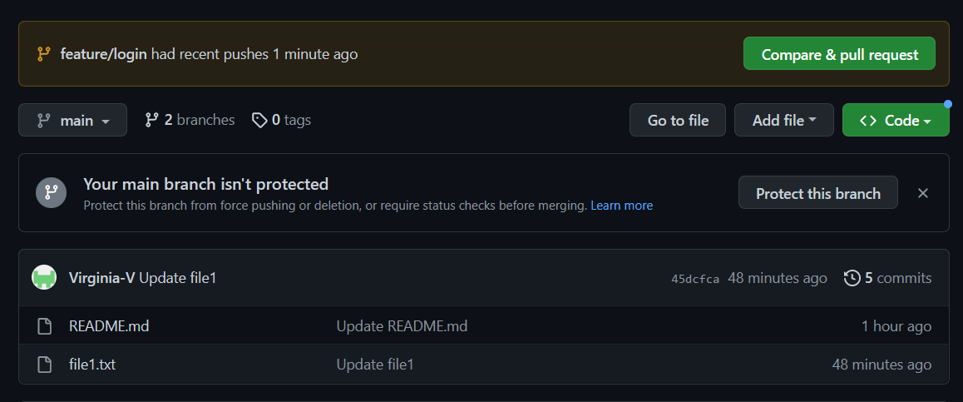

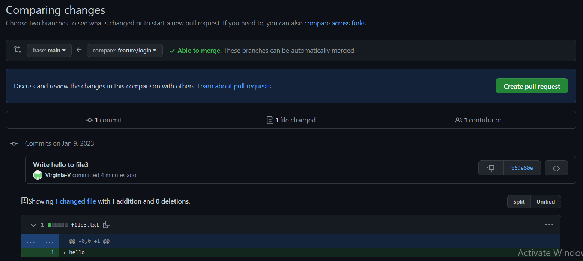

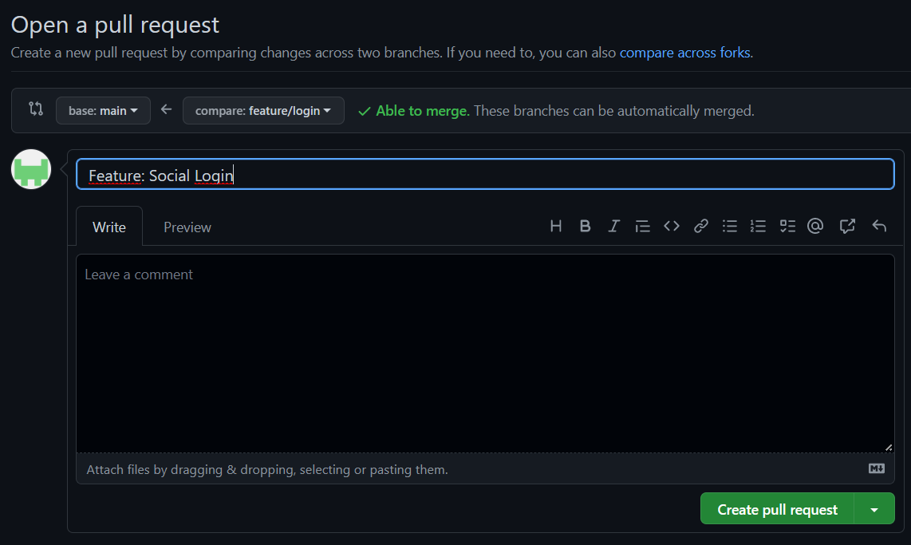

Admin@DESKTOP-76OEGCJ MINGW64 /c/Amy/Mars (feature/login)

$ echo Hello > file3.txt

Admin@DESKTOP-76OEGCJ MINGW64 /c/Amy/Mars (feature/login)

$ git commit -am "Capitalize Hello."

Admin@DESKTOP-76OEGCJ MINGW64 /c/Amy/Mars (feature/login)

$ git push

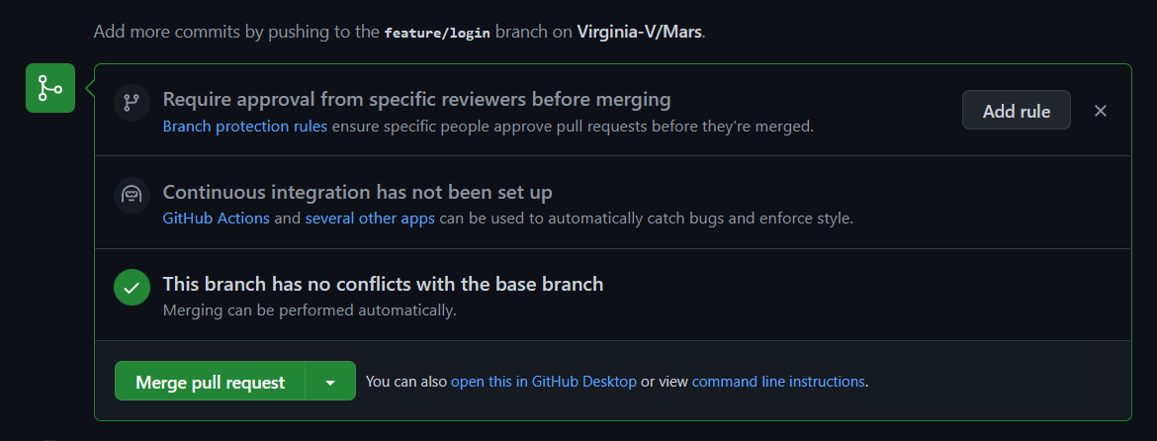

Admin@DESKTOP-76OEGCJ MINGW64 /c/Amy/Mars (feature/login)

$ git switch main

Admin@DESKTOP-76OEGCJ MINGW64 /c/Amy/Mars (main)

$ git pull

Admin@DESKTOP-76OEGCJ MINGW64 /c/Amy/Mars (main)

$ git log --oneline --all --graph

* 96222c2 (HEAD -> main, origin/main, origin/HEAD) Merge pull request #1 from Virginia-V/feature/login

|\

| * 0080fbd (origin/feature/login, feature/login) Capitalize Hello.

| * b69e60e Write hello to file3

|/

* 45dcfca Update file1

* 50d4994 Add file1

* 351b189 Update README.md

* fab5baa Update README.md

* c98c283 Initial commit

Admin@DESKTOP-76OEGCJ MINGW64 /c/Amy/Mars (main)

$ git remote prune origin

Pruning origin

URL: https://github.com/Virginia-V/Mars.git

* [pruned] origin/feature/login

Admin@DESKTOP-76OEGCJ MINGW64 /c/Amy/Mars (main)

$ git branch -d feature/login

Deleted branch feature/login (was 0080fbd).

**Resolving Conflicts**

Admin@DESKTOP-76OEGCJ MINGW64 /c/Amy/Mars (main)

$ git switch -C feature/logout

Switched to a new branch 'feature/logout'

Admin@DESKTOP-76OEGCJ MINGW64 /c/Amy/Mars (feature/logout)

$ echo hello > file1.txt

Admin@DESKTOP-76OEGCJ MINGW64 /c/Amy/Mars (feature/logout)

$ git commit -am "Write hello to file1"

Admin@DESKTOP-76OEGCJ MINGW64 /c/Amy/Mars (feature/logout)

$ git push -u origin feature/logout

Admin@DESKTOP-76OEGCJ MINGW64 /c/Amy/Mars (feature/logout)

$ git switch main

Admin@DESKTOP-76OEGCJ MINGW64 /c/Amy/Mars (main)

$ echo world > file1.txt

Admin@DESKTOP-76OEGCJ MINGW64 /c/Amy/Mars (main)

$ git commit -am "Write world to file1"

Admin@DESKTOP-76OEGCJ MINGW64 /c/Amy/Mars (main)

$ git push

