Insomnia NMA

Prepared by Virginia Chiocchia on 7th August, refers to a single outcome analysis (Daytime impairment) in a frequentist setting

## Description of the network

This network formed by studies examining the outcome Daytime impairment is composed by two sub-networks. The following treatments were excluded as they were disconnected to the two main sub-networks:

* Mindfulness Based Stress Reduction Program
* waitlist
* sleep hygiene
* lormetazepam + sleep hygiene
* artificial juice
* tart cherry juice

The only crossover study for this outcome (Vinkari 1984) was excluded as it had no available p-value needed to calculate the adjusted standard error.

### Sub-network 1

Below is a description for the sub-network including the following interventions

## [1] "doxepin"   
## [2] "eszopiclone"   
## [3] "flurazepam"   
## [4] "food supplement (melatonin, magnesium, zinc)"  
## [5] "pbo"   
## [6] "propiomazine"   
## [7] "quazepam"

Number of included interventions:

## [1] 7

Number of included studies:

## [1] 6

The plot below shows the available data  
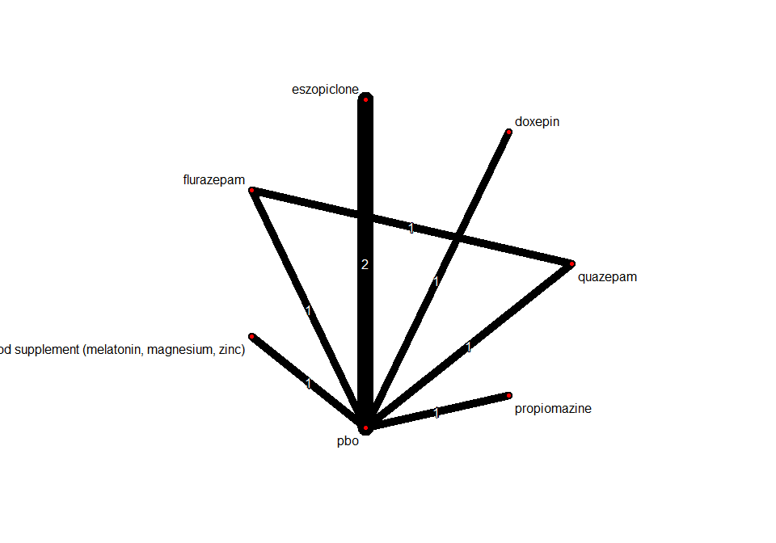

## Frequentist network meta-analysis

Below are the relative treatment effects from the NMA model.

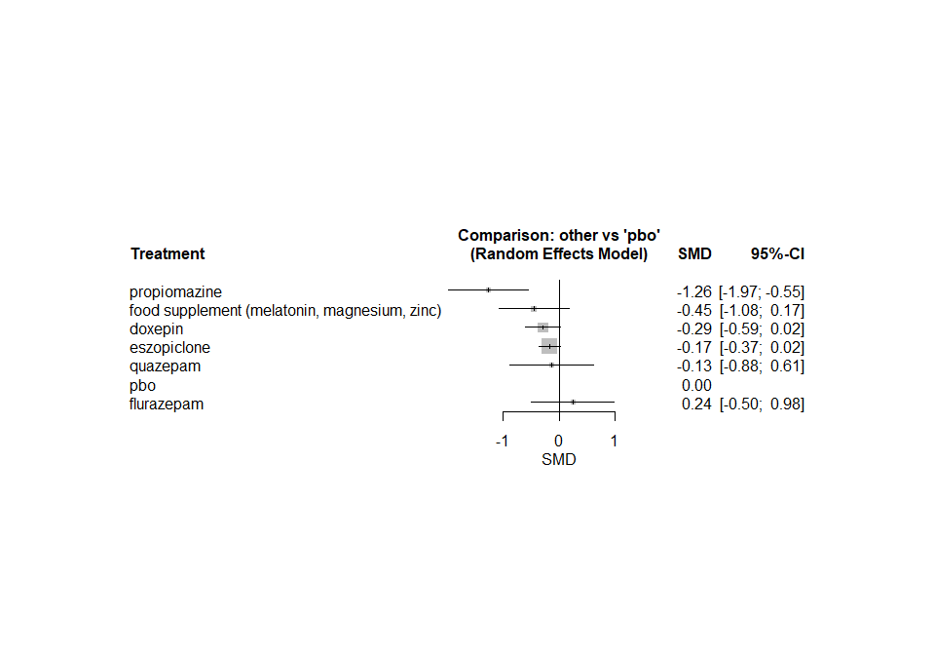

The heterogeneity standard deviation is estimated at

## tau= 0.076

and I-square (total) is

## I2= 28 %

### Sub-network 2

Below is a description for the sub-network including the following interventions

## [1] "chlormethiazole" "loprazolam" "nitrazepam" "triazolam"   
## [5] "zopiclone"

Number of included interventions:

## [1] 5

Number of included studies:

## [1] 4

The plot below shows the available data

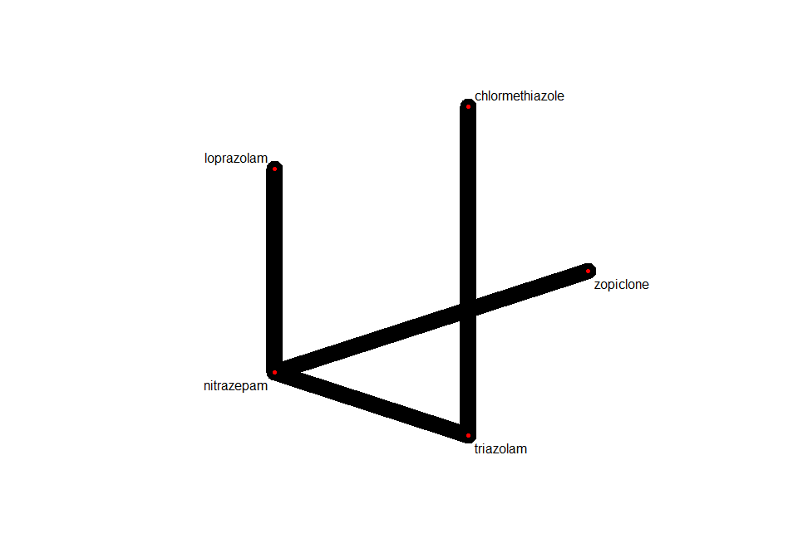

Below are the relative treatment effects from the NMA model.

